**1. Create an Android App which has a toast on all the lifecycle methods.**

**MainActivity.java:**

package com.example.sr.toastonalllifecycle;

import android.support.v7.app.AppCompatActivity;

import android.os.Bundle;

import android.util.Log;

import android.view.View;

import android.widget.Button;

import android.widget.Toast;

public class MainActivity extends AppCompatActivity {

Button b;

@Override

protected void onCreate(Bundle savedInstanceState) {

super.onCreate(savedInstanceState);

setContentView(R.layout.activity_main);

b=(Button)findViewById(R.id.button);

b.setOnClickListener(new View.OnClickListener() {

@Override

public void onClick(View v) {

Toast.makeText(getApplicationContext(),"Toast onCreate() created", Toast.LENGTH_LONG).show();

}

});

}

@Override

protected void onStart() {

super.onStart();

Toast.makeText(getApplicationContext(),"Toast onStart() created", Toast.LENGTH_LONG).show();

}

@Override

protected void onResume() {

super.onResume();

Toast.makeText(getApplicationContext(),"Toast onResume() created",Toast.LENGTH_LONG).show();

}

@Override

protected void onPause() {

super.onPause();

Toast.makeText(getApplicationContext(),"Toast onPause() created",Toast.LENGTH_LONG).show();

}

@Override

protected void onStop() {

super.onStop();

Toast.makeText(getApplicationContext(),"Toast onStop() created",Toast.LENGTH_LONG).show();

}

@Override

protected void onDestroy() {

super.onDestroy();

Toast.makeText(getApplicationContext(),"Toast onDestroy() created",Toast.LENGTH_LONG).show();

}

}

**Activity_main.xml:**

<?xml version="1.0" encoding="utf-8"?>

<android.support.constraint.ConstraintLayout xmlns:android="http://schemas.android.com/apk/res/android"

xmlns:app="http://schemas.android.com/apk/res-auto"

xmlns:tools="http://schemas.android.com/tools"

android:layout_width="match_parent"

android:layout_height="match_parent"

tools:context=".MainActivity">

<Button

android:id="@+id/button"

android:layout_width="185dp"

android:layout_height="85dp"

android:layout_marginStart="8dp"

android:layout_marginLeft="8dp"

android:layout_marginTop="8dp"

android:layout_marginEnd="8dp"

android:layout_marginRight="8dp"

android:layout_marginBottom="8dp"

android:text="Click"

app:layout_constraintBottom_toBottomOf="parent"

app:layout_constraintEnd_toEndOf="parent"

app:layout_constraintStart_toStartOf="parent"

app:layout_constraintTop_toTopOf="parent" />

<TextView

android:id="@+id/textView2"

android:layout_width="239dp"

android:layout_height="44dp"

android:layout_marginStart="8dp"

android:layout_marginLeft="8dp"

android:layout_marginTop="8dp"

android:layout_marginEnd="8dp"

android:layout_marginRight="8dp"

android:layout_marginBottom="8dp"

android:text="Press on click to view Toast."

android:textSize="18sp"

app:layout_constraintBottom_toBottomOf="parent"

app:layout_constraintEnd_toEndOf="parent"

app:layout_constraintStart_toStartOf="parent"

app:layout_constraintTop_toTopOf="parent"

app:layout_constraintVertical_bias="0.739" />

</android.support.constraint.ConstraintLayout>

**OUTPUT:**

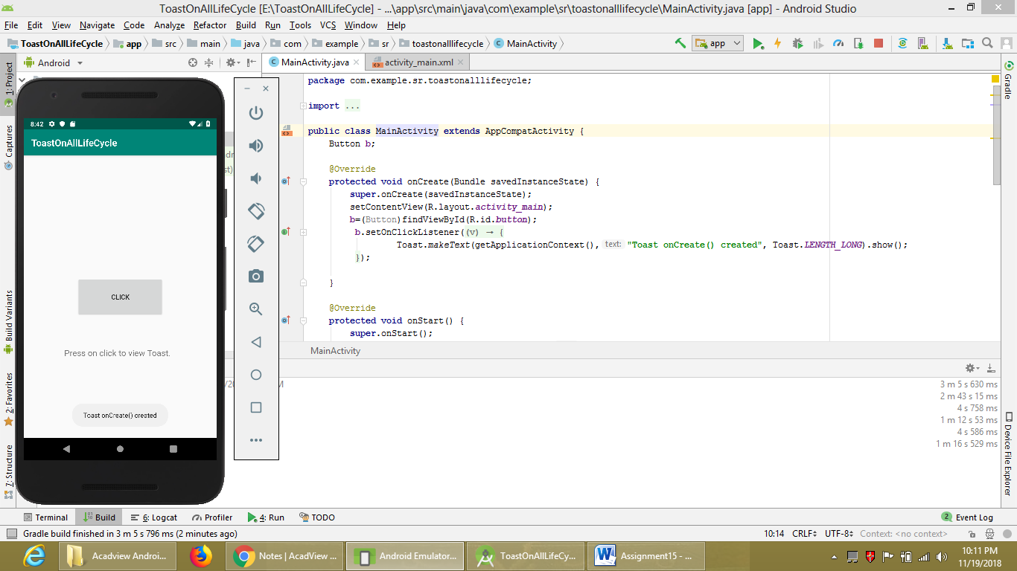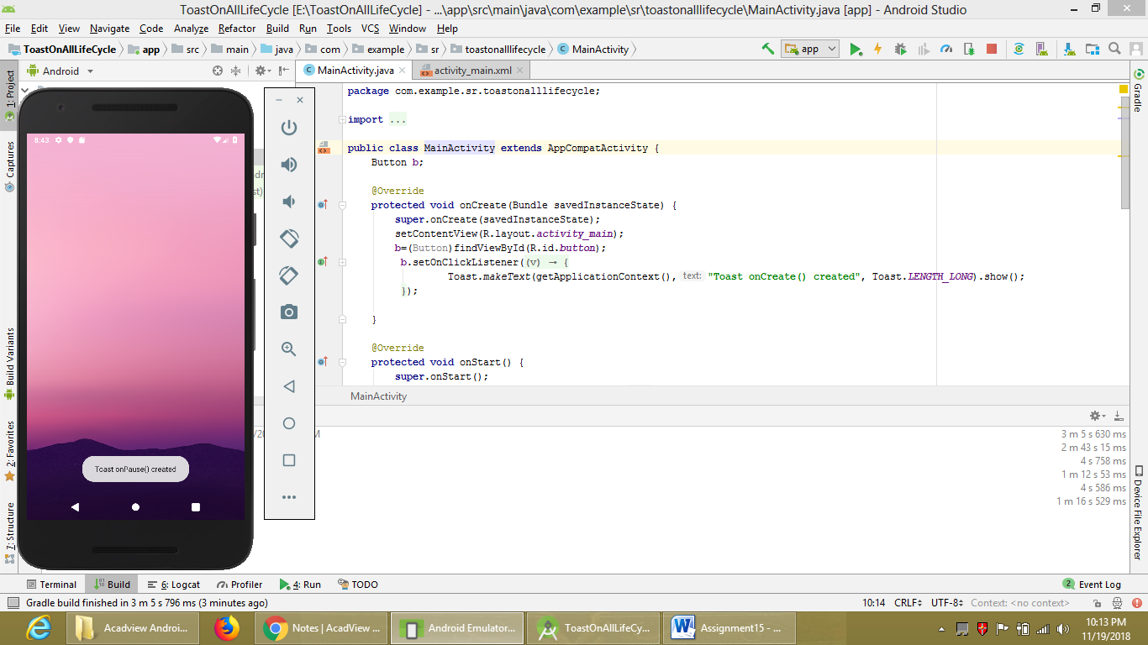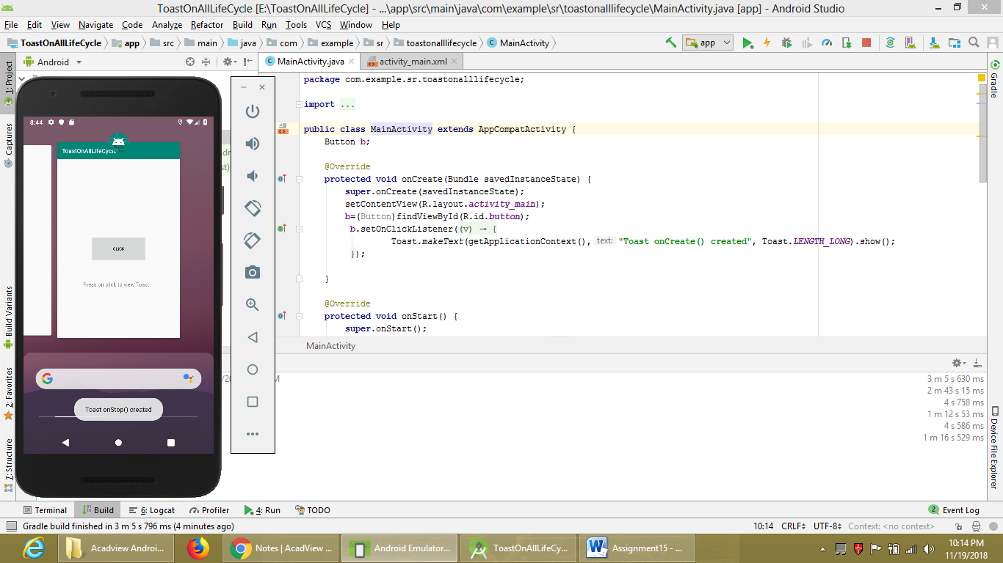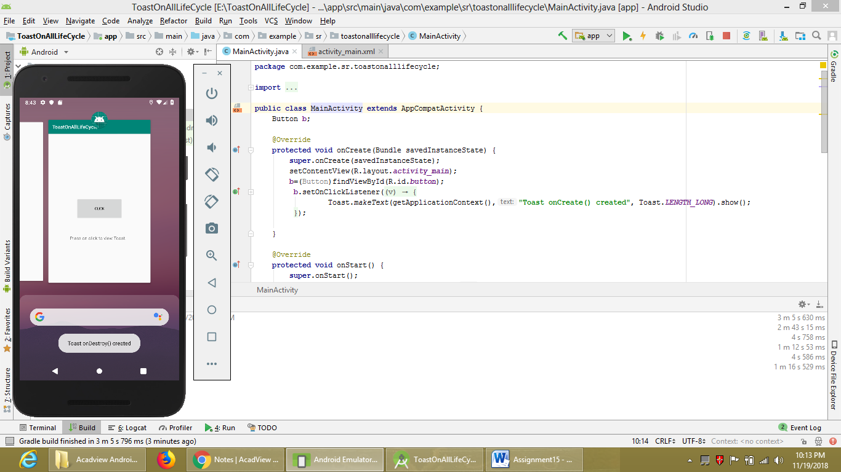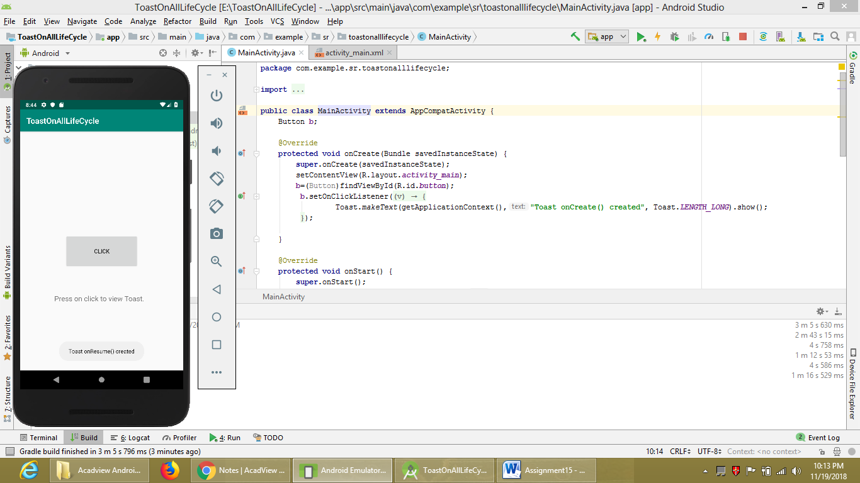

**2. Create an Android App with a Toast onCreate() which is shown in the center of the Activity.**

**MainActivity.java:**

package com.example.sr.toastcreation;

import android.support.v7.app.AppCompatActivity;

import android.os.Bundle;

import android.util.Log;

import android.view.Gravity;

import android.view.View;

import android.widget.Button;

import android.widget.Toast;

import static android.widget.Toast.*;

public class MainActivity extends AppCompatActivity {

Button b;

@Override

protected void onCreate(Bundle savedInstanceState) {

super.onCreate(savedInstanceState);

setContentView(R.layout.activity_main);

b=(Button)findViewById(R.id.button);

b.setOnClickListener(new View.OnClickListener() {

@Override

public void onClick(View v) {

Toast t;

t=Toast.makeText(getApplicationContext(), "Toast in ceneter.", Toast.LENGTH_LONG);

t.setGravity(Gravity.CENTER,60,100);

t.show();

}

});

}

}

**activity_main.xml:**

<?xml version="1.0" encoding="utf-8"?>

<android.support.constraint.ConstraintLayout xmlns:android="http://schemas.android.com/apk/res/android"

xmlns:app="http://schemas.android.com/apk/res-auto"

xmlns:tools="http://schemas.android.com/tools"

android:layout_width="match_parent"

android:layout_height="match_parent"

tools:context=".MainActivity">

<TextView

android:layout_width="wrap_content"

android:layout_height="wrap_content"

android:text="Click on SHOW TOAST Button to see the Toast in the center"

android:textSize="18sp"

app:layout_constraintBottom_toBottomOf="parent"

app:layout_constraintHorizontal_bias="1.0"

app:layout_constraintLeft_toLeftOf="parent"

app:layout_constraintRight_toRightOf="parent"

app:layout_constraintTop_toTopOf="parent"

app:layout_constraintVertical_bias="0.888" />

<Button

android:id="@+id/button"

android:layout_width="wrap_content"

android:layout_height="wrap_content"

android:layout_marginStart="124dp"

android:layout_marginLeft="124dp"

android:layout_marginEnd="8dp"

android:layout_marginRight="8dp"

android:text="Show Toast"

android:textSize="24sp"

app:layout_constraintEnd_toEndOf="parent"

app:layout_constraintHorizontal_bias="0.0"

app:layout_constraintStart_toStartOf="parent"

tools:layout_editor_absoluteY="90dp" />

</android.support.constraint.ConstraintLayout>

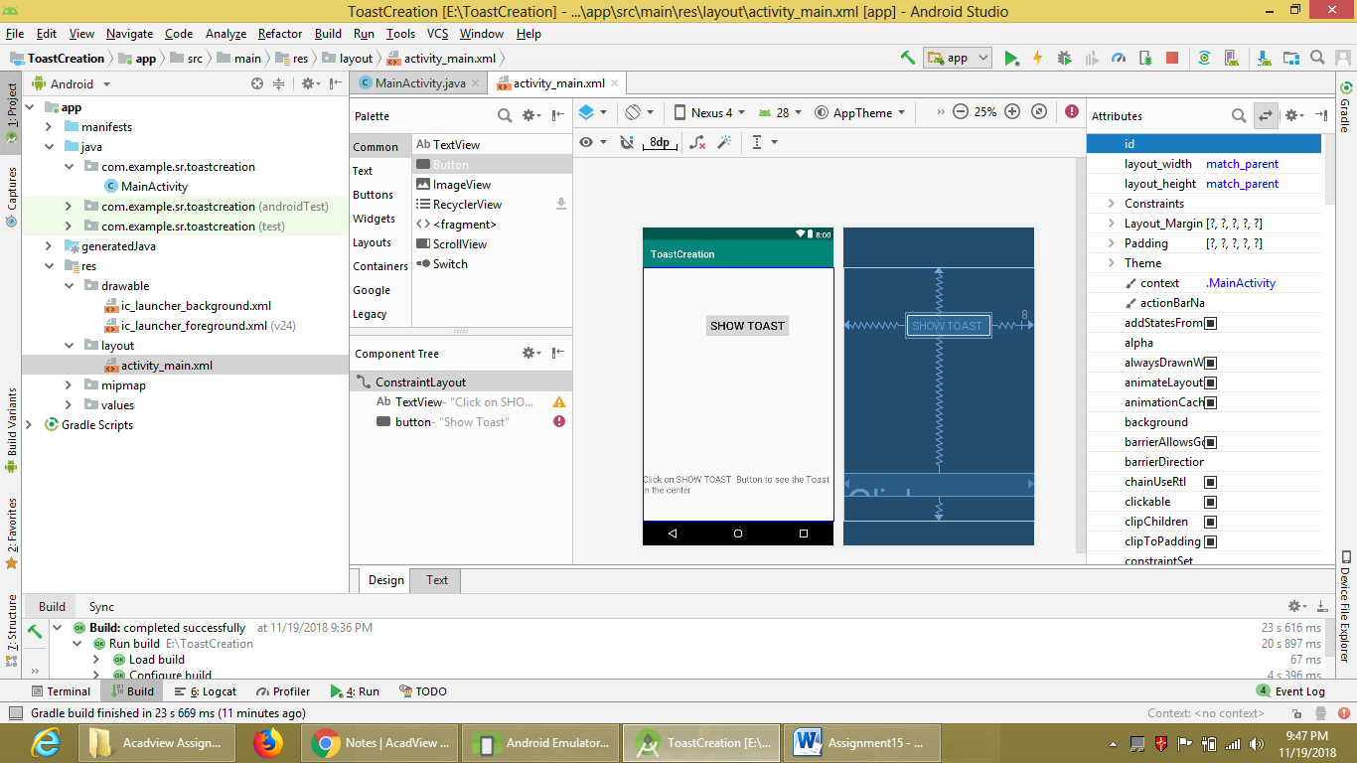

**OUTPUT:**

