**ASSIGNMENT 4**

**1. Create a class Rectangle with length and breadth as it’s data members. Create a member function called CalculateArea() which displays the area of the rectangle object.**

package assignment4;

import java.util.Scanner;

public class Rectangle {

Scanner s=new Scanner(System.in);

double l,b;

Rectangle(){

System.out.println("Enter the length of the rectangle: ");

l=s.nextDouble();

System.out.println("Enter the breath of the rectangle: ");

b=s.nextDouble();

}

Rectangle(double l,double b){

this.l=l;

this.b=b;

}

Rectangle(double v){

this.l=this.b=v;

}

double CalculateArea(){

return (l*b);

}

}

public class RectangleFunction {

public static void main(String arg[]) {

Rectangle r=new Rectangle();

//double area=r.CalculateArea();

System.out.println("The area of the rectangle is: "+r.CalculateArea());

Rectangle r1=new Rectangle(4.0,5.0);

System.out.println("The area of the rectangle is: "+r1.CalculateArea());

Rectangle r2=new Rectangle(9.5);

System.out.println("The area of the rectangle is: "+r2.CalculateArea());

}

}

**OUTPUT:**

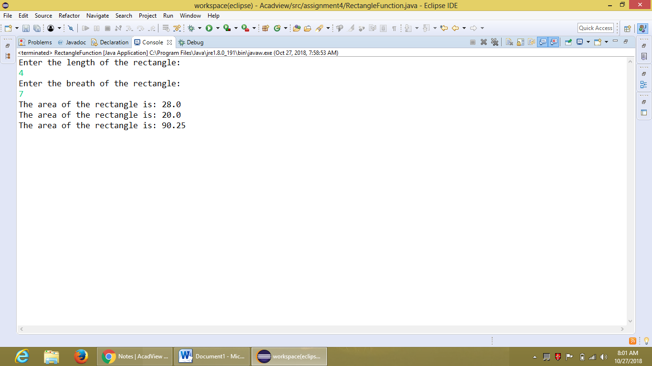

**2. Create a class Complex with real and imaginary parts as it’s data members. Create a member function called Display() to display the complex number properly.   
Example : real part = 2 and imaginary part = 5, then the function should show 2+5i.**

package assignment4;

import java.util.Scanner;

public class Complex {

Scanner s=new Scanner(System.in);

int real,imaginary;

Complex(){

System.out.println("Enter the Integer value for the real part of the Complex

number: ");

real=s.nextInt();

System.out.println("Enter the Integer value for the imaginary part of the Complex

number: ");

imaginary=s.nextInt();}

Complex(int real,int imaginary){

this.real=real;

this.imaginary=imaginary;

}

void Display(){

System.out.println("The given Complex number is: "+real+"+"+imaginary+"i");

}

}

public class DisplayComplex {

public static void main(String arg[]) {

Complex c=new Complex();

Complex c1=new Complex(3,7);

c.Display();

c1.Display();

}

}

**OUTPUT:**

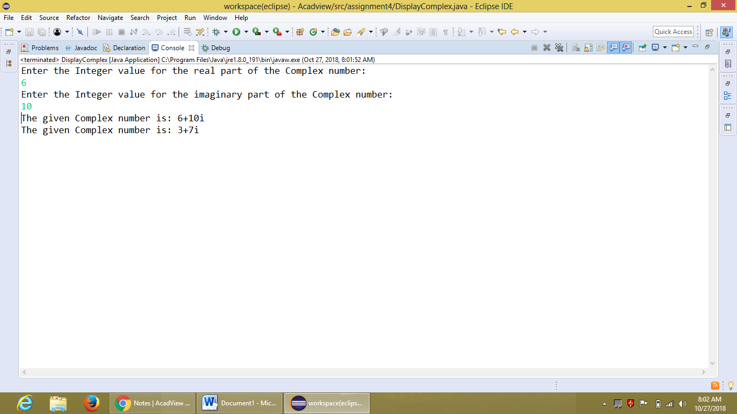

**3.Write a program to take an array of 10 numbers as input from the user and find the second largest element in the array.**

package assignment4;

import java.util.Scanner;

public class SecondLargestNumber {

public static void main(String arg[]) {

int a[]=new int[10];

int largest=0,secondl=0;

Scanner s=new Scanner(System.in);

System.out.println("Enter the 10 integer numbers for the array: ");

for(int i=0;i<10;i++) {

a[i]=s.nextInt();

}

System.out.println("The elements of the given array are: ");

System.out.print("a={ ");

for(int i=0;i<10;i++) {

System.out.print(a[i]);

if(i==9) {

continue;}

System.out.print(", ");

}

System.out.println(" }");

largest=a[0];

secondl=0;

for (int i=1;i<10;i++) {

if(largest<a[i]) {

secondl=largest;

largest=a[i];

}

else {

if (secondl<a[i])

secondl=a[i];}

//System.out.println(i +":"+largest +","+secondl);

}

//System.out.println(largest);

System.out.println("The second largest number in the given array is: "+secondl);

}

}

**OUTPUT:**

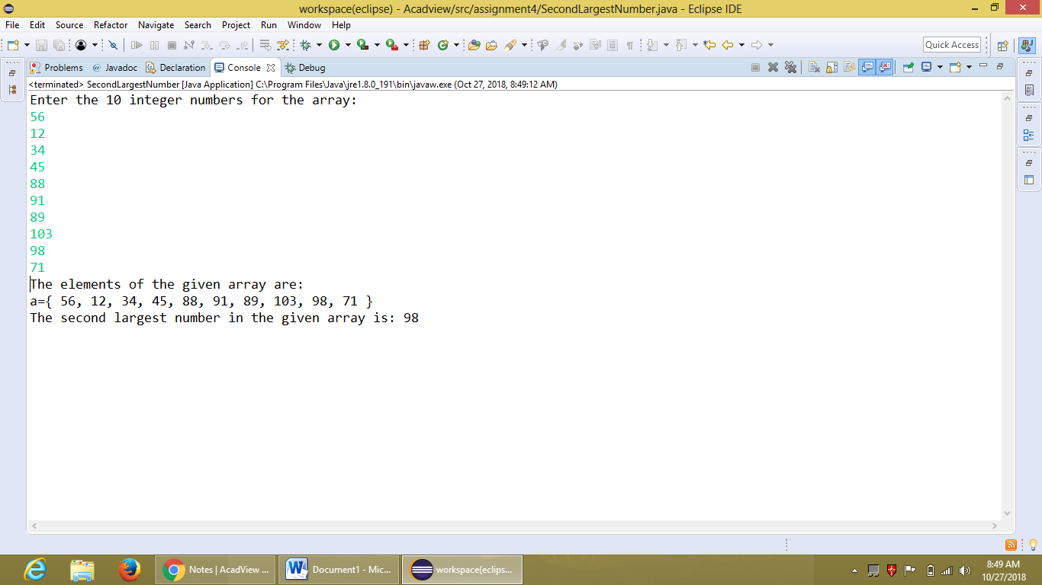

**4. Write a program to take an array of 10 numbers from the user and arrange the elements in a waveform.   
For example, if the array is {1,2,3,4,5,6,7,8,9,10} then it should become {2,1,4,3,6,5,8,7,10,9}.**

package assignment4;

import java.util.Scanner;

public class ElementsInWaveform {

public static void main(String arg[]) {

int a[]=new int[10];

int temp;

Scanner s=new Scanner(System.in);

System.out.println("Enter the 10 integer numbers for the array: ");

for(int i=0;i<10;i++) {

a[i]=s.nextInt();

}

System.out.println("The elements of the given array are: ");

System.out.print("a={ ");

for(int i=0;i<10;i++) {

System.out.print(a[i]);

if(i==9) {

continue;}

System.out.print(", ");

}

System.out.println(" }");

for(int i=0;i<9;) {

temp=a[i];

a[i]=a[i+1];

a[i+1]=temp;

i=i+2;

}

System.out.println("The elements of the array arranged in a waveform: ");

System.out.print("a={ ");

for(int i=0;i<10;i++) {

System.out.print(a[i]);

if(i==9) {

continue;}

System.out.print(", ");

}

System.out.println(" }");

}

}

**OUTPUT:**

