**ASSIGNMENT 6**

**1. Create an Interface called Animals with speak(), eat() methods. Create two classes Cat and Dog implementing their own versions of these methods.**

package assignment6;

interface Animal{

void speak();

void eat();

}

class Cat implements Animal{

public void speak(){

System.out.println("The cat speak as 'mmmmnnnnaaaawwwww'.");

}

public void eat(){

System.out.println("The cat mostly like to eat non-vegetarian food.");

}

}

class Dog implements Animal{

public void speak() {

System.out.println("The dog speak as 'bow-wow'.");

}

public void eat() {

System.out.println("The dog eat vegetarian and non-vegetarian food.");

}

}

public class AnimalInterface {

public static void main(String arg[]) {

Dog d=new Dog();

d.speak();

d.eat();

Cat c=new Cat();

c.speak();

c.eat();

}

}

**OUTPUT:**

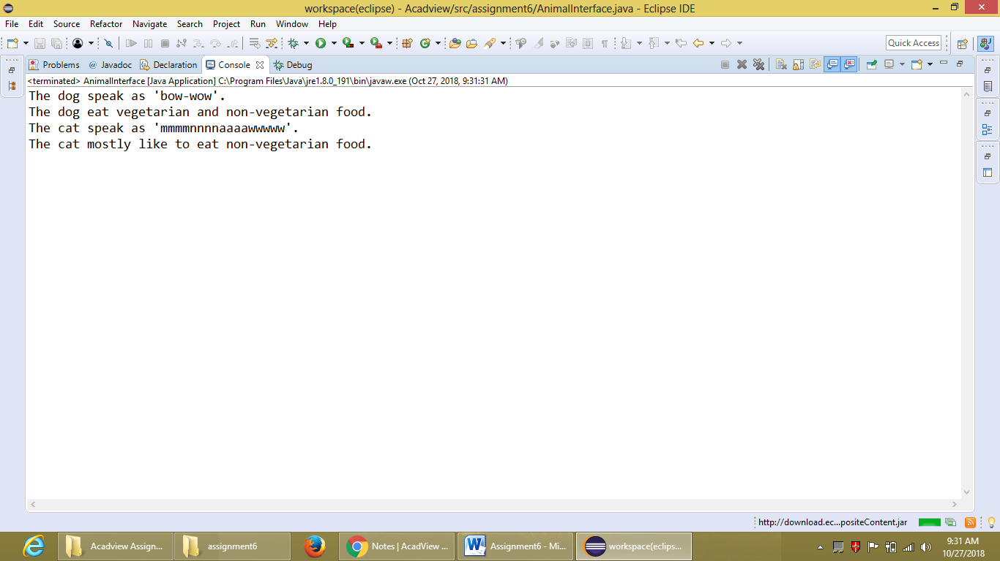

**2. Create an Abstract Class Animals with color, breed and name as variables, along with eat() abstract method and also a speak() method which is not abstract.**

package assignment6;

import java.util.Scanner;

abstract class Animals{

String name, color, breed;

Scanner s=new Scanner(System.in);

Animals(){

System.out.println("Enter the name of the animal: ");

name=s.nextLine();

System.out.println("Enter the breed of the animal: ");

breed=s.nextLine();

System.out.println("Enter the color of the animal: ");

color=s.nextLine();

System.out.println("I have a "+color+" dog name '"+name+"' of breed

'"+breed+"'.");

}

abstract void eat();

void speak() {

System.out.println(name+" is starting to speak.");

}

}

class Dogs extends Animals{

void eat() {

System.out.println(name+" like to eat biscuit.");

}

}

public class AbstractAnimals {

public static void main(String arg[]) {

Dogs d=new Dogs();

d.speak();

d.eat();

}

}

**OUTPUT:**

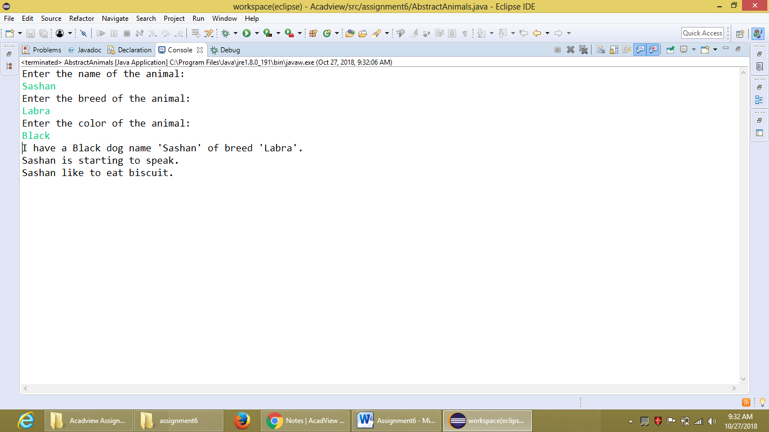

**3. Take two numbers as string input and convert them into Integers and find the maximum of the two numbers.**

package assignment6;

import java.util.Scanner;

class FindMaximum{

String a, b;

Scanner s=new Scanner(System.in);

FindMaximum(){

System.out.println("Enter the two integer numbers: ");

a=s.nextLine();

b=s.nextLine();

}

int maximum() {

int a, b;

a=Integer.parseInt(this.a);

b=Integer.parseInt(this.b);

if(a>b) {

return a;

}

else

return b;

}

}

public class ConvertAndFindMax {

public static void main(String arg[]) {

FindMaximum max=new FindMaximum();

System.out.println("The maximum number between "+max.a+" and "+max.b+" is:

"+max.maximum());

}

}

**OUTPUT:**

