**ASSIGNMENT 7**

**1. Write a Java program to reverse a String.**

package assignment7;

public class ReverseString {

public static void main(String arg[]) {

StringBuffer str =new StringBuffer("Welcome to Acadview");

System.out.println("The string before reverse is: "+str);

System.out.println("The string after reverse is: "+ str.reverse());

}

}

**OUTPUT:**

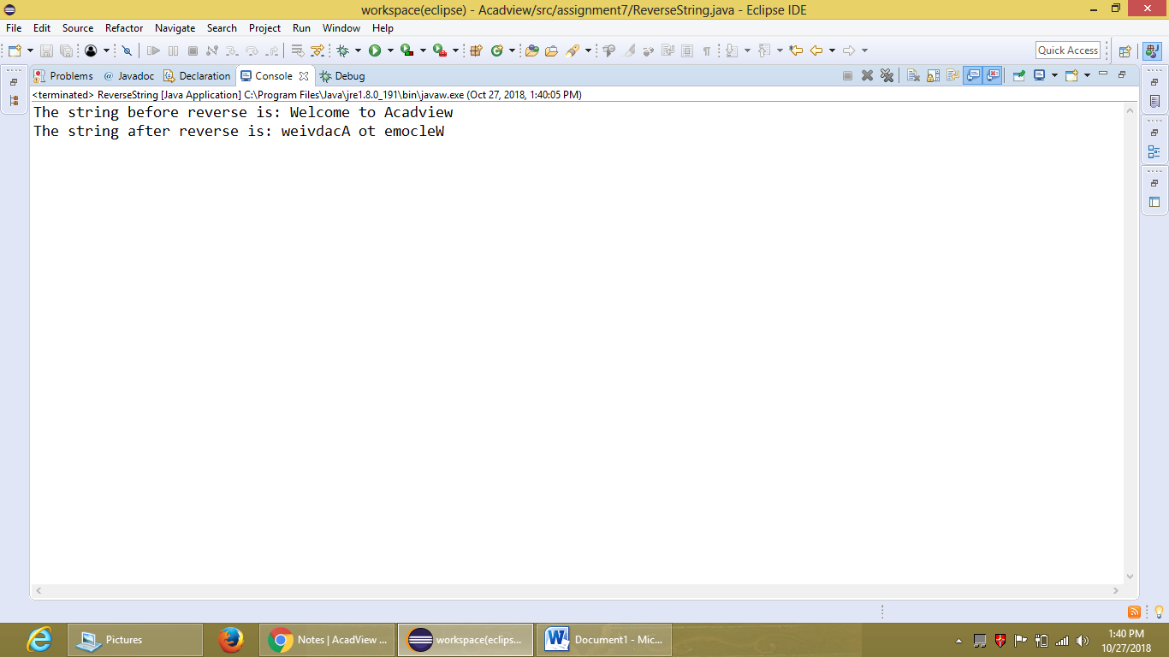

**2. Write a Java program to generate all substrings of the string ‘xyz’.**

package assignment7;

public class GenerateAllSubstrings {

public static void main(String arg[]) {

String str="XYZ";

int count=1;

System.out.println("The all possible substrings of '"+str+"'");

for(int i=0;i<3;i++) {

for(int j=3;j>=1&&j!=i;j--) {

System.out.println(count+". "+str.substring(i,j));

count=++count;

}

}

//System.out.println(str.substring(i,j));

}

}

**OUTPUT:**

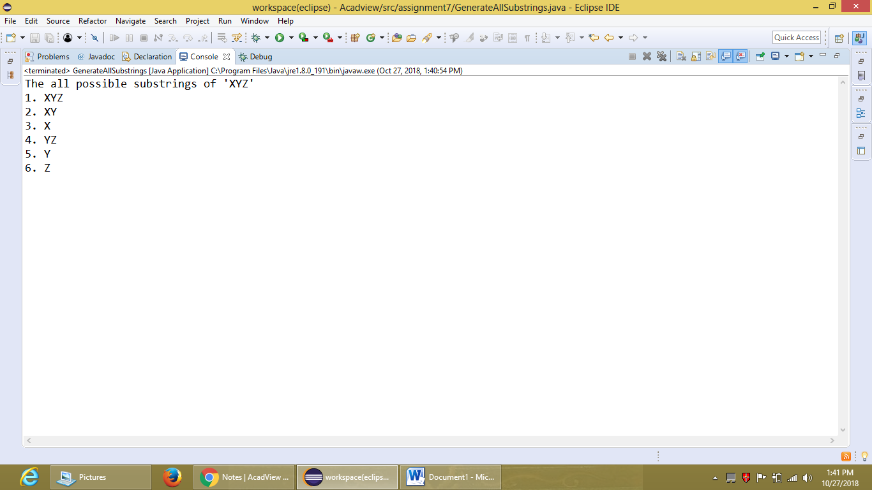

**3. Write a Java program to remove all vowels from the String.**

package assignment7;

import java.util.Scanner;

public class RemoveVowels {

public static void main(String arg[]) {

Scanner s=new Scanner(System.in);

StringBuffer string=new StringBuffer("Hello Acadview ");

StringBuffer vowels=new StringBuffer("AEIOUaeiou");

char a,b;

int length=string.length();

System.out.println("The string before removing is: "+ string);

for(int j=0;j<vowels.length();j++) {

for(int i=0;i<length;i++) {

a=string.charAt(i);

b=vowels.charAt(j);

if(a==b) {

string=string.deleteCharAt(i);

length=string.length();

}

}

}

System.out.println("The string after removing all vowels is: "+ string);

}

}

**OUTPUT:**

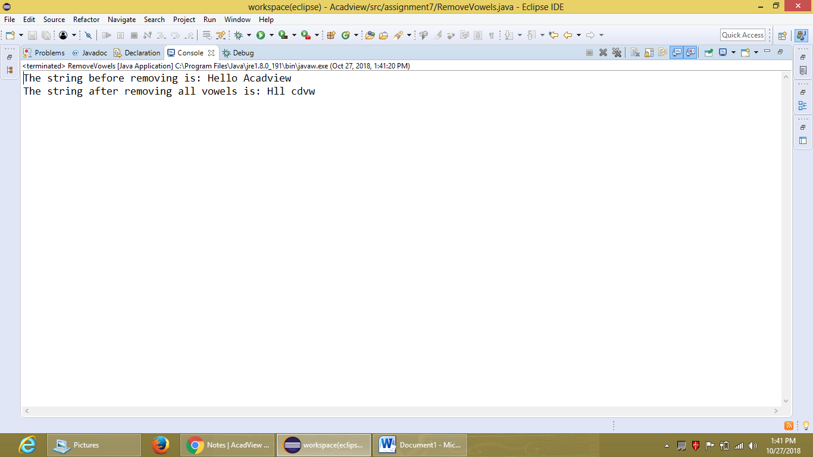

**4. Write a Java program to print the following pattern :**

**a**

**ab**

**abc**

package assignment7;

public class StringPattern {

public static void main(String arg[]) {

//StringBuffer string= new StringBuffer("a");

String string="abcd";

char[]array=new char[4];

for(int i=0;i<string.length();i++) {

string.getChars(i, i+1, array, i);

for(int j=0;j<=i;j++) {

System.out.print(array[j]);

}

System.out.println();

}

}

}

**OUTPUT:**

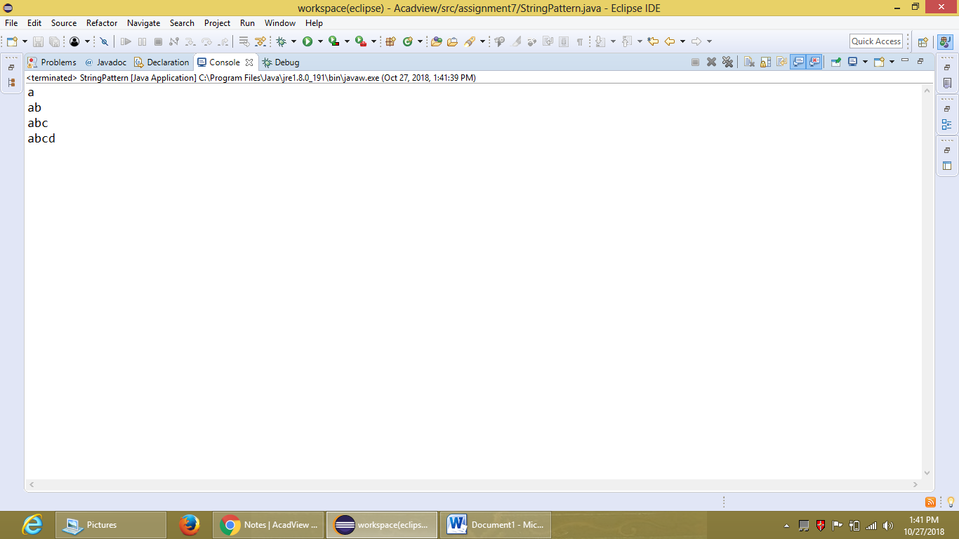

**5. Write a Java program to check occurrence of a string in another string, where both strings are taken as input from the user.**

package assignment7;

import java.util.Scanner;

public class CheckOccurrence {

public static void main(String arg[]) {

String string1, string2, temp;

boolean b=true;

Scanner s= new Scanner(System.in);

System.out.println("Enter the string: ");

string1=s.nextLine();

System.out.println("Enter the another string for that's you want to check the occurence in previous entered string: ");

string2=s.nextLine();

int length=string1.length();

outer:for(int i=0;i<length;i++) {

inner: for (int j=length;j>i;j--){

temp=string1.substring(i,j);

if(string2.compareTo(temp)==0) {

System.out.println("The string '"+string2+"' is occuured in the string '"+string1+"'.");

b=false;

break outer;}

}

}

if (b==true) {

System.out.println("The string '"+string2+"' is not occuured in the string '"+string1+"'.");

}

}

}

**OUTPUT:**

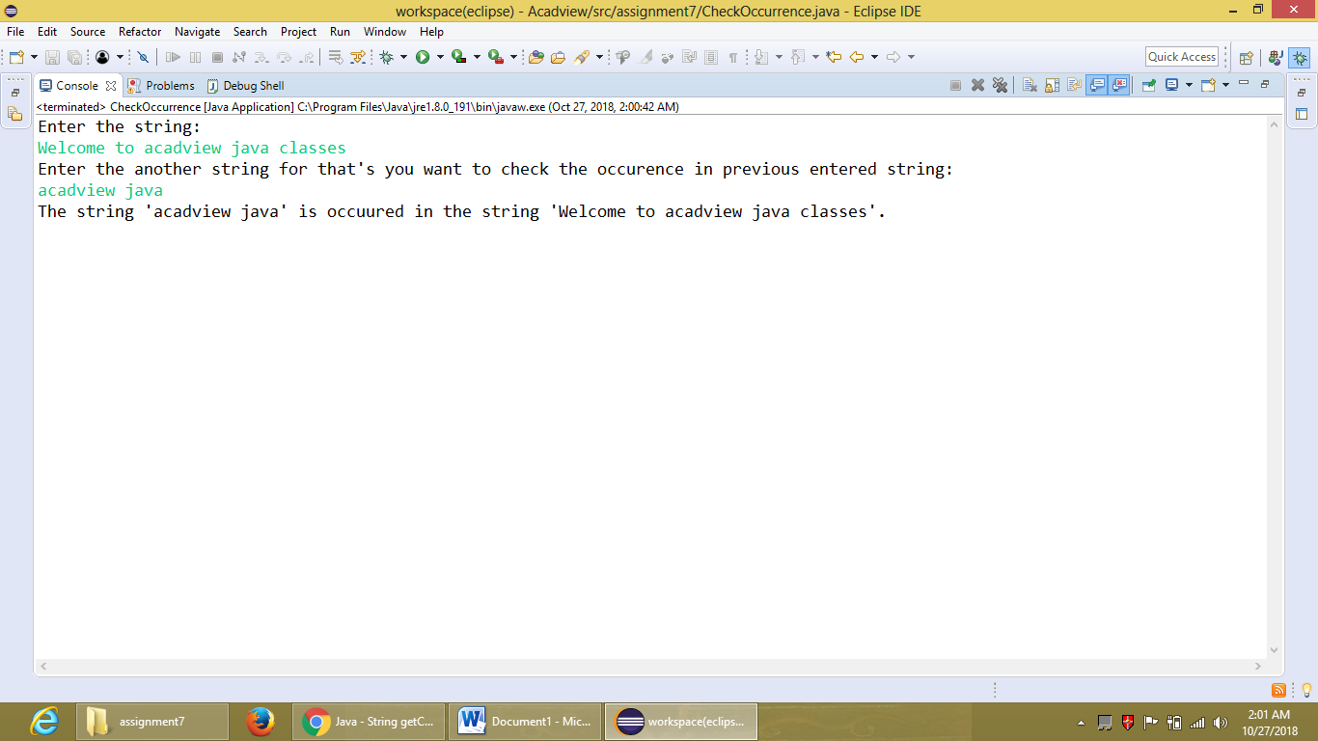

**6. Write a Java program to count the number of words in a sentence taken as input.**

package assignment7;

import java.util.Scanner;

public class CountNoOfWords {

public static void main(String arg[]) {

Scanner s= new Scanner(System.in);

String string;

char temp;

int count=1;

System.out.println("Enter the string: ");

string=s.nextLine();

for(int i=0;i<string.length();i++) {

temp=string.charAt(i);

if(temp==' ') {

count=++count;

}

}

System.out.println("The total number of words in the given sentence are: "+count);

}

}

**OUTPUT:**

