ASSIGNMENT 8

**Make a text file 'abc.txt' and write multiple paths in it (say C:/Users/Test/video.mp4).Read the contents of the file and try to print the path from the file.**

**PART A:**

package assignment8;

import java.io.*;

public class PartA {

public static void main(String arg[]) throws IOException {

File file=new File("/E:/Acadview Assignment Files/Acadview assignment8/abc.txt");

FileReader r=null;

int c;

try {

r=new FileReader(file);

while((c=r.read())!=-1) {

System.out.print((char)c);}

}

catch(FileNotFoundException f) {

System.out.println("The given File is not found.");

}

catch(Exception e) {

System.out.println("Error is occured.");}

finally {

r.close();

}

}

}

**OUTPUT:**

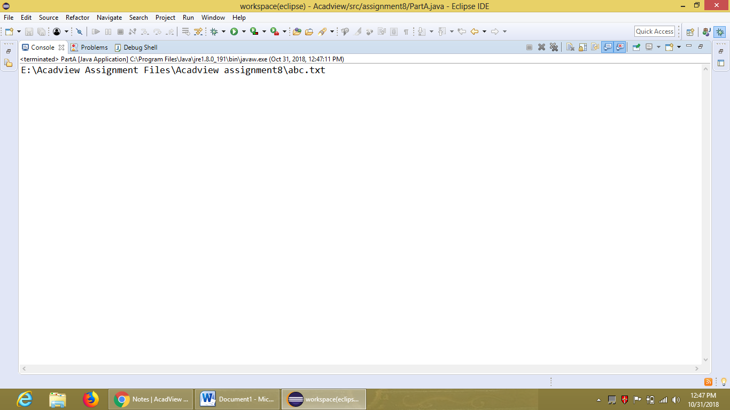

**PART B:**

package assignment8;

import java.io.*;

public class PartB {

public static void main(String arg[]) throws IOException {

File file=new File("E:/Acadview Assignment Files/Acadview assignment8/abc2.txt");

FileReader r=null;

int c;

try {

r=new FileReader(file);

while((c=r.read())!=-1) {

/*if((char)r.read()==' ') {

System.out.println();

}*/

System.out.print((char)c);}

}catch(FileNotFoundException f) {

System.out.println("The given file is not found.");}

catch(Exception e) {

System.out.println("Error is occured.");}

finally {

r.close();

}}

}

**OUTPUT:**

