**1. Write a Java program to print the following pattern :**

**\*\*\*\*\***

**\*\*\*\***

**\*\*\***

**\*\***

**\***

package assignment3;

public class Pattern {

public static void main(String arg[]) {

for(int i=0;i<5;i++) {

for(int j=4;j>=i;j--) {

System.out.print("*");

}

System.out.println();

}

}}

**OUTPUT:**

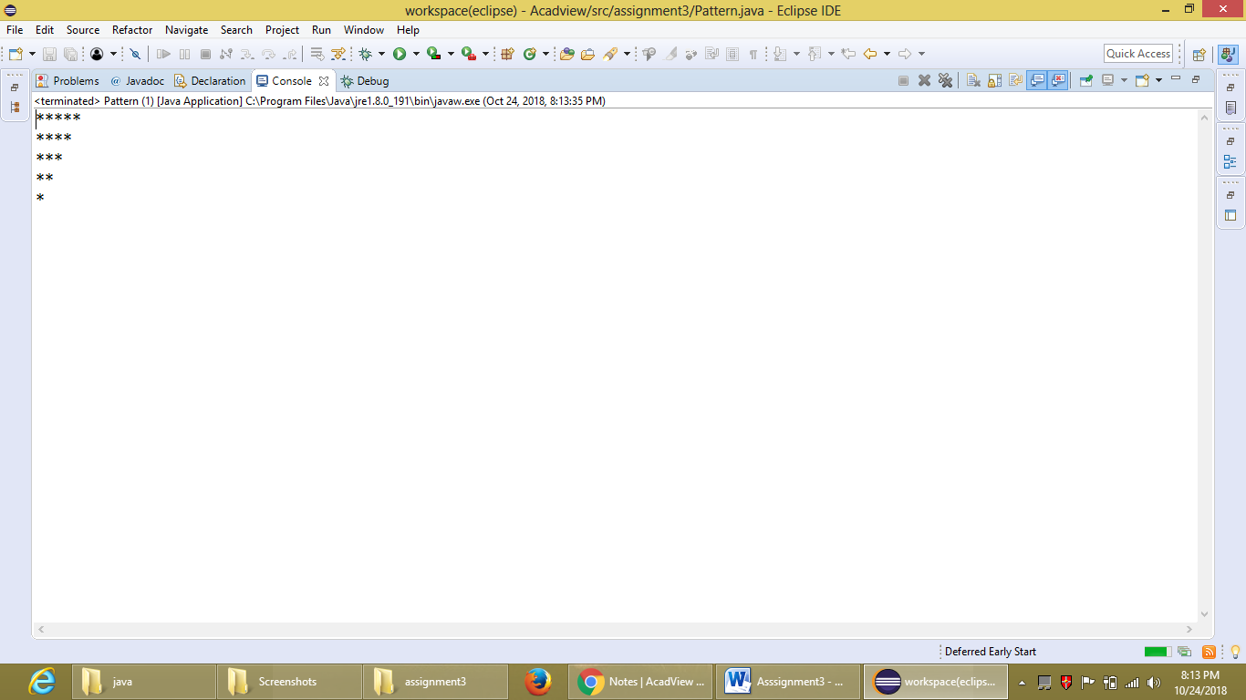

**2. Take a number N from the user as input and find all even numbers upto N.**

public class EvenNumbers {

public static void main(String arg[]) {

int N=Integer.parseInt(arg[0]);

System.out.println("The all Even numbers upto "+N +"are: ");

for(int i=1;i<=N;i++) {

if(i%2==0) {

System.out.print(i+" ");

}

}

}

}

**OUTPUT:**

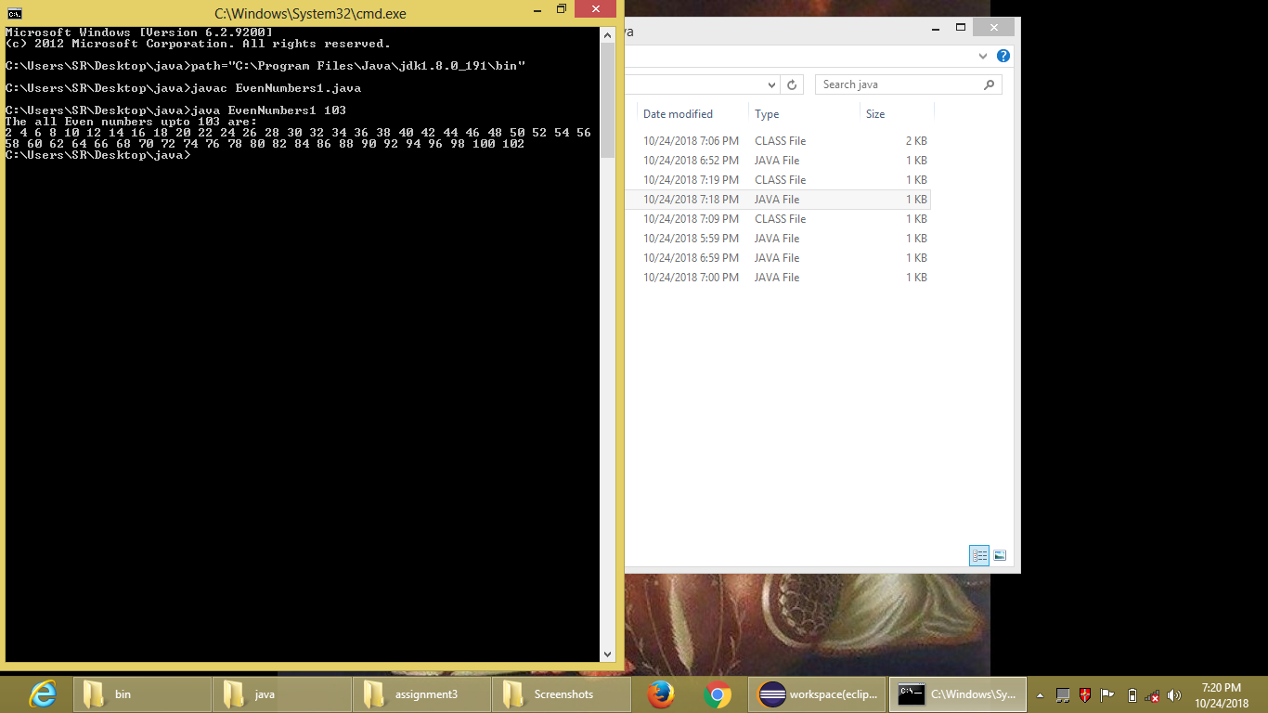

**3. Take a number N from the user as input and find all prime numbers upto N.**

public class PrimeNumbers1 {

public static void main(String arg[]) {

int N=Integer.parseInt(arg[0]);

boolean b;

System.out.println("The all Prime numbers upto "+N+" are:");

for(int i=3;i<=N;i++) {

b=true;

inner:for(int j=2;j<10;j++) {

if((i%j==0)&&(i!=j)) {

b=false;

break inner;}

}

if(b==true)

System.out.print(i+" ");

}

}}

**OUTPUT:**

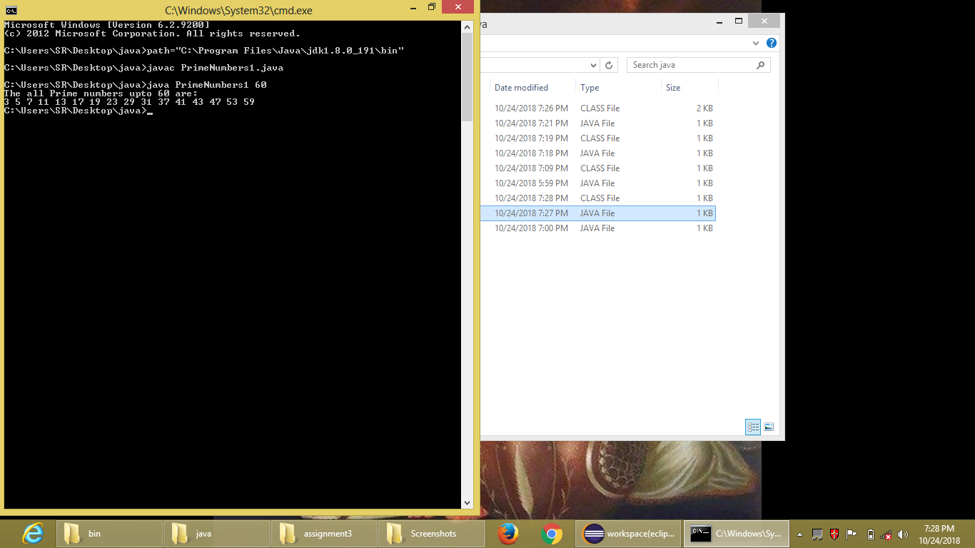

**4. Take a number N as input from the user and check if the given number is armstrong or not.**

import java.lang.Math;

public class ArmstrongNumber1 {

public static void main(String arg[]) {

int N=Integer.parseInt(arg[0]);

int count=0,r=N;

int array[];

for(int i=0;r%10!=0;i++) {

count=++count;

r=r/10;

}

array=new int [count];

r=N;

int result=0;

for(int j=0;j<count;j++) {

array[j]=r%10;

r=r/10;

array[j]=(int)Math.pow((double)array[j],(double)count);

result=result+array[j];

}

if(result==N) {

System.out.println("The given number "+N+" is an armstrong number.");}

else

System.out.println("The given number "+N+" is not an armstrong number.");

}

}

**OUTPUT:**

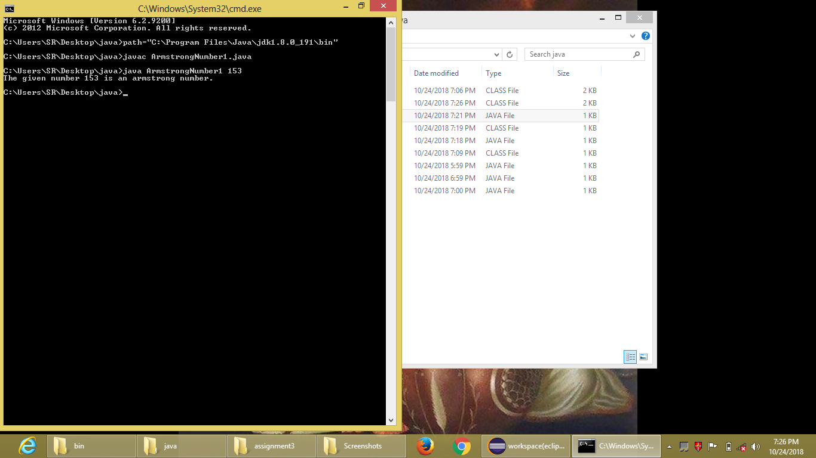

**5. Take a number N from the user and print its reverse.**

public class Reverse1 {

public static void main(String arg[]) {

int N=Integer.parseInt(arg[0]);

int r=N,result=0;

for(int i=0;r!=0;i++) {

result=result*10+r%10;

r=r/10;

//System.out.println(result);

}

System.out.println("The reverse of the given number is "+result);

}

}

**OUTPUT:**

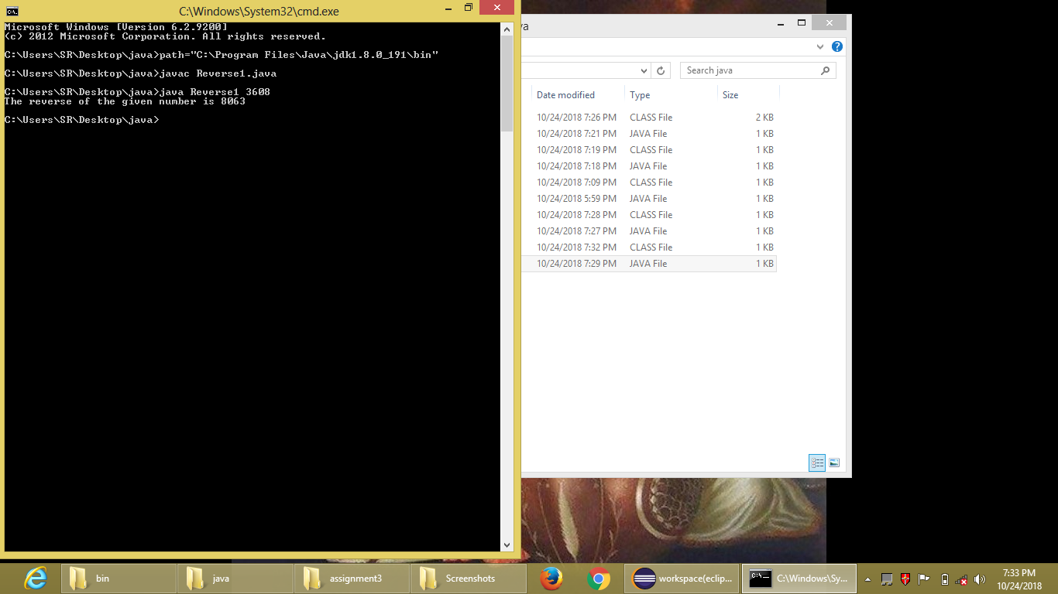

**6. Given the array A = {1,1,1,1,0,0,1,0}. Sort it in ascending order as {0,0,0,1,1,1,1,1} in least computation.**

package assignment3;

public class ArraySorting {

public static void main(String arg[]) {

int A[]= {1,1,1,1,0,0,1,0};

int B;

for(int i=0;i<8;i++) {

for(int j=i+1;j<8;j++) {

if(A[i]>A[j]) {

B=A[i];

A[i]=A[j];

A[j]=B;

}}

}

System.out.println("The sorted array is: ");

System.out.print("A={");

for(int z=0;z<8;z++) {

System.out.print(A[z]);

if(z==7) {

continue;}

System.out.print(", ");}

System.out.println("}");

}

}

**OUTPUT:**

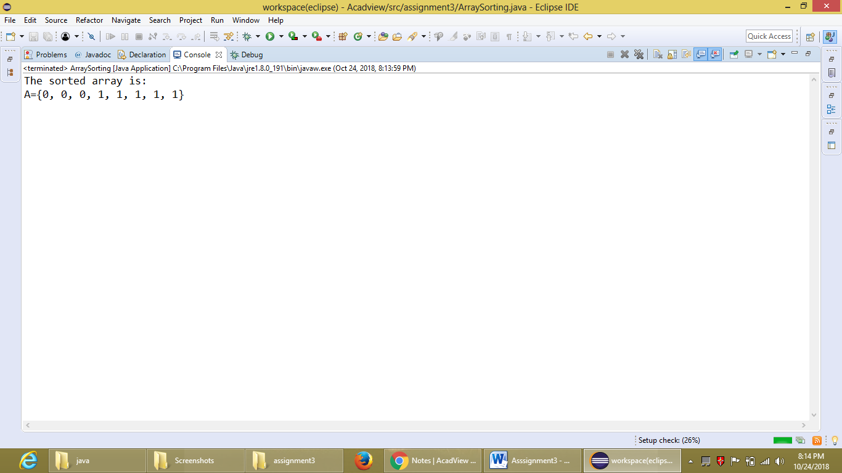

**7. Given a sorted array A = {1,4,6,7,8,9,10}. Write a program to take a Number N from the user and check if it is in the array or not in least computation.**

public class FindNumber1 {

public static void main(String arg[]) {

int A[]= {1,4,6,7,8,9,10},n=20;

boolean b=false;

for(int i=0;i<7;i++) {

if(A[i]==Integer.parseInt(arg[0])) {

System.out.println("The number "+ arg[0]+" is present in the given array.");

b=true;

}}

if(b!=true) {

System.out.println("The number "+ arg[0]+" is not present in the given array.");}

}

}

**OUTPUT:**

