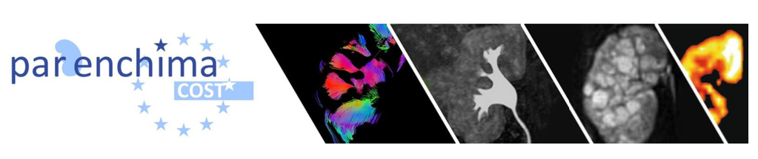

MAGNETIC RESONANCE IMAGING

**BIOMARKERS FOR CHRONIC KIDNEY DISEASE**

**renal DWI and IVIM**

**MRI acquisition protocol**

**Version 0.1**

**Feb 28, 2020**

**Author:** Pim Pullens   
pim.pullens@uzgent.be

**Description:** MRI sequence parameters for renal DWI and IVIM

* Vendor: Siemens
* Model: Magnetom PrismaFit 3T
* Software version: VE11C AP01
* Location: Ghent Institute for functional and Metabolic Imaging, Ghent University & Ghent University Hospital, Belgium



**Provenance:**

First implementation of the renal DWI and IVIM MRI acquisition consensus, developed as part of COST Action PARENCHIMA (CA16103), supported by the COST (European Cooperation in Science and Technology).

<https://www.renalmri.org/>

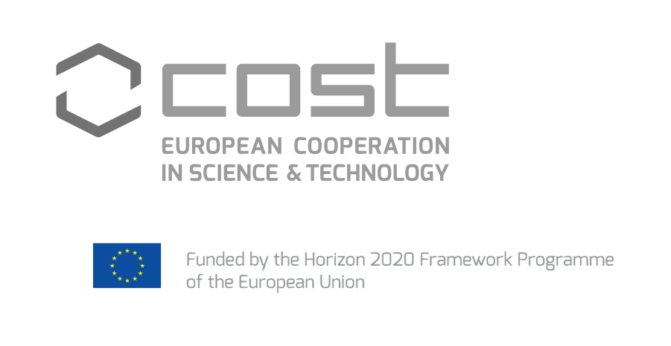

**Licensing:**

This protocol is made available under a CC-BY 4.0 International license:

<https://creativecommons.org/licenses/by/4.0/>

**References:**

1. Ljimani A, Caroli A, Laustsen C, Francis S, Mendichovszky IA, Bane O, et al. Consensus-based technical recommendations for clinical translation of renal diffusion-weighted MRI. Magn Reson Mater Phy. 2019

2. Mendichovszky I, Pullens P, Dekkers I, Nery F, Bane O, Pohlmann A, et al. Technical recommendations for clinical translation of renal MRI: a consensus project of the Cooperation in Science and Technology Action PARENCHIMA. Magn Reson Mater Phy. 2019