Walmart Scintilla APIs to Databricks Bronze Ingestion
Technical Implementation Guide
Owner : PARESH RANJAN ROUT
Focus: implementation mechanics, API calls, file transfer, Bronze loading, historical backfill, and daily incremental processing
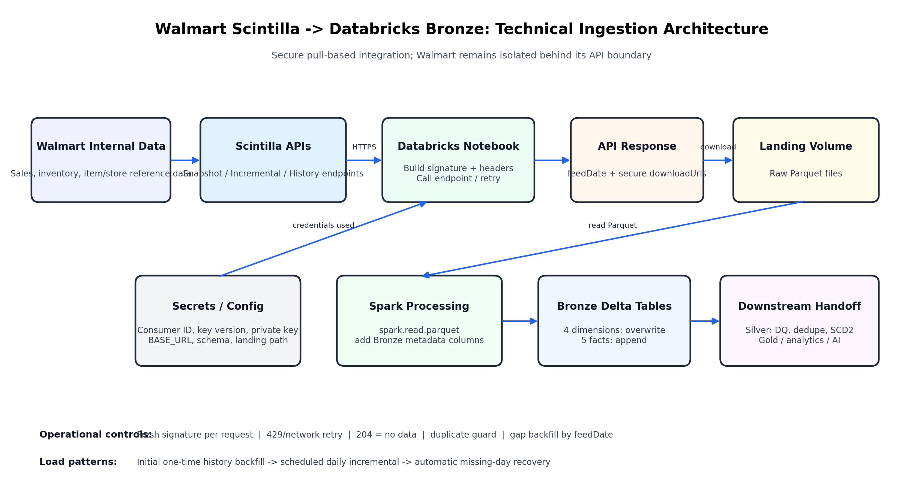
Scope This guide describes the Walmart-to-Bronze ingestion path. Silver/Gold transformations are shown only as the downstream handoff boundary.

1. What the Integration Actually Does
The integration is a pull-based data pipeline. Databricks initiates authenticated HTTPS requests to Walmart Scintilla. Walmart validates the request and, when data is available and the account is entitled, returns secure download URLs. Databricks then downloads Parquet files, reads them with Spark, adds ingestion metadata, and writes them to Bronze Delta tables.
Key boundary We do not directly connect to or query Walmart internal databases. Walmart keeps those systems isolated and exposes only approved operations through Scintilla API endpoints.

2. Source Components in the Databricks Implementation
Notebook / File | Responsibility | Execution pattern
00_config_setup | Read production secrets and define fixed settings: base URL, JAR path, Bronze schema, landing path. | Imported by the remaining notebooks.
01_common_functions.py | Generate signature, build headers, retry API calls, define 9 feeds, download Parquet, load Delta. | Reusable library logic.
02_load_dimensions.py | Load 4 dimension snapshot feeds using overwrite mode. | Manual or scheduled snapshot refresh.
03_load_fact_history.py | One-time history backfill and controlled older-history / gap utilities. | Manual; not part of daily job.
04_load_fact_incremental.py | Daily incremental load for 5 facts plus missing-day recovery. | Scheduled daily job.

3. Configuration and Secret Retrieval
The configuration notebook separates secrets from reusable logic. It reads the following values from a Databricks secret scope and does not hard-code the actual secret values in the ingestion notebooks:
- Consumer ID
- Key version
- Private key PEM
It also defines the production Scintilla base URL, signature-generator JAR path, Bronze schema, and landing location. The implementation validates that the secret scope exists and that the required secrets are present before any API work starts.
Security rule Never print or embed the private key in logs or documentation. The implementation only prints a shortened Consumer ID prefix as a setup confirmation.

4. Authentication: Building the Walmart Request
Every Walmart API call is signed immediately before the request. The private key is written to a temporary PEM file because the Walmart signature-generator JAR expects a file path. The temporary file is deleted in a finally block after signature generation.
sig, ts = make_signature()
headers = {
'WM_CONSUMER.ID': CONSUMER_ID,
'WM_CONSUMER.INTIMESTAMP': ts,
'WM_SEC.AUTH_SIGNATURE': sig,
'WM_SEC.KEY_VERSION': KEY_VERSION
}
Header | Implementation meaning
WM_CONSUMER.ID | Identifies the Walmart account making the request.
WM_CONSUMER.INTIMESTAMP | Fresh timestamp produced with the signature.
WM_SEC.AUTH_SIGNATURE | Digital signature generated using Walmart's signing tool and our private key.
WM_SEC.KEY_VERSION | Identifies the registered key version.

5. Walmart Scintilla API Operations
For fact feeds, Walmart exposes separate operations for the latest data, a specific feed date, available history, and targeted history retrieval. In the implemented pipeline, the most important paths are the incremental and history endpoints.
Operation | HTTP | Endpoint pattern | Used for
Get Latest Data | GET | /bulkfeeds/incremental/{feed} | Normal daily pull.
Get Data By FeedDate | POST | /bulkfeeds/incremental/{feed} | Recover a specific missing day; request body contains feedDate.
Get Available History | GET | /bulkfeeds/history/{feed} | Initial history backfill / history availability.
Get History By FileName | POST | /bulkfeeds/history/{feed} | Target specific historical file names when required by the Walmart API workflow.
Important GET versus POST is the HTTP request method; it does not mean "incremental versus historical" by itself. The operation and endpoint path determine the requested behavior.

6. Feed Mapping Implemented in Code
Feed | Type | Endpoint pattern | Bronze table
dcdimensions | Dimension | /bulkfeeds/snapshot/dcdimensions | dim_dc_dimensions
itemattributes | Dimension | /bulkfeeds/snapshot/itemattributes | dim_item_attributes
productdimensions | Dimension | /bulkfeeds/snapshot/productdimensions | dim_product_dimensions
storedimensions | Dimension | /bulkfeeds/snapshot/storedimensions | dim_store_dimensions
digitaltransactability | Fact | /bulkfeeds/incremental|history/digitaltransactability | fact_digital_transactability
ecomitem | Fact | /bulkfeeds/incremental|history/ecomitem | fact_ecomm_inventory
omni-sales2 | Fact | /bulkfeeds/incremental|history/omni-sales2 | fact_omni_sales
storeitem | Fact | /bulkfeeds/incremental|history/storeitem | fact_store_inventory
store-sales2 | Fact | /bulkfeeds/incremental|history/store-sales2 | fact_store_sales

7. One Request End-to-End
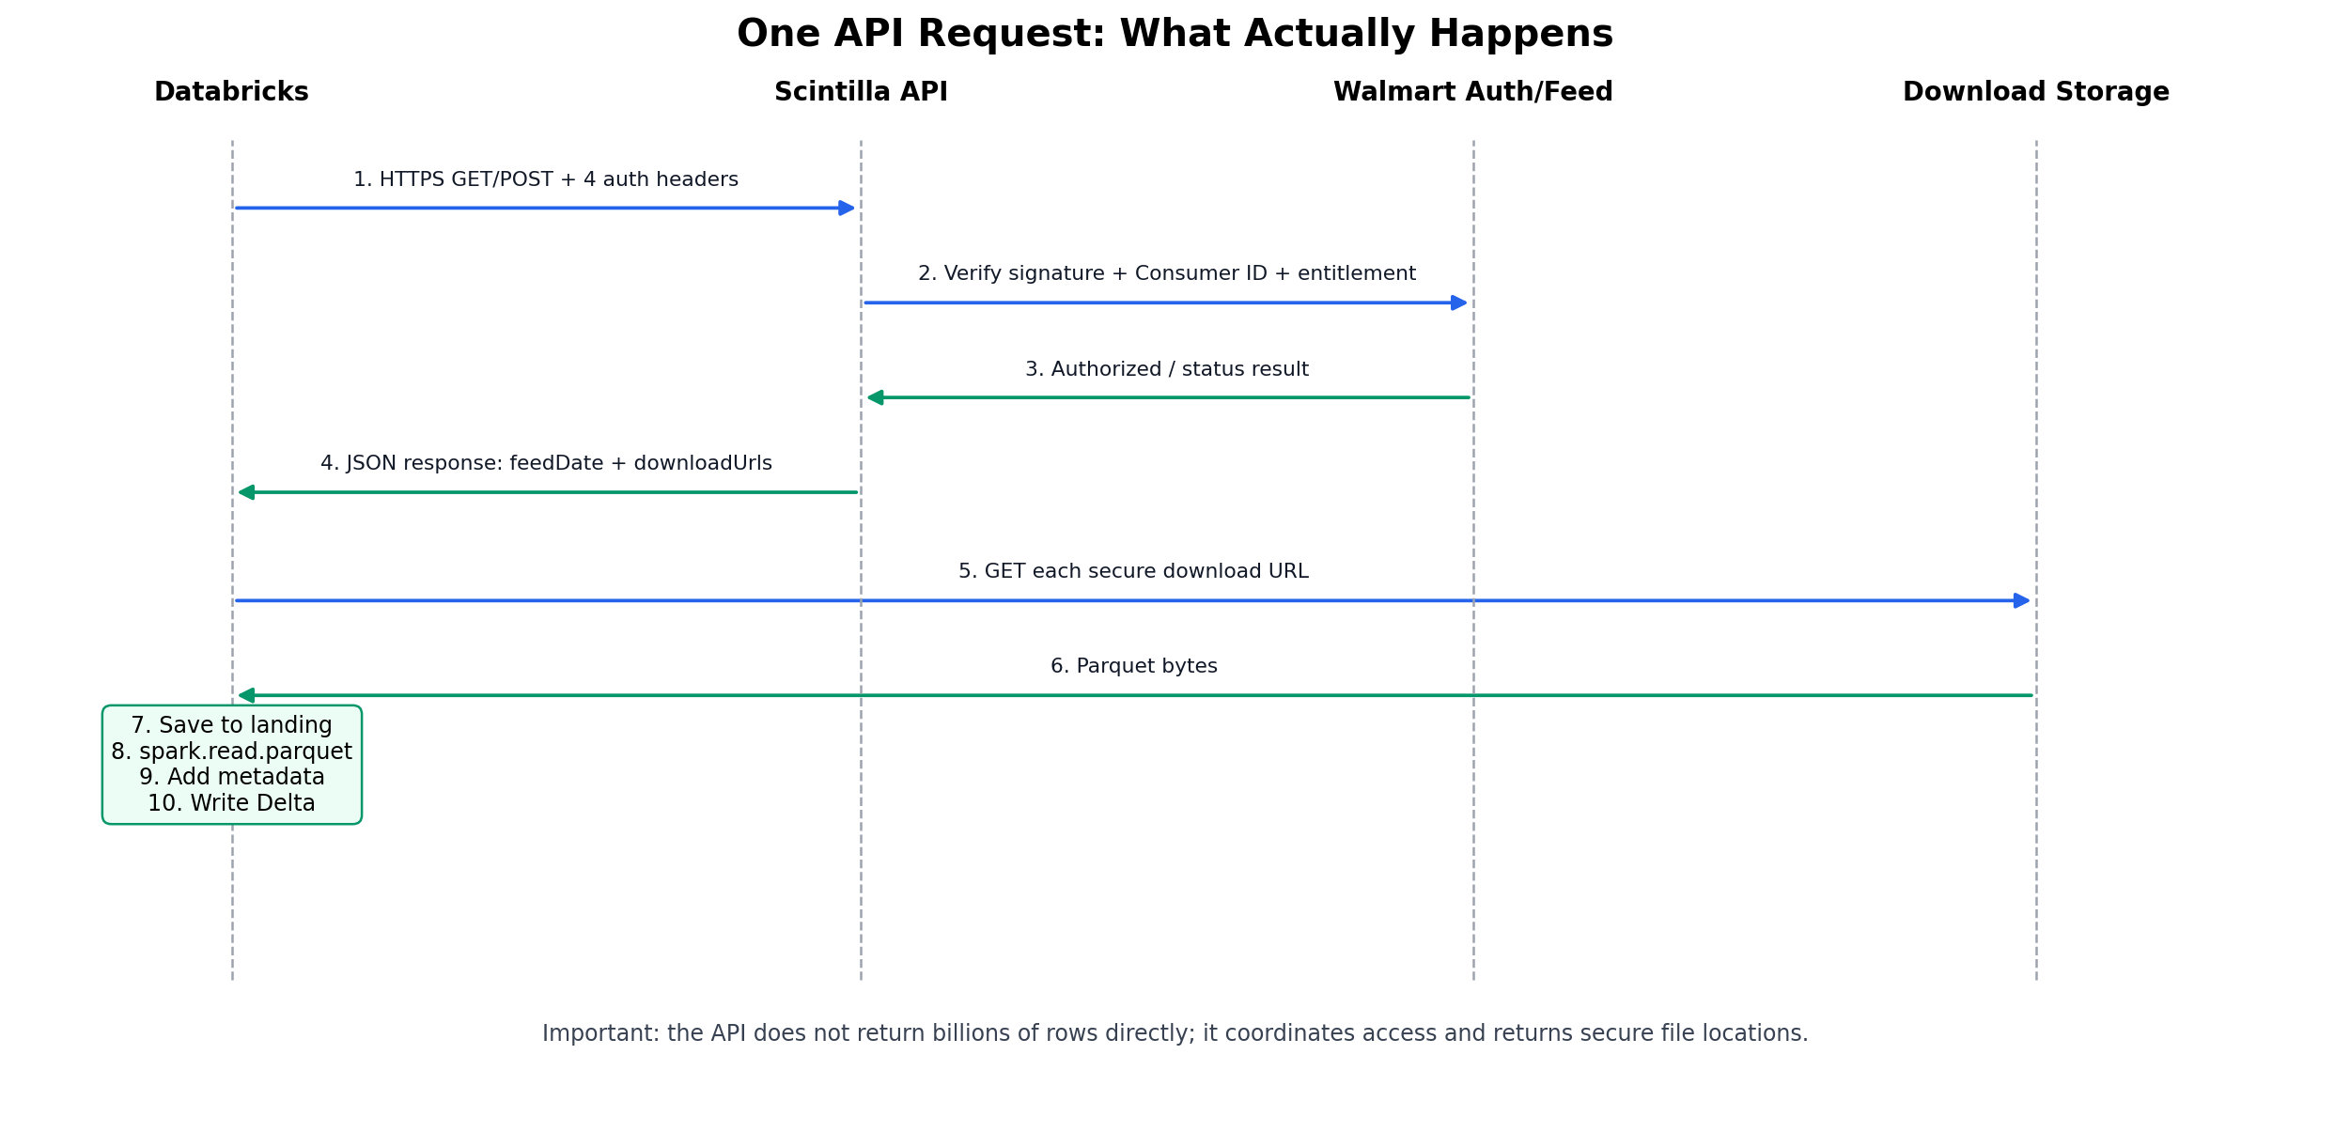
1. Build fresh authentication headers: request_headers() calls make_signature() before the request.
2. Call the Walmart endpoint: requests.get(...) for latest/history; requests.post(...) with JSON body for feedDate recovery.
3. Check HTTP result: 200 = process response; 204 = no new data; 429 = retry after waiting; other non-200 results are surfaced as failures/skips.
4. Parse downloadUrls: The API response is JSON; the implementation extracts each item in downloadUrls.
5. Download Parquet: Each secure URL is downloaded as binary content to a landing folder.
6. Read with Spark: spark.read.parquet(landing) creates the DataFrame.
7. Add ingestion metadata: Add _ingested_at, _source_feed, _load_type (facts), _feed_date (facts), and _env.
8. Write Delta: Dimensions overwrite; fact history/incremental data appends.

8. Core Implementation Path in 01_common_functions.py
resp = request_with_retry(BASE_URL + path)
# API response contains secure file URLs
urls = [u['url'] for u in resp.json().get('downloadUrls', [])]
# Download raw Parquet
for i, url in enumerate(urls):
with open(f'{landing}/part_{i}.parquet', 'wb') as f:
f.write(requests.get(url, timeout=60).content)
# Read and write Bronze
df = spark.read.parquet(landing)
The API is therefore the control plane for the request, while the Parquet download is the actual bulk data-transfer step.

9. Dimension / Snapshot Loading
The four dimension feeds represent the current reference snapshot. For every run, the corresponding landing folder is cleared, new Parquet files are downloaded, and the target Delta table is overwritten with overwriteSchema enabled.
df.withColumn('_ingested_at', F.current_timestamp()) \
.withColumn('_source_feed', F.lit(name)) \
.withColumn('_env', F.lit(ENV)) \
.write.format('delta').mode('overwrite') \
.option('overwriteSchema', 'true').saveAsTable(full_table)

10. Historical Fact Backfill
The history notebook performs the initial backfill for the five fact tables. It is intentionally not part of the daily job. Before loading a feed, it checks whether the target table already exists and already contains rows. If so, it skips the feed rather than blindly appending the same historical dataset again.
Why this guard exists History is large and append-only. A careless re-run can duplicate months or years of data. The notebook therefore treats historical backfill as a controlled one-time operation.

For the additional older omni-sales2 history, the implementation first downloads a fresh history copy, checks the real business-date range, and appends only rows whose business date is earlier than the current earliest date. This prevents duplication of the already-loaded period.

11. Daily Incremental Loading
The daily notebook loops through all five active fact feeds and calls load_fact(feed, mode="incremental"). The common loader uses the incremental endpoint and checks _feed_date before writing. If that date already exists, it returns already_loaded and does not append the same date again.
if mode == 'incremental' and feed_date_already_loaded(full_table, feed_date):
return 'already_loaded'
# otherwise append new rows to the Delta fact table

12. Missing-Day Detection and Automatic Recovery
After the normal daily pull, the incremental notebook compares each fact table's maximum _feed_date with yesterday. When a gap is detected, it loops from the next missing date through yesterday and sends a POST request to the same incremental feed endpoint with a JSON body such as:
{ 'feedDate': '2026-07-13' }
For each recovered day, the response downloadUrls are downloaded, read with Spark, tagged with _load_type="gap_backfill", and appended to the same Bronze Delta table.

13. Error Handling and Reliability Controls
Condition | Implementation behavior | Reason
Network exception | Retry with increasing wait time. | Temporary network failures should not automatically fail the whole feed.
HTTP 429 | Wait and retry. | Walmart throttling / request-rate protection.
HTTP 204 | Return no_new_data; not treated as a pipeline failure. | No data is currently available for that feed/date.
Other non-200 | Return skip / raise task failure at notebook level. | Real authentication, entitlement, URL, or service problem must be visible.
Incremental date already loaded | Skip write. | Idempotency / duplicate prevention.
Historical target already populated | Skip history feed. | Protect against accidental full-history duplication.

14. Entitlement Diagnosis: omni-sales2 and store-sales2
The source notebooks contain diagnostic cells that called /bulkfeeds/status and compared working feeds against omni-sales2 and store-sales2. The implementation also tested GET, POST with feedDate, response headers, and a deliberately fake feed name to build evidence that the issue was account-level feed entitlement rather than the authentication code or a particular date request.
Architecture lesson Authentication and authorization are separate. A valid signature proves the caller identity; Walmart still independently decides which feeds that Consumer ID may access.

15. Bronze Metadata and Write Strategy
Metadata column | Purpose
_ingested_at | When Databricks ingested the file.
_source_feed | Which Walmart feed produced the row.
_load_type | history, incremental, gap_backfill, or older_history_backfill as applicable.
_feed_date | Walmart feed date used for incremental idempotency and gap checks.
_env | Environment identifier, currently production.
Bronze intentionally performs minimal transformation. Business validation, deduplication, SCD Type 2, and downstream modelling belong to the Silver/Data Modelling layer.

16. Operational Runbook
Normal daily operation: Run 04_load_fact_incremental as the scheduled Databricks job. Review success/failure notification and logs.
No new data: HTTP 204 is expected; do not treat it as an error.
Missing date detected: Allow the built-in gap-check to POST feedDate and recover the missing day.
Need full historical setup: Run 03_load_fact_history manually only after verifying the target table is empty or intentionally reset.
Feed returns authorization/URL error: Check authentication headers, then Walmart feed entitlement/status before rewriting ingestion logic.
Dimension refresh: Run 02_load_dimensions; each snapshot replaces the prior dimension table.

17. Data Architect View: Why This Design Works
This design separates concerns cleanly: Walmart owns the source and controls exposure through APIs; Databricks owns orchestration and ingestion; the landing area decouples file transfer from table writes; Bronze preserves source fidelity with traceability metadata; Silver/Gold remain separate transformation layers. Historical and daily ingestion are separated because their operational risk and repeatability requirements are different.
One-line architecture Databricks securely pulls entitled Walmart Scintilla feeds through authenticated REST APIs, downloads the returned Parquet files to a landing area, and persists them as traceable Bronze Delta tables with separate historical and daily incremental controls.

Appendix A. Implementation Source Map
- 00_config_setup.dbc - secret retrieval and fixed environment paths.
- 01_common_functions.py - authentication, retry, feed definitions, loading functions.
- 02_load_dimensions.py - dimension snapshot orchestration and API diagnostics.
- 03_load_fact_history.py - initial fact history, older-history safe append, manual gap-fill utilities.
- 04_load_fact_incremental.py - scheduled daily incremental load and automated gap recovery.
- walmart_bronze_stakeholder_review.docx - architecture scope, production schedule, challenges, status, and Silver handoff.

