Mahatma Education Society’s
Pillai College of Art’s Commerce & Science
(Autonomous)
New Panvel

A Data Science Project Report On

Submitted By
Pari Rathod
Roll.No: 5360

Under the guidance of
‘Miss.Princi Yadav’

Submitted in Partial Fulfilment of the Requirements for
the Degree B.Sc. Computer Science – Semester IV
Batch: 2024 – 2027



Certificate

This is to verify that Miss. Pari Rathod
Examination Seat no. 5360 has successfully
completed a Project of the Subject Data Science
in partial fulfillment for the degree of Bsc
(Computer Science) SEM IV, affiliated to the
University of Mumbai for the academic year
2024-2025.

Internal Examiner

Head of the department

External Examiner

INTRODUCTION
Transportation is an essential part of everyday life, directly affecting productivity, comfort, and quality of living. With rapid urbanization and increasing population density, the demand for efficient, affordable, and reliable transport services has grown significantly. The rise of online transport platforms alongside traditional offline transport modes has transformed how people commute daily. However, users often face challenges such as high costs, long waiting times, trip cancellations, and safety concerns.
This project focuses on analyzing transportation usage patterns and satisfaction levels of users by applying data science techniques to real-world survey data. The dataset captures various aspects of user travel behavior, including trip frequency, cost, travel time, transport preferences, and satisfaction with online and offline services. By performing exploratory data analysis and visualization, this study aims to uncover hidden patterns and relationships that influence user satisfaction and transport choices.

ATTRIBUTES INCLUDED IN THE DATASET
The dataset contains structured survey responses collected from multiple users. Each attribute provides valuable information for analysis:
- Timestamp – Records the exact date and time when the survey response was submitted.
- Name – Identifies the respondent (used only for reference, not analysis).
- Age – Represents the age group of the user, helping in demographic analysis.
- Gender – Indicates gender distribution among respondents.
- Trips_Per_Week – Shows how frequently users travel in a week.
- Daily_Transport_Cost – Average amount spent daily on transportation.
- Transport_Service – Type of transport service used (online/offline/public/private).
- Travel_Purpose – Main reason for travel such as work, education, or personal use.
- Online_Transport_Problems – Problems faced while using online transport services.
- Safer_Mode – Preferred mode of transport based on safety considerations.
- Overall_Preference – User’s overall transport preference.
- Daily_Travel_Time – Time spent daily on commuting.
- Waiting_Time – Average waiting time experienced during travel.
- Avg_Trip_Distance – Distance covered per trip on average.
- Trip_Cancellation_Freq – Frequency of trip cancellations experienced by users.
- Online_Satisfaction – Satisfaction level with online transport services.
- Offline_Satisfaction – Satisfaction level with offline transport services.

AIM OF THE PROJECT
The main aim of this project is to analyze and understand user transportation behavior and satisfaction levels using data science techniques. The project focuses on examining how various factors such as travel frequency, daily transport cost, travel time, waiting time, trip distance, transport service type, and trip cancellation frequency influence the overall travel experience of users.
Another important objective of this study is to compare user satisfaction with online and offline transport services. By analyzing satisfaction levels, the project aims to identify strengths and weaknesses in current transport systems and understand the reasons behind user preferences. Special attention is given to identifying whether frequent trip cancellations and service-related problems negatively impact user satisfaction.
The project also aims to apply exploratory data analysis (EDA) and data visualization techniques to convert raw survey data into meaningful insights. Through graphical representations such as pie charts, bar plots, box plots, scatter plots, histograms, waterfall charts, and correlation heatmaps, the project seeks to uncover hidden patterns, trends, and relationships within the data.
Additionally, this project aims to demonstrate the practical application of data science tools and libraries such as Python, Pandas, NumPy, Matplotlib, and Seaborn in solving real-world problems. The analysis is intended to support data-driven decision-making and provide actionable insights that can help transport service providers improve service reliability, reduce cancellations, optimize costs, and enhance overall customer satisfaction.

IMPLEMENTATION
The project was implemented in a systematic and structured manner:
- Data Collection
Survey data was collected using Google Forms and exported as a CSV file.
- Data Cleaning and Preprocessing
Column names were standardized, extra spaces were removed, and categorical values were cleaned for consistency.
- Data Transformation
Ordinal variables like satisfaction levels were converted into numerical form to allow statistical analysis and visualization.
- Exploratory Data Analysis (EDA)
Various visualization techniques such as pie charts, bar plots, histograms, scatter plots, box plots, waterfall charts, heatmaps, and giant plots were used to explore patterns in the data.
- Analysis and Interpretation
Each visualization was carefully analyzed to understand user behavior, identify trends, and detect relationships between variables such as trip cancellations and satisfaction.
- Insight Generation
Meaningful insights were derived to explain how transport services impact daily travel experience and user satisfaction.

TOOLS USED
The following tools and technologies were used throughout the project:
- Python – Main programming language for data analysis
- Pandas – Data handling and manipulation
- NumPy – Numerical computations
- Matplotlib – Data visualization
- Seaborn – Advanced statistical plots
Importing Data and Libraries:
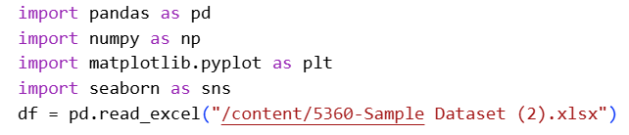

Univariate Analysis
Q1.What is the distribution of respondents across different age groups?
CODE:-
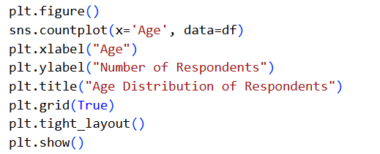
OUTPUT:-
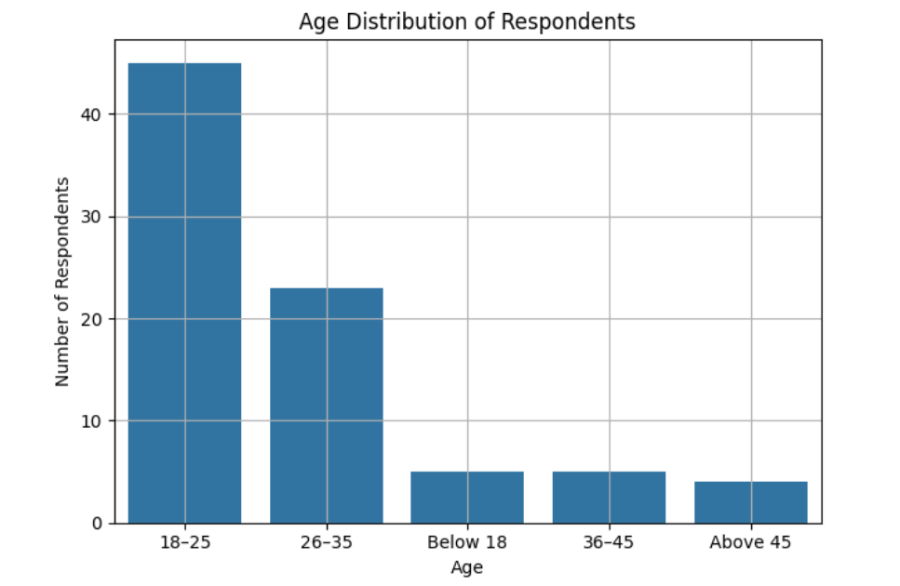

Q2.How frequently do respondents travel per week, and which trip frequency category is most common?
CODE:-
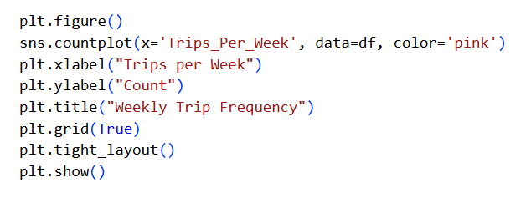

OUTPUT:-
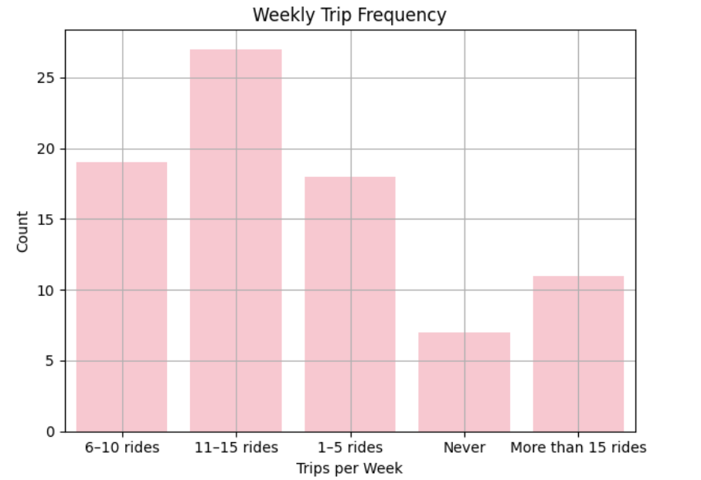
Q3.What are the most commonly used transport services among the respondents?
CODE:-
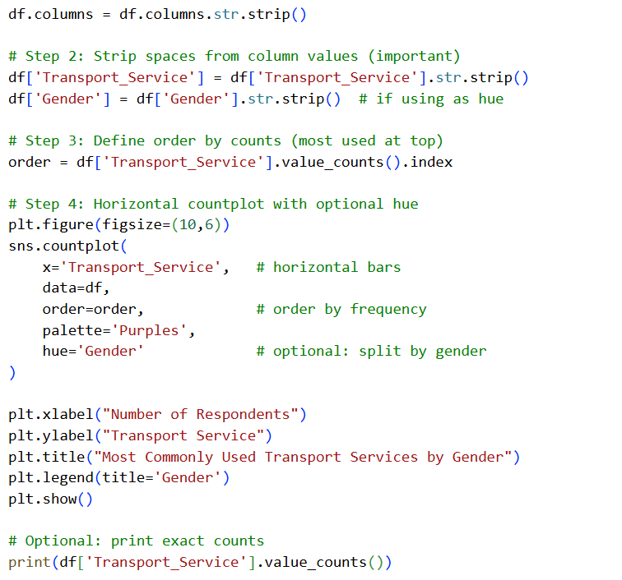
OUTPUT:-
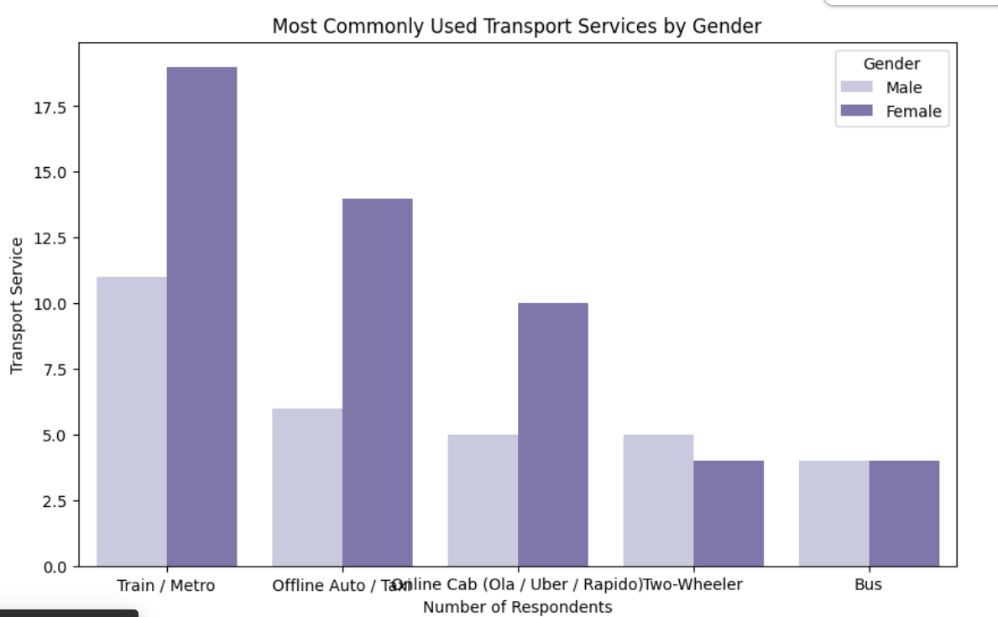

Q4.How are respondents distributed across different average daily transport cost ranges?
CODE:-
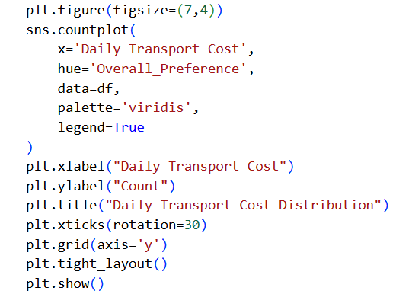
OUTPUT:-
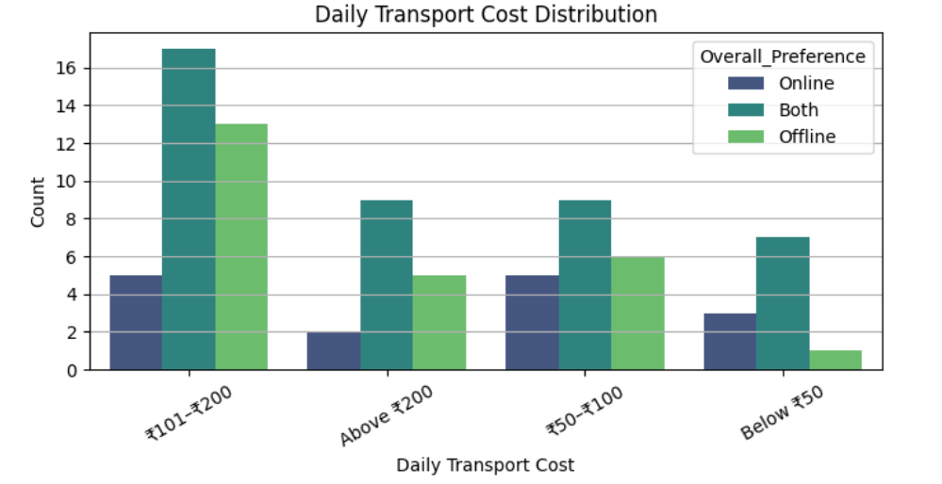
Q5.What is the frequency distribution of overall preference (online vs offline transport)?
CODE:-
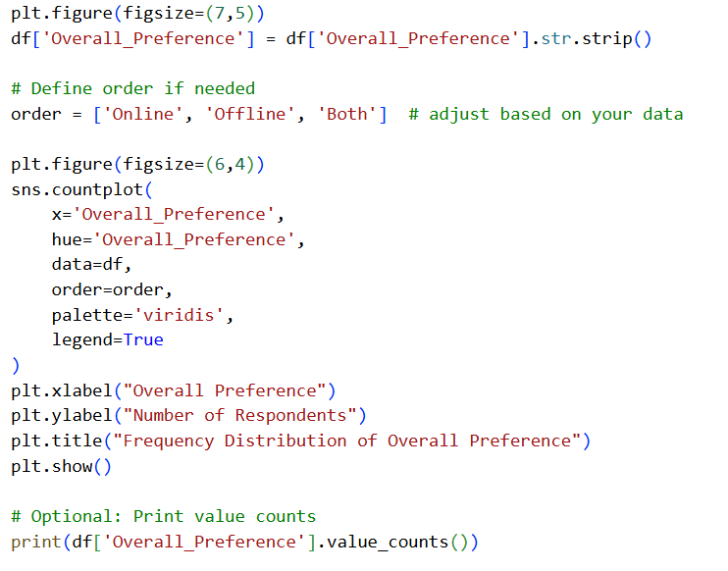
OUTPUT:-
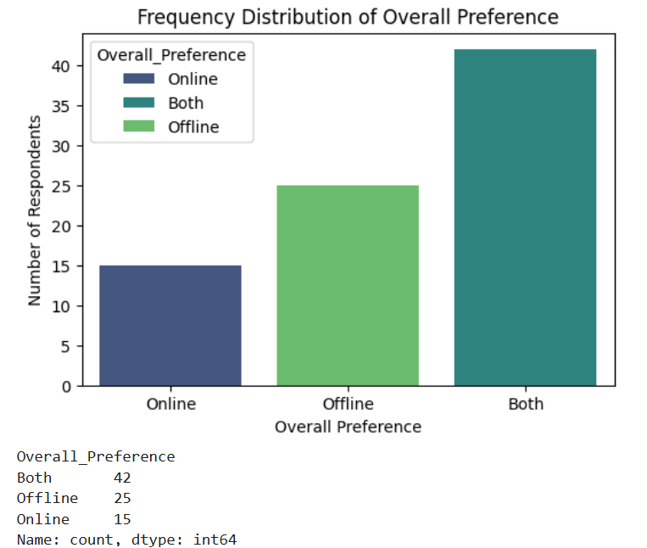

Bivariate Analysis

Q6.How does trip frequency per week vary with age group?
CODE:-
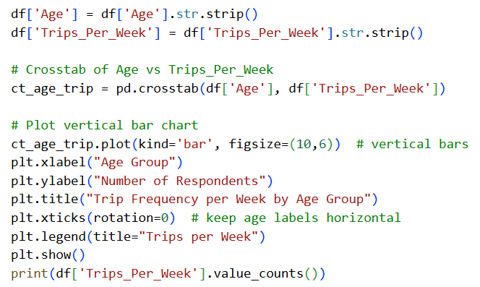
OUTPUT:-
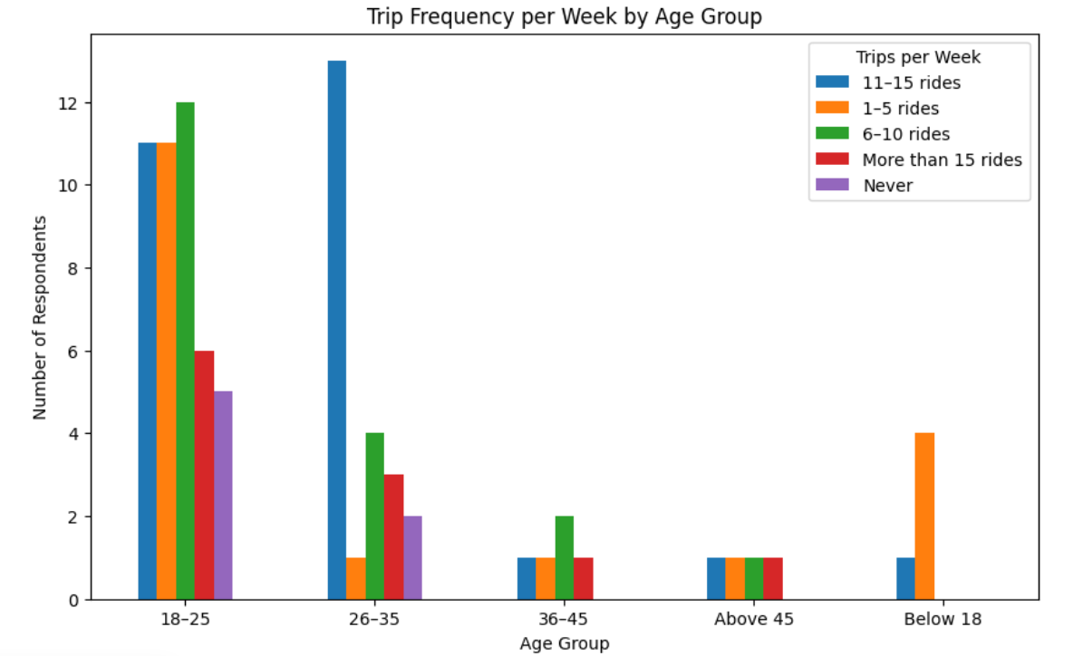
Q7.Is there any association between average daily transport cost and transport service used most often?
CODE:-
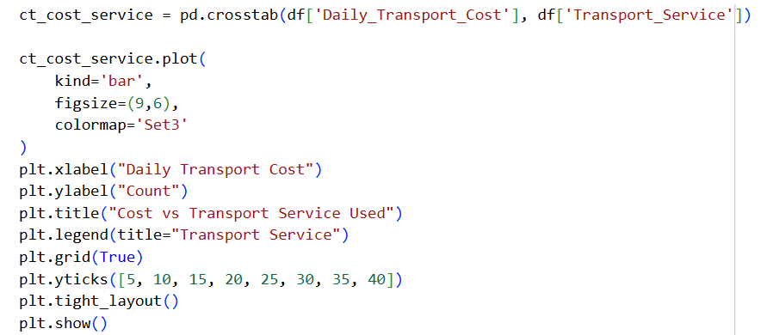
OUTPUT:-
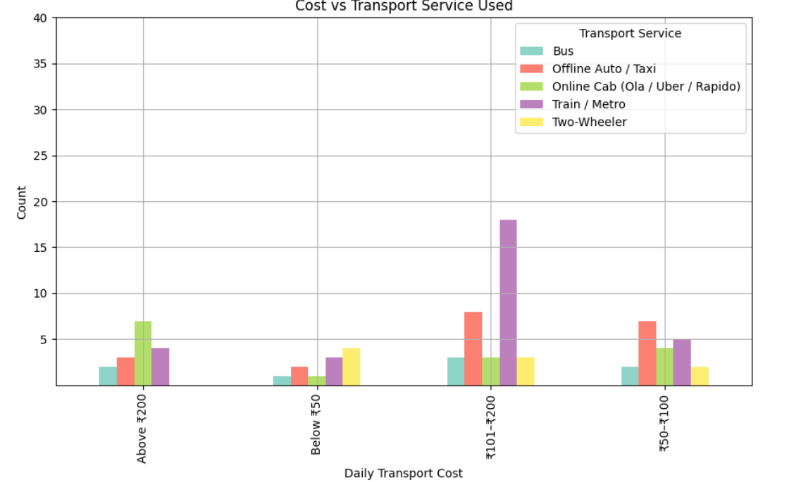

Q8.How does main purpose of travel relate to the preferred transport mode?
CODE:-
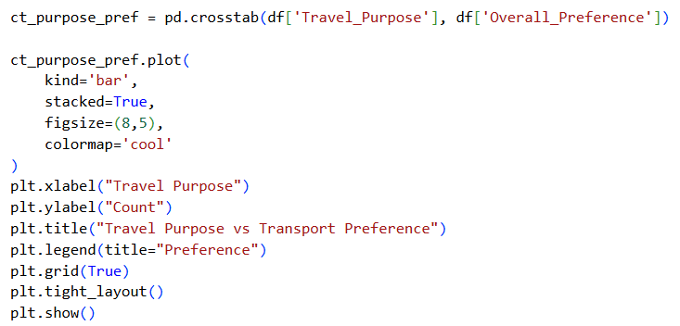
OUTPUT:-
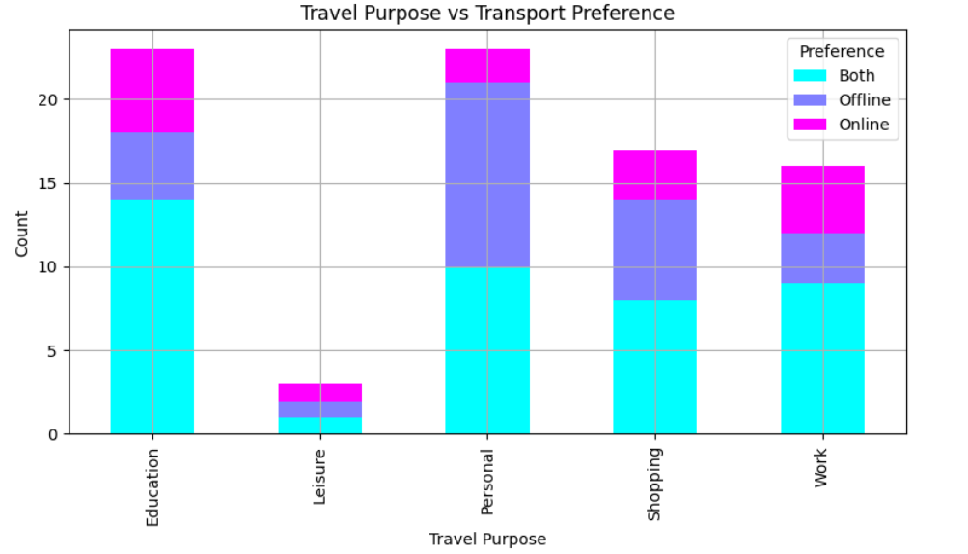

Multivariate Analysis
Q9.How do travel time per day, waiting time, and average trip distance jointly influence overall transport preference?
CODE:-
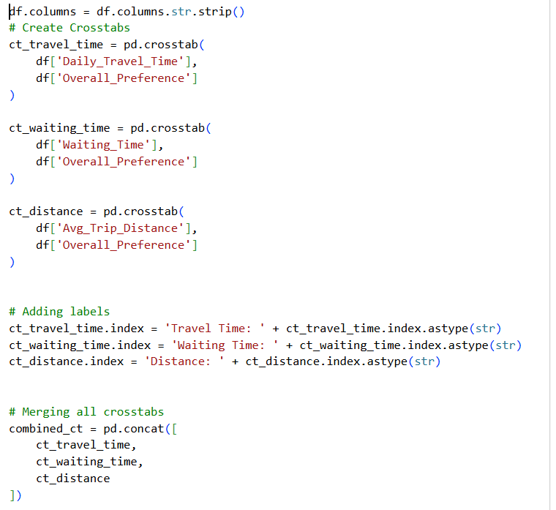
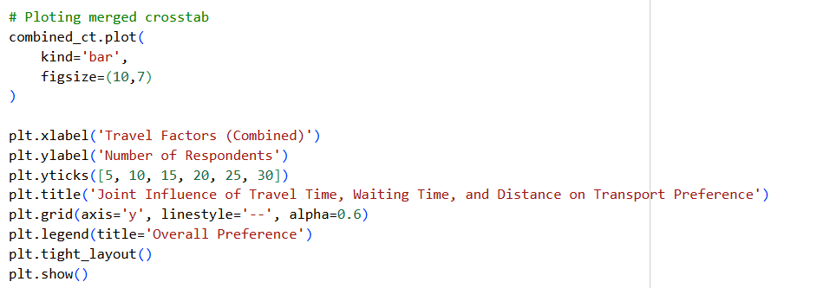

OUTPUT:-
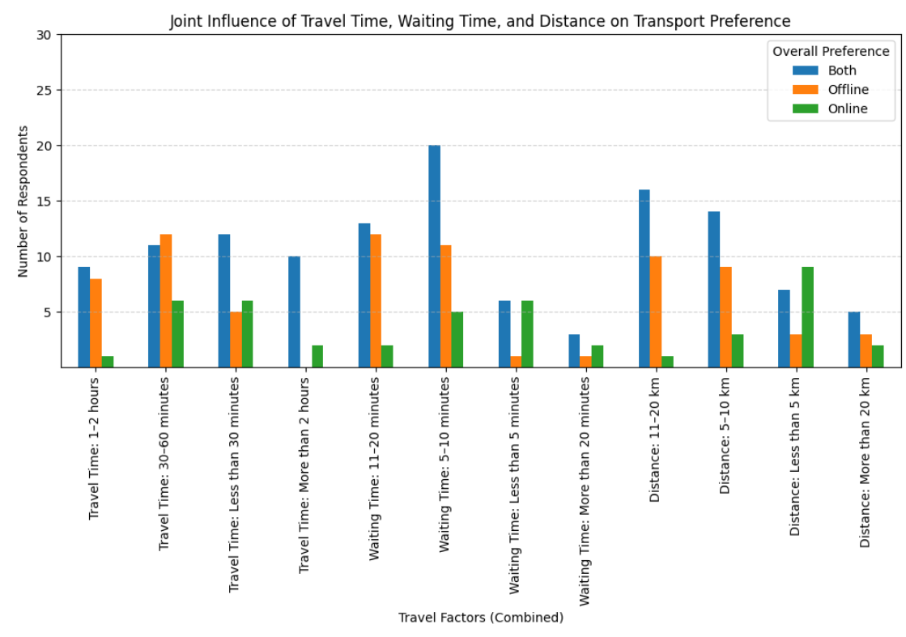

Q10.What combined effect do transport problems faced and trip cancellation frequency have on satisfaction with online transport services?
CODE:-
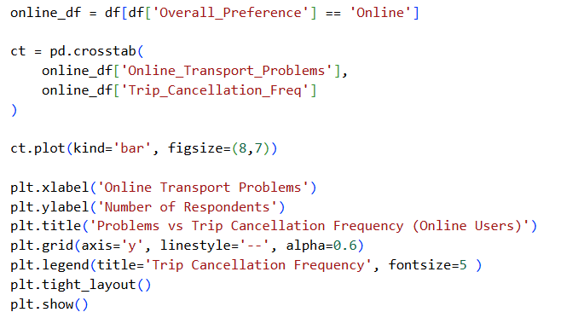
OUTPUT:-
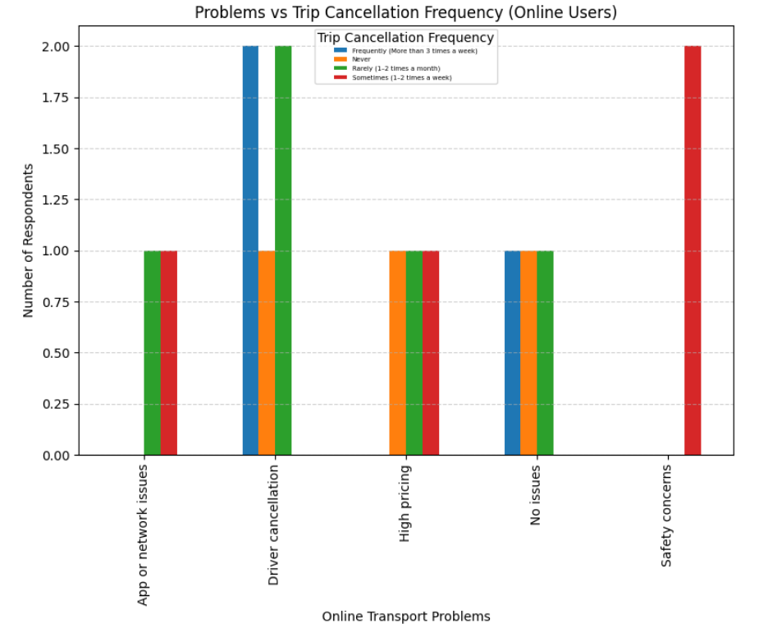
Q11.How do age group, transport service used, and safety perception together affect overall transport preference?
CODE:-
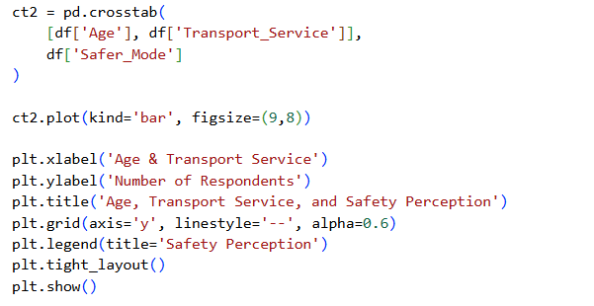
OUTPUT:-
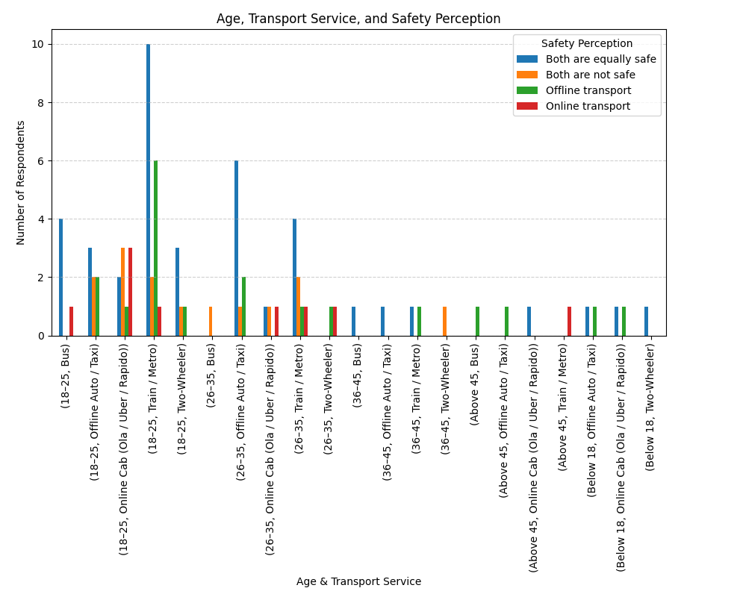

Insights and Information
Q12.travel behavior patterns can be identified for respondents who prefer online transport services?
CODE:-
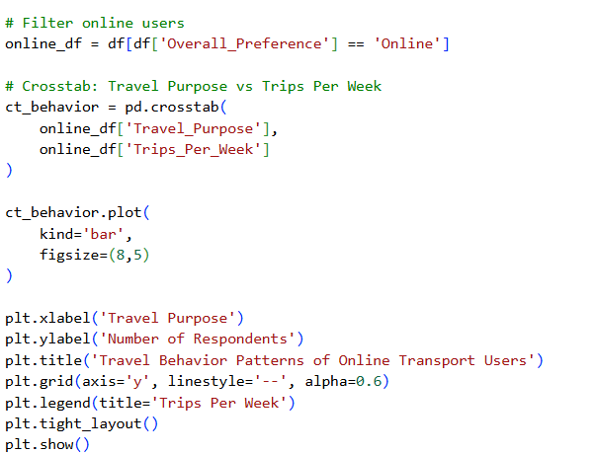
OUTPUT:-
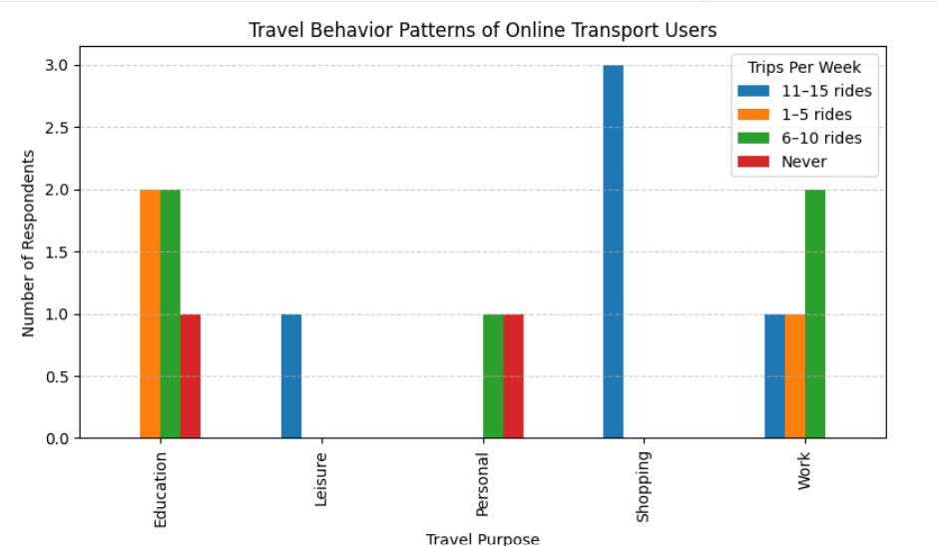
Q13.Are users who experience frequent trip cancellations generally less satisfied with transport services?
CODE:-
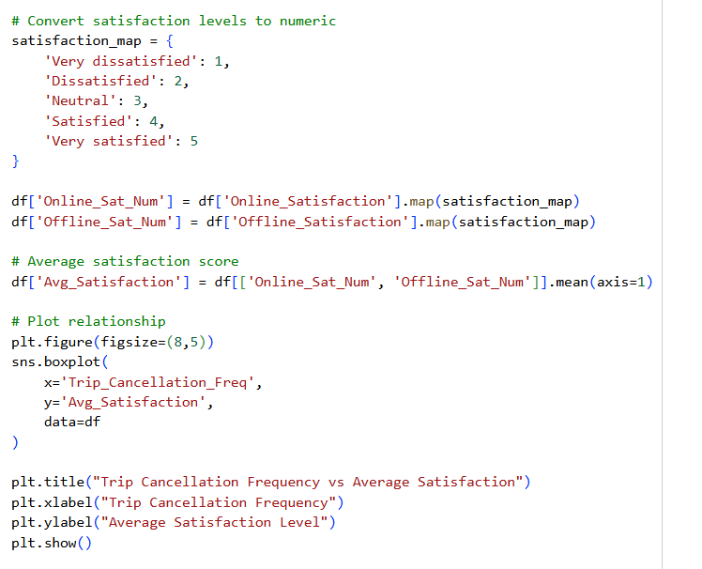
OUTPUT:-
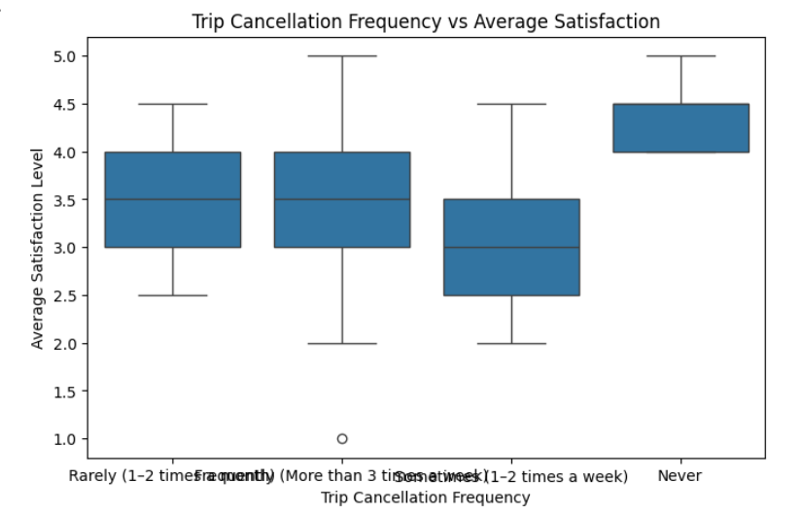

Q14.What key factors appear to most strongly influence user satisfaction with online versus offline transport?
CODE:-
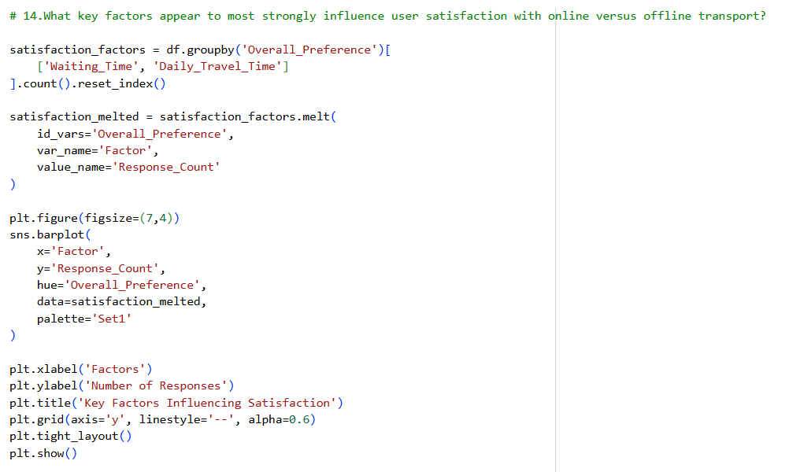
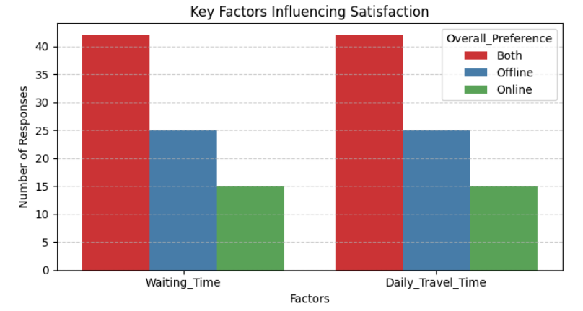
Q15.Based on the dataset, what actionable insights can be suggested to improve transport service reliability and user satisfaction?
CODE:-
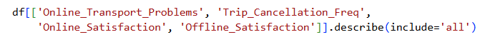
OUTPUT:-
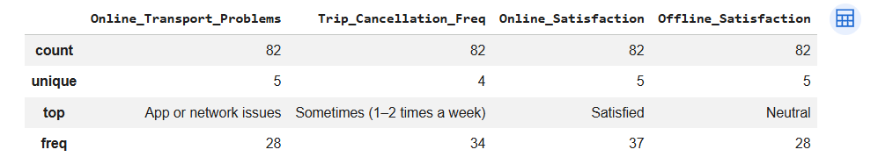

CONCLUSION:
This data science project successfully analyzed transportation usage patterns and user satisfaction using real-world survey data. The analysis revealed that factors such as daily transport cost, travel time, waiting time, and trip cancellation frequency significantly influence user satisfaction. Users experiencing frequent trip cancellations generally reported lower satisfaction levels, highlighting the importance of service reliability.
The visualizations provided clear insights into user preferences, travel behavior, and satisfaction trends. Overall, the project demonstrates how data science techniques can be effectively used to analyze real-life problems and support better decision-making in transport services. The findings of this project can help transport service providers improve service quality, reduce cancellations, and enhance customer satisfaction.

