**Group Members :**

PUSHKAR PARMAR , Dr B.C Roy Engineering College Durgapur , 32301215069

K SHWETA RANJAN , Dr B.C Roy Engineering College Durgapur , 32301215041

MADHU KUMARI , MAKAUT Kolkata ,30000214010

RANVIR KUMAR SINGH , MAKAUT Kolkata , 30000214014

**CUSTOMER FEEDBACK CAPUTURING SYSTEM FOR HOTEL AND RESTAURANTS**

**TABLE OF CONTENT**

**Acknowledgement………….……………………………………………………………………………………..3**

**Project Objective ..................................................................................................................................... 4**

**Project Scope........................................................................................................................................... 5**

**Requirement Specification...................................................................................................................... 6**

**Database Design...................................................................................................................................... 7**

**Screenshots........................................................................................................................................... ..8**

**Code……………………………..................................................................................................................11**

**Result..................................................................................................................................................... ..15**

**Future Scope…….....................................................................................................................................16**

**Acknowledgement**

I take this opportunity to express my profound gratitude and deep regards to my faculty Mr. Prasun Neogi for his exemplary guidance, monitoring and constant encouragement throughout the course of this project. The blessing, help and guidance given by him/her time to time shall carry me a long way in the journey of life on which I am about to embark.

I am obliged to my project team members for the valuable information provided by them in their respective fields. I am grateful for their cooperation during the period of my assignment

PUSHKAR PARMAR

K SHWETA RANJAN

MADHU KUMARI

RANVIR KUMAR SINGH

**Project Objective**

**One of the most fundamental objectives of an Customer feedback capturing system for hotel and restaurants is to increase the global reach of a hotel by their feedback. Through it, hoteliers are able to launch hotel website so that various users around the world can access the website. Thus it increases the chances of a number of bookings by seeing feedback and rating. Also, it saves a lot of time and effort for customers as they can conveniently book hotel rooms from their homes by seeing feedback and ratings.**

**Other common objectives fulfilled by Customer feedback capturing system for hotel and restaurants:**

* **To provide a platform to manage on-desk and online bookings**
* **To display organized information of hotel, Feedback and rating.**
* **Store customer information which can be accessed anytime.**
* **A user-friendly interface for customers for the easy customer feedback process.**

**Project Scope**

* **To provide a platform to manage on-desk and online bookings**
* **To display organized information of hotel, Feedback and rating.**
* **Store customer information which can be accessed anytime.**
* **A user-friendly interface for customers for the easy customer feedback process.**

**Requirement Specification**

**Software Requirement:**

* **Python**
* **Anaconda**
* **SPYDER**
* **MS-Word**

**Hardware Requirement:**

* **RAM – 8GB**
* **ROM – 1TB**
* **Mouse**
* **Keyboard**

**Operating System:**

* **Windows 8.1**

**Database Design**

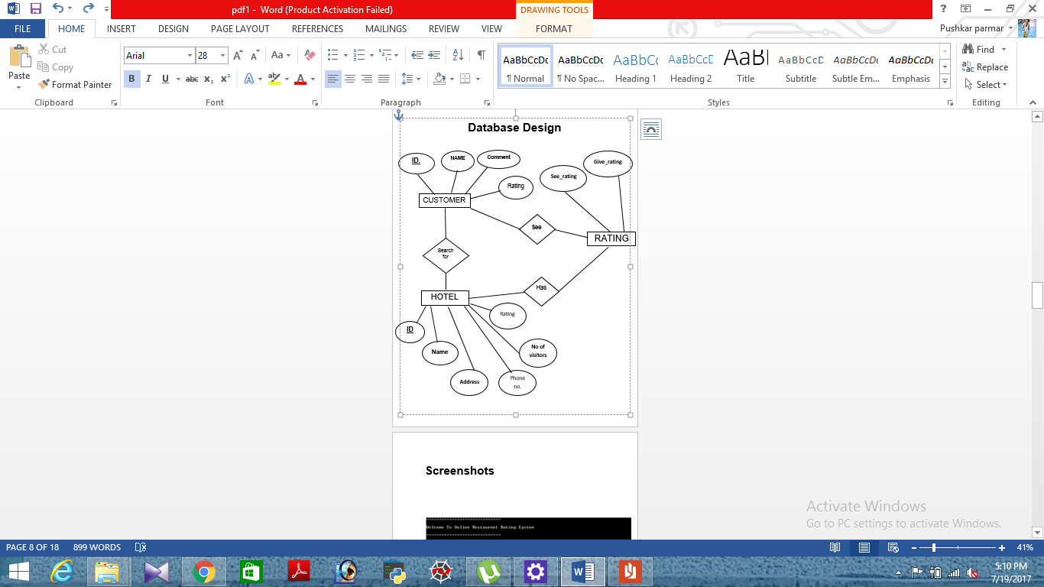

**Screenshots**

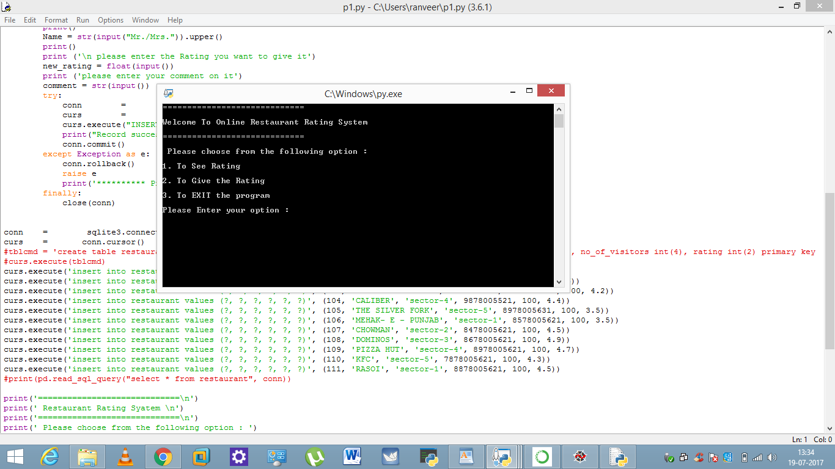

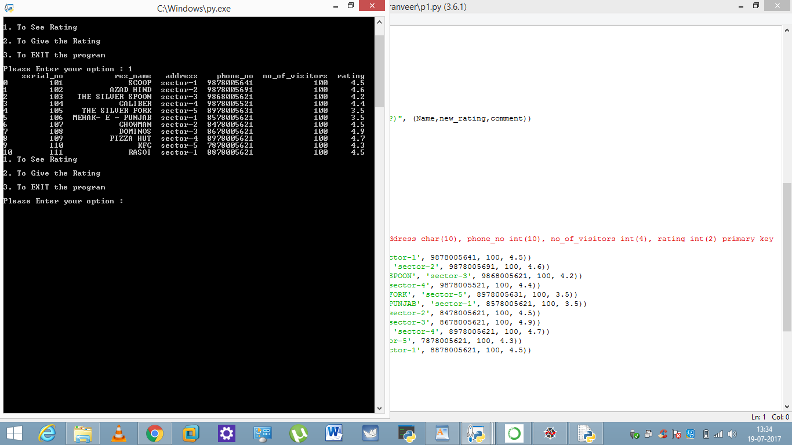

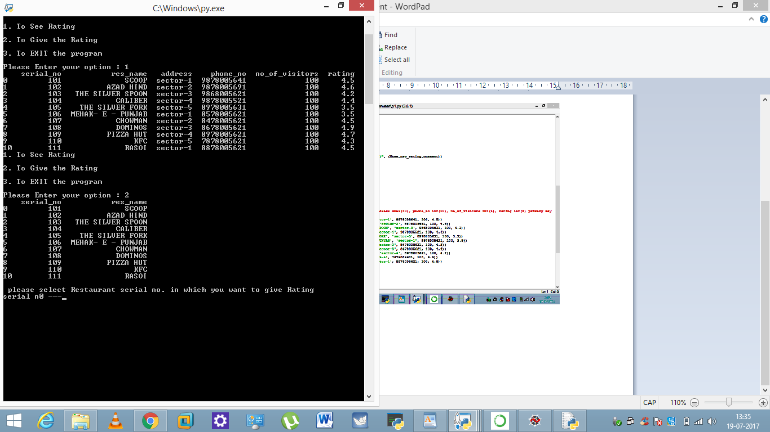

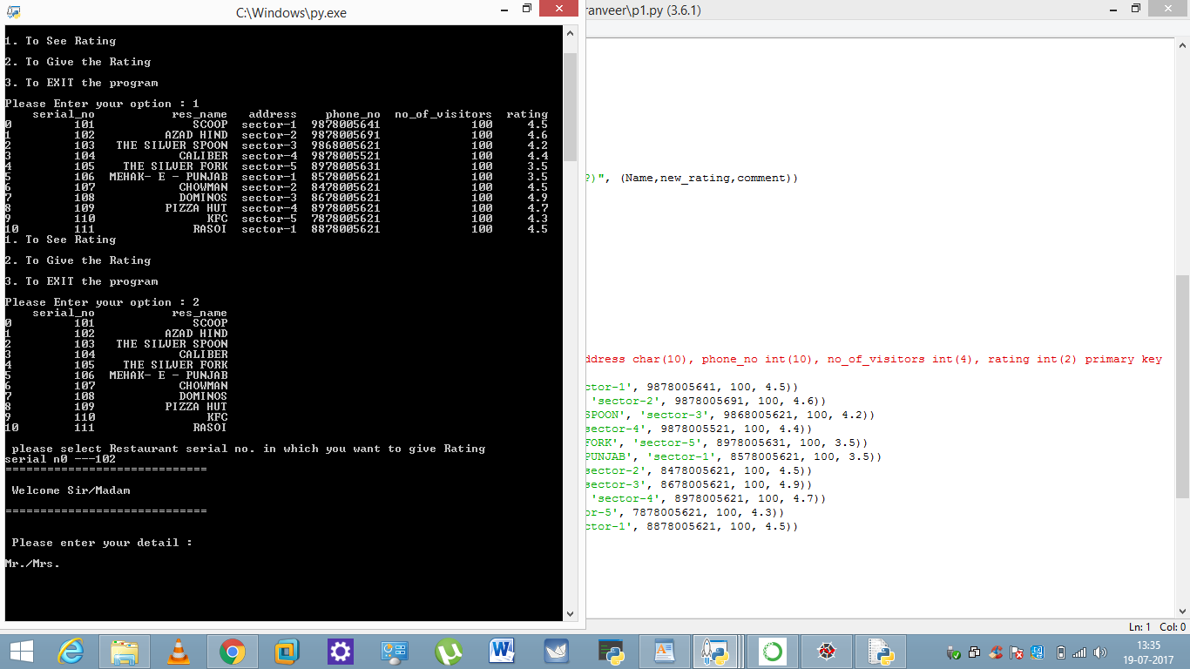

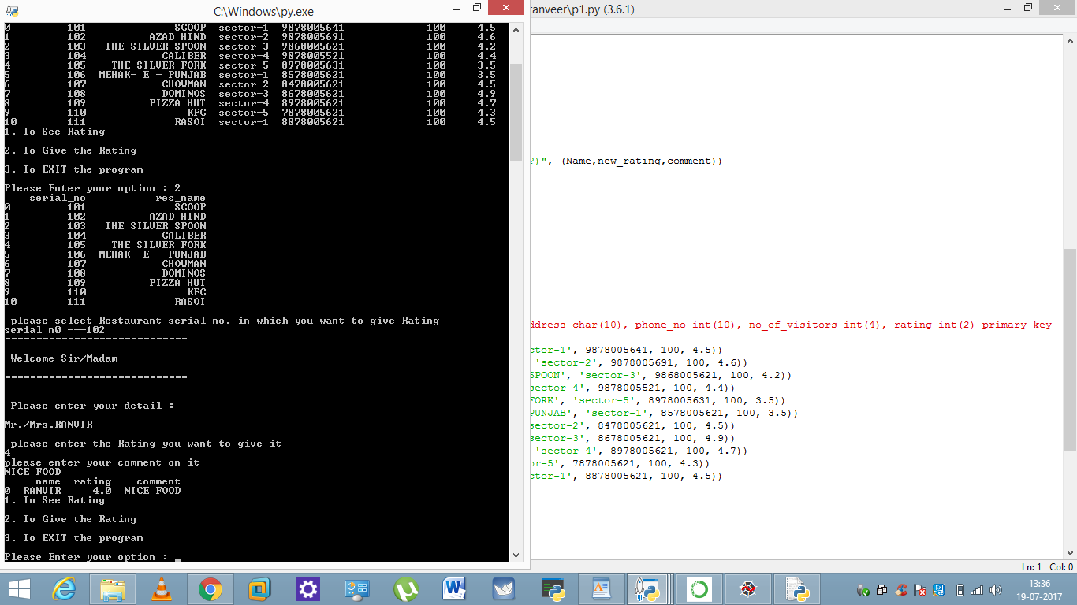

**Code**

import sqlite3

import pandas as pd

db = sqlite3.connect('dbase1')

curs = db.cursor()

curs.execute('''DROP TABLE IF EXISTS customer''')

#sqlcmd = 'create table customer2 ( name char(2), rating float, comment char(500))'

#curs.execute(sqlcmd)

def connect(dbase1):

""" Make connection to an SQLite database file """

conn = sqlite3.connect(dbase1)

c = conn.cursor()

return conn, c

def close(conn):

""" Commit changes and close connection to the database """

conn.commit()

conn.close()

def See_rating() :

db1 = sqlite3.connect('dbase1')

print(pd.read_sql_query("select * from restaurant", db1))

def Give_Rating() :

while True:

try:

conn = sqlite3.connect('dbase1')

curs = conn.cursor()

curs.execute("INSERT INTO customer2 (name, rating,comment) values (?,?,?)", (Name,new_rating,comment))

print("Record successfully Inserted ....!!!\n")

conn.commit()

except Exception as e:

conn.rollback()

raise e

print('********** Problem while Inserting records in table *********')

finally:

close(conn)

conn = sqlite3.connect('dbase1')

curs = conn.cursor()

#tblcmd = 'create table restaurant (serial_no int(4) NOT NULL, res_name char(30), address char(10), phone_no int(10), no_of_visitors int(4), rating int(2) primary key (serial_no))'

#curs.execute(tblcmd)

#curs.execute('insert into restaurant values (?, ?, ?, ?, ?, ?)', (102, 'AZAD HIND', 'sector-2', 9878005691, 100, 4.6))

#curs.execute('insert into restaurant values (?, ?, ?, ?, ?, ?)', (103, 'THE SILVER SPOON', 'sector-3', 9868005621, 100, 4.2))

#curs.execute('insert into restaurant values (?, ?, ?, ?, ?, ?)', (104, 'CALIBER', 'sector-4', 9878005521, 100, 4.4))

#curs.execute('insert into restaurant values (?, ?, ?, ?, ?, ?)', (105, 'THE SILVER FORK', 'sector-5', 8978005631, 100, 3.5))

#curs.execute('insert into restaurant values (?, ?, ?, ?, ?, ?)', (106, 'MEHAK- E - PUNJAB', 'sector-1', 8578005621, 100, 3.5))

#curs.execute('insert into restaurant values (?, ?, ?, ?, ?, ?)', (107, 'CHOWMAN', 'sector-2', 8478005621, 100, 4.5))

#curs.execute('insert into restaurant values (?, ?, ?, ?, ?, ?)', (108, 'DOMINOS', 'sector-3', 8678005621, 100, 4.9))

#curs.execute('insert into restaurant values (?, ?, ?, ?, ?, ?)', (109, 'PIZZA HUT', 'sector-4', 8978005621, 100, 4.7))

#curs.execute('insert into restaurant values (?, ?, ?, ?, ?, ?)', (110, 'KFC', 'sector-5', 7878005621, 100, 4.3))

#curs.execute('insert into restaurant values (?, ?, ?, ?, ?, ?)', (111, 'RASOI', 'sector-1', 8878005621, 100, 4.5))

#print(pd.read_sql_query("select * from restaurant", conn))

print('=============================\n')

print('Welcome To Online Restaurant Rating System \n')

print('=============================\n')

print(' Please choose from the following option : ')

print()

while True:

print('1. To See Rating \n' )

print('2. To Give the Rating \n')

print('3. To EXIT the program \n')

choice = int(input("Please Enter your option : "))

if choice == 1:

See_rating()

elif choice == 2:

db1 = sqlite3.connect('dbase1')

print(pd.read_sql_query("select serial_no,res_name from restaurant",db1))

print ('\n please select Restaurant serial no. in which you want to give Rating')

A = input("serial n0 ---")

print('=============================\n')

print(' Welcome Sir/Madam \n')

print('=============================\n')

conn = sqlite3.connect('dbase1')

curs = conn.cursor()

print('\n Please enter your detail : \n')

Name = str(input("Mr./Mrs.")).upper()

print ('\n please enter the Rating you want to give it')

new_rating = float(input())

conn = sqlite3.connect('dbase1')

curs = conn.cursor()

print ('please enter your comment on it')

comment = str(input())

conn = sqlite3.connect('dbase1')

curs = conn.cursor()

curs.execute("INSERT INTO customer2 values (?,?,?)", (Name,new_rating,comment))

## print(pd.read_sql_query("select res_name from restaurant WHERE serial_no = A",db1))

print(pd.read_sql_query("select * from customer2",conn))

#Give_Rating()

elif choice == 3:

conn.close()

break

else:

print("Invalid choice ....!!!!\n")



**Result**

**Future Scope**

* **To provide a platform to manage on-desk and online bookings**
* **Customer can book hotel by seeing hotels feedback and rating.**