Laplacian after linear transformation of coordinates

Suppose we define:

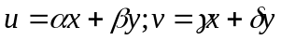

Clearly:

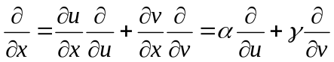

This leads to:

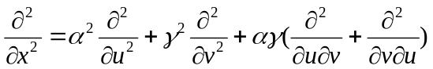

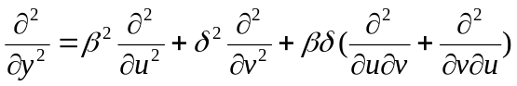

And:

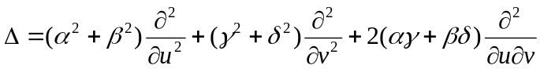 ()

In most cases we can assume that the order of differentiation does not matter. So we can merge the 2 mixed terms into one.

The next step is to convert this into a difference equation.

A more general representation (3D)

Suppose we have a new coordinate system in the form:

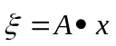

And suppose that A is a reversible matrix with B=A⁻¹

The jacobian of the transformation is: 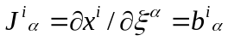

The Laplacian with the new coordinates is given by eq. (3) of ref [] by:

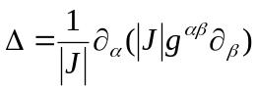 ()

Where:

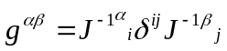

Since J is simply the matrix B (which is constant) we can remove the determinant from eq. () because it is canceled out, and also we can recognize that J⁻¹=A, and we get instead of eq. () the following expression for the Laplacian:

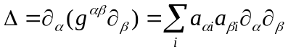 ()

In the last summation, I dropped the covariant and contravariant convention for the indices. If we check eq. () for the special case of 2D with the matrix elements described earlier we would get exactly the result of eq. ().

2D for parallelepiped cell with equal faces

In this case the diagonals of the cell are orthogonal and we can use them as a coordinate system for the laplacian. I’ll write this in more detail later.

2D general case

Suppose we have a non-orthogonal coordinate system with u and v.
And suppose we have a laplacian that is given by:

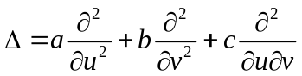 ()

We can define a third, dependent coordinate w to be: 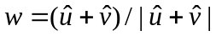 where 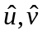 are unit vectors parallel to the axis. It follows from the definition of directional derivative that:

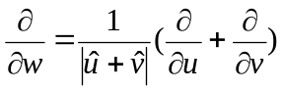 ()

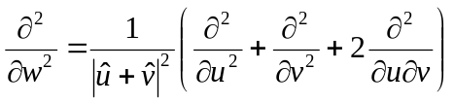 ()

If we now wish to express the laplacian of equation () in terms of u,v and w we would get through comparison of coefficients the following:

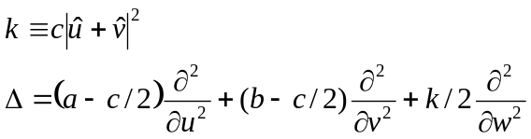 ()

Few remarks:

- I believe the choice w=u+v or w=u-v can affect the efficiency after translating to a discrete grid. I need to check that.
- The choice of w leads to points that are already on the grid! – this means that the expression of equation () can easily be translated to a grid.

In some cases it is better to work in the direction u-v to that we need to develop a similar equation for that direction:

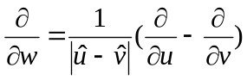

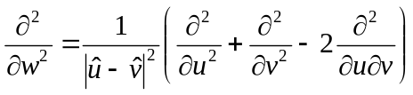

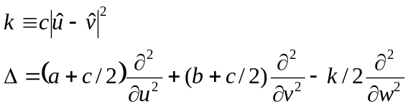

Effect of unequal grid step size – 2D case
Suppose that the grid spacing in u and in v is not equal, in that cases we cannot choose the direction because of the simple reason that this would result in points that are not situated on the grid. The choice is then the following:

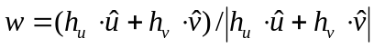 , let’s define 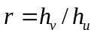

And then:

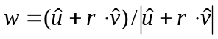

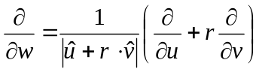

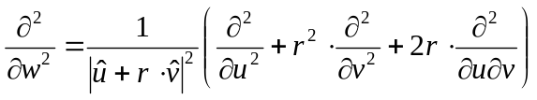

Now we need to do the same thing as before.

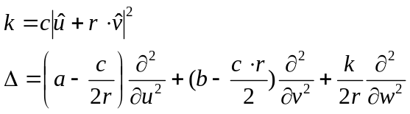

It is assumed that r is close to 1, so no pathologies exist for this expression.

If we choose the “-“ direction, we would get in the same way:

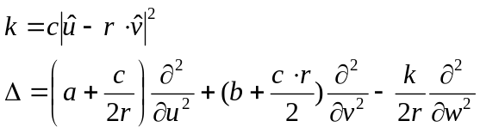

2D case on a grid

The translation to a grid is simple:

If we have a grid (non-orthogonal) u_{i,}v_{j} the expression for the laplacian would be:

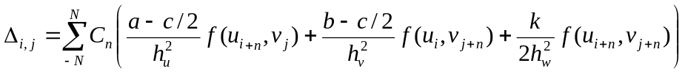

C_{n} are the coefficients that are given in [] for the evaluation of Nth order difference for the second derivative. The error, of order 2N+2, will be dominated by the maximal h difference.

The number of neighbors is rising from 2*2N to 3*2N.

3D case

The extension of equation () to 3D is nearly straightforward, suppose we have un-orthogonal coordinate system x,y,z. one needs to define w_{xy},w_{xz},w_{yz}, for example w_{yz}=y+z.

Suppose we have a laplacian of the form:

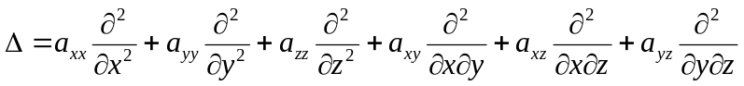

Let us define:

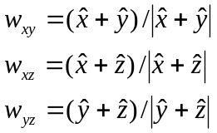

In a way that is similar to the 2D case, we would get the following:

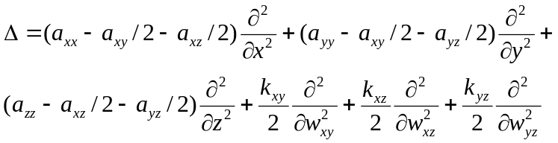

if we do the + direction and the following for the “-“ direction:

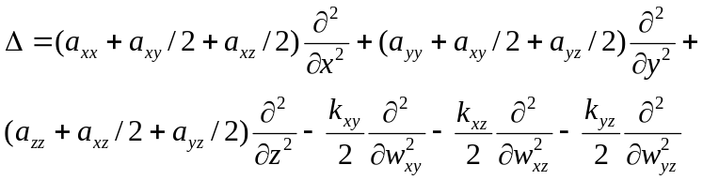

A remark here – according to computational efficiency we can mix + and – directions in different planes.

N.A. Modine, Gil Zumbach and Efthimios Kaxiras, Phys. Rev. B. 55, 10289 (1997).
James R. Chelikowsky, N. Trouiller, K. Wu and Y. Saad, Phys. Rev. B. 50, 11355 (1994)

