

DEPARTMENT: COMPUTER SCIENCE& ENGINEERING
SUBJECT CODE: BTES-302-18
SUBJECT: DIGITAL ELECTRONICS LABORATORY
COURSE COORDINATOR: Mrs. Tanu Chandel
SESSION: JULY-DEC 2025

Course Code:  BTES302-18 | Course Title:  Digital Electronics Lab | 0L:0T:4P | 2Credits

LISTOFEXPERIMENTS

S.No. | Title of Experiment
1 | To verify the Truth-tables of all logic gates.
2 | To realize and verify the Half&full adder circuits using logic gates.
3 | To realize Half & full susbtractor circuits using logic gates.
4 | To realize Encoder and Decoder circuits
5 | To realize Multiplexer circuits
6 | To realize 4-bit binary-gray &gray-binary converters.
7 | Torealizecomparatorcircuitfortwobinarynumbersof2-biteach.
8 | To realize Full adder &full subtractor circuits using encoder.
9 | To design Full adder&full subtractor circuits using multiplexer.
10 | To design and verify the Truth tables of all flip-flops.
11 | To design Mod-6/Mod-9synchronous up-down counter.

Prepared by: Approved By:

Mrs. Tanu chandel HOD CSE

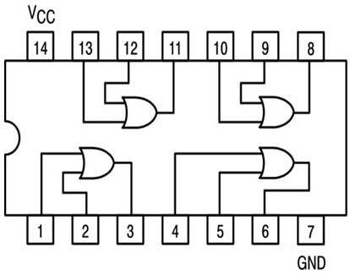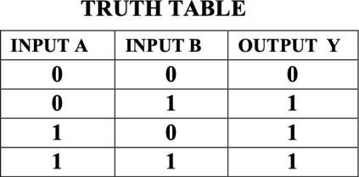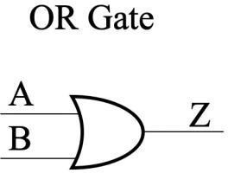

EXPERIMENT-1
AIM: To verify the Truth-tables of all logic gates.
OBJECTIVE: To understand how digital gates can implement various unique digital logics patterns.
PREREQUISITES: Basic knowledge of logic gates.

RESOURCE/EXPERIMENTAL SET-UP/EQUIPMENT/APPARATUS/TOOLS:-
Prototyping board (breadboard), DC Power Supply, Connecting Wires, 7400, 7404,7408,7432,7486, 7402

THEORY AND APPLICATION:

- OR GATE: Function of OR gate is to give output true when one of the either inputs and both inputs are true. In the remaining case output becomes false. Following table justify the statement:-

IC7432

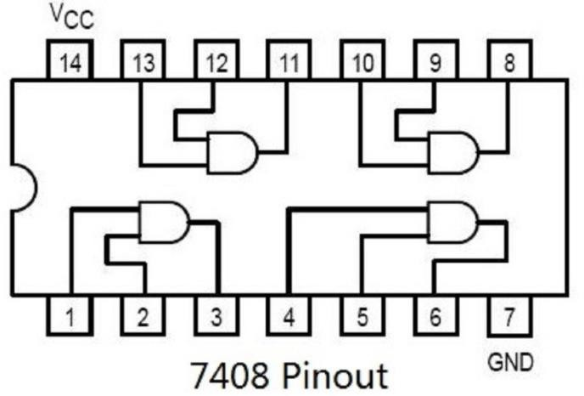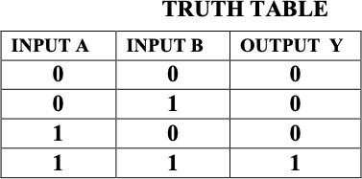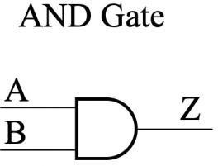

- ANDGATE: Function of AND gate is to give the output true when both the inputs are true. In all the other remaining cases output becomes false. Following table justifies the statement:-

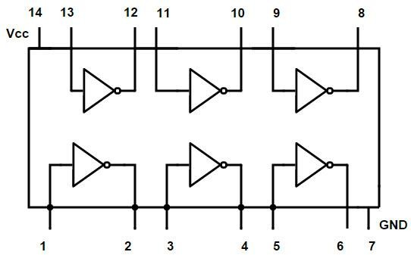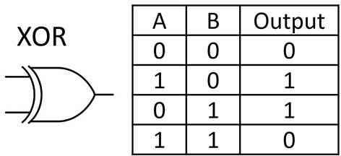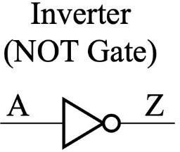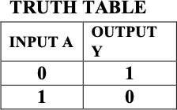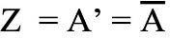

- NOT GATE: Function of NOR gate is to reverse the nature of the input. It converts true input to false and vice versa. Following table justifies the statement :-

IC7404

- XORGATE:-The function of XOR gate is to give output true only when either of one input is true. Following table explain this:-

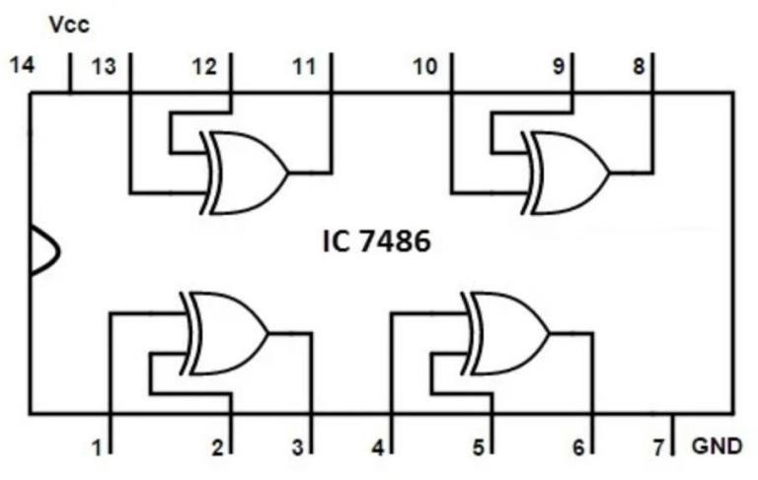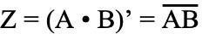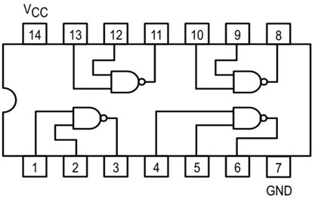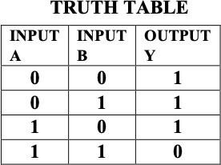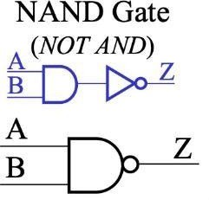

- NAND GATE: -Function of NAND gate is to give true output when one of the two provided input and both inputs are false. Following table justifies the statement :-

- NORGATE:-NOR gate gives the output true when both the two provided input are false. In all the other cases output remains false. Following table justifies the statement :-

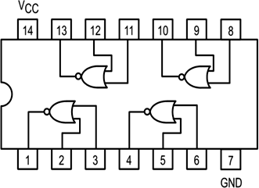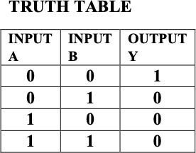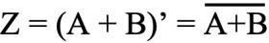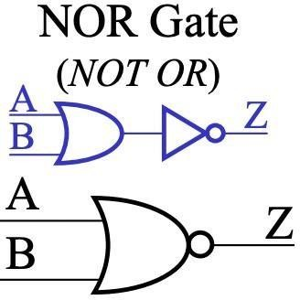

Procedure:

- From the IC No.find out the type of gate.

- Identify the pin no’s of the given IC.

- Check for the proper working of the gate.

- Connect the circuit asper circuit diagram.

- For all combination of input condition tabulate the output voltage.

- Verify it with truth Table.

- Repeat the above procedure for all gates

CONCLUSION: All basic Logic Gates are verified.

SAMPLEVIVA-VOVE QUESTIONS:

Q1. What is a logic gate? Q2.What are basic gates? Q3.What are NOT gates?
Q4.Differentiate between NAND&AND gate.
Q5.Whichgates are known as universal Gates and why?

EXPERIMENT-2
AIM: To realize and verify the Half&full adder circuits using logic gates.
OBJECTIVE: To understand how to add numbers with and without carry using half and Full adder circuits.
PREREQUISITES: Basic theory and implementation of Half and Full adder circuits.

RESOURCE/EXPERIMENTALSET-UP/EQUIPMENT/APPARATUS/TOOLS:-
Prototyping board (breadboard),DC Power Supply, Connecting Wires,7404,7408,7432.

THEORYANDAPPLICATION:

Half Adder: A half adder is a combinational circuit with two binary inputs and two binary outputs (sum and carry bits). It adds two inputs (A and B) and produces the sum (S) and the carry (C) bits. It is an arithmetic circuit used to perform the arithmetic operation of addition of two single bit words.
Sum=AXOR B
Carry=A ANDB

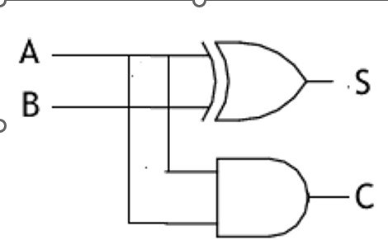
INPUTA | INPUTB | OUTPUTS
INPUTA | INPUTB | S | C
0 | 0 | 0 | 0
0 | 1 | 1 | 0
1 | 0 | 1 | 0
1 | 1 | 0 | 1

CIRCUIT DIAGRAM TRUTHTABLE

FULLADDER:
The full adder adds the bits A and B and the carry from the previous column called the carry in (C in) and the outputs the sum bit(S) and the carry bit called the carryout (Cout).The variables gives the value of the least significant bit of the sum.The variable Cout gives the out carry.

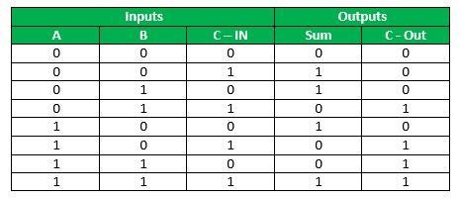
TRUTHTABLE

Expression | for | SUM: | A’B’Cin | + A’ | B CCin’ | + | A | B’Cin’+ | AB | Cin
 |  | Cin | (A’B’+ | AB) | + | Cin’ |  | (A’B | +A | B’)
Cin EX-OR (AEX-OR B)
Expression for Carry(Cout):A’BCin+AB’Cin +ABCin’+ ABCin
AB+BCin + ACin
Or
=AB +Cin(A EX–OR B)

Circuit Diagram:
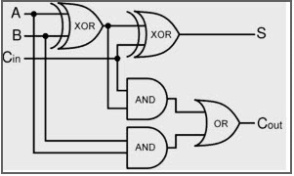

PROCEDURE:
- Identify the pins.
- Connect the circuit as per circuit diagram.
- Obtain outputs with various input combinations.
- Verify it with the Boolean function using truth table.
- ​

CONCLUSION:
Full Adder has been implemented& verified through truth table.
DO’s and DONT’s:

- Read and understand how to carry out an activity thoroughly before coming to the laboratory.

- Shut down the machine once you are done using it.

- Eatables are not allowed in the laboratory.

- Do not open the system unit casing.

- Do not touch, connect or disconnect any plug or cable without your faculty/laboratory technician’s permission.

SAMPLEVIVA-VOCE QUESTIONS

What are the applications of half adder?
Explain the advantages of half adder?
What are the applications of full adder?
Elaborate the advantages of full adder over half adder.

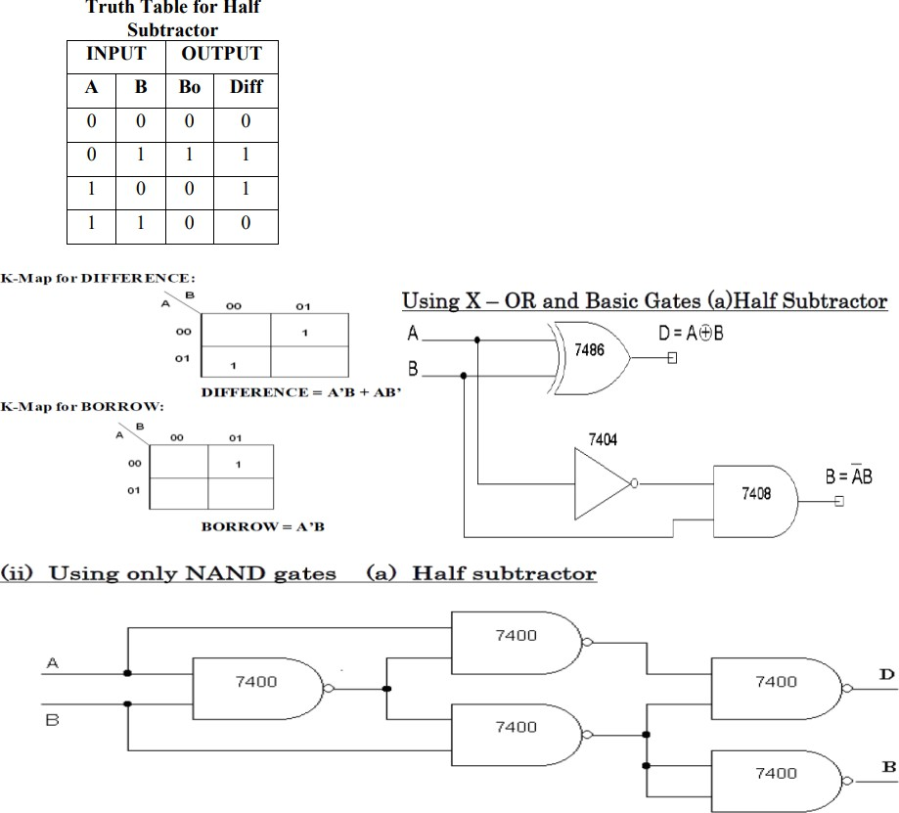

EXPERIMENT-3
AIM: To realize half &full subtractor circuits using logic gates.
OBJECTIVE: To understand how to add numbers with and without carry using half and Full subtractor circuits.
PREREQUISITES: Basic theory and implementation of Half and Full subtractor circuits.

RESOURCE/EXPERIMENTALSET-UP/EQUIPMENT/APPARATUS/TOOLS:-
Prototyping board (breadboard),DC Power Supply,ConnectingWires,7404,7408,7432, 7486.

THEORY AND APPLICATION:

Half Subtractor: The half subtractor is constructed using X-OR and AND Gate. The half subtractor has two input and two outputs. The outputs are difference and borrow. The difference can be applied using X-OR Gate, borrow output can be implemented using an AND Gate and an inverter.

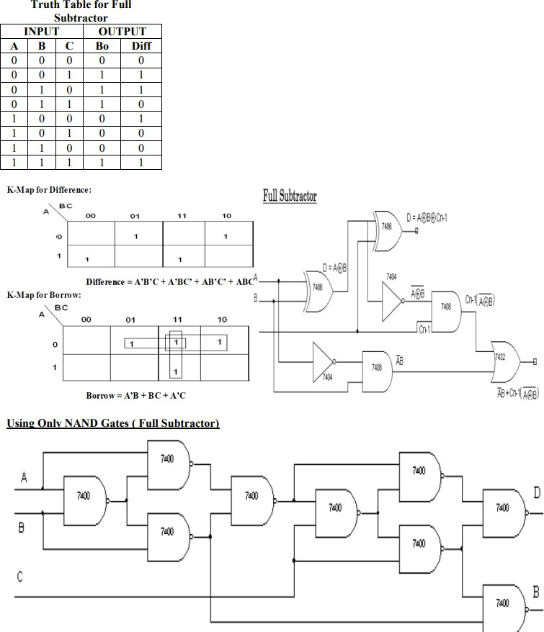

Full Subtractor: The full subtractor is a combination of X-OR, AND, OR, NOT Gates. In a full subtractor the logic circuit should have three inputs and two outputs. The two half subtractor put to get her gives a full subtractor. The first half subtractor will be C and AB. The output will be difference output of full subtractor. The xpression AB assembles the borrow output of the half subtractorandthe second term is the inverted difference output of first X-OR.

PROCEDURE:
- Identify the pins.
- Connect the circuit as per circuit diagram.
- Obtain outputs with various input combinations.
- Verify it with the Boolean function using truth table.
- ​

CONCLUSION:
Half and Full subtractors has been implemented& verified through the truthtable.
DO’sandDONT’s:

- Read and understand how to carry out an activity thoroughly before coming to the laboratory.

- Shutdown the machine once you are done using it.

- Eatables are not allowed in the laboratory.

- Do not open the system unit casing.

- Do not touch, connect or disconnect any plug or cable without your faculty/laboratory technician’s permission.

SAMPLEVIVA-VOCE QUESTIONS

What are the applications of half Subtractor?
Explain the advantages of half subtractor?
What are the applications of full subtractor?
Elaborate the advantages of full subtractor over half subtractor.
If A and B are the inputs of a half subtractor, the sum is given by

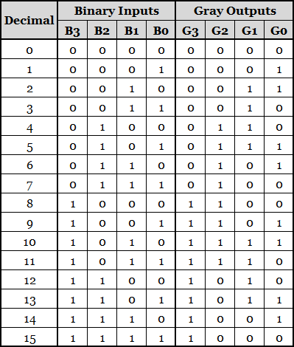

EXPERIMENT-4
AIM :To realize Encoder and Decoder circuits(Binary to Grey and Grey to Binary).
OBJECTIVE: To understand encoding and decoding functions.
PREREQUISITES: Basic theory and implementation Encoder and Decoder circuits.

RESOURCE/EXPERIMENTALSET-UP/EQUIPMENT/APPARATUS/TOOLS:-
Prototyping board (breadboard), DC Power Supply, Connecting Wires,7486.

THEORYANDAPPLICATION:

Binary to Gray code converter: The logical circuit which converts the binary code to equivalent gray code is known as binary to gray code converter.
Truth Table:

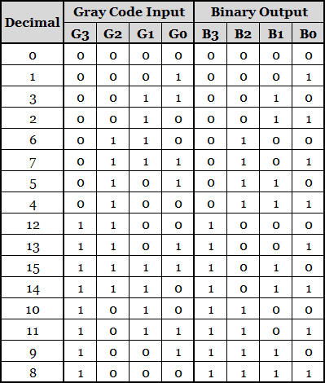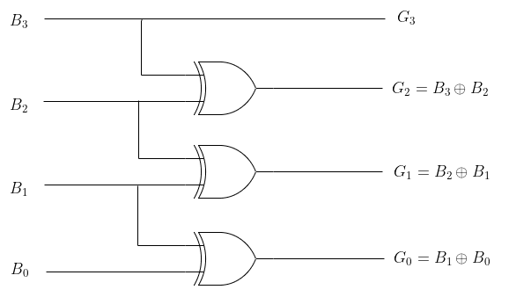

Binary to Gray Code Converter Circuit:

- Gray to Binary Code Conversion: The logical circuit which converts the gray code to equivalent binary code is known as gray to binary code converter.
Truth Table:

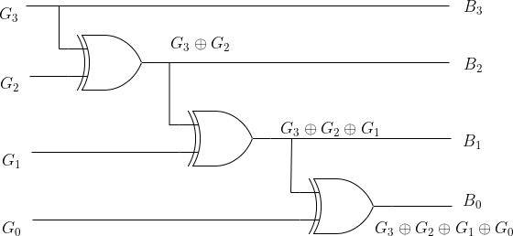

Logical Circuit Diagram for Binary to Gray Code Conversion:

EXPERIMENTAL PROCEDURE:

  - Collect the components necessary to accomplish this experiment.
  - Plug the IC chip in to the bread board.
  - Connect the supply voltage and ground lines to the chips. PIN7 =Ground and PIN14=+5v
  - Make connections as shown in the respective circuit diagram.
  - Connect the inputs of the gate to the inputs witches of the LED.
  - Connect the output of the gate to the output LEDs.
CONCLUSION: Binary to gray and gray to binary code converter has been designed using Ex-OR gate and its truth table verified.

SAMPLEVIVA-VOCE QUESTIONS:

What is a code converter?
Differentiate between translator and code converter.
Explain the primary usage of gray code.

Illustrate the reasons for using gray code.
Why do we use gray code?

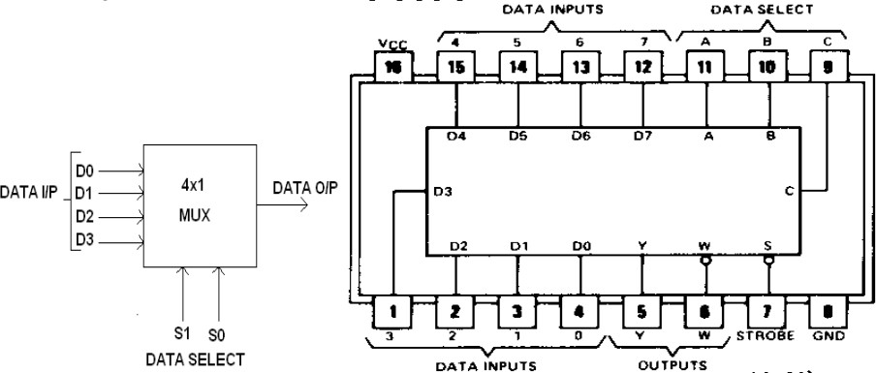

EXPERIMENT-5
AIM:To realize Multiplexer circuits.
OBJECTIVE: To understand &perform the operation of multiplexing.
PREREQUISITES: Basic theory of multiplexers.

RESOURCE/EXPERIMENTALSET-UP/EQUIPMENT/APPARATUS/TOOLS:-
Prototyping board (breadboard),DC PowerSupply,ConnectingWires,74150/74153.

THEORY AND APPLICATION:

A Multiplexer (or a data selector) is logic circuits that accepts several data inputs and allows only one of them at a time to get through to the output. The selection of the desired data input is controlled by the SELECT (or ADDRESS) INPUTS. Multiplexer means transmitting a large number of information units over a smaller number of channels or lines. A digital multiplexer is a combinational circuit that selects binary information from one of many input lines and directs it to a single output line. The selection of a particular input line is controlled by a set of selection lines. Normally there are 2n input line and n selection lines whose bit combination determine which input is selected. Figure below shows the block diagram of a Multiplexer.

In this diagram the inputs and outputs are indicated by means of broad arrows to indicate that there may be one or more lines. Depending upon the digital code applied at the SELECT inputs, one out of the data sources is selected and transmitted to the single output channel. The Multiplexer becomes enabled when the strobe signal is active LOW. The pin out of a 8:1 multiplexer IC 74150 is shown above. The output of this circuit is the inverted input. This is a 16-pin DIP.

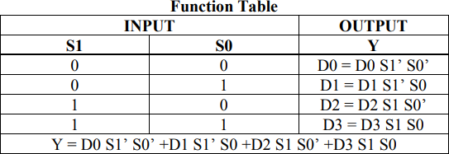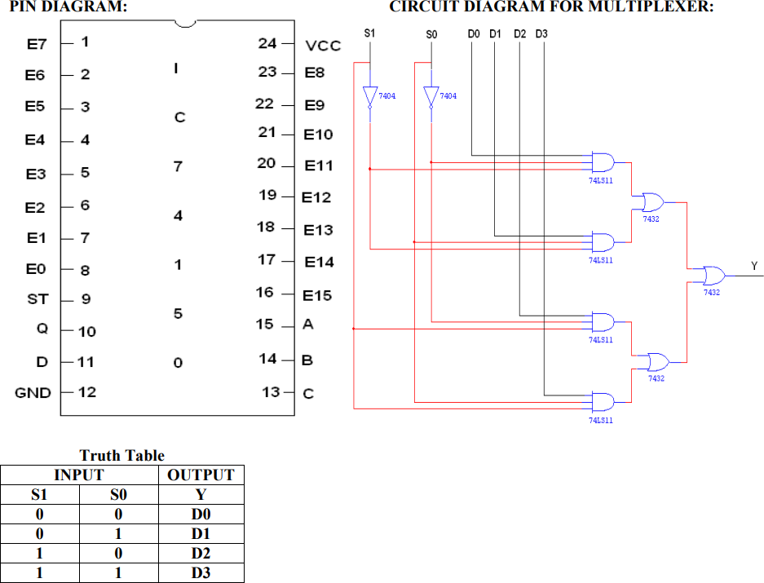

PROCEDURE:- 1)Assemble the circuit on bread board, as per above diagram.
2) Give the logical inputs and check for the proper output, as per the truth table.
CONCLUSION: Hence verified the Multiplexer (8:1) operation using IC-74150.

SAMPLE VIVA-VOCE QUESTIONS:

Q1. Explain the need of multiplexer.
Q2. Which is the major functioning responsibility of the multiplexing combinational circuit? Q3. How many NOT gates are required for the construction of a 4-to-1 multiplexer?
Q4.In1-to-4multiplexer, how many select lines are required? Q5.In1-to-8multiplexer, how many select lines are required?

20

EXPERIMENT-6
AIM: To realize 4-bitbinary-gray&gray-binaryconverters.
OBJECTIVE: To understand encoding and decoding functions.
PREREQUISITES: Basic theory and implementation Encoder and Decoder circuits.

RESOURCE/EXPERIMENTALSET-UP/EQUIPMENT/APPARATUS/TOOLS:-
Prototyping board (breadboard), DC Power Supply, Connecting Wires,7486.

THEORYANDAPPLICATION:

Binary to Gray code converter: The logical circuit which converts the binary code to equivalent gray code is known as binary to gray code converter.
Truth Table:

Binary to Gray Code Converter Circuit:

- Gray to Binary Code Conversion: The logical circuit which converts the gray code to equivalent binary code is known as gray to binary code converter.
Truth Table:

Logical Circuit Diagram for Binary to Gray Code Conversion:

EXPERIMENTAL PROCEDURE:

  - Collect the components necessary to accomplish this experiment.
  - Plug the IC chip in to the bread board.
  - Connect the supply voltage and ground lines to the chips. PIN7 =Ground and PIN14=+5v
  - Make connections as shown in the respective circuit diagram.
  - Connect the inputs of the gate to the inputs witches of the LED.
  - Connect the output of the gate to the output LEDs.
CONCLUSION: Binary to gray and gray to binary code converter has been designed using Ex-OR gate and its truth table verified.

SAMPLE VIVA-VOCE QUESTIONS:

What is a code converter?
Differentiate between translator and code converter.
Explain the primary usage of gray code.

Illustrate the reasons for using gray code.
Q.10 Why do we use gray code?

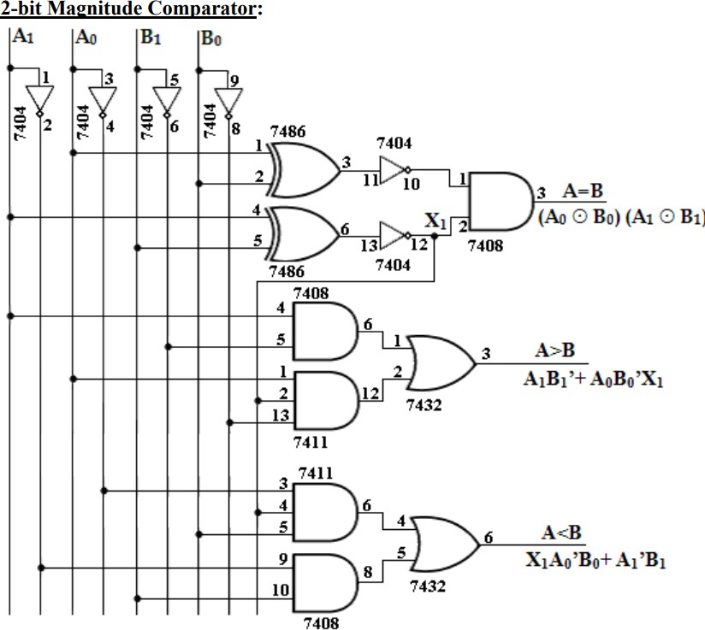

EXPERIMENT-7
AIM:To realize comparator circuit for two binary numbers of 2-bit each.
OBJECTIVE: To understand the comparator circuits.
PREREQUISITES: Basic theory and implementation of comparator circuits.

RESOURCE/EXPERIMENTALSET-UP/EQUIPMENT/APPARATUS/TOOLS:-
Prototyping board (breadboard),DC PowerSupply,ConnectingWires,7486,7404,7432, 7408.

THEORY AND APPLICATION:

A magnitude comparator is a combinational circuit that compares two given numbers (A and B) and determines whether one is equal to, less than or greater than the other. The output is in the form of three binary variables representing the conditions A = B, A>B and A<B, if A and B are the two numbers being compared. The two binary numbers A and B with two digits each, written in descending order as, A = A1A0B=B1B0Eachsubscriptedletterrepresentsoneofthedigitsinthenumber.Itisobserved fromthe bit contents of two numbers that A = B, when A1 = B1 and A0 = B0. When the numbers are binary they possess the value of either 1 or 0, the equality relation of each pair can be expressed logically by the equivalence function as,



To satisfy the equality condition of two numbers A and B, it is necessary that all Xi must be equal to logic1.This indicates the AND operation of all Xi variables. In other words, we can write the Boolean expression for two equal 2-bit numbers. (A = B) = X1 X0. The binary variable (A=B) is equal to 1 only if all pairs of digits of the two numbers are equal. To determine if A is greater than or less than B, we inspect there lative magnitudes of pairs of significant bits starting from them f significant bit. If the two digits of the most significant position are equal, the next significant pair of digits is compared. The comparison process is continued until a pair of unequal digits is found. It may be concluded that A>B, if the corresponding digit of A is 1 and B is0. If the corresponding digit of A is 0 and B is 1, we conclude that A<B.

PROCEDURE:
    - Connections are given as per the logic diagram.
    - Logic inputs are given as per the truth table.
    - Observe the logic output and verify with the truth tables.

RESULT: Thus the2-bit magnitude comparator was designed and implemented using logic gates.

SAMPLEVIVA-VOCE QUESTIONS:
What does a comparator do?
How we can implement 8bit comparator.
Name the ICs used to design a 2bit Comparator.
How comparators are different from multiplexer circuit.
Name the IC used for 8bit comparator.

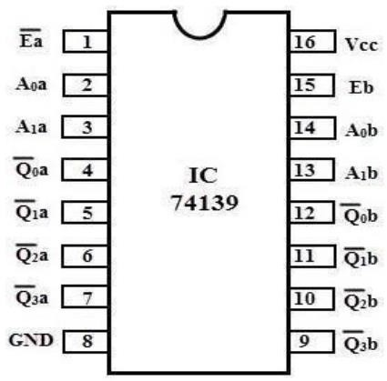

EXPERIMENT-8
AIM: To realize Full adder & full subtractor circuits using encoder/decoder.
OBJECTIVE: To learn how to writer recursive programs for complex iterative problems
PREREQUISITES: Concept and Usage of recursion using stacks.

RESOURCE/EXPERIMENTALSET-UP/EQUIPMENT/APPARATUS/TOOLS:-
Prototyping board (breadboard), DC Power Supply, Connecting Wires,74139.

THEORYANDAPPLICATION:

A decoder is a combinational circuits that connects the binary information from“n ”input lines to a maximum of 2n unique output lines. Decoder is also called a min-term generator/maxterm generator. A min-term generator is constructed using AND and NOT gates. The appropriate output is indicated by logic 1 (positive logic). Max-term generator is constructed using NAND gates. The appropriate output is indicated by logic 0(Negative logic). The IC 74139acceptstwo binary inputs and when enable provides 4 individual active low outputs. The device has 2 enable inputs (Two active low). Pin Diagram:

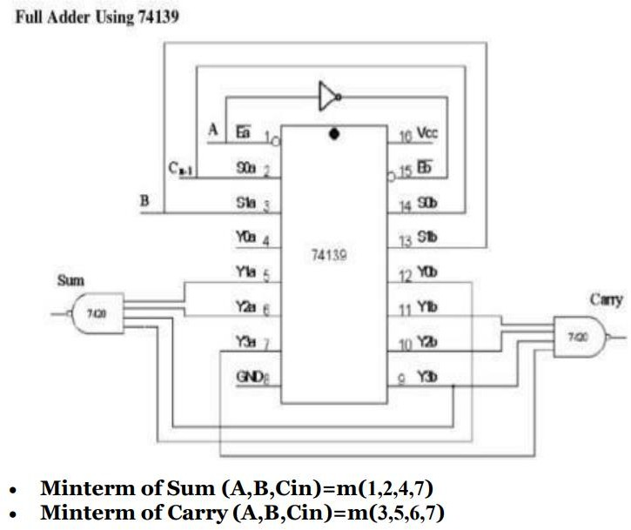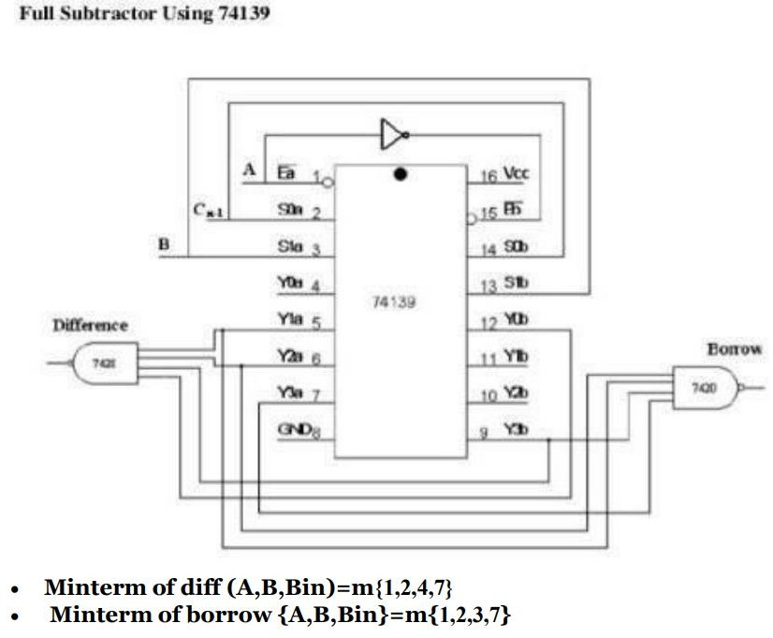

PROCEDURE:
- The IC is fixed on the IC zip socket andVcc&Gndconnectionsaregivenfrom5V Supply.
- Connections are made as shown in the Logic diagram.
- All the inputs are connected to the switches &output to the LEDs.
- Truth table is verified for different combinations of input.

RESULT: Thus Adder and Subtractor was designed and implemented using encoder/decoder.

SAMPLEVIVA-VOCE QUESTIONS:
What does anencoderdo?
How we can implement adder using encoder/decoder?
Name the ICs used for a decoder.
How encoders are different from multiplexer circuit.
Name the IC used for encoder.

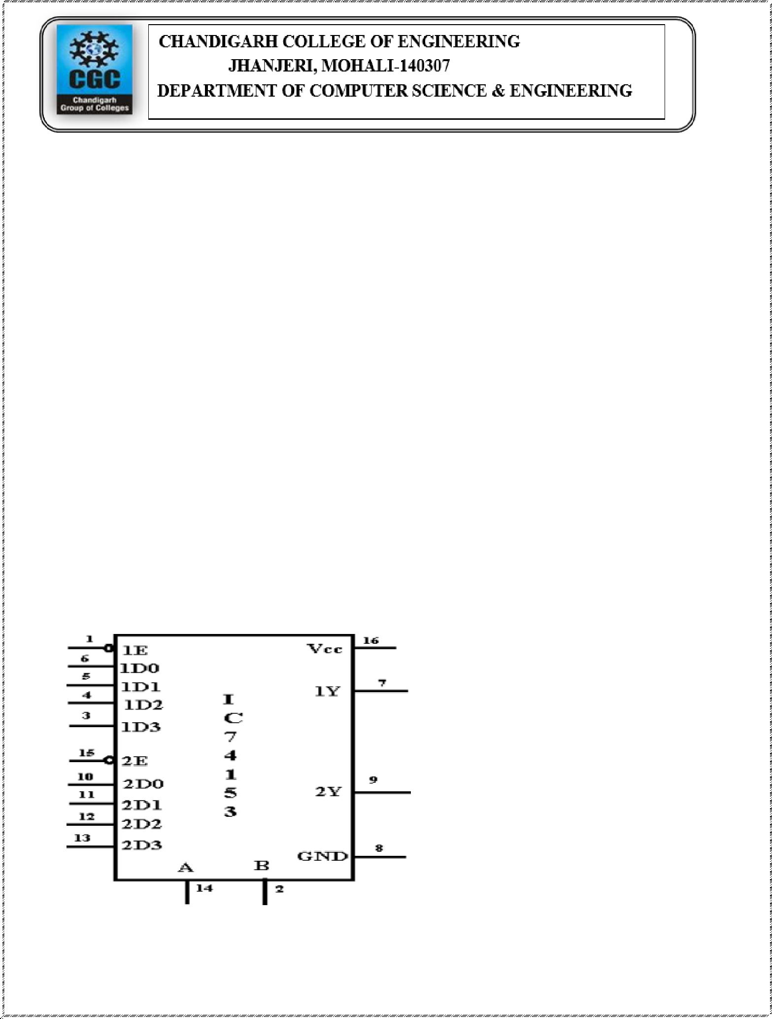

EXPERIMENT-9
AIM:To design Full adder&full subtractor circuits using multiplexer.
OBJECTIVE:To learn and implement adders and subtractors using multiplexers.
PREREQUISITES: Multiplexers

RESOURCE/EXPERIMENTALSET-UP/EQUIPMENT/APPARATUS/TOOLS:-
Prototyping board(breadboard),DCPowerSupply,ConnectingWires,74153.

THEORYANDAPPLICATION:

The multiplexer (or data selector)is a logic circuit that gets one out of several inputs to single output. The input selected is controlled by a set of select inputs. For selecting one out of n-inputs, a set of m- select inputs is required, where 2 m =n.
DE- MULTIPLEXER: The Demultiplexer performs the reverse operation of a multiplexer. It accepts single input & distributes it over several outputs. The selected I/P code determines to which output, the data input will be transmitted.

a)Adder &SubtractorusingIC74153.

Pin Diagram

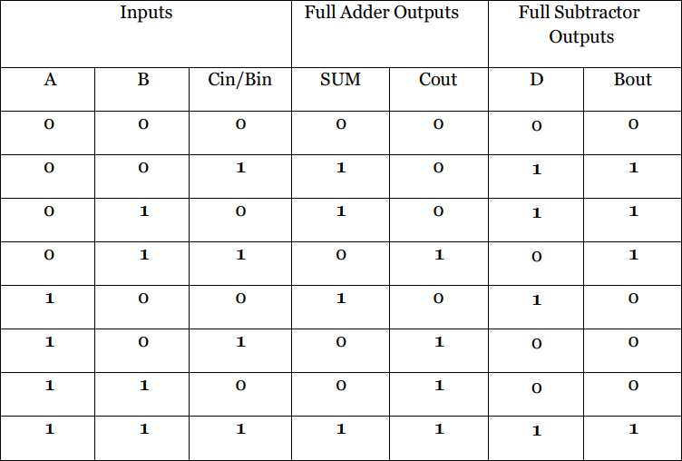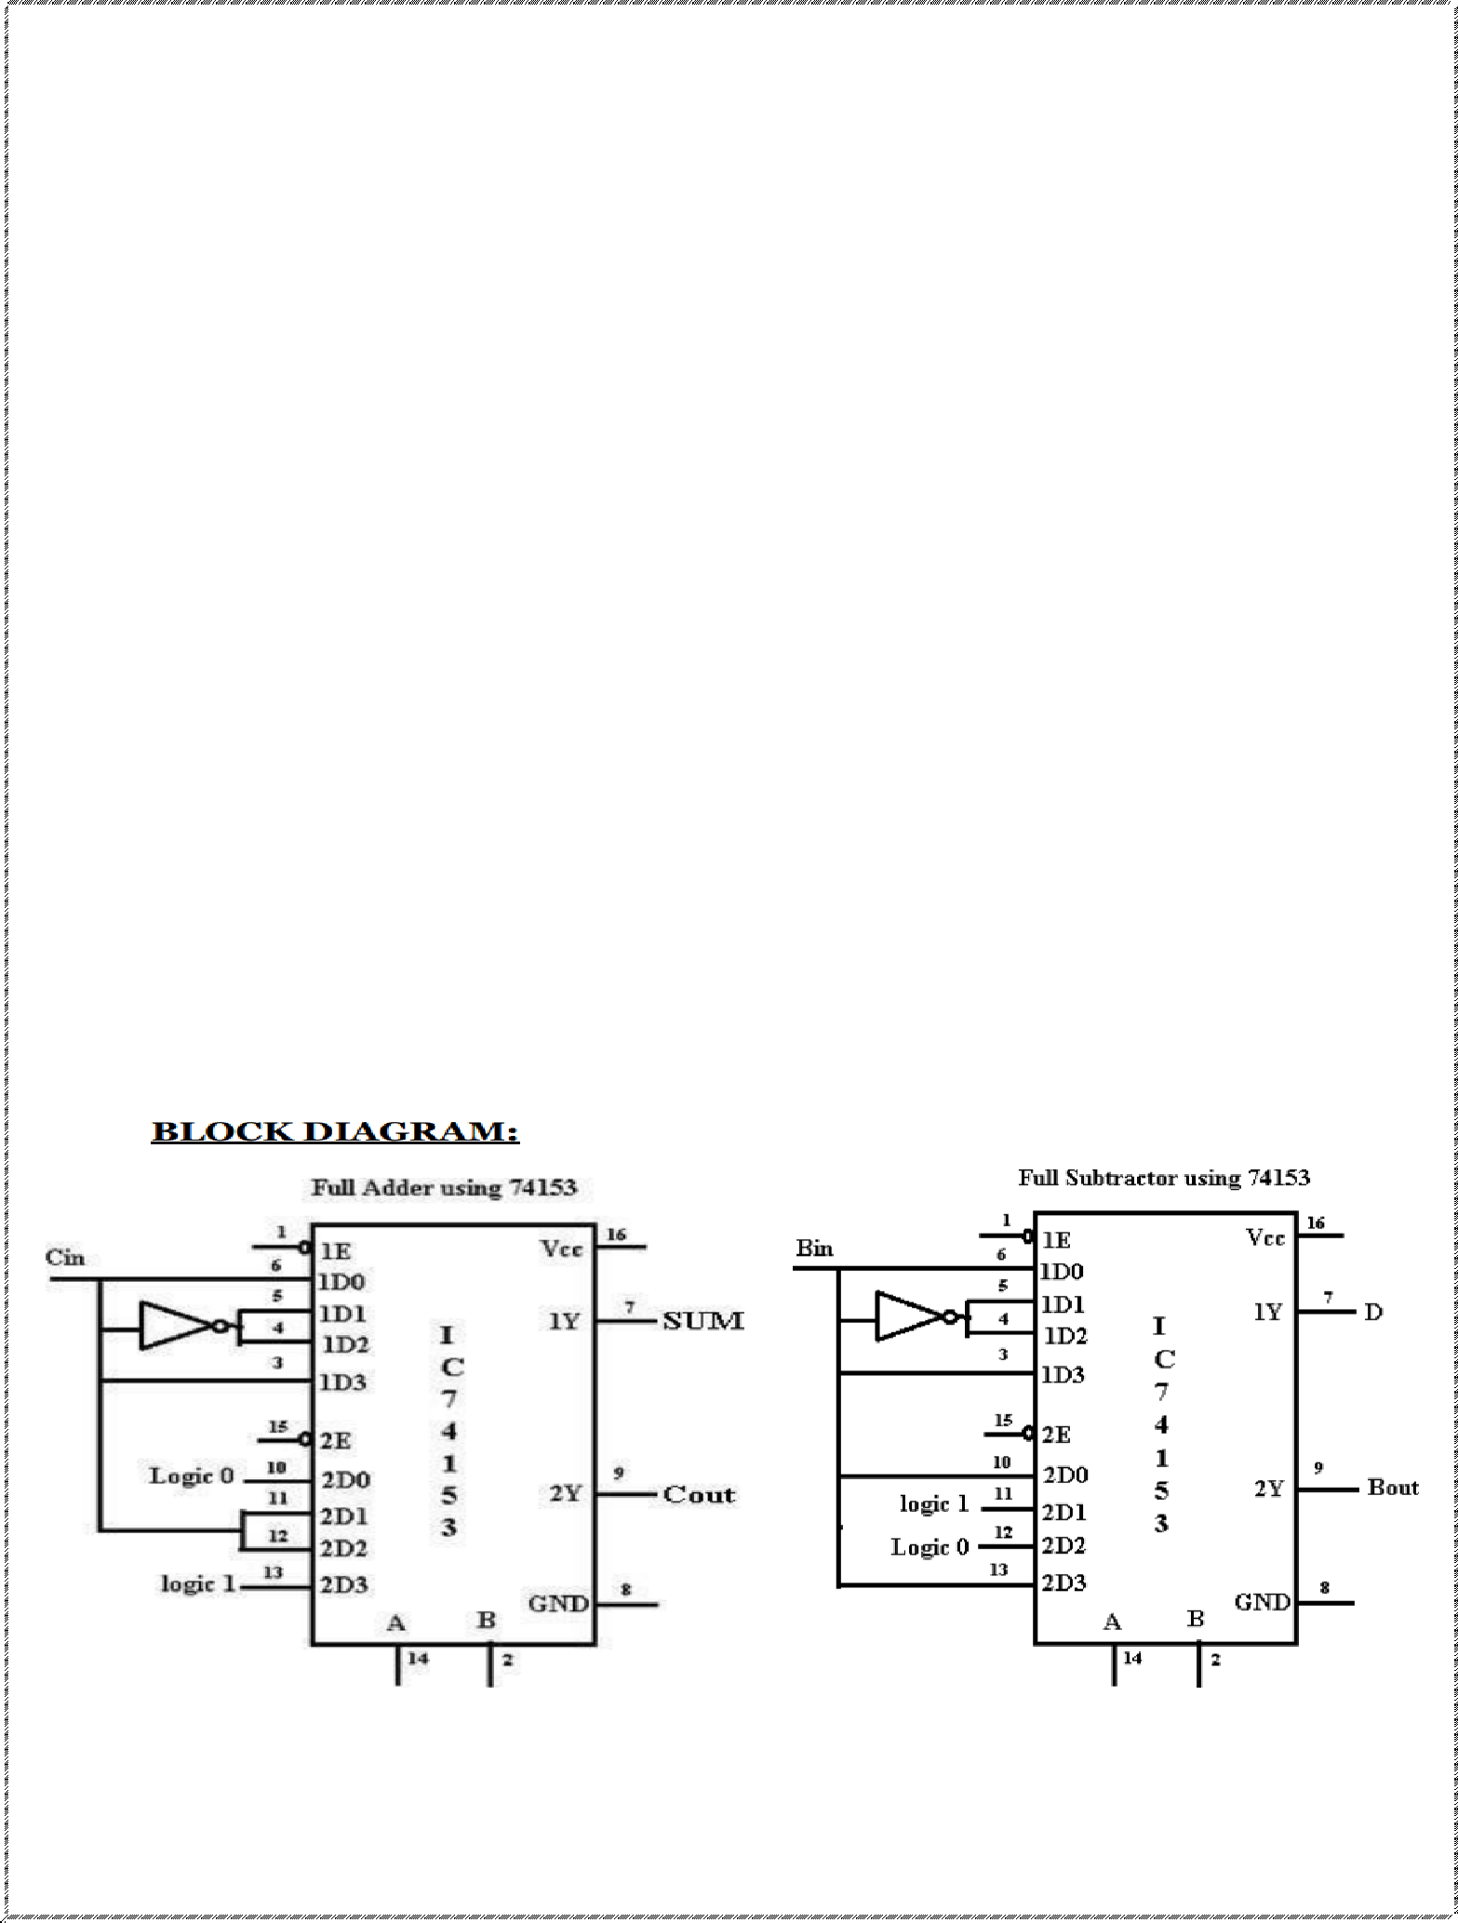

TruthTableofFull adderandFull subtractor:

PROCEDURE:

- The IC is fixed on the IC zip socket and Vcc & Gnd connections are given from 5V Supply.
- Connections are made as shown in the Logic diagram.
- All the inputs are connected to the switches & output to the LEDs.
- Truth table is verified for different combinations of input.

RESULT: Thus, Adder and Subtractor was designed and implemented using multiplexer.

SAMPLEVIVA-VOCE QUESTIONS:
What does a multiplexer do?
How we can implement anted using multiplexer?
Name the ICs used for a multiplexer.
How encoders are different from multiplexer circuit.
Name the IC used for 8:1 multiplexer.

EXPERIMENT-10
AIM: To design and verify the Truth tables of all flip-flops.

OBJECTIVE: To understand various flip flops.
PREREQUISITES: Basics of Flip-flops.

RESOURCE/EXPERIMENTALSET-UP/EQUIPMENT/APPARATUS/TOOLS:-
Prototyping board (breadboard), DC Power Supply, Connecting Wires,7400, 7402,7404, 7408,
7432, 7486.

THEORY AND APPLICATION:

Flip-flops are synchronous bi-stable devices. The term synchronous means the output changes state only when the clock input is triggered. That is, changes in the output occur in synchronization with the clock. A flip-flop circuit has two outputs, one for the normal value and one for the complement value of the stored bit. Since memory elements in sequential circuits are usually flip-flops, it is worth summarizing the behavior of various flip-flop types before proceeding further. All flip-flops can be divided into four basic types: SR, JK, D, and T. They differ in the number of inputs and in the response invoked by different values of input signals. The four types of flip-flops are defined in the Table below.
State Table:-The satiable representation of a sequential circuit consists of three sectionslabeledpresent state next state and output. The present state designates the state of flip-flops before the occurrence of a clock pulse. The next state shows the states of flip-flops after the clock pulse, and the output section lists the value of the output variables during the present state.
Flip-Flop:-The basic one-bit digital memory circuit is known as a flip-flop. It can store either 0 or 1. Flip- flops are classified according to the number of inputs.

- R-SFlip-Flop:-The circuit is similar to SR latch except the enable signal is replaced by a clock pulse.

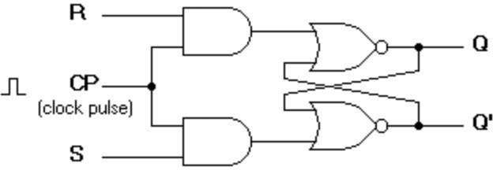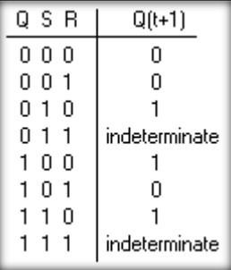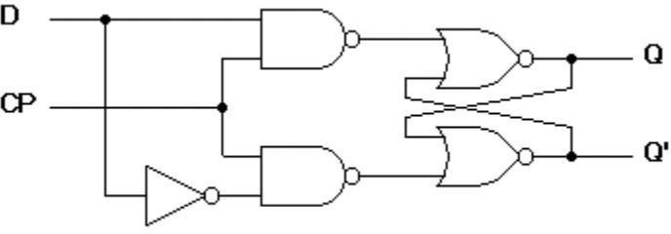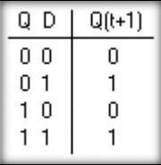

- D Flip-Flop:-The modified clocked SR flip-flop is known as D-flip-flop. From the truth table of SR flip-flop, we see that the output of the SR flip-flop is in an unpredictable state when the inputs are same and high. In many practical applications, these input conditions are not required. These input conditions can be avoided by making them complement of each other.

- 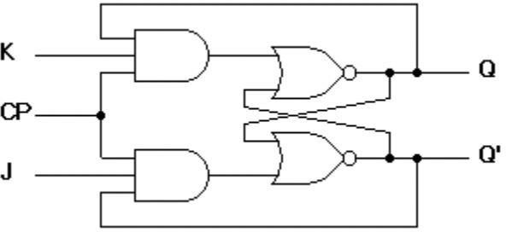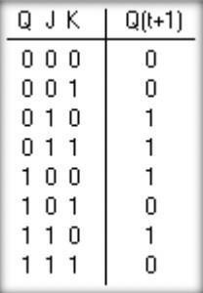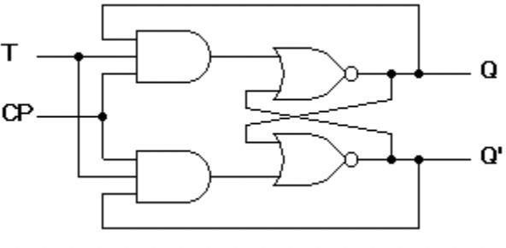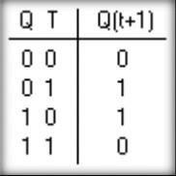J-K Flip-Flop:-In a RS flip-flop the input R=S=1 leads to an indeterminate output. The RS flip-flop circuit may be re-joined if both inputs are 1 then also the outputs are the complement of each other.

- T Flip-Flop:-T flip-flop is known as toggle flip-flop. The T flip-flop is modification of the J-K flip-flop.BoththeJKinputsoftheJKflip-flopareheldatlogic1andtheclocksignalcontinuoustochange.

EXPERIMENTALPROCEDURE:

  - Collect the components necessary to accomplish this experiment.

  - Plug the IC chip into the breadboard.

  - Connect the supply voltage and ground lines to the chips. PIN7=Ground and PIN14 =+5V.

  - Make connections as shown in the respective circuit diagram.

  - Connect the inputs of the gate to the input switches of the LED.

  - Connect the output of the gate to the output LEDs.

  - Once all connections have been done, turn on the power switch of the breadboard

  - Operate the switches and fill in the truth table (Write"1"ifLEDis ON and "0"ifL1is OFF. Apply the various combinations of inputs according to the truth table and observe the condition of Output LEDs.

RESULT: Thus verified excitation table of various flip flops.

SAMPLEVIVA-VOCE QUESTIONS:
Q1.How is a JK Flip Flop made to toggle?
Q2.How many stable states does a Flip Flop has?
Q3.What is the significance of the JandK terminals on the JK flip-flop? Q4. The truth table for an S-R flip-flop has how many VALID entries?
Q5.What is difference between Latch and Flip Flop?

EXPERIMENT-11
AIM: To design Mod-6/Mod-9 synchronous up-down counter.

OBJECTIVE: To understand the detailed process of designing synchronous counters.
PREREQUISITES: Counters design and implementation.

RESOURCE/EXPERIMENTALSET-UP/EQUIPMENT/APPARATUS/TOOLS:-
Prototyping board (breadboard), DC Power Supply, Connecting Wires.

THEORY AND APPLICATION:

What is a Mod-N Counter?
A Mod-N counter counts from 0 up to N-1 and then rolls over to 0.
  - Mod-6 → Counts: 0, 1, 2, 3, 4, 5 → Back to 0
  - Mod-9 → Counts: 0, 1, 2, ..., 8 → Back to 0

What is a Synchronous Up-Down Counter?
All flip-flops are triggered by the same clock.
It can count up or count down, based on a control signal (Up/Down).

Requirements
Component | Details
Flip-flops | Typically JK or T flip-flops
Control inputs | UP/DOWN, MOD_SELECT (for switching between Mod-6 and Mod-9)
Logic gates | AND, OR, NOT gates to control the states
Reset logic | To reset counter when it reaches terminal count for chosen MOD
Clock | Synchronous clock signal.



Design Approach

A. Number of Flip-Flops
For Mod-9, you need to count up to 8 → requires 4 flip-flops (since 2⁴ = 16)
For Mod-6, max count is 5 → still need 3 flip-flops, but to combine both Mod-6 and Mod-9, use 4 flip-flops.

B. State Table
Define states from 0000 to:
(101)(Decimal 5) for Mod-6
1000 (decimal 8) for Mod-9

C. Counter Control Logic
Use MOD_SELECT to determine whether to reset at count 6 (Mod-6) or 9 (Mod-9)
Use UP/DOWN input to determine whether to increment or decrement count.

4. Procedure to Design

Step 1: Choose Flip-Flop Type
Use JK Flip-Flops (toggle mode) or T Flip-Flops (simpler)

Step 2: Draw State Diagram
For both Mod-6 and Mod-9 in up and down direction.

Step 3: Create Excitation Table
Determine the required inputs for JK flip-flops for transitions.

Step 4: K-Map for Flip-Flop Inputs
Minimize expressions using Karnaugh Maps for each flip-flop input based on the present and next state.

Step 5: Add Reset Logic
- For Mod-6, reset when counter reaches 110 (6) while counting up
- For Mod-9, reset when counter reaches 1001 (9) while counting up
Use combinational logic (e.g., AND gates) to generate reset signals based on MOD_SELECT

Step 6: Add Direction Logic (UP/DOWN)
- Use multiplexers or logic gates to change the next state logic based on UP/DOWN input.

Step 7: Assemble the Circuit
- Connect flip-flops, combinational logic, and control inputs.
Diagram:

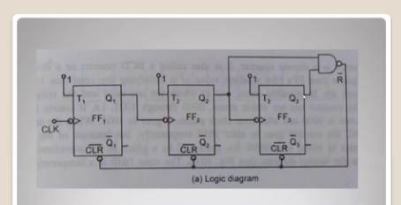

Mod 6 synchronous counter using T flip flop.

K-Map implementation using T flip flop for mod 6 synchronous counters:

State Table
Present State (Q2 Q1 Q0) | Next State (Q2' Q1' Q0')
000 | 001
001 | 010
010 | 011
011 | 100
100 | 101
101 | 000
110 | 000 (reset state)
111 | 000 (reset state)

2. Excitation Table for T Flip-Flops
T Flip-Flop:
- T = 1 if present and next state differ
- T = 0 if present and next state are the same
Q2 Q1 Q0 | Q2' Q1' Q0' | T2 | T1 | T0
0 0 0 | 0 0 1 | 0 | 0 | 1
0 0 1 | 0 1 0 | 0 | 1 | 1
0 1 0 | 0 1 1 | 0 | 0 | 1
0 1 1 | 1 0 0 | 1 | 1 | 1
1 0 0 | 1 0 1 | 0 | 0 | 1
1 0 1 | 0 0 0 | 1 | 0 | 1
1 1 0 | 0 0 0 | 1 | 1 | 0
1 1 1 | 0 0 0 | 1 | 1 | 1

K-Map for T Flip-Flop Inputs

We need three K-maps: for T0, T1, and T2.

T0 K-map
Q2\Q1\Q0 | 00 | 01 | 11 | 10
0 | 1 | 1 | 1 | 1
1 | 1 | 1 | 1 | 0
Simplified T0 = 1 (always toggles)
T1 K-map
Q2\Q1\Q0 | 00 | 01 | 11 | 10
0 | 0 | 1 | 0 | 0
1 | 0 | 0 | X | X
Simplified T1 = Q0

T2 K-map
Q2\Q1Q0 | 00 | 01 | 11 | 10
0 | 0 | 0 | 1 | 0
1 | 0 | 1 | X | X
Simplified T2 = Q1·Q0 + Q2·Q0

4. Final T Flip-Flop Input Equations
- T0 = 1
- T1 = Q0
- T2 = Q1·Q0 + Q2·Q0

5. Reset Logic for MOD-6
Since it's a MOD-6 counter, we need to reset the counter when the state reaches 110 (Q2Q1Q0 = 110) or 111.
Reset = Q2 · Q1
Use this to asynchronously clear all flip-flops to 000 when an invalid state is reached.

Conclusion
This counter combines modular arithmetic and direction control. The key design challenges are:
- Ensuring correct wrap-around logic for each mod value
- Clean synchronous design
- Debounced and properly timed clock and control inputs

