Bus Pass Management System
By:
Parth Patni
(B.C.A. SEMESTER V)
Exam No:-58
Submitted as
Partial fulfilment of
BCA degree
2026 – 2027
Submitted to
Mr Maulin Punjabi

S. G. M. English Medium College of Commerce and Management (SEMCOM)
The Charutar Vidya Mandal University (CVMU)

The Charutar Vidya Mandal University
S.G.M. English Medium College of Commerce and Management
Vallabh Vidyanagar
CERTIFICATE
Date: 25/03/2026
This is to certify that Parth Patni of BCA – SEM - V (seat no: - ) and Enrolment No: - 12401020801058 has worked on project entitled Bus Pass Management System from 01/09/2026 to 25/09/2026. This project (101020505) is an in-house project course of 2 credits.
He was regular in his work and developed projects including analysis and design. He has completed the project satisfactorily.
Principal Project Guide
Dr. Preethi Luhana Maulin Punjabi

Acknowledgement
I would like to express my sincere gratitude to all those who helped me in the successful completion of this project on “BUS PASS MANAGEMENT SYSTEM”.
First and foremost, I would like to thank my project guide Maulin Punjabi sir for their valuable guidance, continuous support, and encouragement throughout the development of this project. Their suggestions and insights have been extremely helpful in completing this work effectively.
I am also thankful to the faculty members of my department for providing the necessary knowledge and resources required for this project.
I would like to extend my heartfelt thanks to my friends and classmates for their support, cooperation, and valuable suggestions during the project work.
Finally, I express my deepest gratitude to my parents and family for their constant encouragement and moral support, which helped me complete this project successfully.
Thank You
Parth Patni

Index
Sr. No | Description of Topic | Page No
1 | Title Page of Project
2 | College Certificate
3 | Acknowledgement
4 | Index
5 | Introduction To The Project | 1
6 | An Existing System | 2
7 | Need of proposed System | 3
8 | System Features | 4
9 | Hardware and Software | 5
10 | Data Flow Diagram / OOAD / UML | 6
11 | Database Layout / File Layout | 9
12 | Design Of Input Screens | 12
13 | Design Of Output Screens & Reports | 17
14 | Limitations | 19
15 | Conclusion | 20
16 | Bibliography | 21

Introduction To The Project
✓ Introduction:
The Bus Pass Management System (BPMS) is a comprehensive desktop database application developed to automate, digitize, and modernize the entire lifecycle of passenger bus passes. Built using Visual Basic .NET (VB.NET), Windows Forms, and Microsoft SQL Server, the application offers a unified, centralized platform for transit administrators and ticket office staff to catalog transit routes, register commuters, calculate concession fares, issue serialized bus pass cards, and track validity in real time.
✓ Introduction about Bus Pass Management System:
The Bus Pass Management System is engineered specifically for city transport authorities, university bus services, and private transit corporations seeking to eliminate manual paperwork and handwritten ledger registers. In conventional transit depot offices, the pass issuance process involves laborious manual verification of physical documents, manually computing concession percentages for students and senior citizens, hand-writing cards, and maintaining bulky paper archives.
This software elevates the operational efficiency of transit agencies by providing an interactive management dashboard, automated monthly and multi-month fare calculations, concession logic (Student, Senior Citizen, General, Employee), rapid record lookup, instant pass renewal with automatic validity recalculation, and print-ready digital identity pass cards. By maintaining a robust relational database with complete data integrity, the system ensures transparency, prevents pass tampering, and significantly reduces commuter wait times at ticketing counters.

An Existing System
Existing bus pass issuance and management operations across most municipal and regional transport corporations are primarily manual or semi-automated. Under this traditional workflow, commuters are required to physically visit depot counters, fill out physical paper applications, attach passport-sized photographs, and submit photocopies of age and institutional identity proofs. Clerical staff must manually examine each application, verify route fare matrices from printed charts, calculate concession discounts using hand calculators, and write pass details into large manual ledger books.
This reliance on paper-based processes creates numerous bottlenecks and operational vulnerabilities. Commuters face agonizingly long queues during the start of academic terms and monthly renewal cycles. Handwritten paper and laminated cards are prone to severe wear and tear, water damage, forgery, and alteration of expiry dates. For the administration, tracking expired passes is virtually impossible without tedious manual cross-referencing, causing substantial revenue loss. Moreover, generating statistical reports on route patronage, revenue collection, and demographic pass distributions requires days of manual compilation.

Need of Proposed System
✓ Centralized Transit & Route Control:
The proposed system establishes a unified Microsoft SQL Server database that stores the complete transit network, including route identifiers, origin stops, destination stops, and monthly fares. Any updates made by administrators to route schedules or fare structures are instantly reflected across the entire system, guaranteeing synchronized data integrity.
✓ Automated Fare Calculation & Concession Handling:
The system automatically calculates the gross fare and applicable concessions based on the commuter's selected category. Predefined rules (such as 30% discount for Students and 50% discount for Senior Citizens) are applied instantly, eliminating human calculation error and safeguarding transit revenues.
✓ Instant Digital Pass Issuance & Renewal:
Pass creation takes under a minute, capturing passenger profile details, verified ID numbers, route stops, and validity duration. Pass renewal is handled with a single click—automatically calculating extension fees, updating expiration dates, and appending records to the renewal audit trail.
✓ Secure Administrator Authentication:
A secure authentication module restricts administrative privileges to authorized depot personnel only. Passwords are securely checked against the database, and administrators can modify credentials through an integrated change password interface.
✓ Real-Time Dashboard & Lifecycle Monitoring:
The interactive dashboard provides instant real-time visualization of total passes issued, currently active passes, expired passes requiring renewal, and active transit corridors. Any pass whose validity has lapsed is automatically identified and highlighted by the database upon application launch.

System Features
✓ Core Module Features:
User Authentication: Secure administrator login verified against the SQL Server database with session management, role security, and credential update capabilities.
Interactive Dashboard: Live KPI indicator cards tracking total passes issued, active passes, expired passes, and total operational transit routes, accompanied by an audit table of recent pass issuances.
Route Management: Complete CRUD interface enabling administrators to create, update, deactivate, and view transit routes, defining origin terminals, destination terminals, and base monthly fares.
New Pass Registration: Intuitive passenger registration capturing full name, gender, age, contact details, ID proof type (Aadhaar, College ID, Voter ID, Passport), route selection, validity period (1, 3, 6, 12 months), and auto-calculated concession discounts.
Pass Search & Filtering: High-performance multi-criteria search engine allowing instant lookups by Pass Number, Passenger Name, Mobile Number, Category, or Route Stops, filterable by Active, Expired, or Cancelled status.
Pass Renewal & Audit Log: Streamlined renewal subsystem enabling extension of expiring passes with automatic fee computation and permanent archiving into the PassRenewals history database.
Printable Bus Pass Generation: Built-in card generator producing professional digital transit ID cards formatted with commuter demographics, route bounds, validity dates, concession badge, barcode representation, and official authorization seals.

Hardware And Software
✓ Hardware Requirements:
Operating System: Windows 7 / 8 / 10 / 11 (32-bit or 64-bit)
Processor: Intel Core i3 Processor or higher (equivalent AMD CPU)
System Memory (RAM): 4 GB RAM or higher
Hard Disk / Storage: 128 GB SSD / HDD or higher
Display Resolution: 1366 x 768 pixels or higher for optimal WinForms UI layout
Peripherals: Standard Keyboard, Mouse, and Desktop Thermal / Card Printer
✓ Software Requirements:
Programming Language: Visual Basic .NET (VB.NET), .NET Framework 4.0 Client Profile
Integrated Development Environment (IDE): Microsoft Visual Studio 2010 Professional
User Interface Framework: Windows Forms (WinForms) with custom responsive panel styling
Database Management System: Microsoft SQL Server Express (SQL Server 2008 R2 / .\SQLEXPRESS)
Database Connectivity Architecture: ADO.NET (System.Data.SqlClient) with Service-Based MDF file

Data Flow Diagram
✓ Process Hierarchy:
The process hierarchy diagram below outlines the top-down decomposition of the Bus Pass Management System into its core operational subsystems and underlying feature functions.
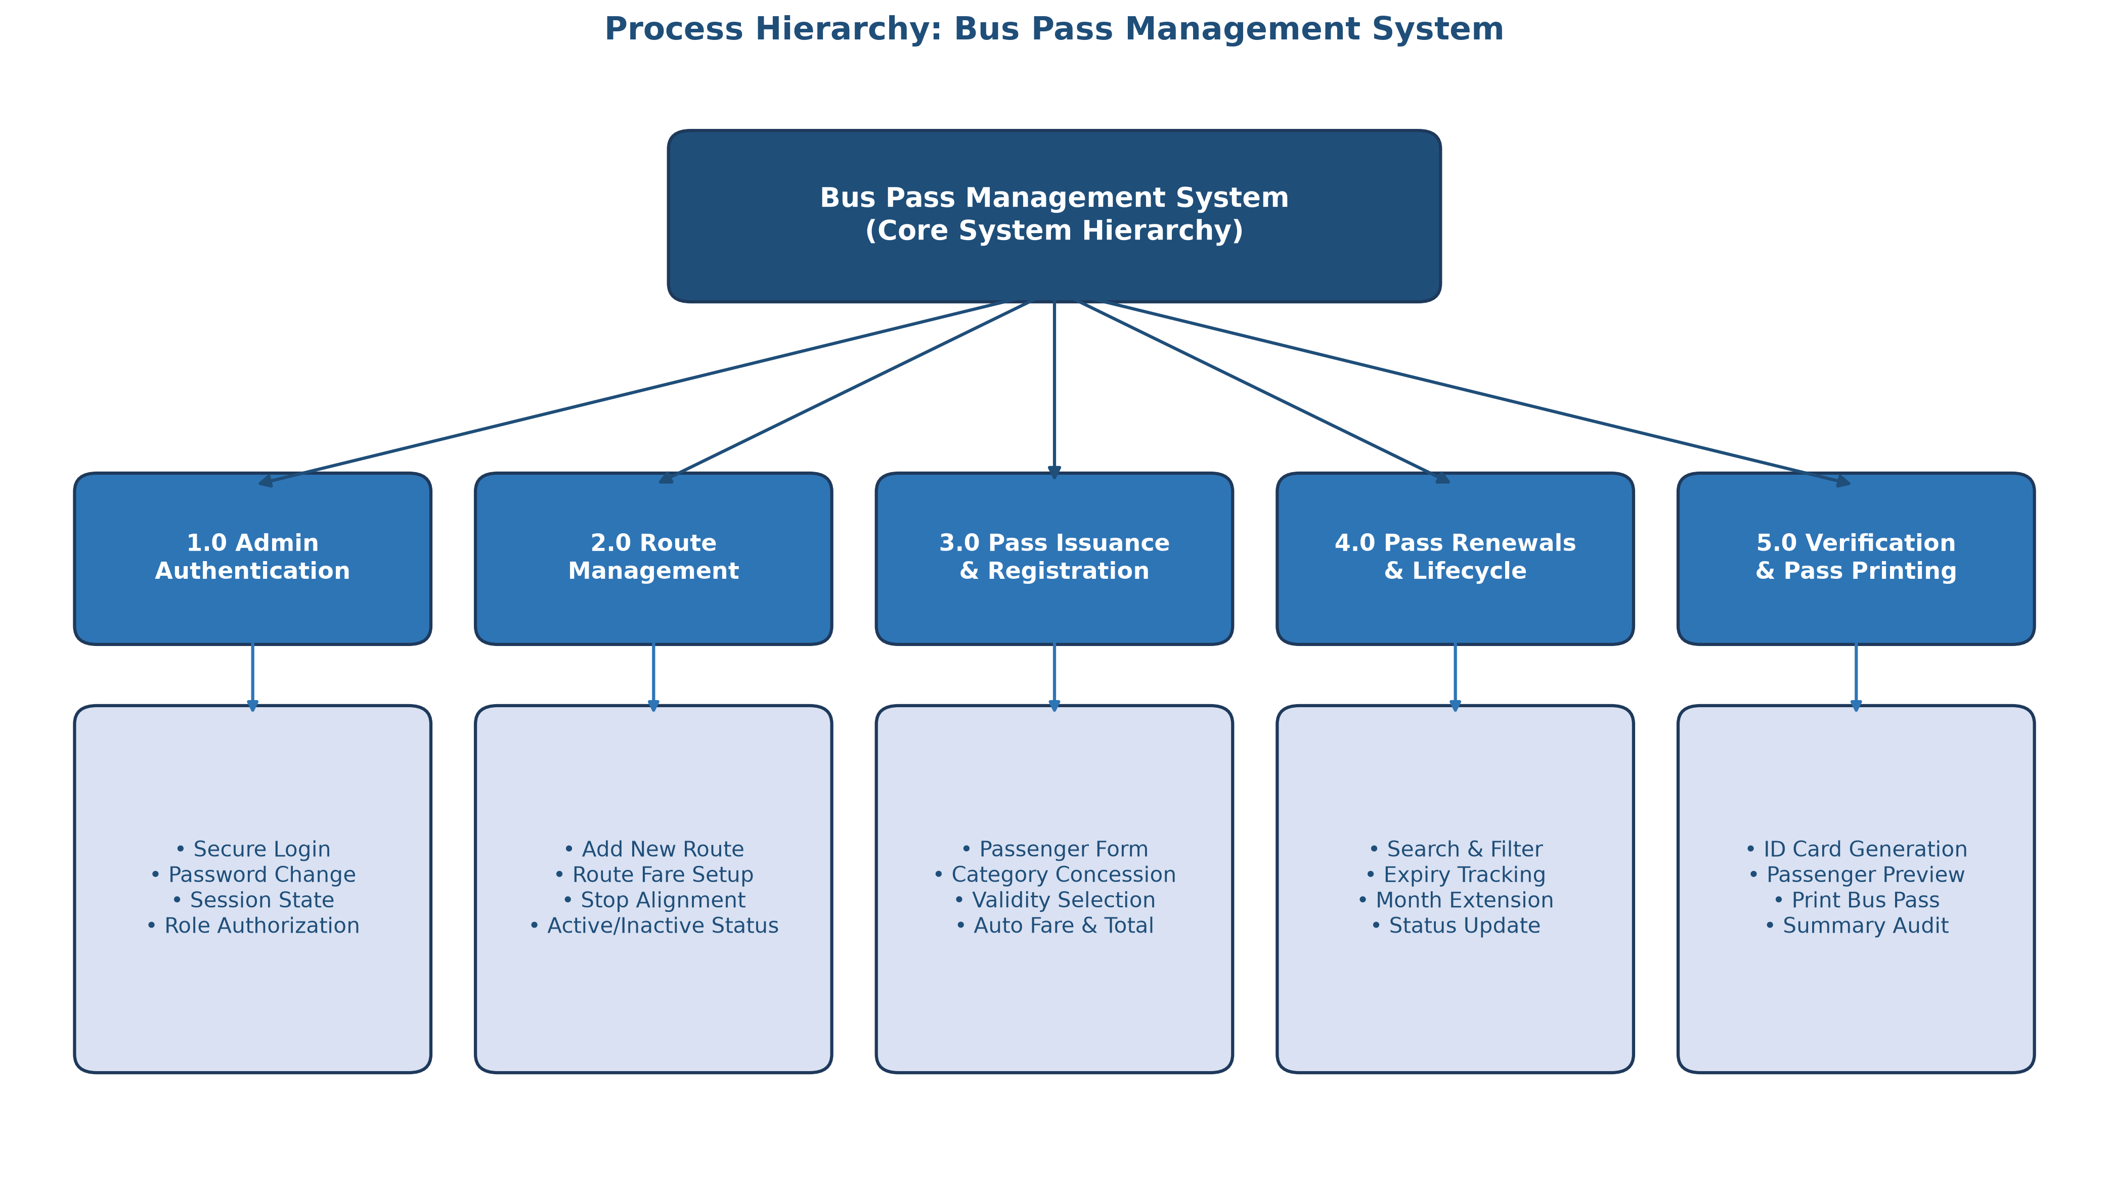

✓ CONTEXT LEVEL DFD (Level 0):
The context level data flow diagram (Level 0 DFD) models the overall interaction between the external entities (Passenger / Commuter and System Administrator) and the central Bus Pass Management System boundary.
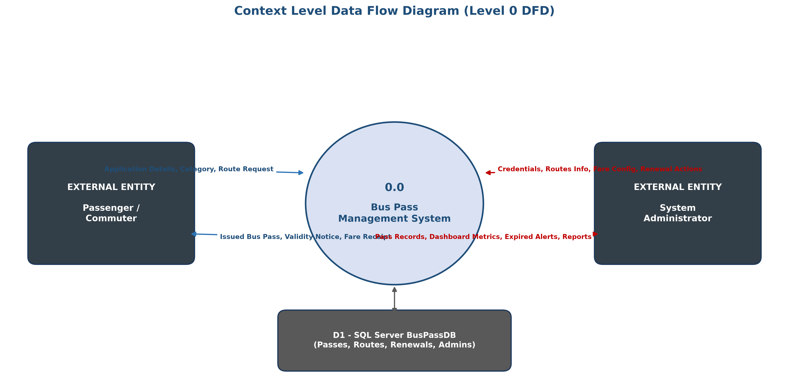

✓ Level 1 Data Flow Diagram:
The Level 1 DFD illustrates the internal breakdown of the system into distinct sub-processes (1.0 Login, 2.0 Route Management, 3.0 Pass Issuance, 4.0 Renewals, 5.0 Verification & Card Printing) and their data exchanges with database stores (D1: AdminLogin, D2: Routes, D3: Passes, D4: PassRenewals).
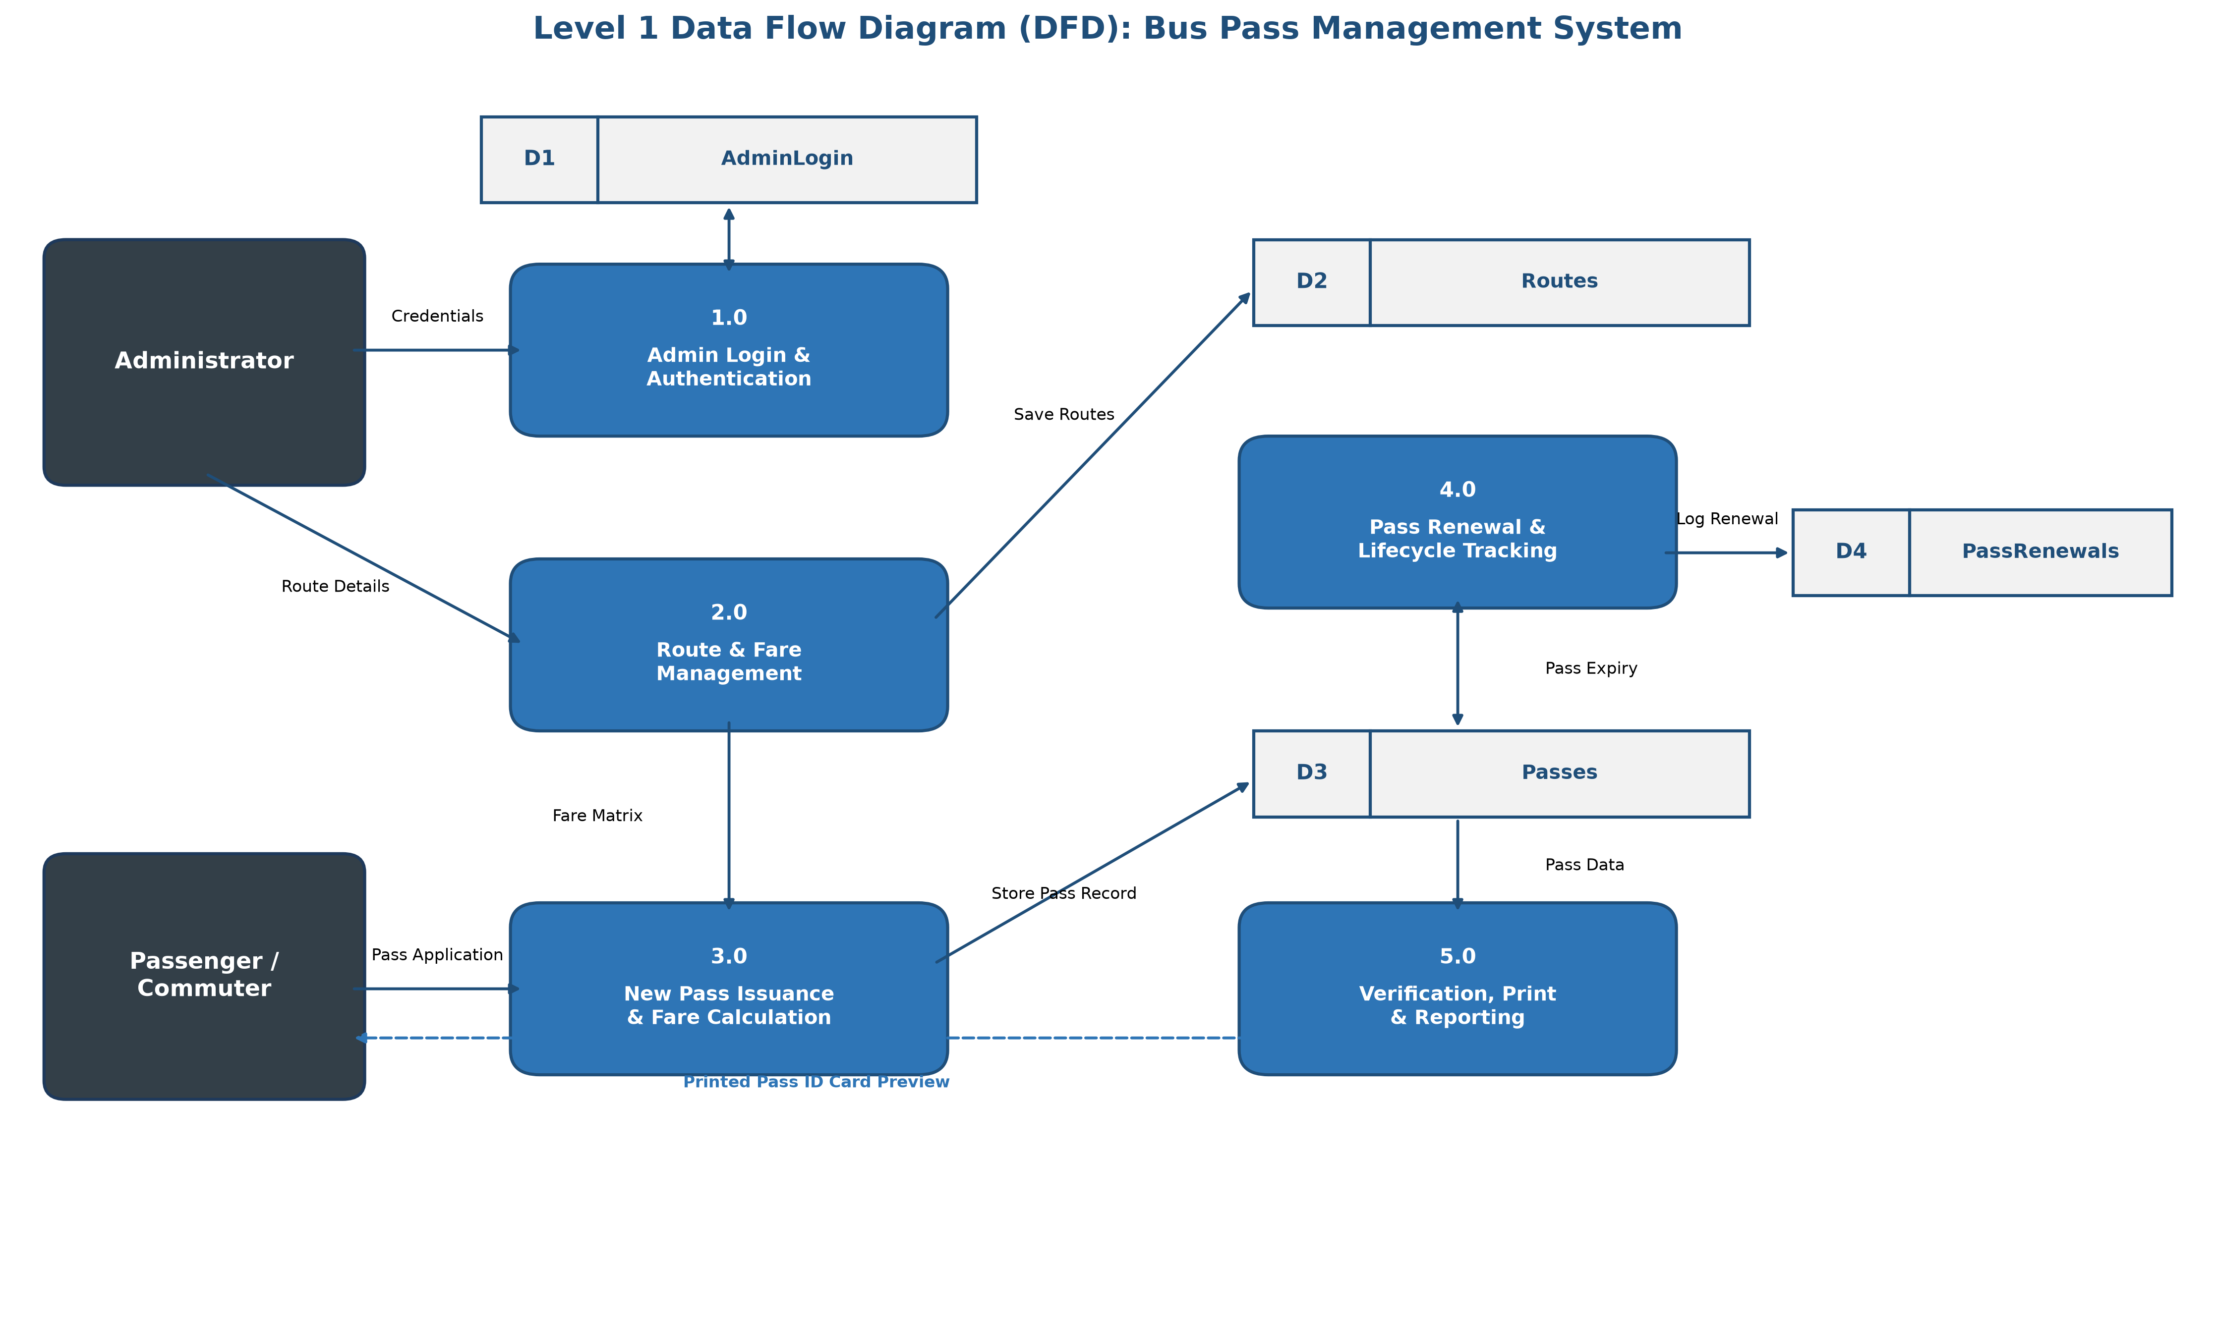

Database Layout
❖ AdminLogin
Sr. no. | Column name | Type and size | Constraints | Description
1. | AdminId | INT | Primary Key, IDENTITY | Unique identifier for administrator
2. | Username | NVARCHAR(50) | NOT NULL, UNIQUE | Administrator login account name
3. | Password | NVARCHAR(50) | NOT NULL | Password for login authentication
4. | FullName | NVARCHAR(100) | NOT NULL | Full display name of administrator
5. | CreatedDate | DATETIME | DEFAULT GETDATE() | Account creation timestamp
❖ Routes
Sr. no. | Column name | Type and size | Constraints | Description
1. | RouteId | INT | Primary Key, IDENTITY | Unique transit route identifier
2. | RouteNumber | NVARCHAR(20) | NOT NULL, UNIQUE | Route code (e.g. R-101, R-102)
3. | RouteName | NVARCHAR(100) | NOT NULL | Descriptive name of transit route
4. | SourceStop | NVARCHAR(100) | NOT NULL | Originating bus terminal / stop
5. | DestinationStop | NVARCHAR(100) | NOT NULL | Terminating bus terminal / stop
6. | MonthlyFare | DECIMAL(10,2) | NOT NULL | Base monthly commute fare
7. | Status | NVARCHAR(20) | DEFAULT 'Active' | Route status (Active / Inactive)

❖ Passes
Sr. no. | Column name | Type and size | Constraints | Description
1. | PassId | INT | Primary Key, IDENTITY(1001,1) | Unique internal pass tracking ID
2. | PassNumber | NVARCHAR(30) | NOT NULL, UNIQUE | Official serial number (e.g. BP-1001)
3. | FullName | NVARCHAR(100) | NOT NULL | Passenger full legal name
4. | Gender | NVARCHAR(10) | NOT NULL | Passenger gender (Male/Female/Other)
5. | Age | INT | NOT NULL | Passenger age in completed years
6. | ContactNumber | NVARCHAR(20) | NOT NULL | Primary mobile / contact number
7. | Email | NVARCHAR(100) | NULL | Passenger email address
8. | Address | NVARCHAR(250) | NULL | Residential home address
9. | PassCategory | NVARCHAR(50) | NOT NULL | Concession category (Student, General, etc.)
10. | IdProofType | NVARCHAR(50) | NOT NULL | Government/College proof submitted
11. | IdProofNumber | NVARCHAR(50) | NOT NULL | Unique ID card / proof reference number
12. | RouteId | INT | FK (Routes.RouteId) | Associated bus transit route ID
13. | SourceStop | NVARCHAR(100) | NOT NULL | Boarding station for passenger
14. | DestinationStop | NVARCHAR(100) | NOT NULL | Destination station for passenger
15. | ValidityPeriod | NVARCHAR(30) | NOT NULL | Duration (1, 3, 6 Months, 1 Year)
16. | StartDate | DATE | NOT NULL | Pass commencement date
17. | ExpiryDate | DATE | NOT NULL | Pass validity expiration date
18. | FareAmount | DECIMAL(10,2) | NOT NULL | Gross base fare before discount
19. | Discount | DECIMAL(10,2) | DEFAULT 0.00 | Concession discount amount deducted
20. | TotalAmount | DECIMAL(10,2) | NOT NULL | Final net amount paid by commuter
21. | Status | NVARCHAR(20) | DEFAULT 'Active' | Pass status (Active/Expired/Cancelled)
22. | CreatedDate | DATETIME | DEFAULT GETDATE() | Pass registration date and time
❖ PassRenewals
Sr. no. | Column name | Type and size | Constraints | Description
1. | RenewalId | INT | Primary Key, IDENTITY | Unique renewal transaction number
2. | PassId | INT | FK (Passes.PassId) | Reference to original pass record
3. | PassNumber | NVARCHAR(30) | NOT NULL | Serialized pass number renewed
4. | PreviousExpiryDate | DATE | NOT NULL | Pass expiry date before renewal
5. | NewExpiryDate | DATE | NOT NULL | Updated pass expiry date
6. | MonthsExtended | INT | NOT NULL | Number of additional months granted
7. | RenewalAmount | DECIMAL(10,2) | NOT NULL | Extension fee charged for renewal
8. | RenewalDate | DATETIME | DEFAULT GETDATE() | Timestamp of renewal transaction

Input Screens
Login Page :-
The Administrator Login Screen provides secure entry into the application. It authenticates administrator credentials against the SQL Server database, verifies passwords, and initializes the administrator session.
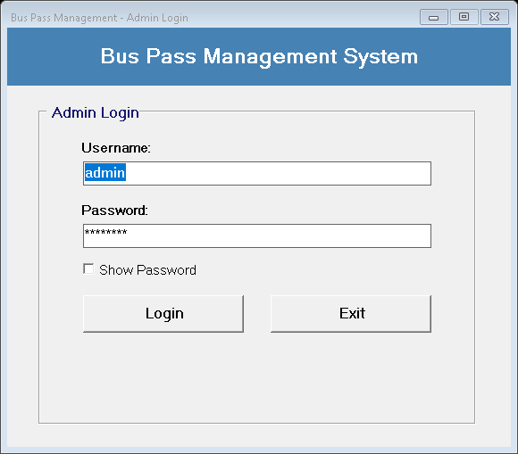

Dashboard :-
The Main Administrative Dashboard displays real-time statistic cards summarizing Total Passes Issued, Active Passes, Expired Passes, and Active Routes. It provides one-click navigation buttons to all core system modules and includes an automatic audit grid of recent passes.
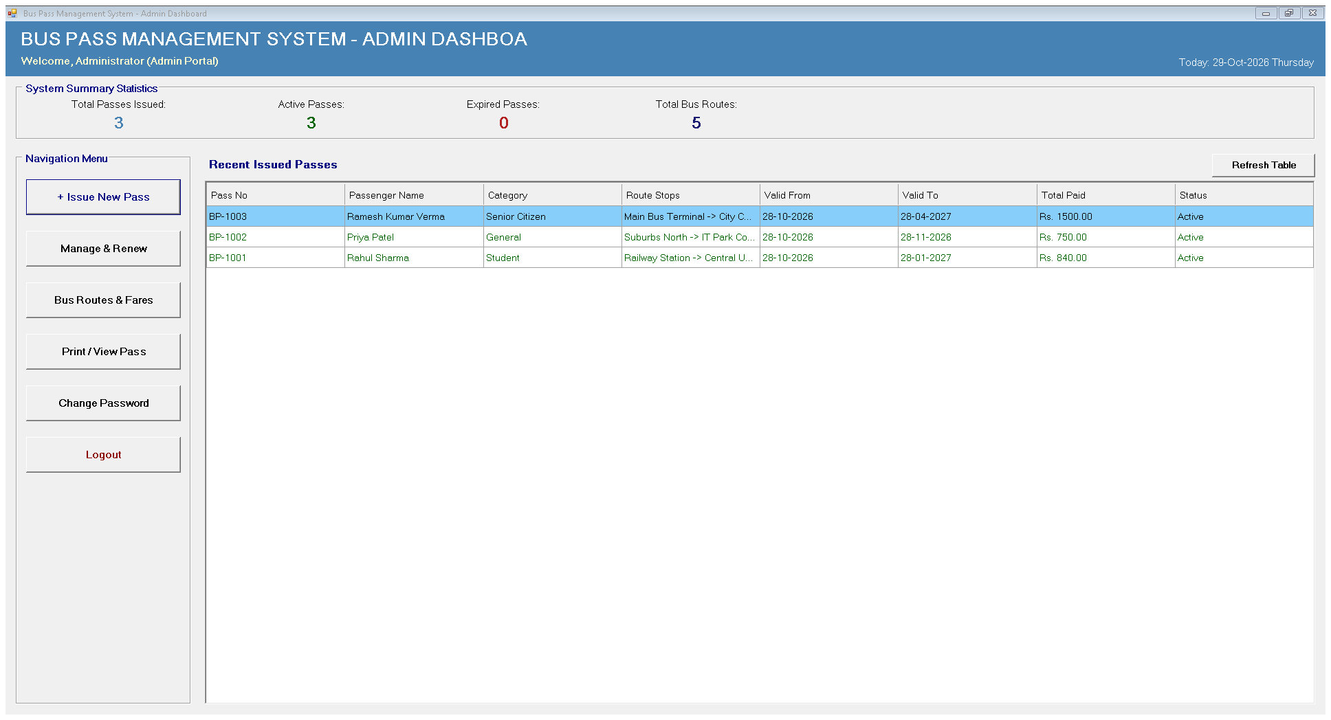

New Pass Registration :-
The New Bus Pass Form enables staff to register commuters by entering passenger demographics, contact details, ID proof documents, selecting transit routes, and choosing validity periods. It automatically computes monthly fares, concessions, and total payable amounts.
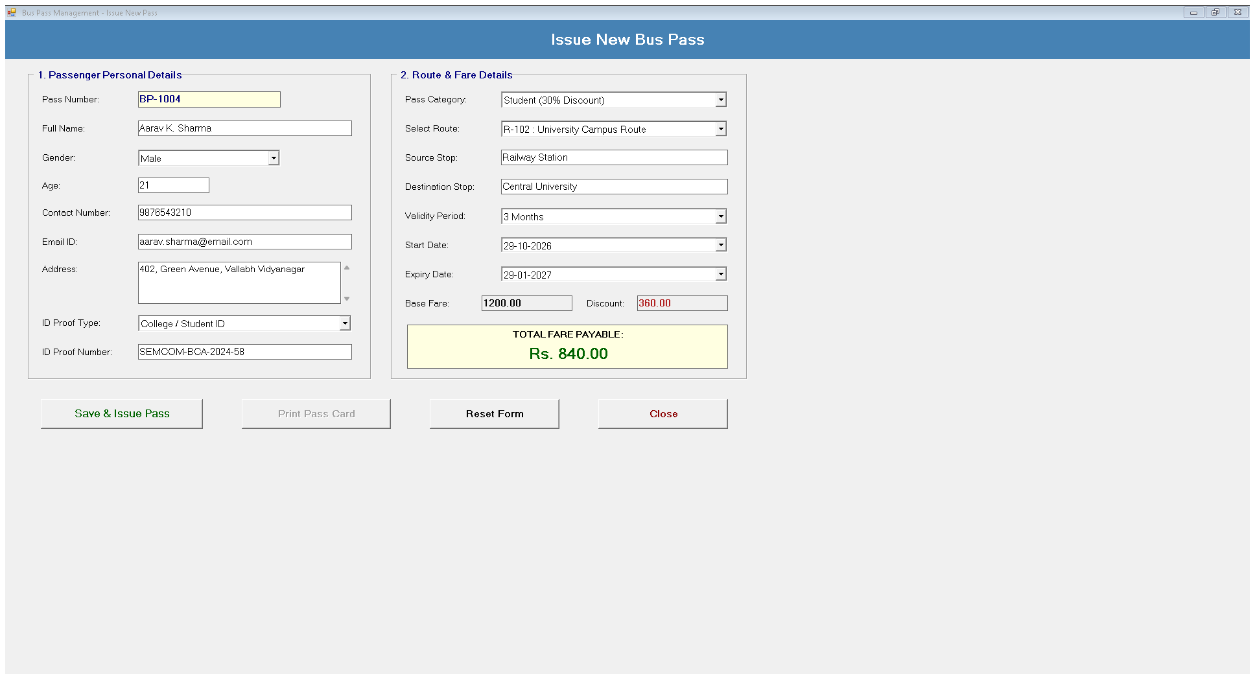

Route Management :-
The Route Management module allows administrators to define and maintain the transit network. Staff can configure route numbers, route titles, starting bus stops, destination bus stops, monthly base fare amounts, and active operating status.
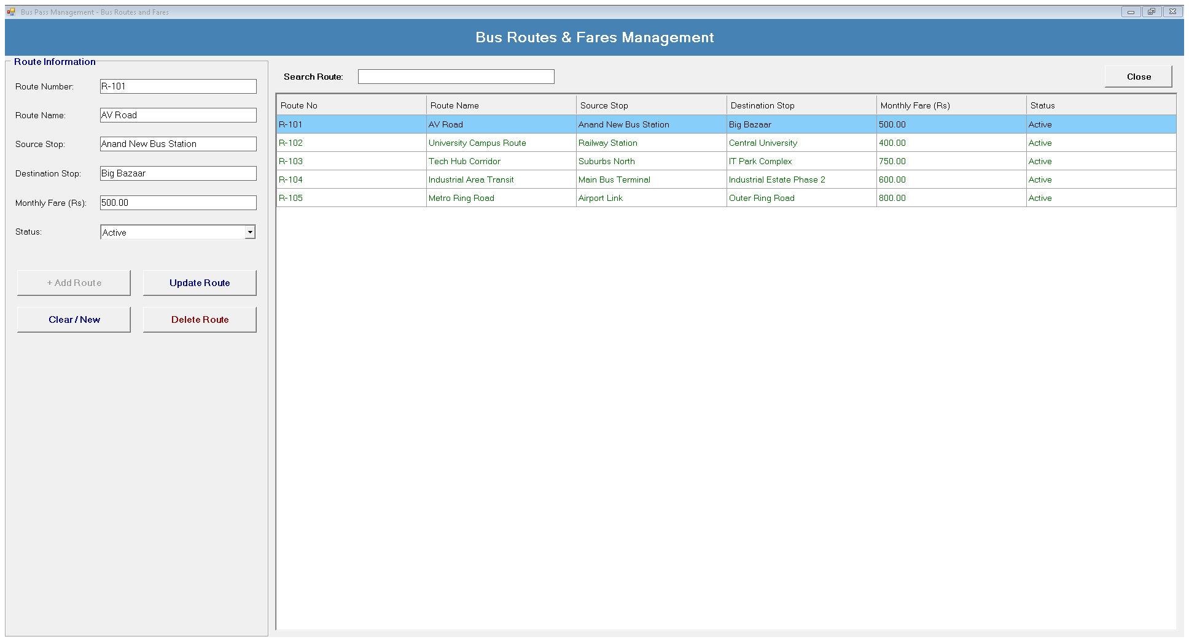

Change Password :-
The Change Password module provides administrative account security by verifying current credentials and updating administrator passwords in the database.
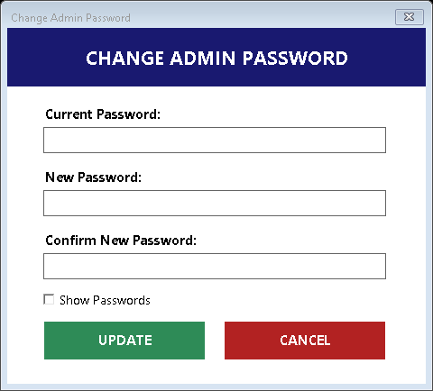

Output Screens
Manage & Search Passes :-
The Manage Passes module functions as a comprehensive reporting and search hub. Staff can search and filter commuter records by Pass Number, Passenger Name, Mobile, Category, or Route Stops, filter by Active/Expired/Cancelled status, and process one-click renewals.
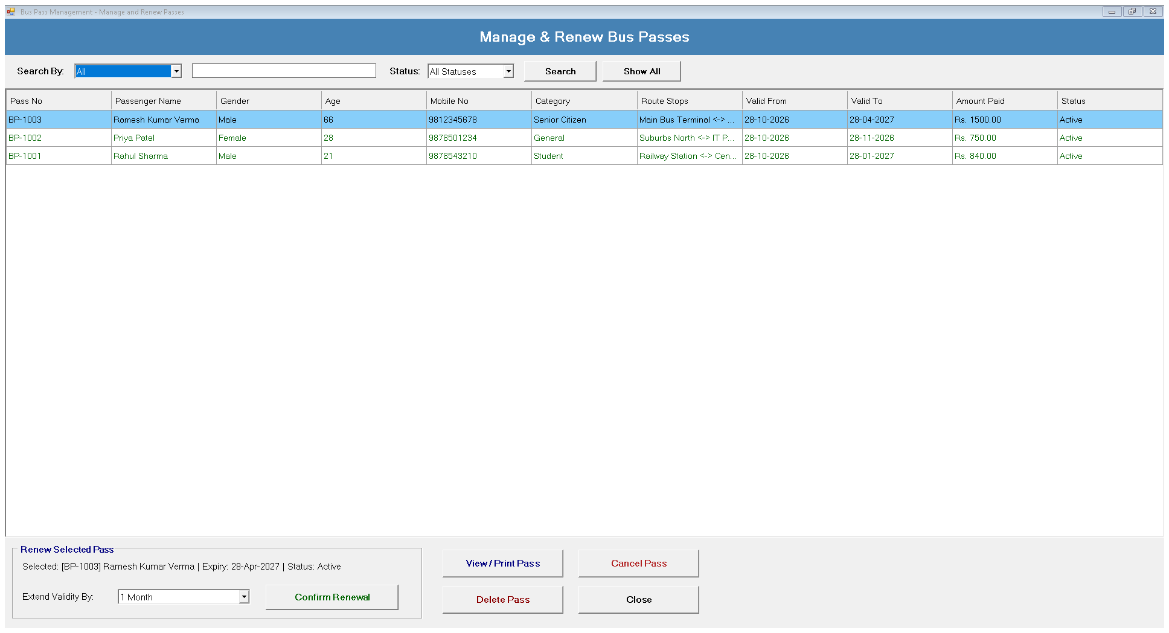

Bus Pass ID Card Preview & Print Preview :-
The Print Pass module generates an official digital Bus Pass ID card layout for any issued pass number. It renders passenger credentials, route endpoints, validity dates, concession badge, barcode placeholder, and administrative seal for direct printing.
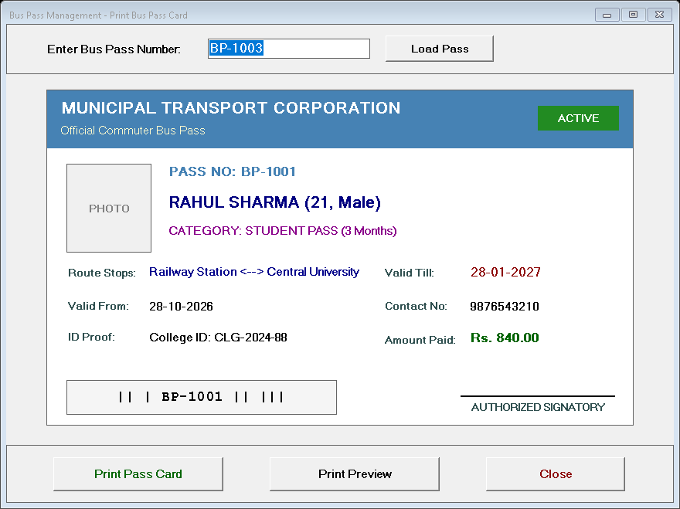

Limitations
Single Admin Role: The current version supports a single administrator role with no differentiated permission levels for junior ticket clerks, field inspectors, or senior depot managers.
No Online Passenger Self-Service Portal: Commuters cannot apply for passes or submit digital identity documents remotely via a web browser; all pass applications must be processed in person at physical depot terminals.
No RFID / Smart Card Turnstile Integration: While passes are printed with visual layouts and barcodes, the system does not interface directly with automated metro turnstile gates or electronic bus ticket machines (ETMs).
No Automated SMS / Email Expiry Alerts: The system displays expired passes on the admin dashboard, but does not yet feature automated SMS or email reminders notifying commuters before their pass expires.
Local Network Deployment: The current Microsoft SQL Server Express architecture is configured for a single depot/local network and does not yet feature cloud database synchronization across multi-city regional transit hubs.

Conclusion
The Bus Pass Management System (BPMS) is a fully functional desktop application developed using VB.NET, Windows Forms, and Microsoft SQL Server. The project successfully demonstrates how a traditional, manually run transit pass issuing counter can be transformed into a modern, digitally managed operation.
The system provides a seamless experience for transport authority staff — from cataloguing bus routes and fare rules, to registering passengers, computing concessionary fares, issuing digital pass cards, and processing renewals. The dashboard offers complete, real-time visibility into commuter passes and operational metrics, enabling administrators to make informed decisions from a single interface.
The project meets its primary objectives of eliminating manual record-keeping, ensuring accurate real-time fare calculation, automating pass lifecycle and renewal workflows, and providing secure administrator authentication.
Overall, this project has provided valuable hands-on experience in desktop application development, relational database design, and software engineering principles, and serves as a strong foundation for building more advanced public transportation and smart ticketing systems in the future.

Bibliography
https://learn.microsoft.com/en-us/dotnet/visual-basic/
https://learn.microsoft.com/en-us/sql/sql-server/
https://learn.microsoft.com/en-us/dotnet/framework/data/adonet/
www.google.com
www.youtube.com

