COMMANDS :

- PWD
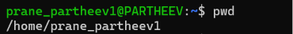

- CLEAR

- HISTORY
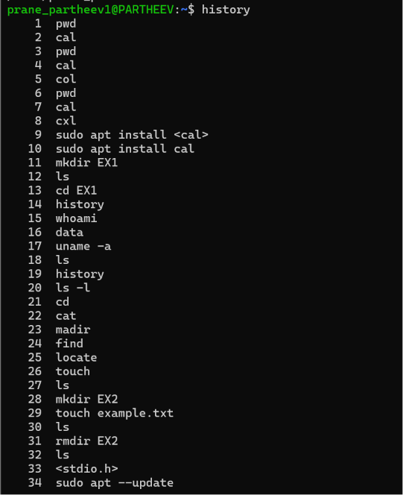

- WHOAMI

- DATE
- HOSTNAME
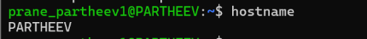

- UNAME -A

- LS
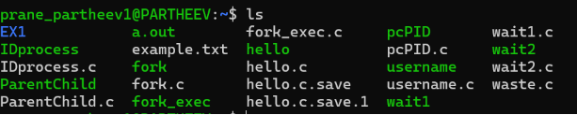
- LS -L
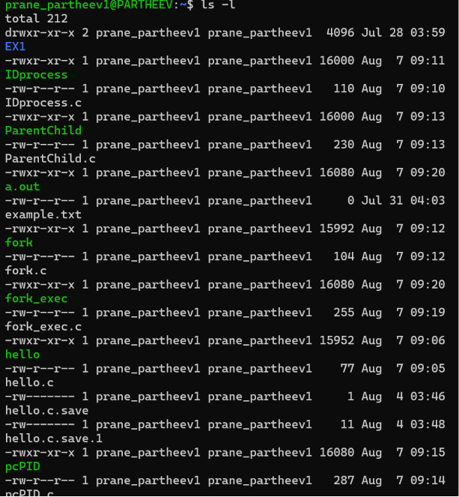

- LS -A
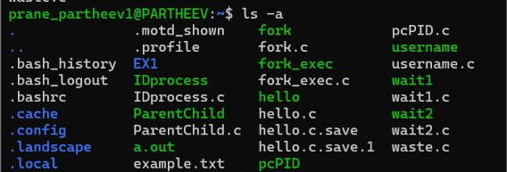

- CD ..
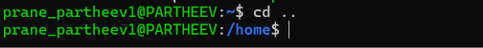

- NANO
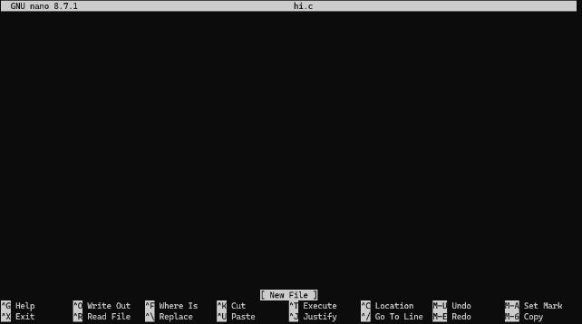

- GCC
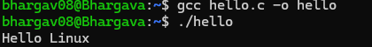

- PS
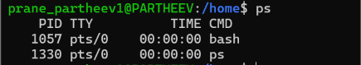

- PS -EF
