**Aim : Write an HTML code to create a frameset having header, navigation and content sections**

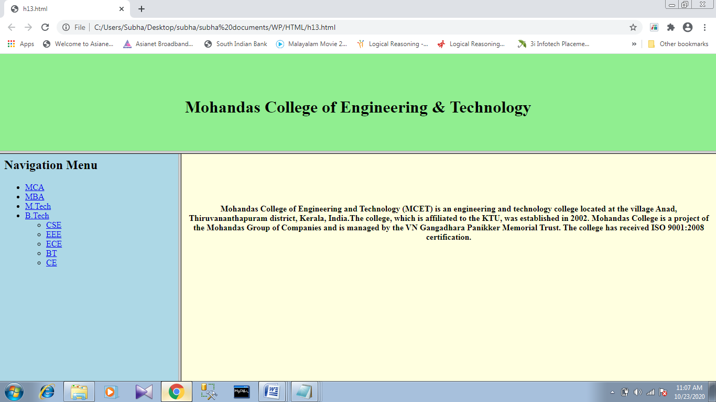

**Source code :**

**topframe.html**

<!DOCTYPE html>

<html>

<body style="background-color:lightgreen">

<h2><center><br><br>Mohandas College of Engineering & Technology</center></h2>

</body>

</html>

**leftframe.html**

<!DOCTYPE html>

<html>

<body style="background-color:lightblue">

<b>Navigation Menu</b>

<ul>

<li><a href="https://www.collegedekho.com/courses/mca/">MCA</a></li>

<li><a href="https://collegedunia.com/courses/master-of-business-administration-mba">MBA</a></li>

<li><a href="https://www.collegedekho.com/courses/master-of-technology-mtech/">M.Tech</a></li>

<li><a href="https://www.shiksha.com/b-tech-bachelor-of-technology-chp">B.Tech</a></li>

<ul>

<li><a href="https://www.shiksha.com/engineering/computer-science-engineering-chp">CSE</a></li>

<li><a href="https://www.sarvgyan.com/courses/engineering/electrical-electronics-engineering">EEE</a></li>

<li><a href="https://www.shiksha.com/engineering/electronics-communication-engineering-chp">ECE</a></li>

<li><a href="https://collegedunia.com/courses/basic-training-certificate-btc">BT</a></li>

<li><a href="https://na.eventscloud.com/ehome/adha16/ce/">CE</a></li>

</ul></ul>

</body>

</html>

**rightframe.html**

<!DOCTYPE html>

<html>

<head>

<style>

div {

text-align: center;

}

</style>

</head>

<body style="background-color:lightyellow">

<br><br><div>

<p> Mohandas College of Engineering and Technology (MCET) is an engineering and technology college located at the village Anad, Thiruvananthapuram district, Kerala, India. The college, which is affiliated to the KTU, was established in 2002. Mohandas College is a project of the Mohandas Group of Companies and is managed by the VN Gangadhara Panikkar Memorial Trust. The college has received ISO 9001:2008 certification.</p>

</div>

</body>

</html>

**Main.html**

<!DOCTYPE html>

<html>

<head>

<title>HTML Frames</title>

</head>

<frameset rows="20%,80%">

<frameset rows>

<frame name="top" src="topframe.html" />

</frameset>

<frameset cols="30%,70%">

<frame name="left" src="leftframe.html" />

<frame name="right" src="rightframe.html" />

</frameset>

</frameset>

<noframes>

<body>

Your browser does not support frames.

</body>

</noframes>

</html>