**Aim : Design the following**

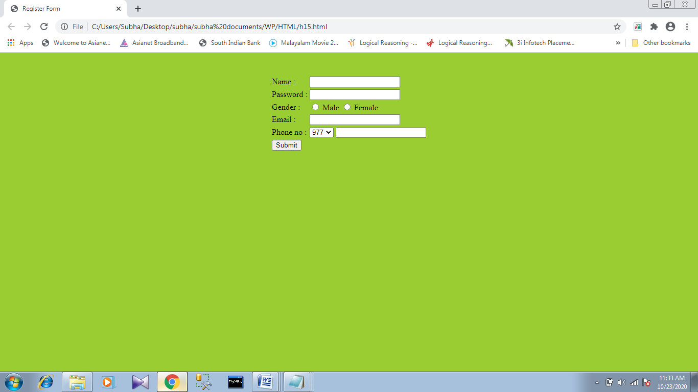

**Source code :**

<!DOCTYPE html>

<html>

<head>

<style>

form {

width: 325px;

padding: 5px;

margin: 200px;

}

</style>

</head>

<body style="background-color:#99cc00">

<form action="" method="post">

<center><br>

Name: <input type="text" id="uname" name="uname"><br><br>

Password: <input type="password" id="psswd" name="pswd"><br><br>

Gender:

<input type="radio" id="gender" name="gender"value="m">Male

<input type="radio" id="gender" name="gender"value="f">Female

<br><br>

Email: <input type="text" id="email" name="email"><br><br>

Phone no:

<select id="phnum" name="phnum">

<option value="977">977</option>

<option value="978">978</option>

</select>

<input type="text" id="ph" name="ph"><br><br>

<input type="submit" value="Submit">

</center>

</form>

</body>

</html>