**Aim : Create the following design**

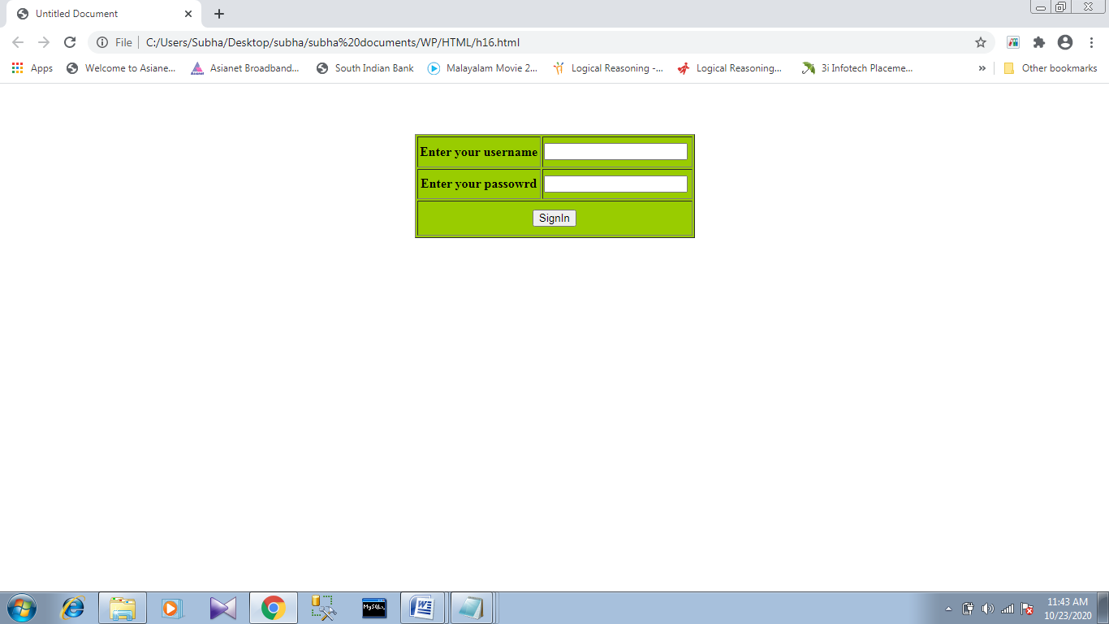

**Source code :**

<!DOCTYPE html>

<html>

<head>

<style>

form {

width: 325px;

border: 1px solid green;

padding: 5px;

margin: 50px;

background-color:lightgreen;

}

</style>

</head>

<body>

<form action="" method="post"><center><br>

Enter your username &nbsp<input type="text" id="uname" name="uname"><br><br>

Enter your password &nbsp<input type="password" id="psswd" name="pswd"><br><br>

<input type="submit" value="Signin"><br><br></center>

</form>

</body>

</html>