Contents

3-2-1 Launch! 1

Materials 1

Safety 2

Procedure 2

Part 1 – 3-2-1 Launch! 2

Part 2 – Weight Drop Launch 2

Data Collection 4

Questions and Analysis 4

# 3-2-1 Launch!

**Your mission** is to use the computational thinking process to create a program that alerts you when to launch your //code.Node cart.

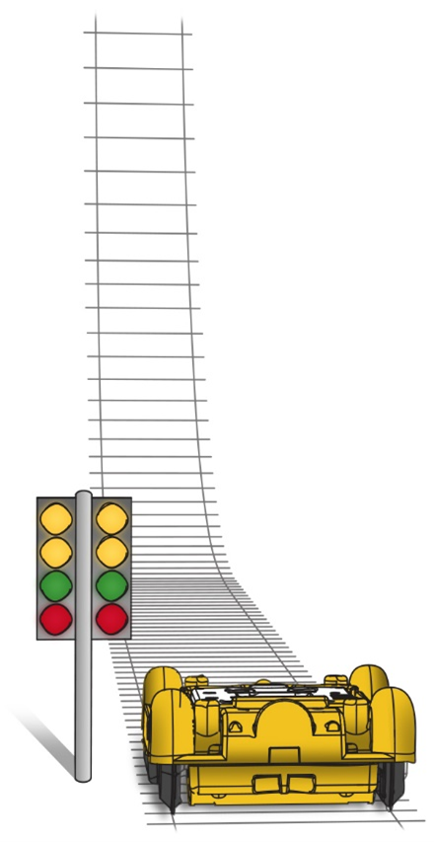

A standard stop light is used by drivers to alert them on when to stop, slow down and/or be alert, or if they are clear to drive through an intersection. In racing, the color of the lights has similar meaning, but are structured a bit differently.

Drivers in drag races need to start at the same time or be alerted of a false start through a lighting system known as a Christmas tree. A Christmas tree has a column of seven lights for each driver. The Top Thrill Dragster™ rollercoaster mimics a drag race start with its light alert system. When the green light illuminates, the cart launches.

In this activity, you will use the //code.Node to recreate a model of the lighting system used in this thrill ride.

## Materials

* Data collection system
* //code.Node
* Mass (4), 50 g
* Textbook
* //code.Node cart
* Spring
* String
* Measuring tape

## Safety

Follow your classroom procedures.

## Procedure

### Part 1 – 3-2-1 Launch!

In this experiment you will be modeling a weight drop launch system used in the past on roller coasters. Working with your partner, one will start collecting data while the other releases the cart. For this challenge, using your knowledge of Blockly coding, create a program that helps you know when to release, or launch, your cart. Make sure to save your program so you can retrieve it for the Weight Drop Launch activity.

Your program must:

* use the 5x5 LED array as an output and have it illuminate a countdown of 3, 2, 1.
* use the RGB LED as an output and have it cycle through red, yellow, and green along with the 3, 2, 1 countdown.
* use the //code.Node speaker output to alert the driver once 1 is reached in the countdown.
* When complete, save your program to use in the Weight Drop Launch activity.

### Part 2 – Weight Drop Launch

How does mass affect the velocity of a //code.Node cart using a weight drop launch system?

A roller coaster with a weight drop launch stores potential energy in a heavy weight that is pulled to a height. The coaster is then launched using the spike in energy provided by letting the weight fall to the ground. The weight drop launch is thought to be the first ever launch system and was introduced in the 1970's. Speeds of around 60 mph could be achieved using this type of system.

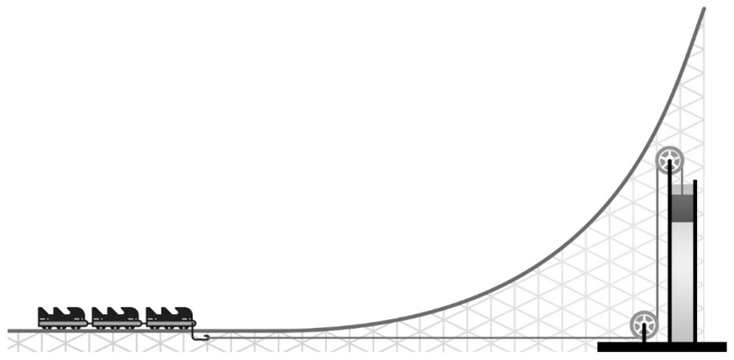

According to Newton's Laws of Motion, an unbalanced force is one that causes a change in the motion of the object to which the force is applied. An object at rest or an object in steady motion continues at rest or in unchanged motion unless it is subjected to an unbalanced force. In that case, the object accelerates in the direction of the force according to the equation: force equals mass times acceleration (F = ma). An unbalanced force continues to accelerate an object until a new balance of forces is established.

1. Clear off an area to be your track for the //code.Node cart. Use a measuring tape to mark about 1 meter of clear space.
2. Place a textbook at the end of the table with the spine aligned to the edge. This will allow the string to move freely.
3. Cut about 1.5 m of string and attach one end to the front of the //code.Node cart.
4. Attach the spring to the front of the cart. This will help protect the cart upon impact.
5. Place three of the 50 g masses into the cart and tie one to the other end of the string. See Figure 1 as to how to set up for the experiment.

Figure 1: Setup for experiment.

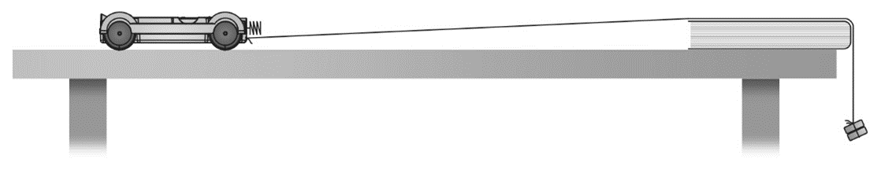

1. Put the //code.Node into the Cart and connect the //code.Node to your device. If using your 3-2-1 Launch program, open this before connecting your //code.Node.
2. Make sure you have a Line Graph Display that displays Cart Velocity vs. Time for data collection.
3. Pull your cart back so that the hanging mass is just below the top of the table. Note: Your string should be long enough so that the mass will reach the floor after release. This ensures you will not launch your cart over the textbook.
4. Start collecting data and release the cart. Note: Data collection will not start the second you press start. This is ok and will not affect your data.
5. Stop collecting data.
6. Repeat the release two more times. Use the coordinates tool to get your max velocity and record this data into Table 1 and calculate the average velocity. See Figure 2 as to how your data may look.
7. Take another 50 g mass from the cart and add it to the end of the string for a total of 100 g hanging mass.

Figure 2: Sample data collection using the Coordinates tool.

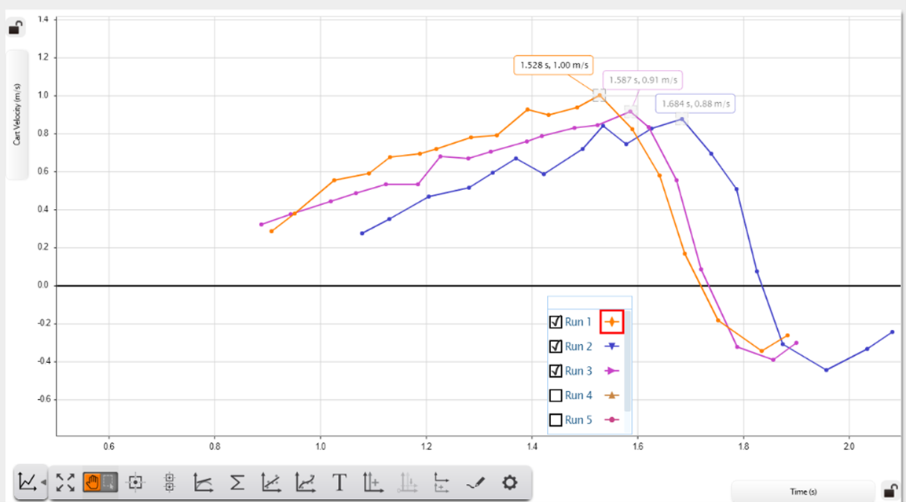

1. Repeat steps 6 - 9 and record this data into Table 2 and calculate the average velocity.
2. Take a third 50 g mass from the Cart and add it to the end of the string for a total of 150 g hanging mass.
3. Repeat steps 6 - 9 and record this data into Table 3 and calculate the average velocity.
4. Save your experiment as Weight Drop or according to your teacher's directions in case you need to refer to it later.

## Data Collection

Table 1: Maximum cart velocity with 50 g weight drop

| Trial | Max Cart Velocity |
| --- | --- |
| 1 | 1.00 m/s |
| 2 | 0.88 m/s |
| 3 | 0.91 m/s |
| Average | 0.93 m/s |

Table 2: Maximum cart velocity with 100 g weight drop

| Trial | Max Cart Velocity |
| --- | --- |
| 1 | 1.29 m/s |
| 2 | 1.33 m/s |
| 3 | 1.29 m/s |
| Average | 1.30 m/s |

Table 3: Maximum cart velocity with 150 g weight drop

| Trial | Max Cart Velocity |
| --- | --- |
| 1 | 1.45 m/s |
| 2 | 1.43 m/s |
| 3 | 1.44 m/s |
| Average | 1.44 m/s |

## Questions and Analysis

1. How were you able to program the RGB LED to illuminate yellow?
2. Were there additional blocks that you needed to add to create a clean countdown from 3 to 1?
3. What hardware block did you use as your conditional?
4. Looking at your data, how was the cart's average velocity affected as you added more weight to the launch system?
5. Explain the motion of the cart and the forces that were acting upon it once it was released.
6. How do you think your data would be affected if you kept all four masses, for a total of 200 g, in your cart during each release? How could you test this?