**Compiler Theory Programming Assignment**

Programming Document for Description

21400646 Lim Chae Eon

1. How to compile this program.



1. How to implement this program



**Make sure to put sample script!**

1. Success case

#1 basic1.jss



#2 sample1.jss



#3 sample2.jss

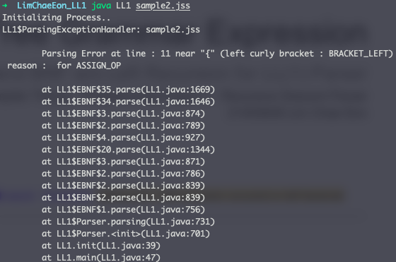

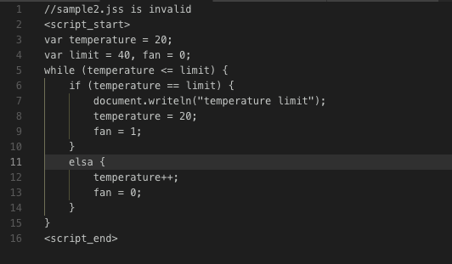

# sample3.jss



# sample5.jss



# sample6.jss

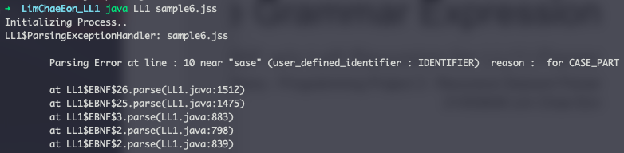

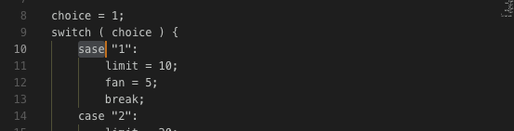

1. Other Docs

Contents for BNF, Removed Left Recursion BNF, First and Follower sets, and Parsing Table are in other files (“Context-free Grammar Expression_PA03.pdf”, “First and Follower Sets”, and “LL(1) Parsing Table” for each)