**Compiler Theory Programming Assignment**

Programming Document for Description

21400646 Lim Chae Eon

1. How to compile this program.



1. How to implement this program



**Make sure to put sample script!**

1. Success case

# a1.jss



# a1Error.jss

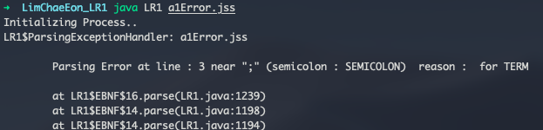

# basic1.jss



# sample1.jss



# sample2.jss

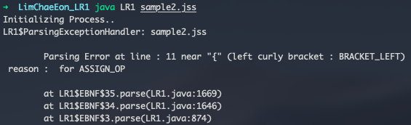

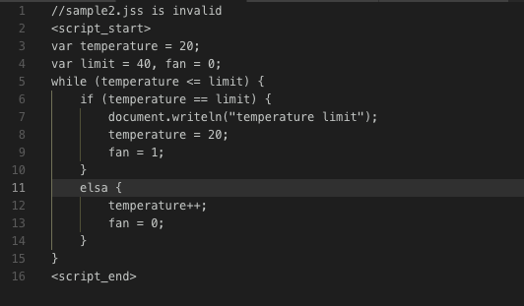

# sample3.jss



# sample5.jss



# sample6.jss

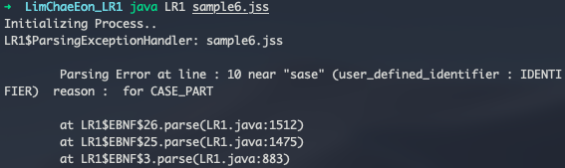

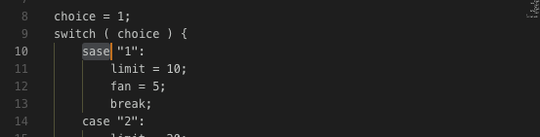

1. Other Docs

Contents for BNF, First and Follower sets, and DFA of LR(1) items are in other files (“Context-free Grammar Expression.pdf”, “First and Follower Sets for LR(1) Parser”, and “LLR(1)_DFA_2.png)