Compiler Theory Programming Assignment

21400646 Lim Chae Eon

1. How to compile this program.



1. How to implement this program



**Make sure to put sample script!**

1. Success case

#1 sample1.jss



#2 sample2.jss

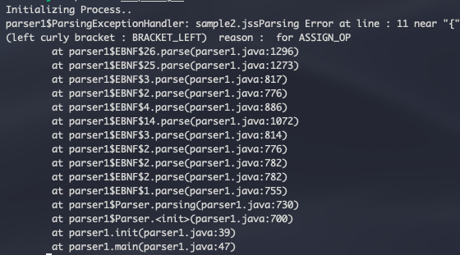

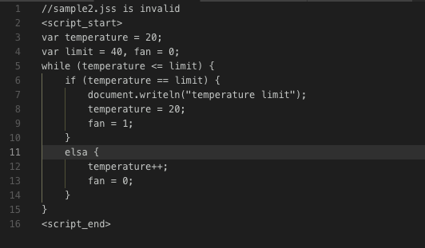

# sample3.jss



# sample5.jss



# sample6.jss

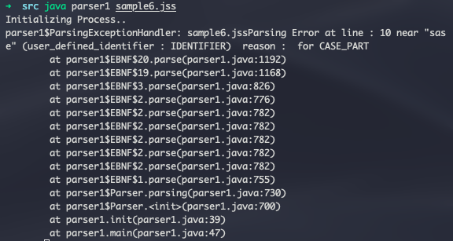

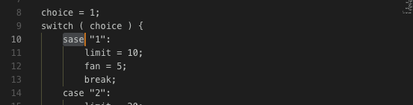

1. Other Docs

Contents for BNF and ENBF are in file (“Context-free Grammar Expression.pdf”)