Compiler Theory Programming Assignment

21400646 Lim Chae Eon

**Regular Expression for Javascript Scanner**

* digit 🡪 [0-9]
* letter 🡪 [a-zA-Z]
* special character 🡪 [!@#$%^&*()-=+[]\{}|;’:”,/<>?]
* keyword id 🡪 var | do | while | if | else | switch | case | break | default | function | return
* keyword tag 🡪 <script_start> | <script_end> | <h1> | </h1> | <h2> | </h2> | <h3> | </h3> | <ul> | </ul> | <ol> | </ol> | <br/>
* keyword logical value 🡪 true | false
* keyword function name 🡪 window | parseFloat | document | squere
* WS (white_space) 🡪 [new_line | tab]
* LN (line_next) 🡪 [line_feed carriage_return | line_feed]

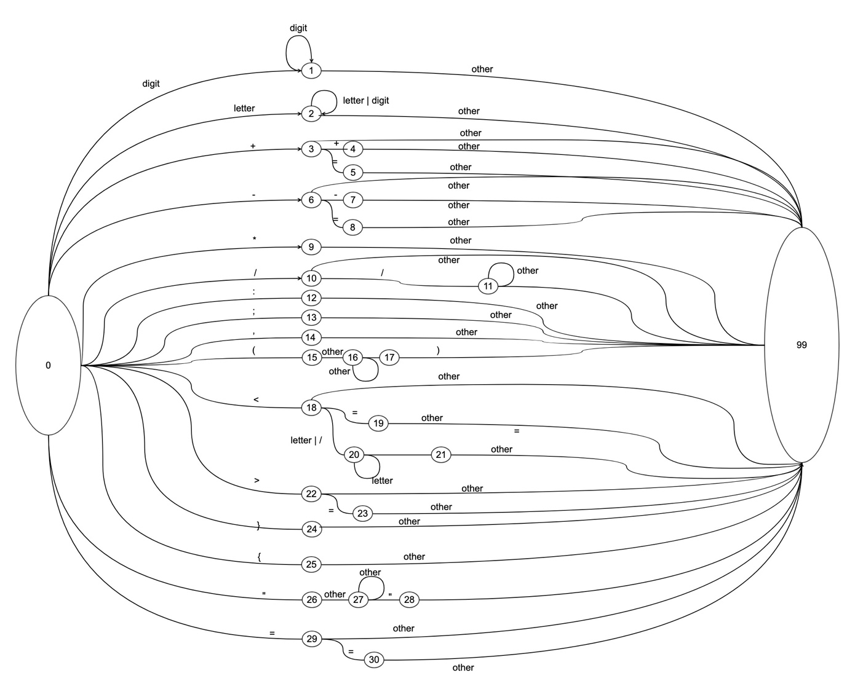

Figure DFA for Javascript Scanner

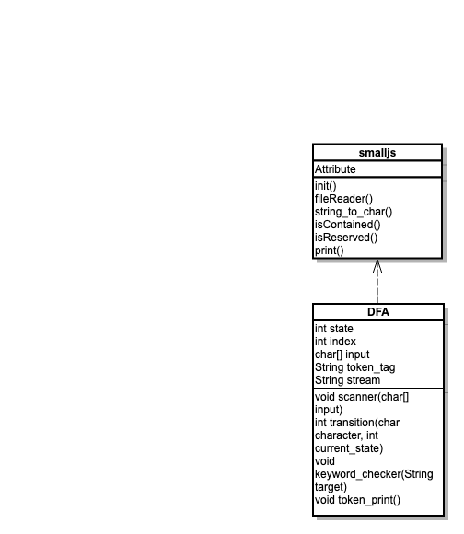This program has only 2 classes.

Figure Simple UML Diagram for this program

For smalljs class is main class and it has one subclass ‘DFA’

‘smalljs’ class usally takes the tasks which are not related to DFA such as file loading or preparing character set, etc.

Those scanning tasks are taken by DFA class. DFA class has scanner, transition method. ‘scanner’ method gives each character of string, then ‘transition’ method returns proper states. By that mechanism, we can get tokens from string.

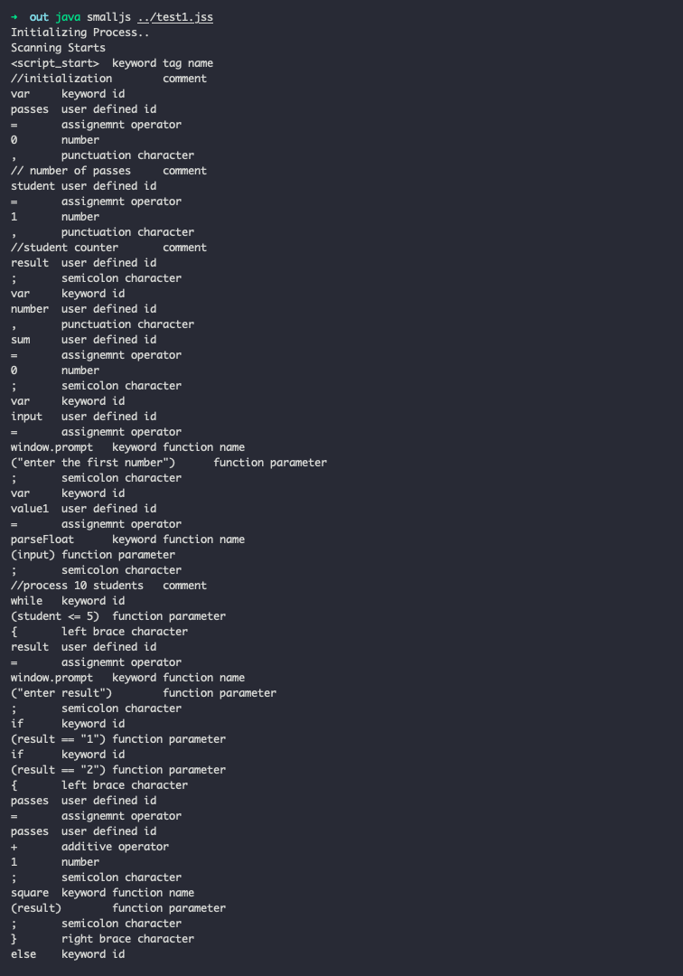

Figure Programming result.

To compile the program. Please follow below instructions.

1. Javac smalljs.java
2. Java smalljs <path/test file name>

// if the location of test file is same with class file, then you can just put the file name

1. Check the result.