Navigating with Badges [Watch a short demo/discussion on YouTube](https://youtu.be/_FoRUJ7DqIc)

Starting in March 2024, ezEML has incorporated colored “badges” that indicate all errors and warnings associated with the various sections and elements of an ezEML data package. These badges are clickable, showing lists of errors and warnings, and the errors and warnings they list are themselves clickable, taking you directly to the item that needs to be added or edited,

scrolling it into view and highlighting it.

Red badges indicate that errors are present in a particular page or section, yellow badges indicate there are warnings only, and green badges indicate the absence of any errors or warnings. Your goal in editing an ezEML data package should be to enter all required and recommended metadata and make corrections until, at the minimum, no red badges remain. Even better would be to get rid of all warnings, as well, and thereby make all badges green.

This is highly dynamic functionality, so the easiest way to see how it works is probably to watch the YouTube video, [here](https://youtu.be/_FoRUJ7DqIc). A textual description follows, however.

Let’s suppose we have loaded two data tables from CSV files. Both are newly loaded, so they have some missing metadata values, such as column definitions, units for numerical variables, etc. Since they have errors, they are displayed with red badges.

If I hover over a table’s badge, a list of errors/warnings drops down. These are all the errors/warnings for the given table.

I can click any of the errors/warnings to be taken to the page where the item needs to be entered or edited.

Alternatively, if I go to the **Edit Column Properties** page for the table, I will see all of its columns listed, each with its own badge. So, in the example below, several columns have been corrected and are now green, but there are still some red badges remaining.

Suppose I hover over the badge for column STEM_MASS_DENSITY. The resulting drop-down list shows the errors/warnings for just that one column.

Suppose I click on the first error, “A column **Definition** is required.” This takes me to the page where the entry needs to be entered, highlights the entry, and scrolls it into view.

Suppose now I fill in the entry, as shown below. The natural thing to do is to go back up to the badge now and get the next error/warning. There is a problem in so doing, however. The change that you have just entered hasn’t been saved yet.

Let’s say you go ahead and click the badge without saving. Then you are shown a dialog box that tells you that you have unsaved changes. It explains that you need to click the **Save Changes** button after making a change, before opening the errors/warnings list again.

Close the dialog and click **Save Changes**. After this happens a few times, you will get into the habit and clicking **Save Changes** without being prompted. After saving changes, you can go back to the errors/warnings list to get the next item. You will see that the error for the missing column definition is no longer in the list since the definition has been entered.

Click the next error. This takes you to where the unit has to be entered, highlights the entry for **Standard Unit**, and scrolls it into view. You actually have the choice of entering a standard unit or a custom unit. ezEML needs to choose one to highlight, and it highlights the standard unit, but you are free to enter either one. The highlighting is intended just to draw your attention to where you need to take action.

Now if we pick a standard unit and **Save Changes**, we will have completed the errors/warnings for this column, so the column’s badge will turn green.

And likewise, the **Edit Column Properties** page now shows a green badge for STEM_MASS_DENSITY.

Continuing in this way, we can use the badges’ errors/warnings drop-down lists to take us to items needing our attention until we’ve gotten rid of all of the red/yellow badges.

The badges associated with the **Contents** list behave a little differently.

If, for example, you click the badge for **Data Tables**, you are taken to the **Check Metadata** page, with the section for data tables highlighted:

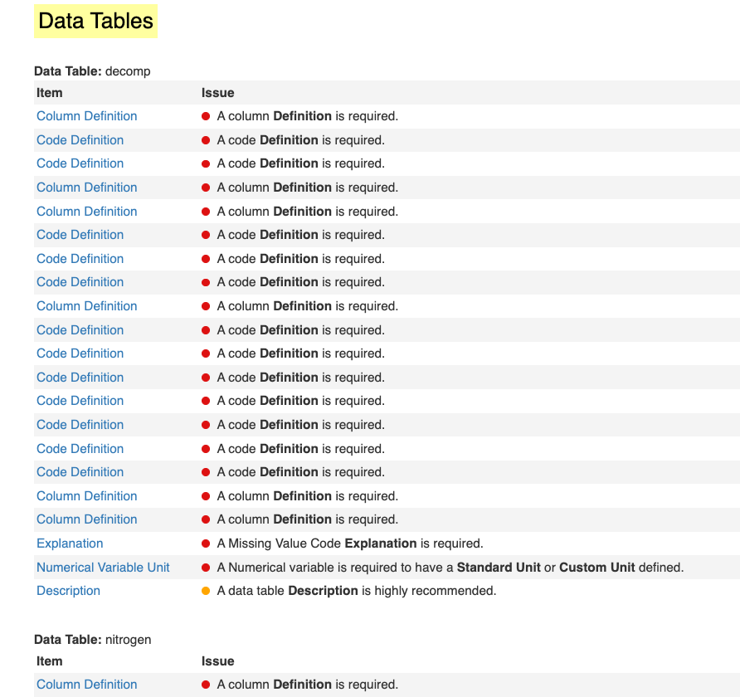

etc.

This lets you see all the errors/warnings for data tables, all at once.

To some extent, the badges supersede the **Check Metadata** page. There is at least one scenario where **Check Metadata** remains especially useful, however. If you fetch a package from the EDI repository with the intent to update it, for example, you may see a number of yellow badges, and you’d like to see what the issues are without going to each of the badges, one at a time. By going to the **Check Metadata** page, you can see them all at once:

