How to use SBT in a scala project as external tool in Eclipse ( JUNO 4.2) ?
HelloWorld example, with a generation of a standalone executable jar.
Author JL PASTUREL November 2012

Table des matières
1.Pre-requires 1
1.1.Install scala-Ide for JUNO : 1
1.2.Install sbt for your box 1
2.Create a new Scala project, and customize it for sbt 2
2.1.Create a project with src source in src/main/scala 2
2.2.Create a “resources” folder in src/main/ 4
2.3.Create a folder “project” at the root of the project 6
2.4.Prepare a minimal build.sbt for your project 7
3.Configure sbt as external tool for Eclipse 7
4.The classic HelloWorld 9
4.1.Create a Scala Object HelloWorld in package hello : 9
4.2.Try it as standalone jar file : 12

Pre-requires
(November , 2012)
Tested with Eclipse JUNO 4.2
This install is described for a Windows box. There is no difficulty to adapt to a Linux Box

Install scala-Ide for JUNO :
http://download.scala-ide.org/nightly-update-juno-master-29x
when the stable release will be ready, switch to it

Install sbt for your box
Download sbt.msi from :
http://www.scala-sbt.org/release/docs/Getting-Started/Setup.html

For the Linux box, the page explain how to install it ( download of sbt-launch.jar and create a script to launch it)
I install it in d:\opt\sbt\
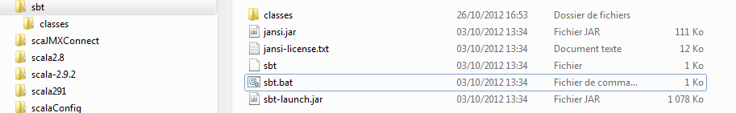
For the first launch, you need an internet connection.
Go to d:\opt\sbt and launch : .\sbt
If you don't get errors, you can continue

Create a new Scala project, and customize it for sbt

Create a project with src source in src/main/scala
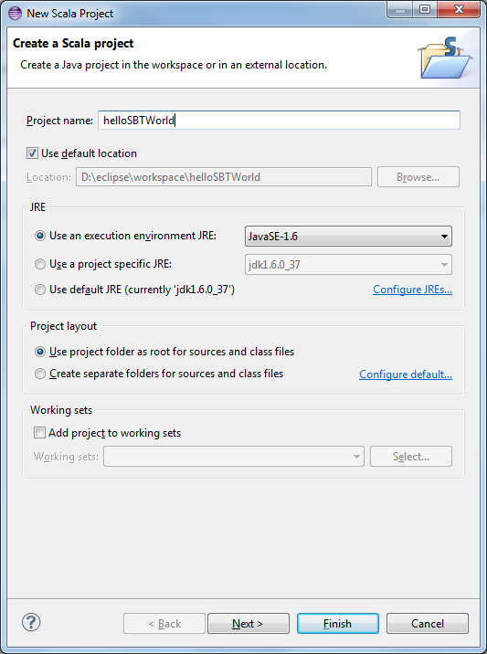
Next =>
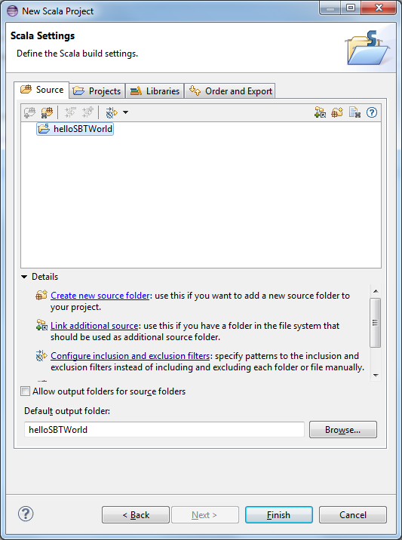
Create new source folder =>
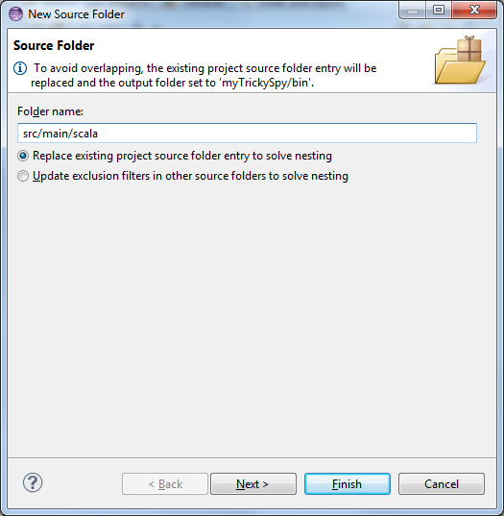
Next =>
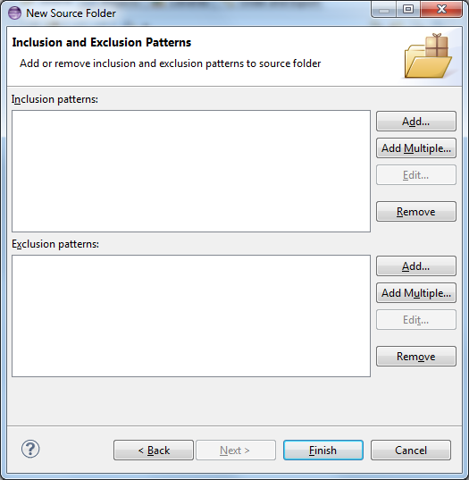
Nothing to fill; Finish =>
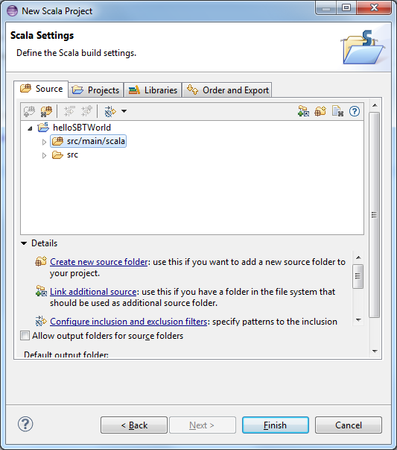
Finish

Create a “resources” folder in src/main/

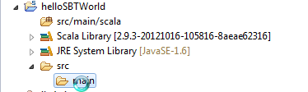

Right click on src/main and add a folder resources

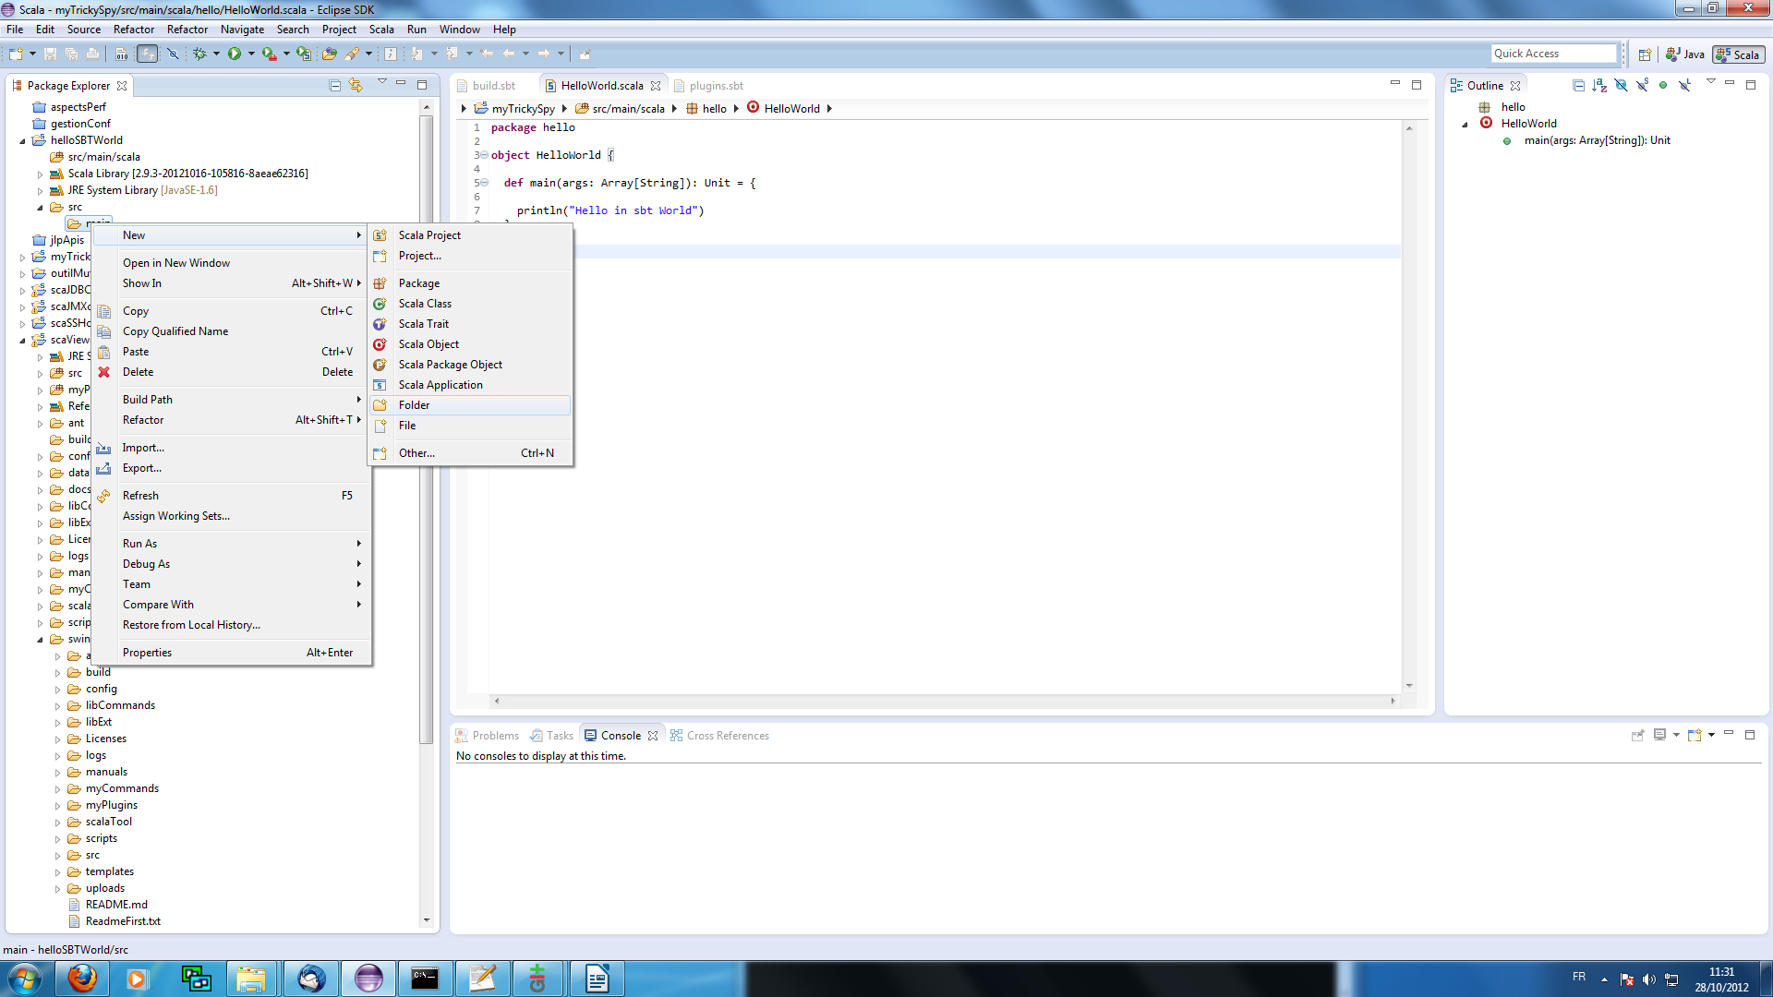

Choose New/Folder =>
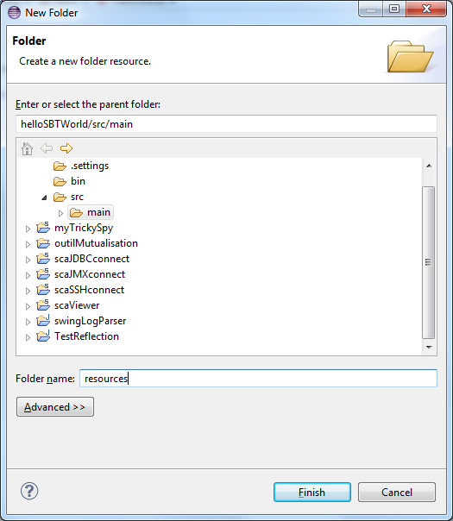
and name it resources => Finish

If you want to test ( Junit/TestNG, ScalaTest), you can create the folders below :
src/test/scala
src/test/resources
make src/test/scala as a source folder ( in build path)

Create a folder “project” at the root of the project
Proceed as shown above.
Create a file plugins.sbt in the folder project.
Fill the file plugins.sbt with theses lines :

resolvers += Resolver.url("artifactory", url("http://scalasbt.artifactoryonline.com/scalasbt/sbt-plugin-releases"))(Resolver.ivyStylePatterns)

addSbtPlugin("com.eed3si9n" % "sbt-assembly" % "0.8.4")

This plug-in permits to generate a standalone executable jar.
https://github.com/sbt/sbt-assembly

Prepare a minimal build.sbt for your project
In this minimal configuration, there is no Ivy/Maven dependencies with external repositories.
To be add, with the requirement of your project.
build.sbt :
import AssemblyKeys._

name := "helloSBTWorld"

version := "1.0"

scalaVersion := "2.9.2"

assemblySettings

Don't forget the new line after each statement !
Put this file, in the root of the project directory, in Eclipse Workspace.
The statement assemblySettings permits to package a standalone executable jar.

Configure sbt as external tool for Eclipse
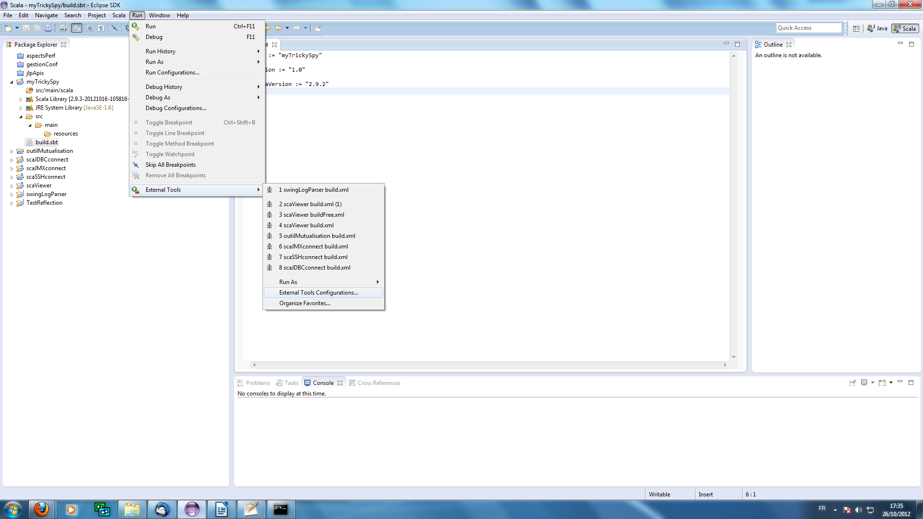
Choose sub-menu External Tools Configuration =>
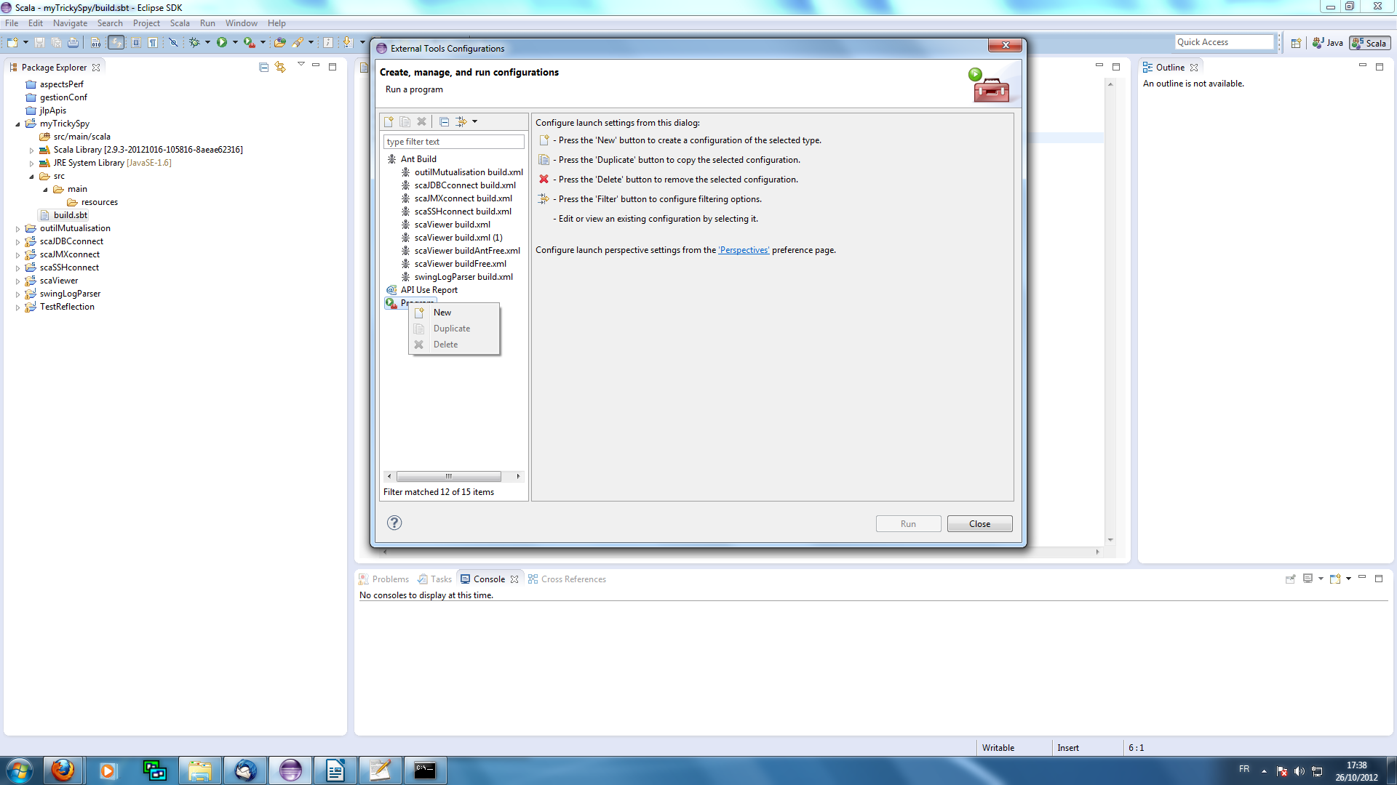
Program / Right Click / New =>
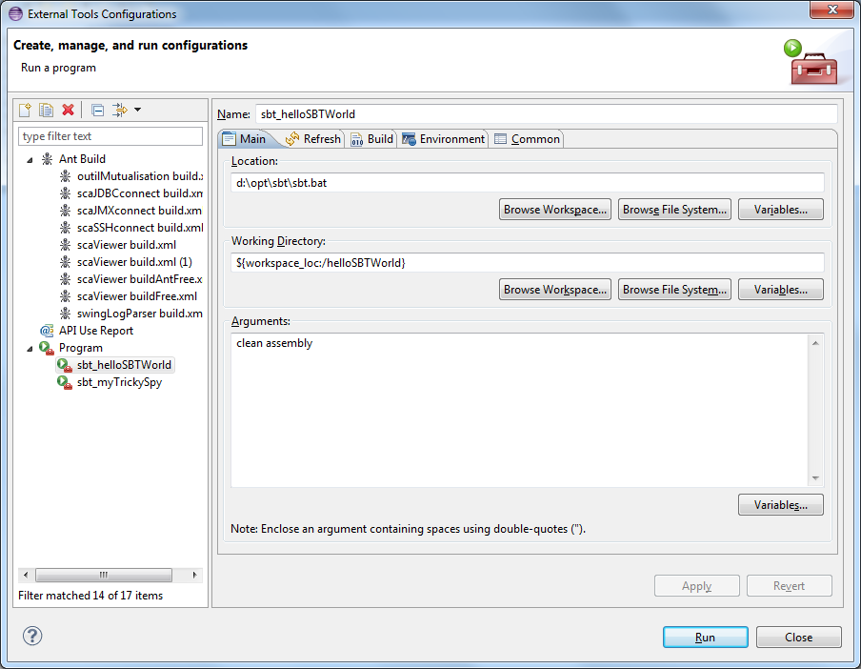Fill the fields :
Name => sbt_helloSTBWorld ( or what you want)
Location => full path to sbt.bat
Working Directory => the root directory of your Eclipse project
Arguments => clean assembly ( clean the target space and generate a jar with compiled classes and jar in src/main/resources). assembly is the task from the plugin sbt-assembly
https://github.com/sbt/sbt-assembly

Others arguments of sbt-core can be run, compile, package ( you can create other program with these arguments)
In the tab Common, you can select Display in favorites menu / External Tools, so the Menu is permanent in External Tool sub-menu

The classic HelloWorld

Create a Scala Object HelloWorld in package hello :

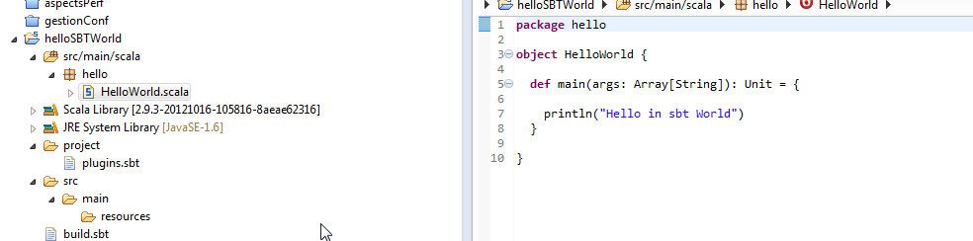
Choose menu Run/External Tools/sbt_helloSTBWorld

The first time, that you lauch the sbt programm, you get this trace in the console ( sbt and the plugin assembly are loaded from internet as a project itself !) :
[info] Loading project definition from D:\eclipse\workspace\helloSBTWorld\project
[info] Updating {file:/D:/eclipse/workspace/helloSBTWorld/project/}default-efb3ad...
[info] Resolving com.eed3si9n#sbt-assembly;0.8.4 ...

M[info] Resolving org.scala-sbt#sbt;0.12.1 ...

M[info] Resolving org.scala-sbt#main;0.12.1 ...

M[info] Resolving org.scala-sbt#actions;0.12.1 ...

M[info] Resolving org.scala-sbt#classpath;0.12.1 ...

M[info] Resolving org.scala-sbt#launcher-interface;0.12.1 ...

M[info] Resolving org.scala-lang#scala-library;2.9.2 ...

M[info] Resolving org.scala-sbt#interface;0.12.1 ...

M[info] Resolving org.scala-sbt#io;0.12.1 ...

M[info] Resolving org.scala-sbt#control;0.12.1 ...

M[info] Resolving org.scala-lang#scala-compiler;2.9.2 ...

M[info] Resolving org.scala-sbt#completion;0.12.1 ...

M[info] Resolving org.scala-sbt#collections;0.12.1 ...

M[info] Resolving jline#jline;1.0 ...

M[info] Resolving org.scala-sbt#api;0.12.1 ...

M[info] Resolving org.scala-sbt#compiler-integration;0.12.1 ...

M[info] Resolving org.scala-sbt#incremental-compiler;0.12.1 ...

M[info] Resolving org.scala-sbt#logging;0.12.1 ...

M[info] Resolving org.scala-sbt#process;0.12.1 ...

M[info] Resolving org.scala-sbt#compile;0.12.1 ...

M[info] Resolving org.scala-sbt#persist;0.12.1 ...

M[info] Resolving org.scala-tools.sbinary#sbinary_2.9.0;0.4.0 ...

M[info] Resolving org.scala-sbt#classfile;0.12.1 ...

M[info] Resolving org.scala-sbt#compiler-ivy-integration;0.12.1 ...

M[info] Resolving org.scala-sbt#ivy;0.12.1 ...

M[info] Resolving org.apache.ivy#ivy;2.3.0-rc1 ...

M[info] Resolving com.jcraft#jsch;0.1.46 ...

M[info] Resolving commons-httpclient#commons-httpclient;3.1 ...

M[info] Resolving commons-logging#commons-logging;1.0.4 ...

M[info] Resolving commons-codec#commons-codec;1.2 ...

M[info] Resolving org.scala-sbt#run;0.12.1 ...

M[info] Resolving org.scala-sbt#task-system;0.12.1 ...

M[info] Resolving org.scala-sbt#tasks;0.12.1 ...

M[info] Resolving org.scala-sbt#tracking;0.12.1 ...

M[info] Resolving org.scala-sbt#cache;0.12.1 ...

M[info] Resolving org.scala-sbt#testing;0.12.1 ...

M[info] Resolving org.scala-sbt#test-agent;0.12.1 ...

M[info] Resolving org.scala-tools.testing#test-interface;0.5 ...

M[info] Resolving org.scala-sbt#command;0.12.1 ...

M[info] Resolving org.scala-sbt#compiler-interface;0.12.1 ...

M[info] Resolving org.scala-sbt#precompiled-2_8_2;0.12.1 ...

M[info] Resolving org.scala-sbt#precompiled-2_10_0-m7;0.12.1 ...
[info] Done updating.
[info] Set current project to helloSBTWorld (in build file:/D:/eclipse/workspace/helloSBTWorld/)
[success] Total time: 0 s, completed 28 oct. 2012 11:43:00
[info] Updating {file:/D:/eclipse/workspace/helloSBTWorld/}default-d0c9d6...
[info] Resolving org.scala-lang#scala-library;2.9.2 ...
[info] Done updating.
[info] Compiling 1 Scala source to D:\eclipse\workspace\helloSBTWorld\target\scala-2.9.2\classes...
[info] No tests to run for test:test
[info] Including scala-library.jar
[info] Merging 'META-INF\MANIFEST.MF' with strategy 'discard'
[info] Packaging D:\eclipse\workspace\helloSBTWorld\target\helloSBTWorld-assembly-1.0.jar ...
[info] Done packaging.
[success] Total time: 27 s, completed 28 oct. 2012 11:43:27

The next times, the traces are less verbose :

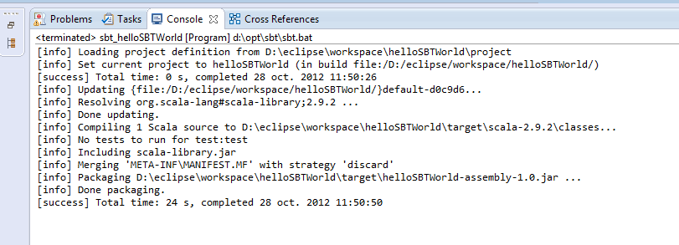
If the program compile correctly, you get a console as above.

The generated package jar is located in :
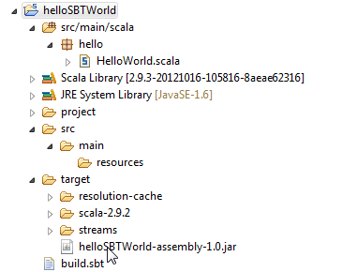

target/helloSBTWorld-assembly-1.0.jar
Browsing this jar, you can see that the scala library is included.
Note : if you have a folder lib on the root project, all the jar files in lib, are included in the standalone jar
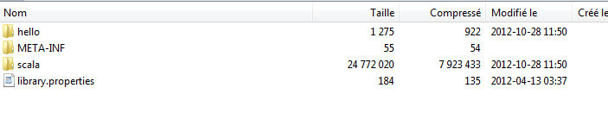

Try it as standalone jar file :
