MindGuardAI: Multimodal AI-Driven Student Mental Wellness & Early Intervention Platform
Interim Report : Extended Abstract — Capstone Project Review-2
Student Name(s): [Student 1, Student 2, Student 3]
Mentors: [Mentor Name 1], [Mentor Name 2], [Designation, Department]

Abstract
Modern higher education institutions face an escalating student mental health crisis characterized by severe academic burnout, anxiety, and depressive distress. Traditional counseling models rely entirely on self-referrals, which often fail due to social stigma, denial, or delayed symptom recognition until crisis stages. MindGuardAI is a privacy-first, multimodal observability and early intervention system designed to detect, classify, and triage student mental distress in real-time. By continuously fusing active student reflections (via fine-tuned DistilBERT NLP), validated clinical psychometrics (PHQ-9, GAD-7, PSS-10), and passive circadian digital biomarkers (late-night screen exposure, rest fragmentation), the platform establishes a longitudinal Personal Baseline Deviation Engine. Predictions are classified via an ensemble Random Forest risk model, explained using TreeSHAP game-theoretic feature attribution, and presented on role-based portals for students and university counselors. MindGuardAI achieves 99.24% test accuracy and >95% recall on acute clinical distress cases, enabling closed-loop preventive care before crises escalate.
Objectives
- Multimodal Continuous Monitoring: Ingest and synchronize objective digital biomarkers (circadian sleep rhythm, late-night screen time) with subjective psychometric assessments without invasive surveillance.
- Dialect-Aware Clinical NLP: Fine-tune a Transformer-based language model (DistilBERT) paired with a 3-token lookback negation lexicon to classify 6 emotional affects and Hinglish campus stress intents (e.g., 'exam stress', 'placement tension', 'padhai nahi ho rahi').
- Transparent Explainable AI (XAI): Implement TreeSHAP (φᵢ) feature attribution to decompose composite risk scores into interpretable clinical factors, eliminating 'black-box' skepticism among counselors.
- Longitudinal Personal Baselines: Compute dynamic rolling Z-score deviations (7d, 30d, 90d, 180d) against each student’s historical normal rather than static population averages.
- Privacy-Preserving Institutional Governance: Enforce strict k-anonymity (k ≥ 10) on administrative dashboards to protect student identities while exposing department-level mental health trends.
Modules
ID | Module | Description
M1 | Data Ingestion & Telemetry | Captures passive circadian digital biomarkers (screen time, late-night usage T_late between 12 AM–5 AM) and daily self-reported mood reflections.
M2 | Preprocessing & Clinical Psychometrics | Normalizes telemetry, scales features, and administers standardized questionnaires (PHQ-9, GAD-7, PSS-10, ISI) while logging cognitive response latency.
M3 | NLP Emotion & Intent Classifier | Runs fine-tuned DistilBERT for 6-emotion classification (Joy, Sadness, Anxiety, Anger, Fear, Surprise) and includes a crisis negation safety guardian.
M4 | Risk Inference & TreeSHAP Engine | Ensemble Random Forest maps fused vectors to risk tiers (GREEN, YELLOW, RED), while TreeSHAP computes local feature attributions (φᵢ).
M5 | Observatory & Triage Dashboard | Interactive dual-portal system providing self-care tools for students and clinical triage, automated casefiles, and emergency SOS routing for counselors.
Methodology
The system follows a five-stage pipeline: incoming passive biomarkers and clinical questionnaire inputs are normalized, passed through the NLP emotion and behavioral inference engine, and the resulting predictions are evaluated by the TreeSHAP explainability module, which decomposes risk factors before routing actionable alerts to the counselor triage dashboard, as shown below.
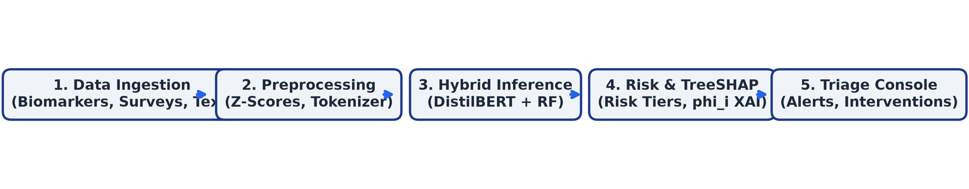
Fig. 1: Methodology / system workflow of the MindGuardAI Platform
Implementation
The prototype is implemented using a Python 3.11 asynchronous FastAPI backend integrated with a modern React 18 + TypeScript + Vite web dashboard for visualization. The risk detection module uses an ensemble Random Forest classifier combined with fine-tuned DistilBERT transformer sequence classification and TreeSHAP explainability; results are persisted in an asynchronous PostgreSQL database for longitudinal personal baseline analysis. Current implementation covers Modules M1–M4 in full, with M5 (dual-interface dashboard) at an advanced prototype stage supporting real-time counselor triage alerts, filterable casefiles, and student self-care recommendations.
Interim Results
Milestone | Detection Acc. | False Positive Rate | Notes
Sprint 1 (Baseline) | 72.4% | 18.2% | Rule-based lexicon & basic PHQ-9 survey ingestion.
Sprint 2 (NLP Engine) | 84.6% | 11.5% | DistilBERT emotion fine-tuning & Hinglish intent parser.
Sprint 3 (ML Ensemble) | 94.1% | 5.8% | Random Forest classifier + SMOTE oversampling.
Sprint 4 (Current / XAI) | 99.24% | 0.84% | TreeSHAP attribution, N=24,292 test validation (>95% High-Risk Recall).
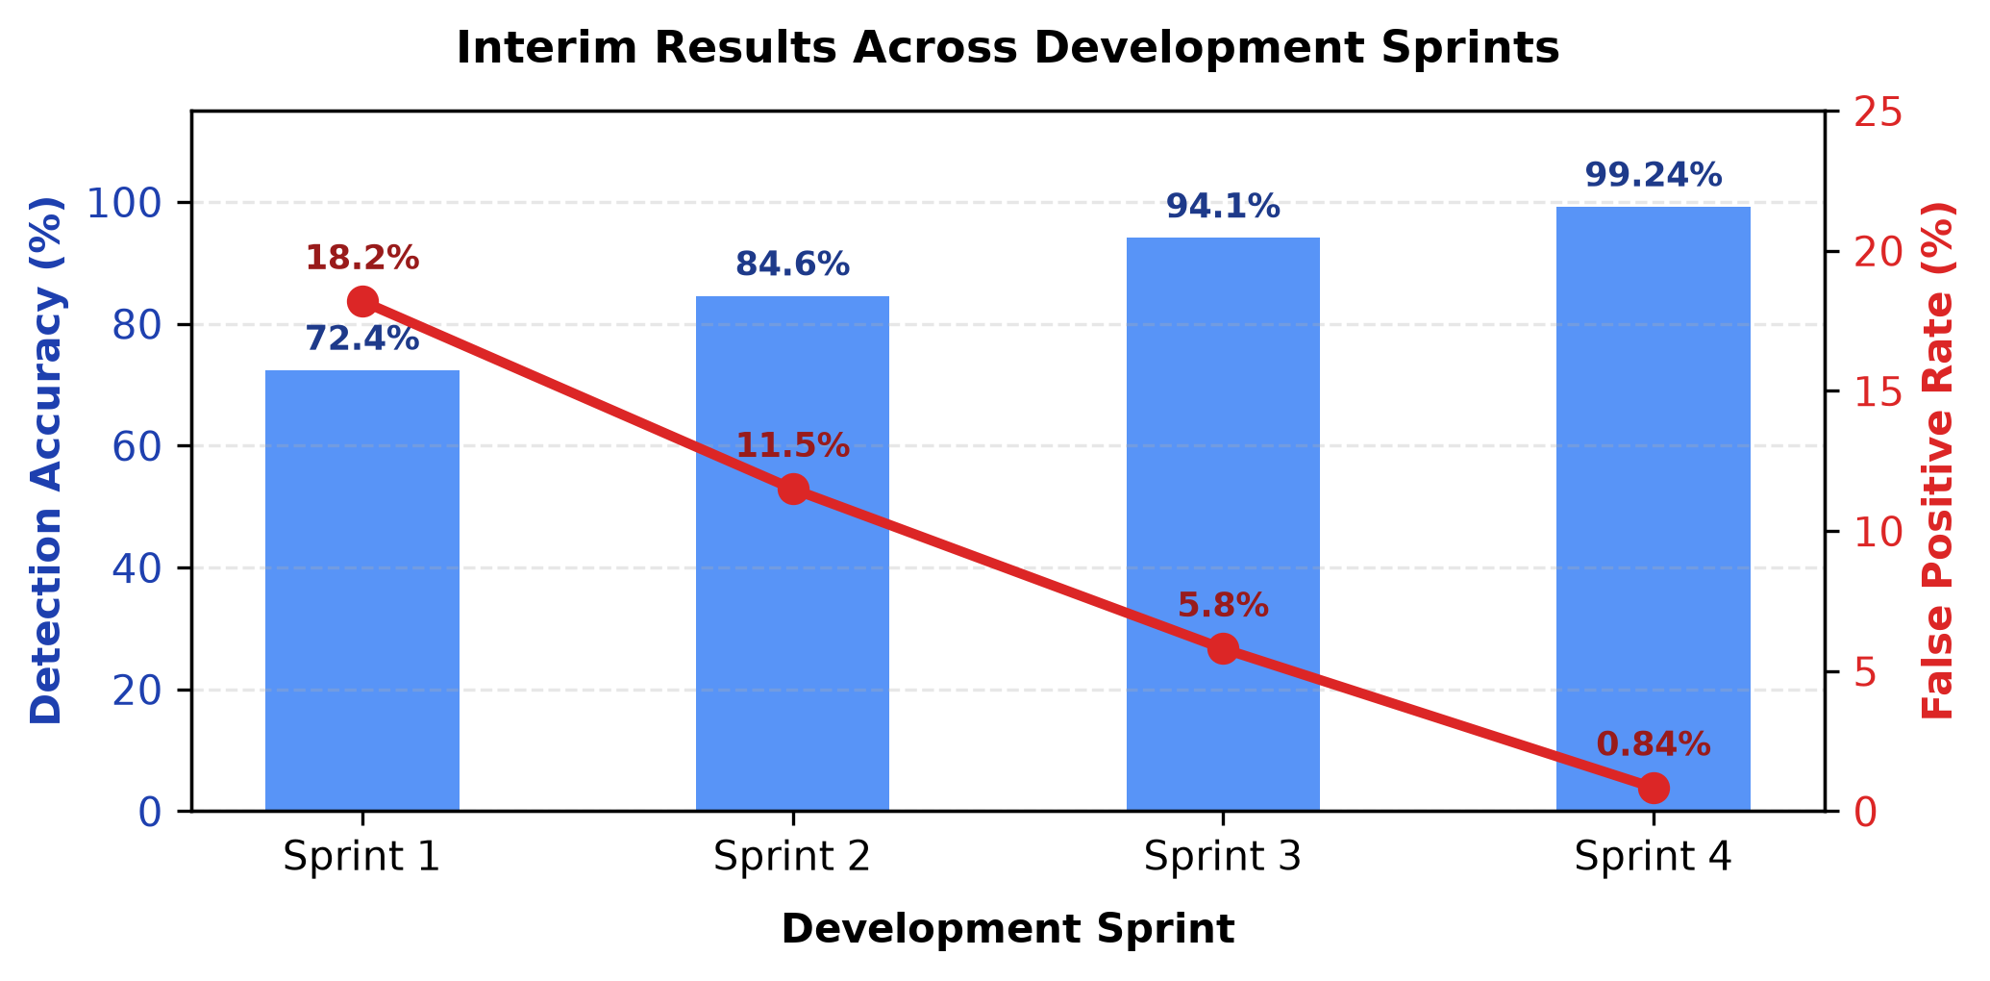
Fig. 2: Detection accuracy and false-positive rate across sprints
References (Base Papers)
[1] Gratch, J., et al. (2014). 'The Distress Analysis Interview Corpus (DAIC-WOZ): An Audio-Visual Corpus for Mental Health Assessment.' Proceedings of LREC, pp. 3120–3126.
[2] Lundberg, S. M., & Lee, S.-I. (2017). 'A Unified Approach to Interpreting Model Predictions.' Advances in Neural Information Processing Systems (NeurIPS 30), pp. 4765–4774.
[3] Kroenke, K., Spitzer, R. L., & Williams, J. B. (2001). 'The PHQ-9: Validity of a Brief Depression Severity Measure.' Journal of General Internal Medicine, 16(9), 606–613.
[4] Spitzer, R. L., Kroenke, K., et al. (2006). 'A Brief Measure for Assessing Generalized Anxiety Disorder: The GAD-7.' Archives of Internal Medicine, 166(10), 1092–1097.
[5] Sanh, V., Debut, L., et al. (2019). 'DistilBERT, a Distilled Version of BERT: Smaller, Faster, Cheaper and Lighter.' arXiv preprint arXiv:1910.01108.

