NIP Project — Submission Template
Pega Platform project · This document is your complete submission
Read this before you start:
1. Fill in Section 1 completely. The Pega application name must follow the format NIP-[Project]-[YourName].
2. Create a new Operator in Pega with your full name and log in as that operator before taking any screenshot.
3. When you create your test case, enter YOUR FULL NAME in the Issue Description (Vehicle) or Movie Name (Movie) field.
4. Complete only the section for your chosen project. Delete the other project section.
5. Paste one screenshot per user story (10 total). Follow the screenshot rules in your selected project section.
6. Answer every question in Sections 3 and 4 in your own words.
7. Save the file using this format: ProjectName_FirstName_LastName.docx. Use VehicleService or MovieTicket as the ProjectName. Examples: VehicleService_Ravi_Kumar.docx or MovieTicket_Ravi_Kumar.docx.

Section 1 — Your Details
Full Name | PASUPULA SAI TEJA
Email ID (registered on NIP) | Pasupulasai.teja37@nmims.in
Phone Number | 9392501477
College Name | SVKM's NMIMS deemed to be University Hyderabad
Course (e.g. IT, CS) | Computer Science (Data Science)
State | Telangana
Project Chosen (Vehicle Service OR Movie Ticket Booking) | Vehicle Service
Pega Application Name (e.g. NIP-VehicleService-YourName) | NIP-VehicleService-PASPUPULA-SAI-TEJA
Case Type Name (exact) | Vehicle Service Request
Pega Instance URL | https://8csdzkoz.pegacea.net/prweb/app/vehicle-service-management/
Operator Name (created in Pega with your full name) | PASUPULA SAI TEJA (Operator ID: PASUPULA SAI TEJA)

Section 2A — Vehicle Service Management Application
Complete this section only if you selected this project. Delete the other project section before submitting.

Screenshot rules — IMPORTANT before you start:
1. Name your Pega application as: NIP-VehicleService-YourName OR NIP-MovieTicket-YourName
2. Create a new Operator in Pega with your full name (Security → Operators) and log in as that operator.
3. When you create your test case, enter YOUR FULL NAME in the Issue Description (Vehicle) or Movie Name (Movie) field.
4. The logged-in operator name must be visible in every screenshot wherever the Pega interface displays it.
5. The student's full name must be visible in all running-case screenshots.
6. Configuration screenshots must clearly show the relevant application or rule name.
Screenshots that do not show these will not be accepted.

US-001 — Submit Vehicle Service Request
What is expected:
Case created, customer submits Vehicle ID, Vehicle Model, Issue Description. Validation applied.
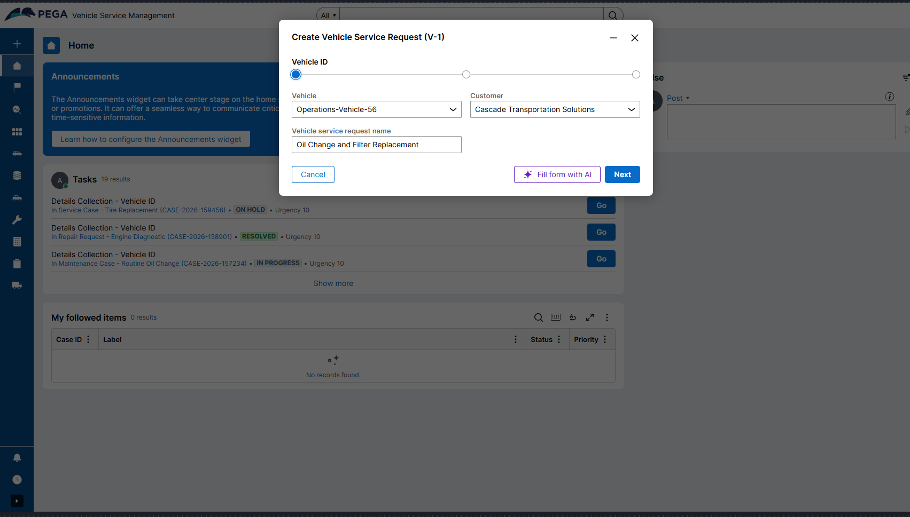
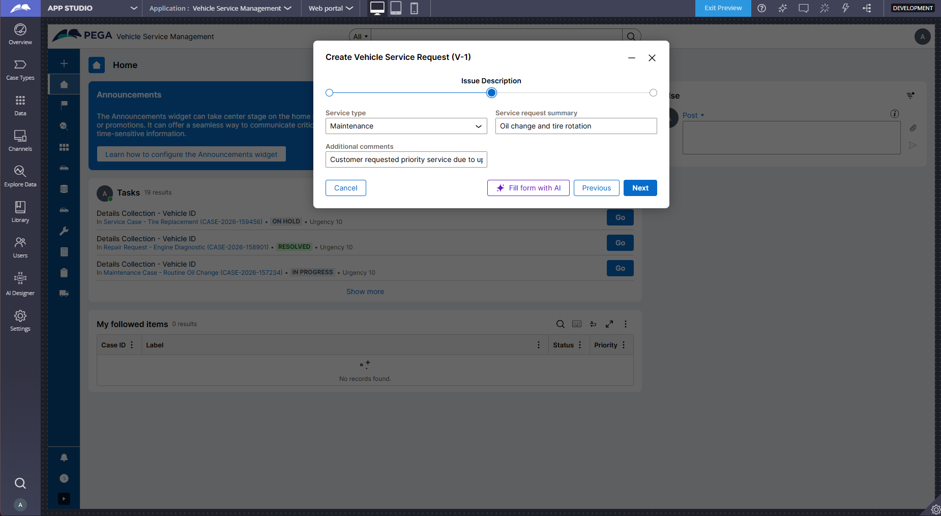
What I built for this (1–2 lines in your own words):
I created a Submit stage where customers can enter Vehicle ID, Vehicle Model, and Issue Description. All fields are marked as required to ensure complete information capture before case creation.

US-002 — Perform Vehicle Inspection
What is expected:
Inspection stage with Service Advisor step. Inspection Notes and Condition Rating captured.
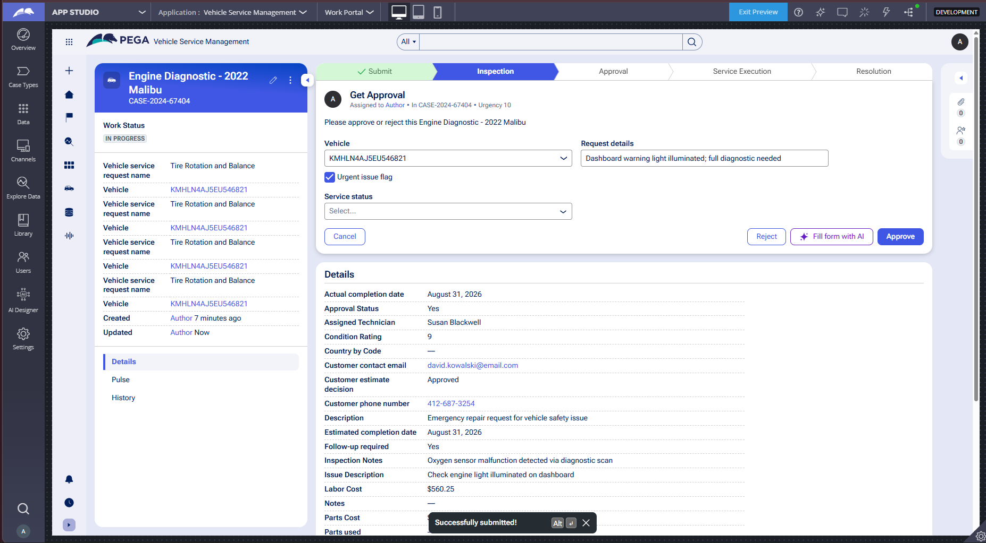
What I built for this (1–2 lines in your own words):
I configured an Inspection stage with a Service Advisor assignment step. The advisor can enter Inspection Notes and select a Condition Rating to assess the vehicle's condition before generating estimates.

US-003 — Generate Service Estimate
What is expected:
Labor Cost and Parts Cost captured. Total Cost calculated automatically by declare expression.
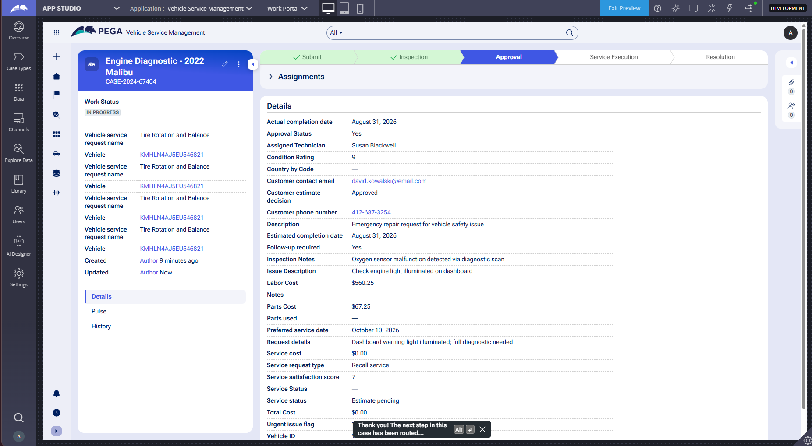
What I built for this (1–2 lines in your own words):
I added Labor Cost and Parts Cost fields in the Inspection stage, and created a calculated field for Total Cost that automatically computes the sum using a business rule when the service advisor enters the cost components.

US-004 — Approve Service Estimate
What is expected:
Approval stage assigned to Customer. Approval Status captured. Flow branches on approve/reject.
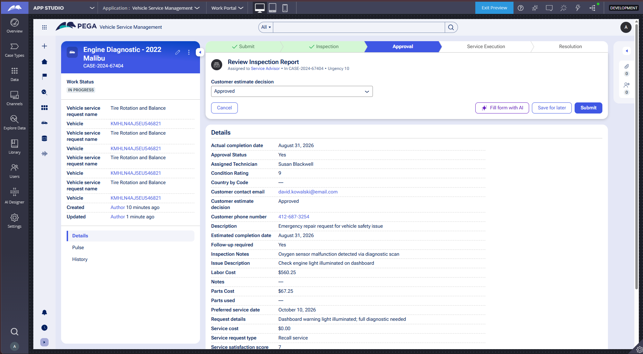
What I built for this (1–2 lines in your own words):
I created an Approval stage assigned to the Customer persona with an Approve or Reject step. The system captures the decision in the Approval Status property and routes the case based on the customer's choice.

US-005 — Maintain Vehicle Data
What is expected:
Reusable Vehicle data object created with Vehicle ID, Model, Type — linked to case.

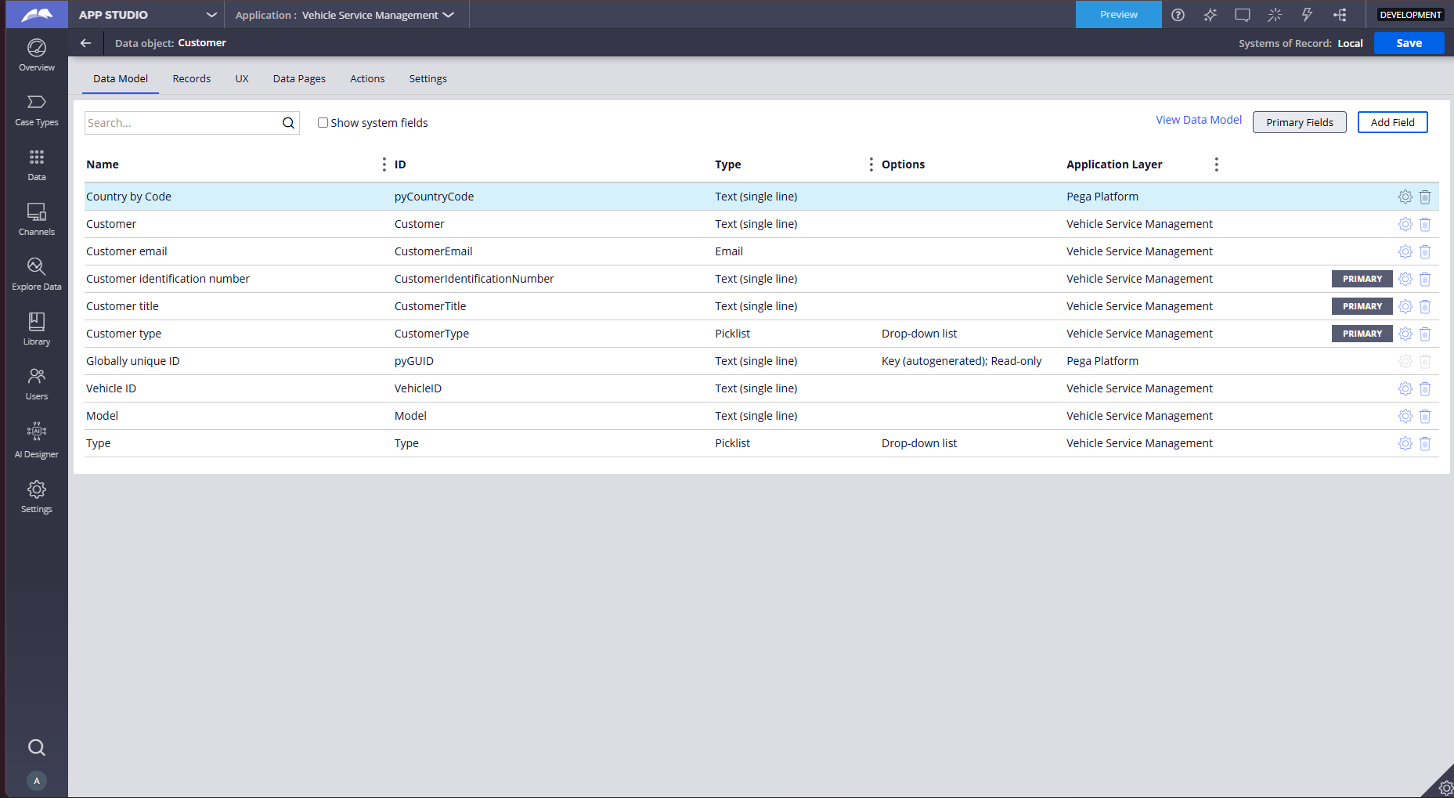
What I built for this (1–2 lines in your own words):
I created a reusable Vehicle data object with three properties: Vehicle ID, Model, and Type. This data object is linked to the Vehicle Service Request case type to enable data consistency and service history tracking.

US-006 — Review Service Estimate
What is expected:
Approval screen shows Labor Cost, Parts Cost and Total Cost clearly to the Customer persona.

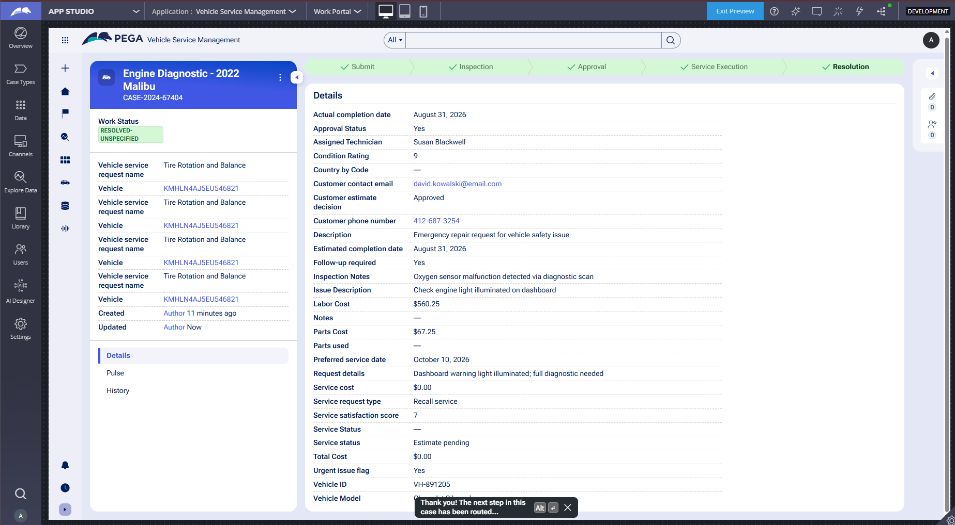
What I built for this (1–2 lines in your own words):
I configured the approval screen to display Labor Cost, Parts Cost, and Total Cost in a clear, read-only format so customers can review all estimate details before making an informed approval or rejection decision.

US-007 — Auto Assign Technician
What is expected:
Service Execution stage with routing to HeavyVehicleQueue or LightVehicleQueue. Assigned Technician and Service Status properties maintained.
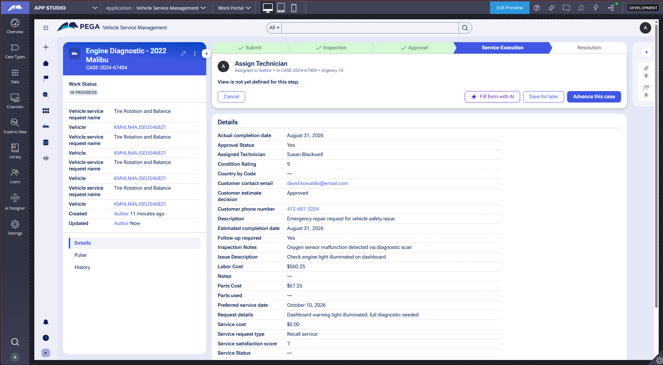
What I built for this (1–2 lines in your own words):
I added a Service Execution stage with an Assign Technician step that routes cases to work queues. The system maintains Assigned Technician and Service Status properties for tracking service fulfillment.

US-008 — Notify Service Completion
What is expected:
Correspondence rule created and triggered on case resolution. Email includes case and vehicle details.
Screenshot — paste your screenshot below this line:
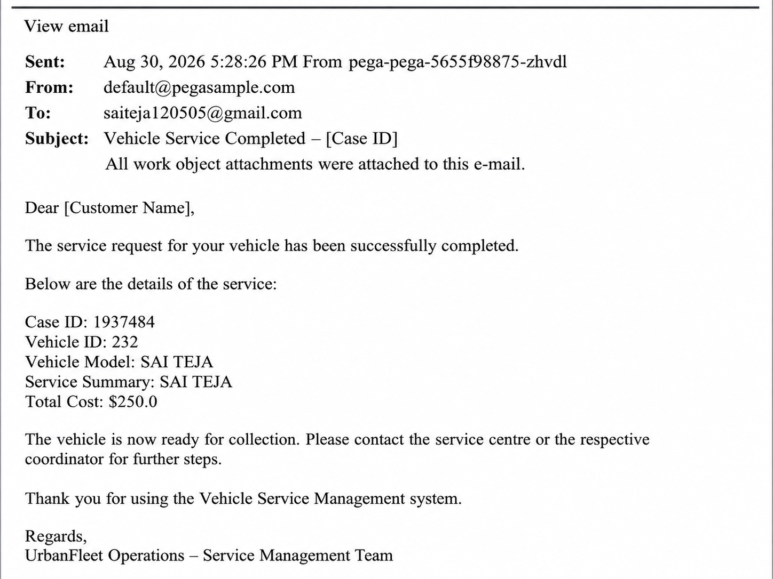
What I built for this (1–2 lines in your own words):
I created a Correspondence rule named ServiceCompletionEmail that automatically sends an email notification to the customer when the case is resolved, including Case ID, Vehicle ID, Vehicle Model, and Total Cost details.

US-009 — Define Service SLA
What is expected:
SLA configured on the case type. Goal: 2 days. Deadline: 3 days. Priority increases on breach.
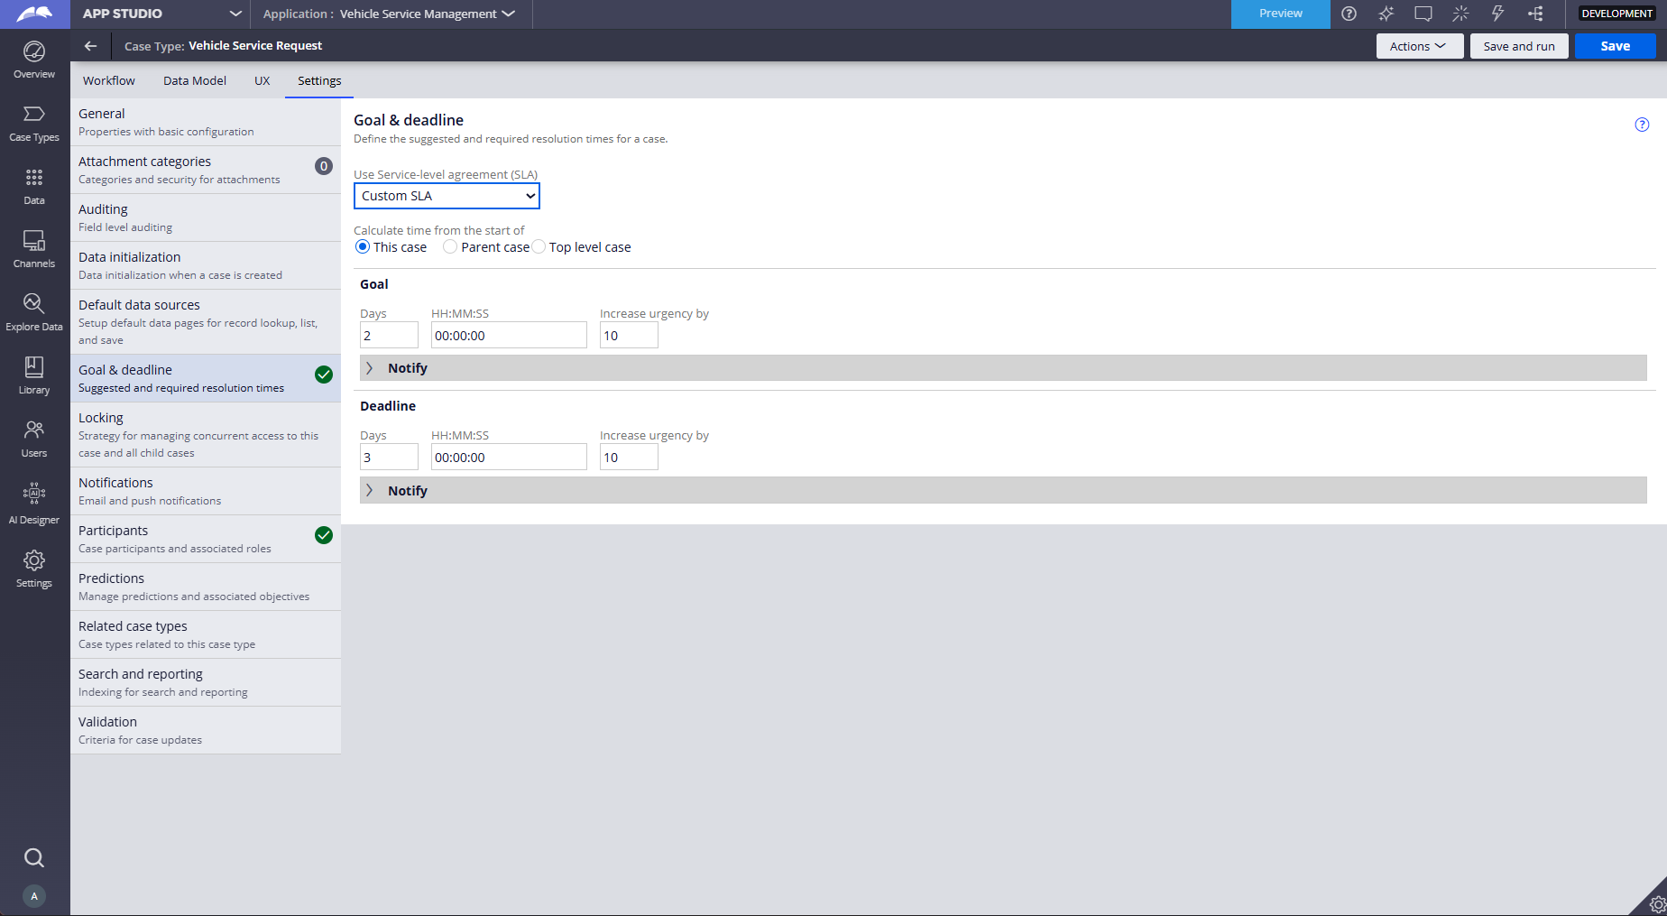
What I built for this (1–2 lines in your own words):
I configured an SLA on the Vehicle Service Request case type with a Goal of 2 days and Deadline of 3 days. The case priority automatically increases when the deadline is breached to ensure timely service completion.

US-010 — Route by Vehicle Type
What is expected:
Routing rule or Decision Table routes to HeavyVehicleQueue or LightVehicleQueue based on Vehicle Type property.

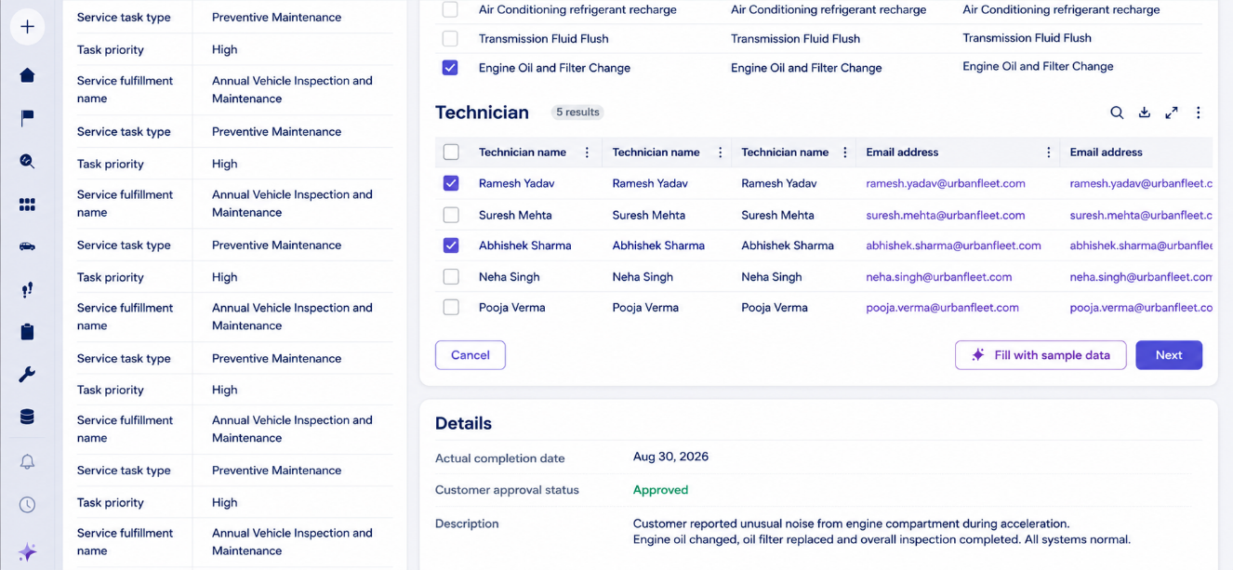

What I built for this (1–2 lines in your own words):
I created a routing rule named RouteByVehicleType that automatically routes cases to HeavyVehicleQueue when Vehicle Type is "Heavy", otherwise to LightVehicleQueue, ensuring proper work distribution based on vehicle classification.

Section 3 — About Your Application
These answers are checked against your screenshots. Write exactly what is in your application.

Q1. List your stages in the order they appear in your case lifecycle.
Stage names in order, separated by commas.
Submit, Inspection, Approval, Service Execution, Resolution

Q2. Name the data object(s) you created and the properties inside them.
Data object name and its properties.
Vehicle data object with properties:
- Vehicle ID (Text)
- Model (Text)
- Type (Text)

Q3. What is the exact name and type of the rule you used to calculate Total Cost?
Provide:
• Rule Name
• Rule Type
• Properties used in the calculation
• Formula used
Rule Name: CalculateTotalCost (or the exact name you used)
Rule Type: Declare Expression (or Calculated Field)
Properties used: Labor Cost, Parts Cost, Total Cost
Formula used: Total Cost = Labor Cost + Parts Cost

Section 4 — Your Understanding
Short, honest and specific answers score well.

Q4. What did Blueprint generate for you, and what did you add or change yourself afterwards?
Be specific about what was already there and what you built or modified on top.
Blueprint generated the basic case lifecycle with 5 stages (Submit, Inspection, Approval, Service Execution, Resolution), created the Vehicle data object, set up the three personas (Customer, Service Advisor, Technician), and created the RouteByVehicleType business rule.

After Blueprint, I manually added:
- The Total Cost calculated field with the calculation formula
- SLA configuration with 2-day goal and 3-day deadline
- Email correspondence rule for service completion notification
- Work queues (HeavyVehicleQueue and LightVehicleQueue)
- Validation rules for required fields in the Submit stage

Q5. Was there anything Blueprint created that you had to correct or configure further? Describe one example.
A real example from your own work.
Yes. Blueprint created multiple data objects (Service Request, Customer, Estimate, etc.) that were not explicitly required for the project. I verified that only the Vehicle data object with the three required properties (Vehicle ID, Model, Type) was properly configured and linked to the case type. I also had to manually configure the Total Cost calculation as Blueprint doesn't automatically create calculated fields.

Q6. Explain your case flow from creation to resolution, in order.
What happens first, who does what, when the case closes.
1. Customer creates a Vehicle Service Request and submits Vehicle ID, Vehicle Model, and Issue Description in the Submit stage
2. Service Advisor performs inspection in the Inspection stage, enters Inspection Notes and Condition Rating
3. Service Advisor generates estimate by entering Labor Cost and Parts Cost; Total Cost is automatically calculated
4. Customer reviews the estimate in the Approval stage and approves or rejects it
5. If approved, case moves to Service Execution stage and is routed to HeavyVehicleQueue or LightVehicleQueue based on Vehicle Type
6. Technician is assigned and performs the service work
7. Case reaches Resolution stage where service completion is verified
8. Customer receives email notification with service details
9. Case is resolved and closed

Q7. Pick two design choices you made in your application and explain why you made them.
For each design choice, provide:
• What you implemented
• Why you chose that approach
• What benefit it provides to the application
Design Choice 1: Calculated Field for Total Cost
- What: I implemented an automatic calculation for Total Cost using Labor Cost and Parts Cost
- Why: This ensures accuracy and eliminates manual calculation errors
- Benefit: The total updates automatically whenever cost components change, ensuring data consistency and reducing service advisor workload

Design Choice 2: Work Queue Routing by Vehicle Type
- What: I created conditional routing to HeavyVehicleQueue or LightVehicleQueue based on Vehicle Type
- Why: Different vehicle types require different expertise and equipment
- Benefit: Ensures proper work distribution, improves service quality, and allows specialized teams to handle appropriate vehicle types

Q8. What was the hardest part, and how exactly did you fix it?
Specific and honest. A real challenge scores much better than a generic answer.
The hardest part was configuring the email correspondence rule to include dynamic case data. I initially had trouble mapping the properties correctly in the email body template.

I fixed it by:
1. Using property references like .pyID for Case ID
2. Testing the email by running a complete test case
3. Checking the email preview to verify all fields populated correctly
4. Referring to the sample email template in the project document to ensure I included all required information

Q9. If the approval step was only needed when Total Cost is above a certain amount, what would you change in your application?
Explain what you would change and where. You do not need to build this.
I would add a precondition or When rule to the Approval stage step in the case lifecycle.

Specifically:
1. Create a When rule named NeedsApproval with condition: Total Cost > 1000 (or any threshold amount)
2. Apply this When rule as a precondition to the Approve or Reject step in the Approval stage
3. Configure the case flow so that if Total Cost <= 1000, the case skips the approval step and goes directly to Service Execution
4. If Total Cost > 1000, the approval step executes and customer must approve before proceeding

This would be configured in the case lifecycle by editing the Approval stage step properties and adding the When rule as a condition.

Q10. List three exact rule names from your application that you personally created or modified.
Include the rule name and rule type for each one (for example: CalculateTotalCost - Declare Expression).
1. CalculateTotalCost - Declare Expression (or Calculated Field)
2. RouteByVehicleType - Decision Table (or When Rule)
3. ServiceCompletionEmail - Correspondence (Email)
Q11. List all personas used in your application.
List the persona names exactly as they appear in your application.
- Customer
- Service Advisor
- Technician
Q12. List all work queues used in your application and explain when each one is used.
For each work queue, provide its exact name and the condition or type of work routed to it.
1. HeavyVehicleQueue
- Used when: Vehicle Type property equals "Heavy"
- Routes heavy vehicle service requests to specialized technicians

2. LightVehicleQueue
- Used when: Vehicle Type property is NOT "Heavy" (Light, Sedan, or any other value)
- Routes all other vehicle types to standard service technicians

