Patricia Hurlocker Date: August 6, 2018

Homework: Weather_py

After collecting weather information from 528 cities using the APIs and creating lists/dataframes to plot the weather data, the following results can be explained for today. Now three months from now, the random cities selected and plotted will show different results.

By definition of weather changes and the changes between the Southern Hemisphere and Northern Hemisphere we will yield something different.

# Starting URL for Weather Map API Call

url = "http://api.openweathermap.org/data/2.5/weather?units=Imperial&APPID=" + api_key

# Get current weather

url = <http://api.openweathermap.org/data/2.5/weather?>

Either way, the visualization is a wave. The Latitudes vs Temperatures is consistent with cooler temperatures in the highest parts of the Northern and Southern Hemispheres. It is winter in the Southern Hemisphere (cooler) and summer in the Northern Hemisphere. As you get close to the Equator, the temperatures are up. The cities and communities near the Equator are always have **warm temperatures, tropical by nature, overcast** with rain (unless the Trade Winds are blowing). These bands always are just above +20 and below -20 of the Equator.

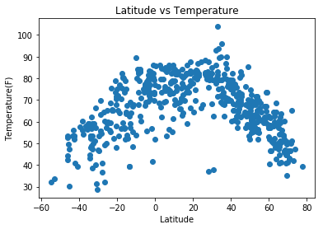

Looking at the other three plots, the information is not as clear cut.

Latitudes vs Wind Speeds – windspeed is a measurement which is constantly moving with rates of change moving from high pressure to low pressure. With the wind comes clouds and possibly rain/real weather. We see from the plot below, windspeed appears to fall within a range of 2-10 mph. There are outlies that are above 30 mph which indicate an atmospheric depression.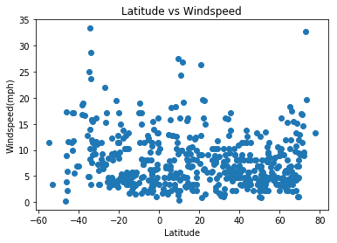

Latitudes vs Cloudiness – has a different and thought-provoking plot. I see both high and low cloudiness, but the data is inconsistent. Clouds form and either drop rain or get blown by the jetstreams. Some areas are always cloudy and others have minimal cloud development.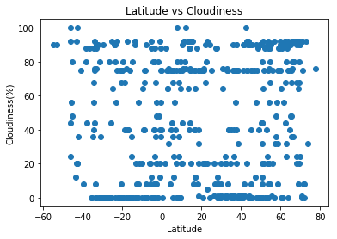

Latitudes vs Humidity – has a strong correlation to temperature/heat. You can see that the high humidity is between -20 and +20. The weather near the Equator is typical of high humidity due to water evaporation and condensation. Once the humidity is so high and the air is saturated, it will rain. The rains will come in the Equatorial regions and if you are near water.

