Patricia Hurlocker Date: July 31, 2018

Homework: pyPHARMA

The observed analysis from the pyPHARMA data is as follows:

1. Capomulin provides the greatest interest in the drugs chosen for this trial.
2. Capomulin provides the least tumor volume increase with a declining trend as compared to the Placebo, Infubinol, and Ketapril.
3. Lab mice have an 85% survival rate on with the treatment of Capomulin.

OBSERVATIONS

The Placebo (no treatment) used as a baseline, reveals the cancer spread decreased for ALL drugs and the Capomulin showing the least spread of the three drugs of interest. The total volume of the cancer for Infubinol, Ketapril and Placebo increased over the 45 day treatment 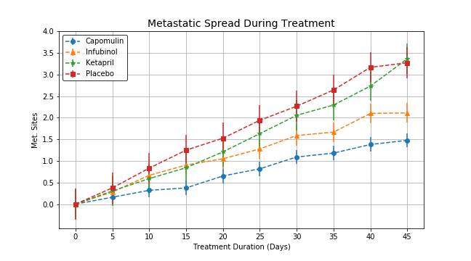

The tumor response to the treatments reveal a down ward trend for Capomulin:

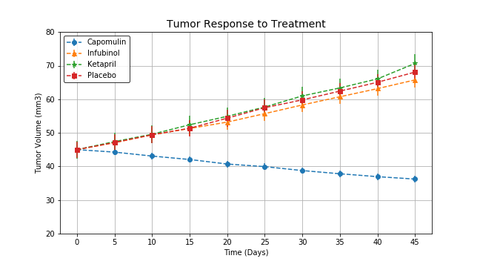

1. Capomulin is the only treatment with a decreasing total volume and a volume change over a 45-day treatment.
2. The drugs Infubinol, Ketapril and the Placebo increased over the 45 day treatment.

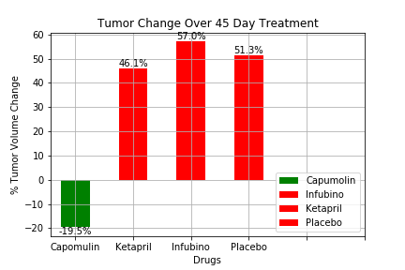

The survival rate for the mice decreased which means that it is tough to be a lab team member. The data suggests that for all courses of treatment, a mouse has an ~ 85% survival rate after 45-days indicating the course of treatment with Capomulin has the best outcome for extending life expectancy. The concern is the quality of life on any of these drugs.

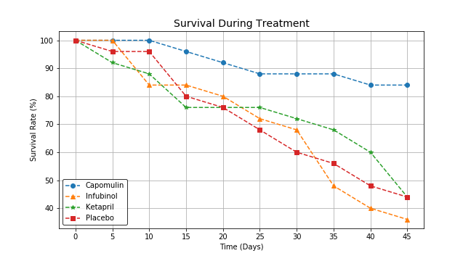

The Placebo (no treatment) used as a baseline, reveals the cancer spread decreased for ALL drugs and the Capomulin showing the least spread of the three drugs of interest.