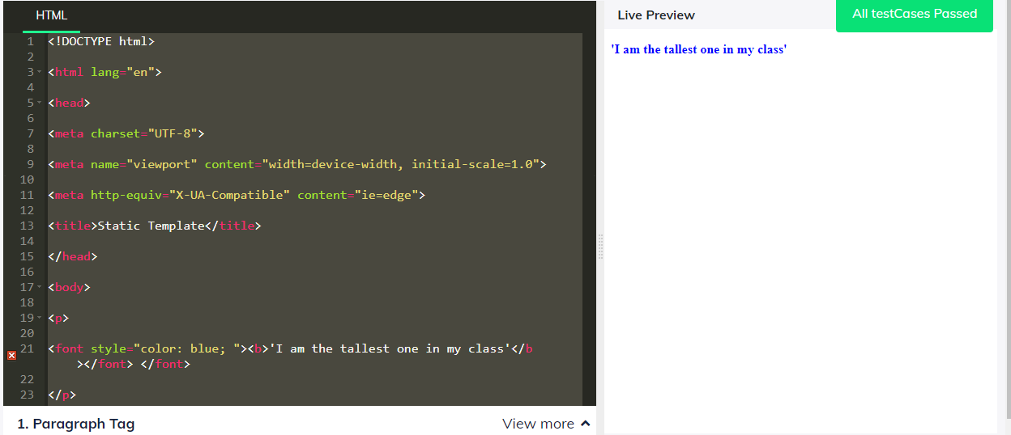

2. Highlight the word 'Attitude' with background color as green in the paragraph 'Attitude plays a major role in life of a person' and the whole paragraph text should be in bold format

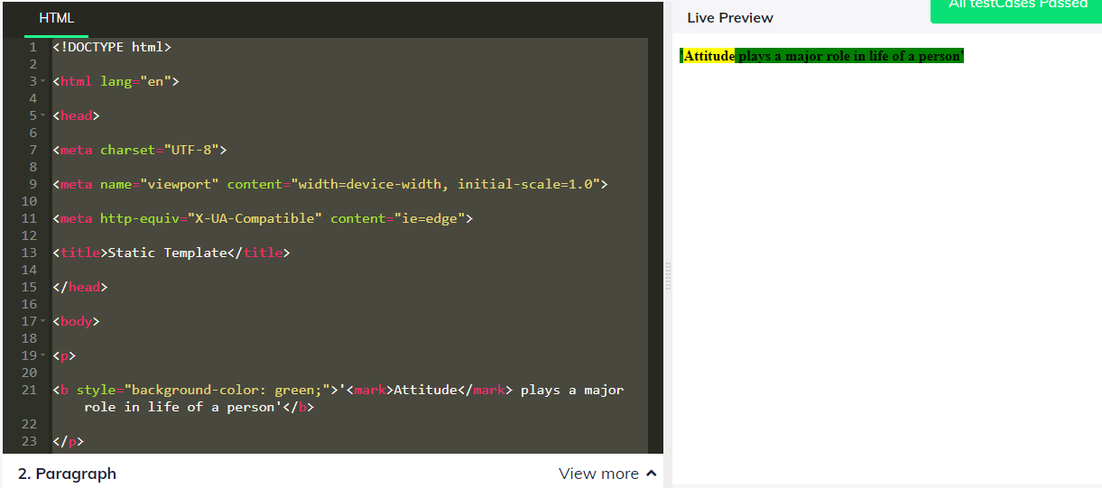

3. Create an ordered list with identifiers as numerals and list items as Alex,Deeksha,Ray,Neha

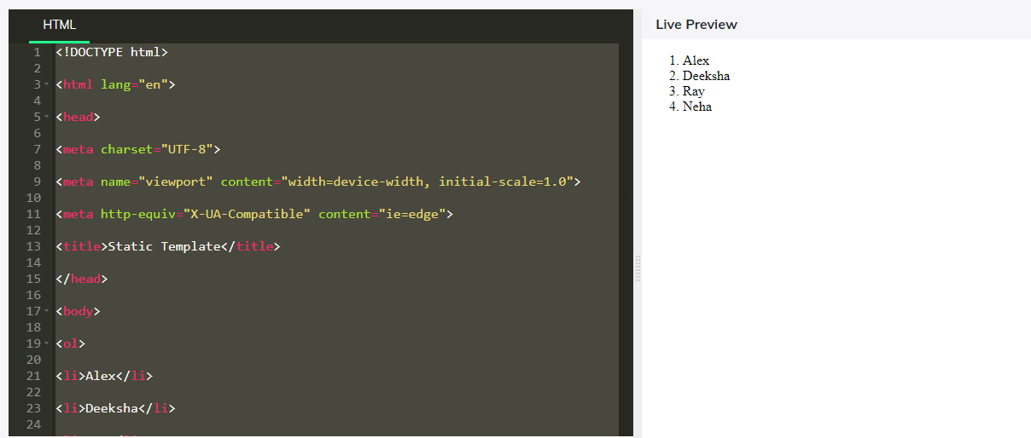

4. Quote using double quotes the word scripting in the sentence "This can be defined as scripting"

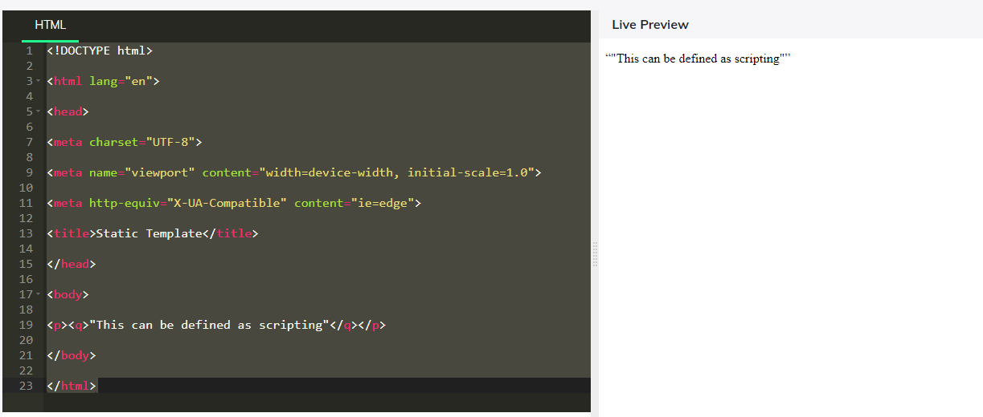

5. Create a textarea of row size as 3 and column width as 120 with content " Lorem Ipsum is simply dummy text of the printing and typesetting industry. Lorem Ipsum has been the industry's standard dummy text ever since the 1500s, when an unknown printer took a galley of type and scrambled it to make a type specimen book".

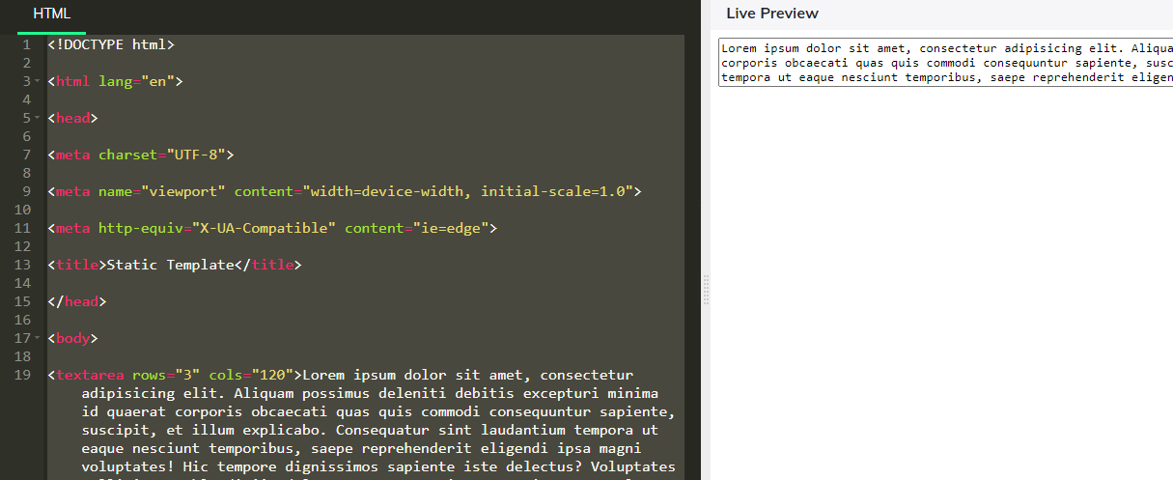

6. Display largest heading "SkillSet" and skillset of a student with the help of progress bars whose attribute value (for and id must be of file) Java with 72%, Python with 95%, C with 63% and C++ with 43%

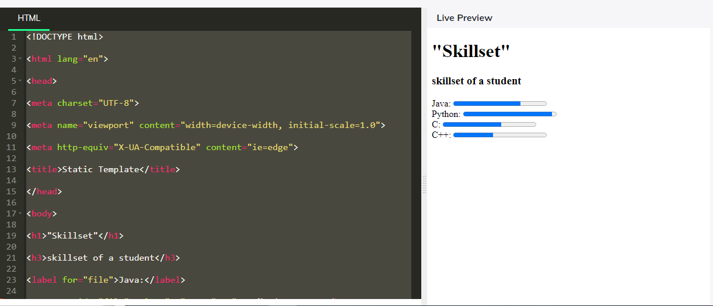

7. Display a text "All is Well" as the largest heading with horizontal and vertical shadow of 2px in red color

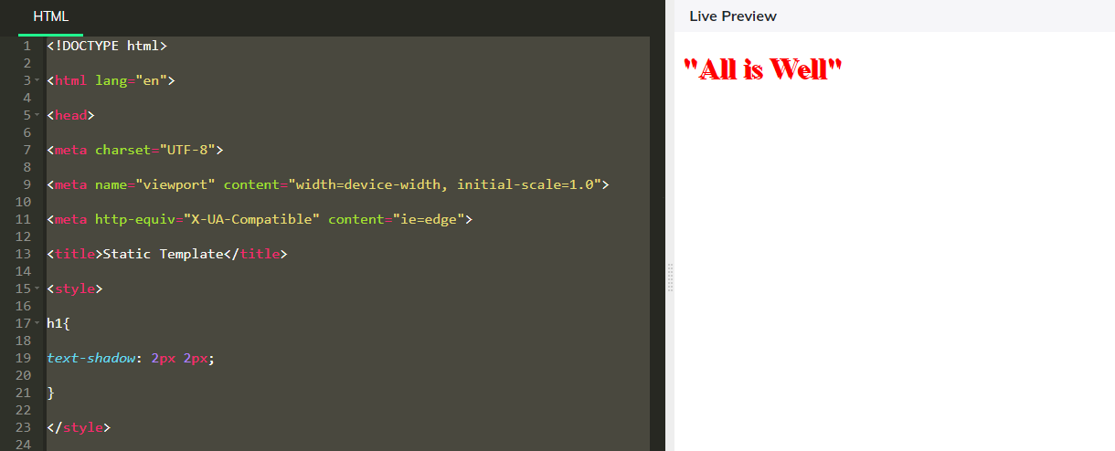

8. Display the given content using the div tag " Culture is the set of knowledge acquired over time. In this sense, multiculturalism values the peaceful coexistence and mutual respect between different cultures inhabiting the same planet. Sometimes "culture" is also used to describe specific practices within a subgroup of a society, a subculture or a counterculture". with an indent of 50px.

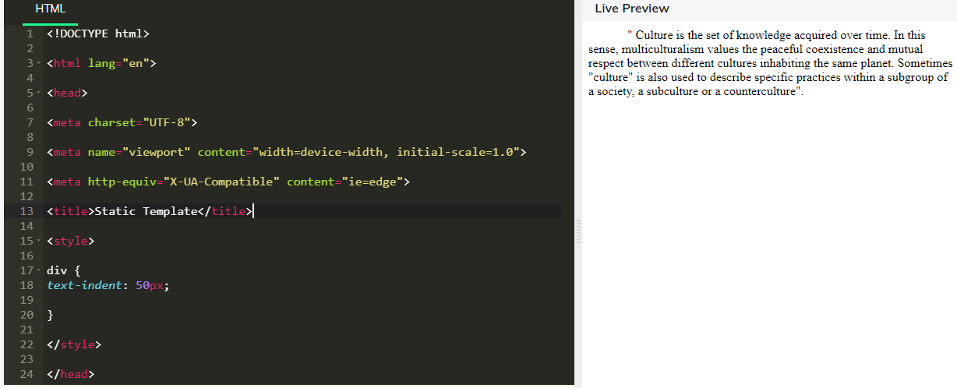

9. Display the words with a spacing of 1cm in the paragraph "Stitch in time saves in nine".

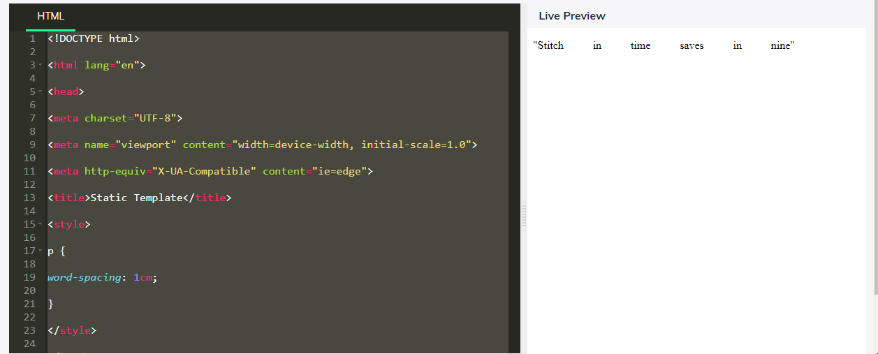

10. Subscript the word 'Honesty' in the paragraph "Honesty is the best Policy"

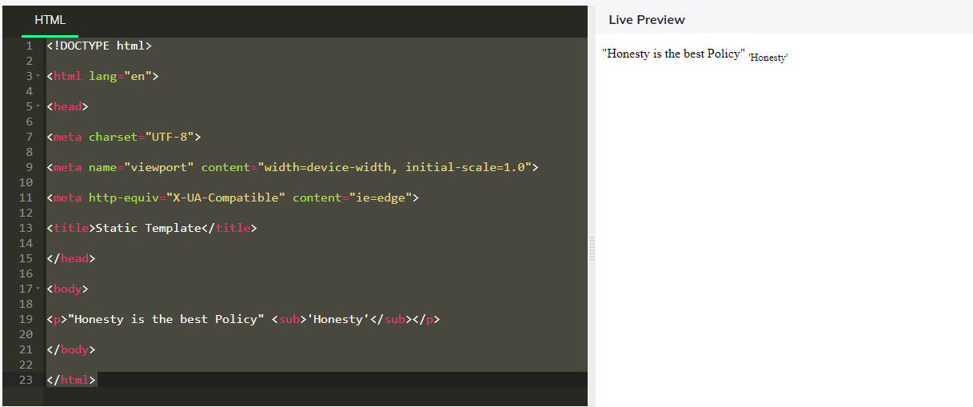

11. Add font-family 'courier' to the given paragraph text "This is a paragraph"

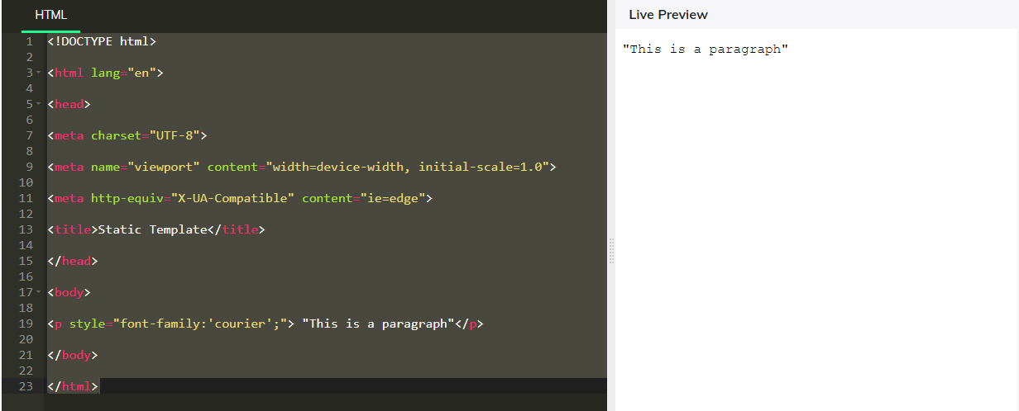

12. Given a paragraph "I am a quick grasper". Make the text "I am a' "as bold and "quick grasper" as italic

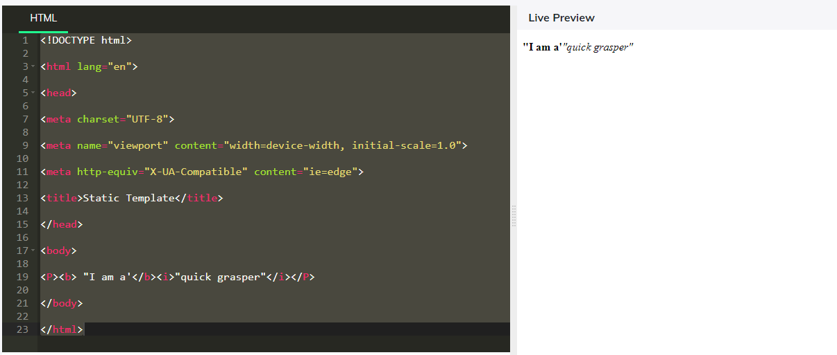

13.

Display a link "www.google.com" with href= 'www.google.com' and change the color of the link to red when it is visited, and change the color to green when it is moused over

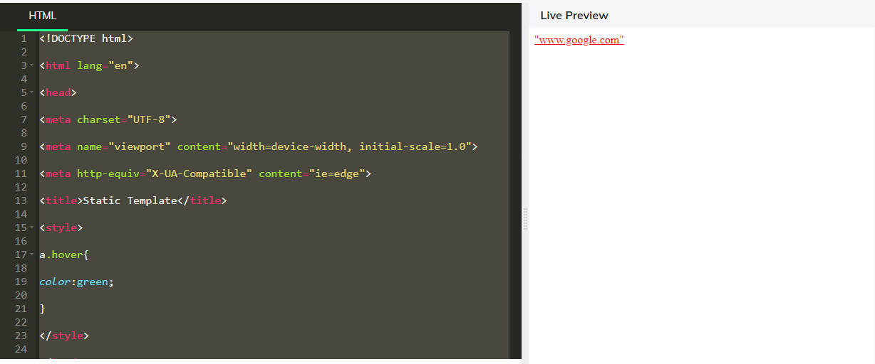

14. Display a button with value "Click Me!" and reduce its opacity to 0.5 when it is hovered

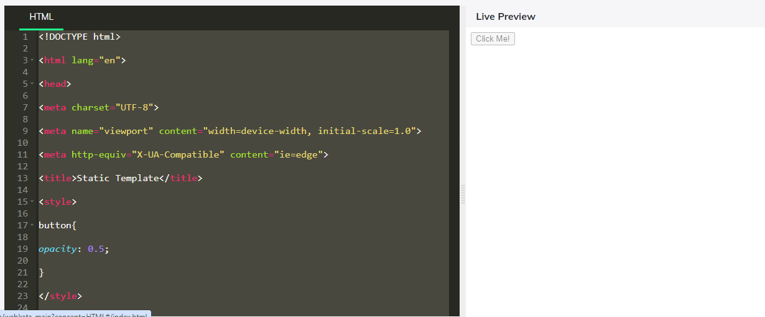

15. Create an empty div element with a height of 200px and width of 50% with background color set to pink

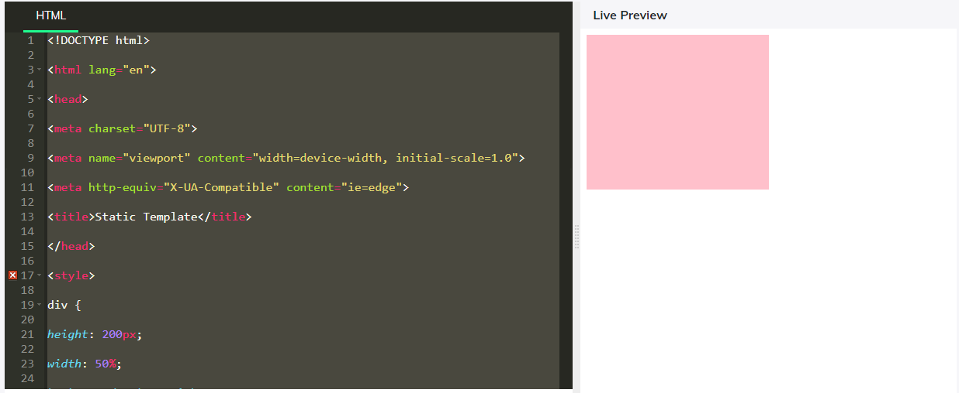

16. Align heading h1 with text "I am at right side of the page" at the right side of web page

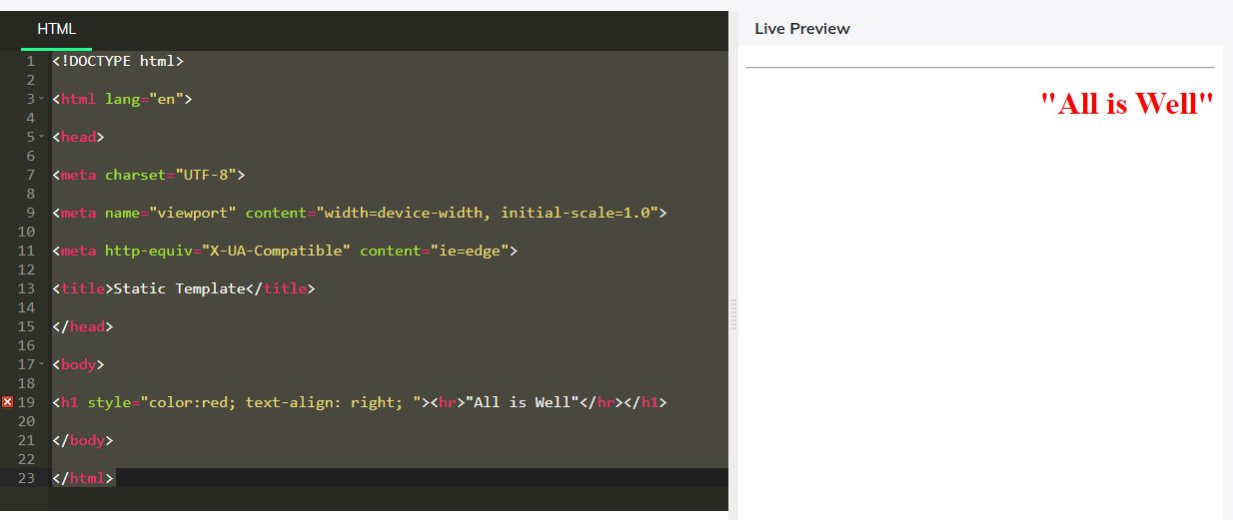

17. Underline the text "I am highlighted by underlining me"

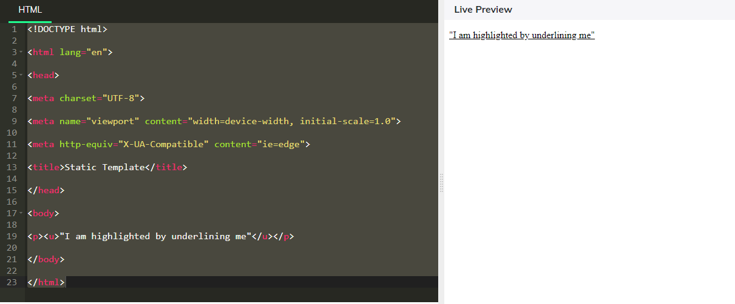

18. Rotate a paragraph by 160 degrees in the clockwise direction. The paragraph is "This div element is rotated clockwise 160 degrees." this paragraph should come after heading h1 with text 'Rotation'

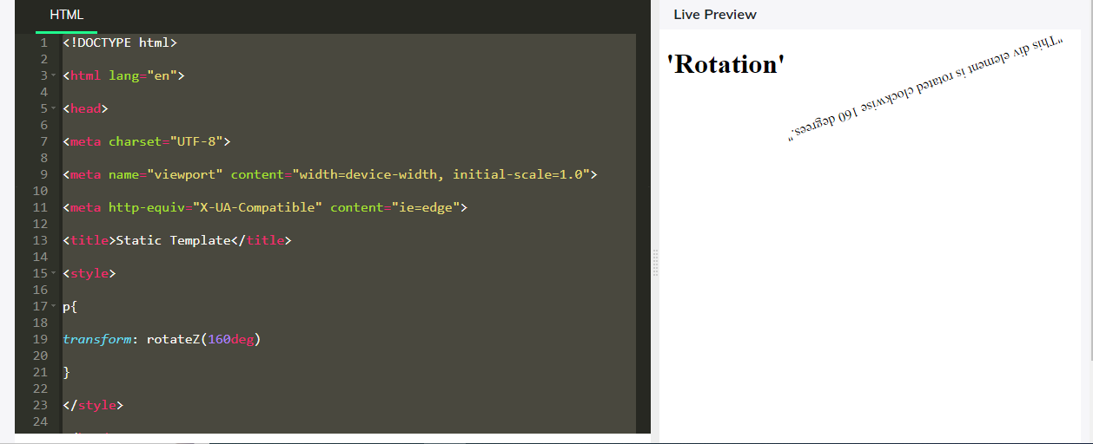

19. Create a pagination denoted with page numbers from 1 to 7. using a tag .And also change the display property of the pagination to inline-block

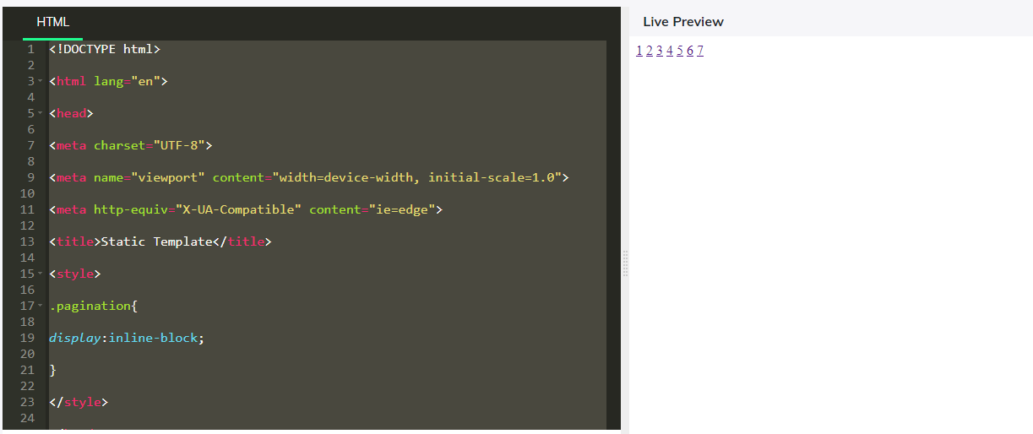

20. Create a border of width 2px solid black around the text "I can be resized vertically" with a padding of 20px and give it an option to resize vertically when we drag the bottom right corner also add the overflow property to auto

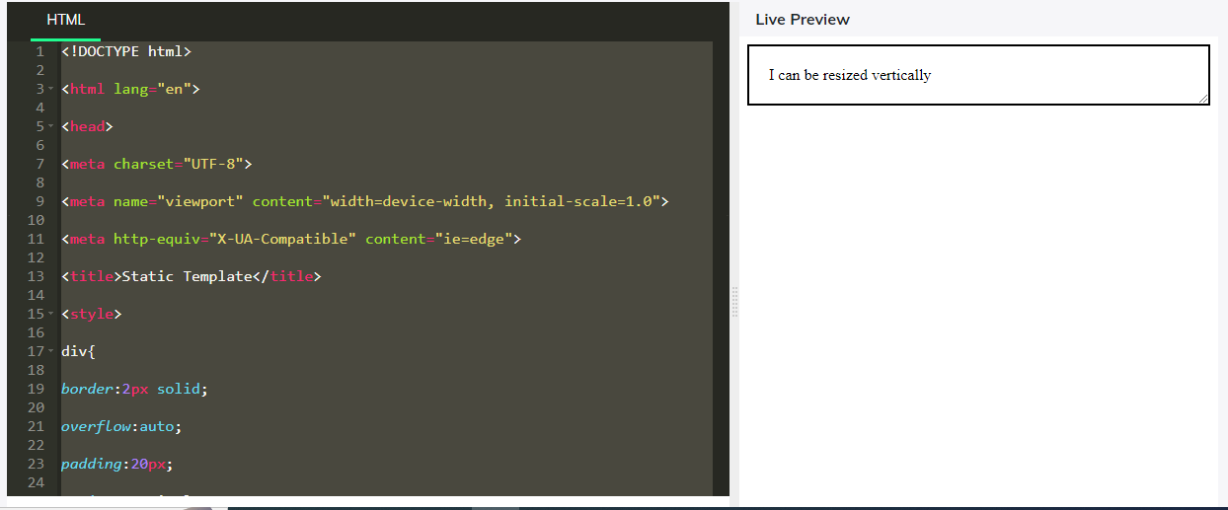

21. Strike the whole context of paragraph "Honesty is the best Policy"

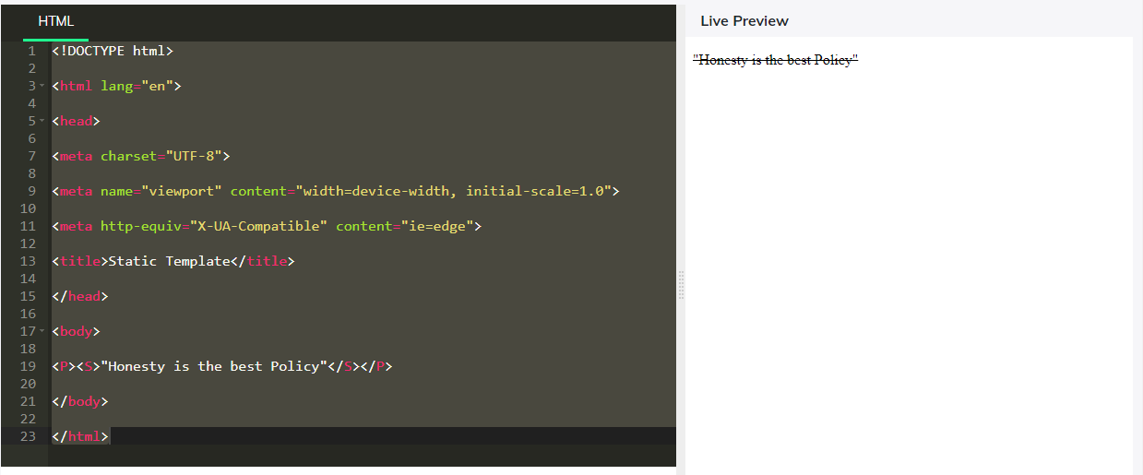

22. Create list items such as Coffee,Milk. List item Coffee should have description "Black hot drink'" and Milk should have description "White cold drink"

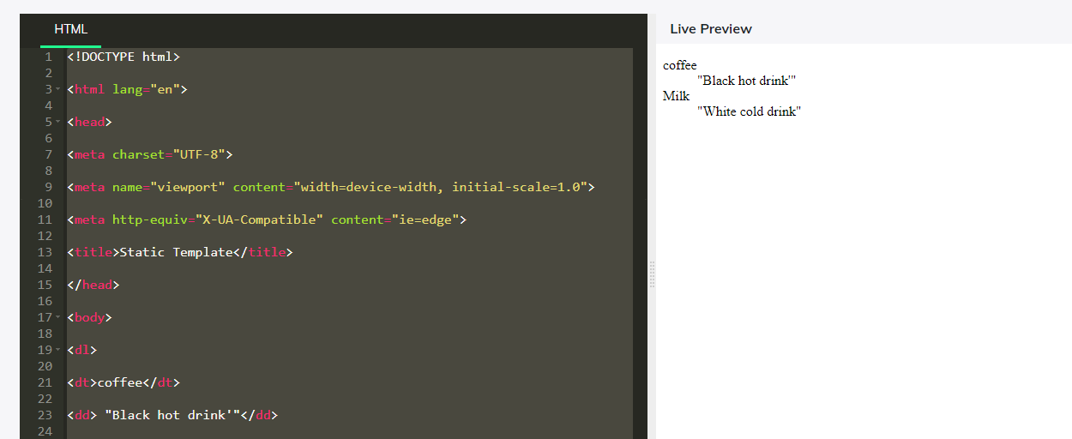23. Add font-family 'Arial' to the given paragraph text "This is a paragraph"

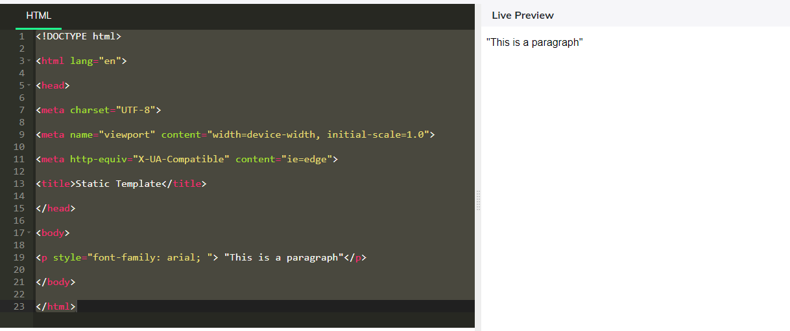

24. Display "Hello Everyone!!!" in a paragraph tag.

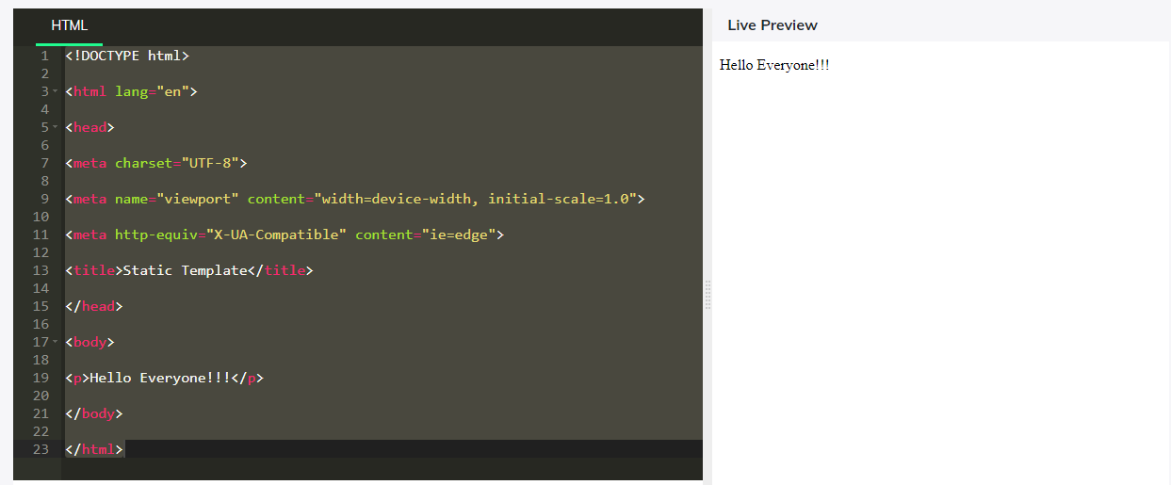

25. Display 'GUVI GEEK' in a h1 tag

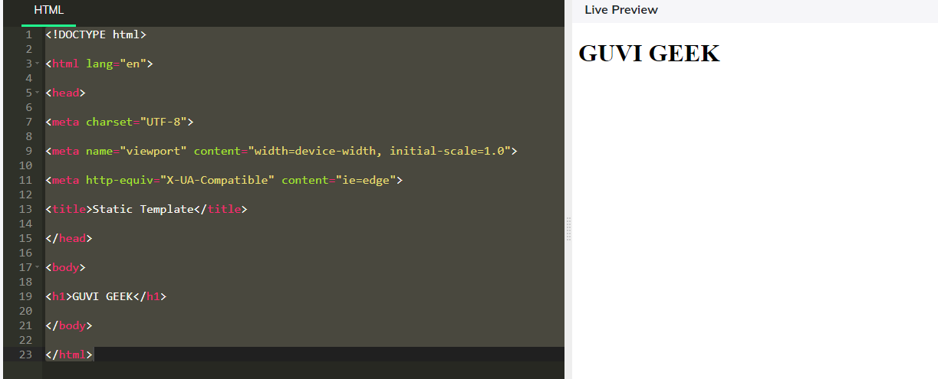

26. Display "Hello From Guvian" using a paragraph tag

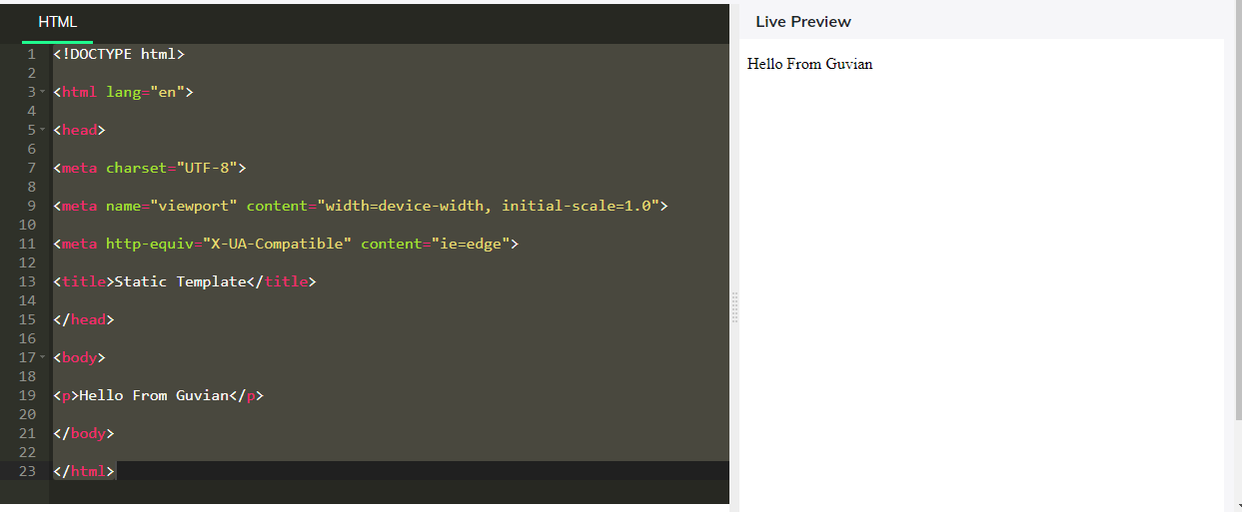

27. Display ''Hello from Guvian" in red colour in H1 tag

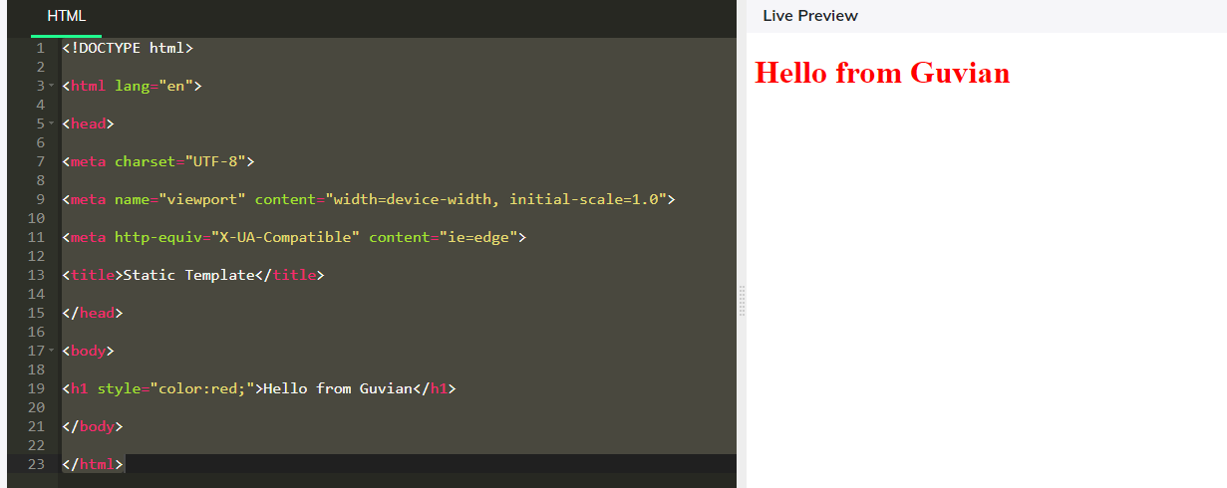

28. Display "Hello from guvian" with background colour. (red) in paragraph tag

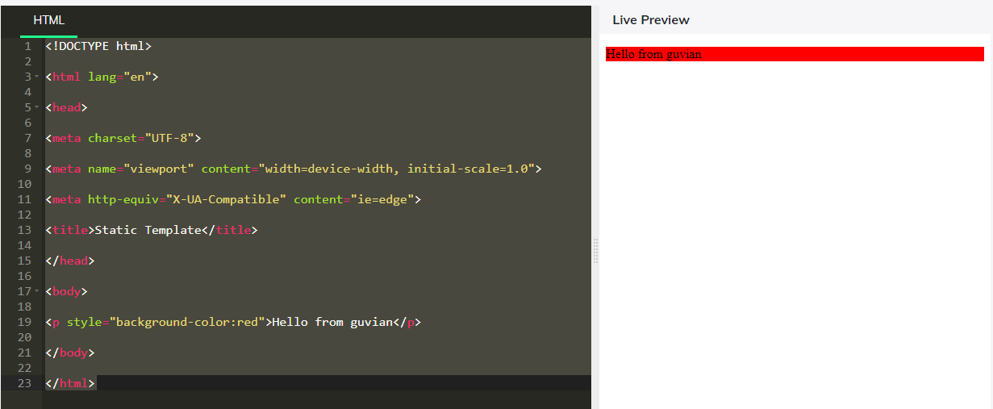

29. Display a text "Hi, How are you?" in bold tag.

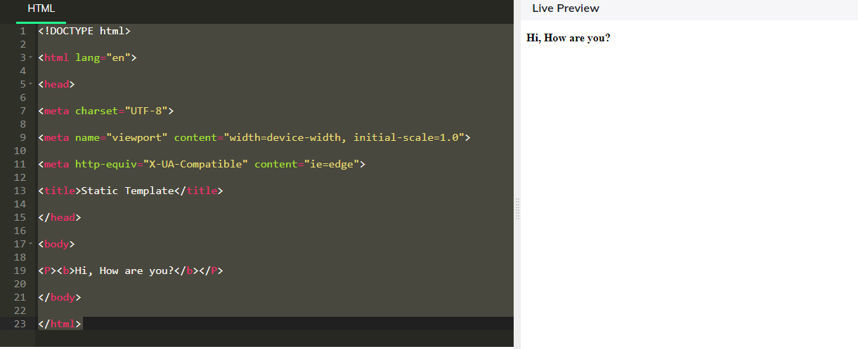

30. Display an ordered list with coffee,milk,tea items.

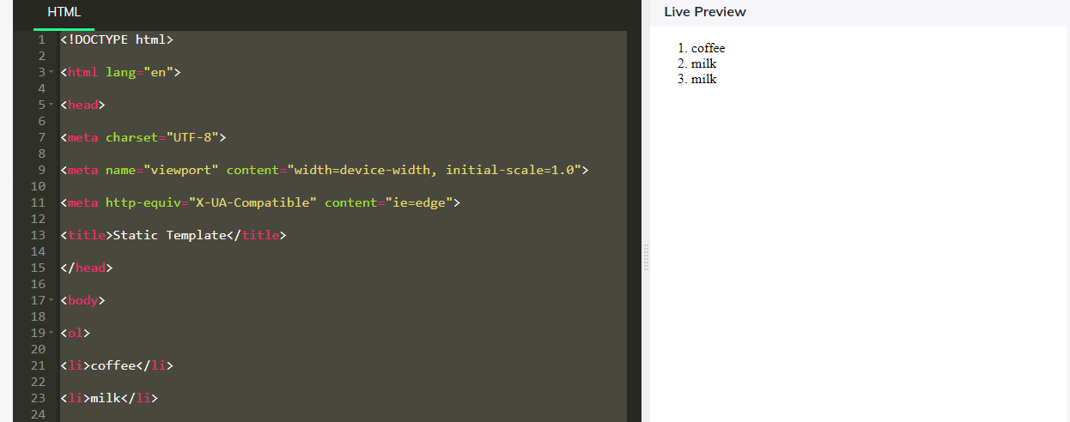

31. Display an unordered list as inline with elements HTML,CSS,JS

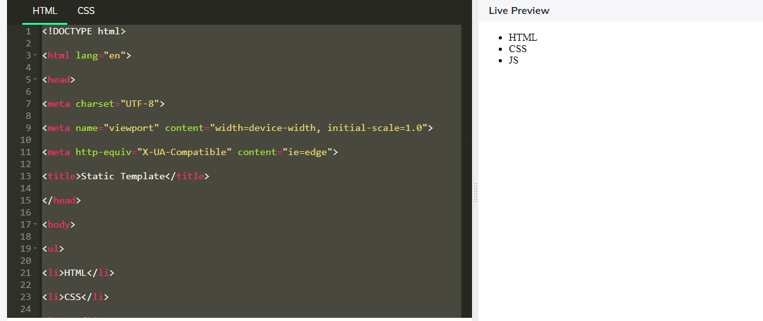

32. Underline the given text "Cookies" using html tag.

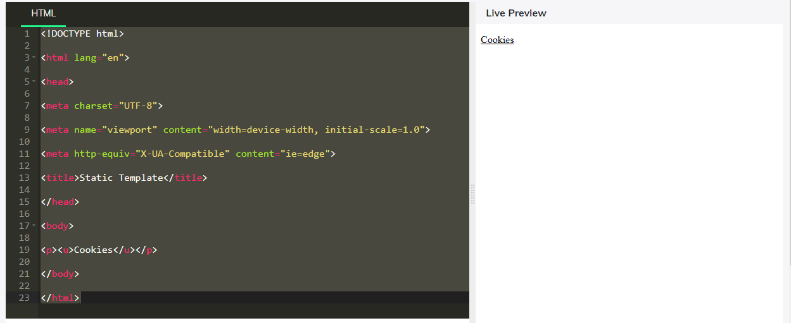

33. Display the text "GUVI GEEK" ranging from h1 to h6 tags in html.

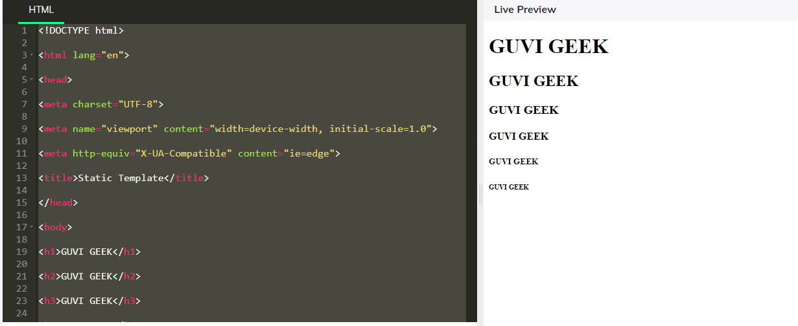

34. Mark the word 'Google' in the given paragraph 'Google more to explore the things' use p tag

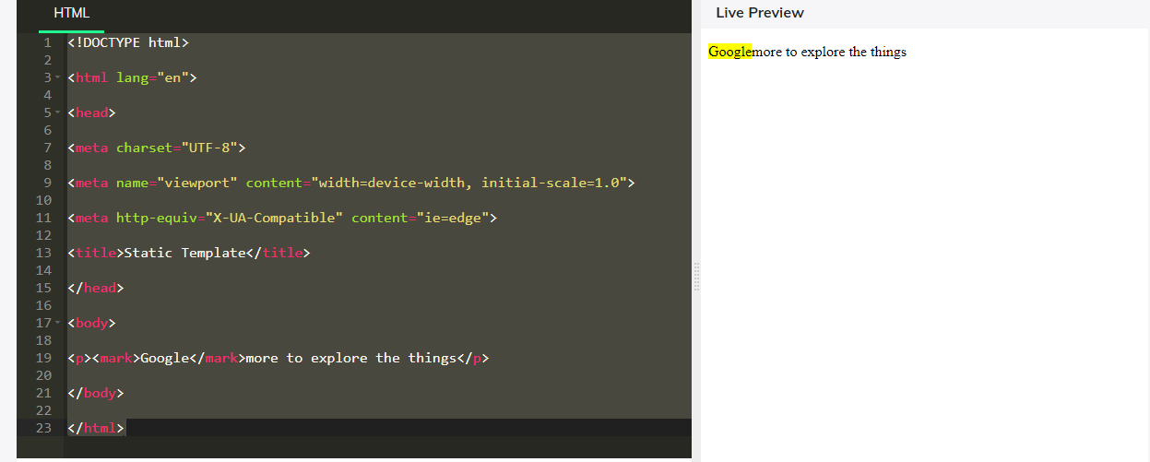

35. Superscript the word 'Well' in the given paragraph 'All is Well'

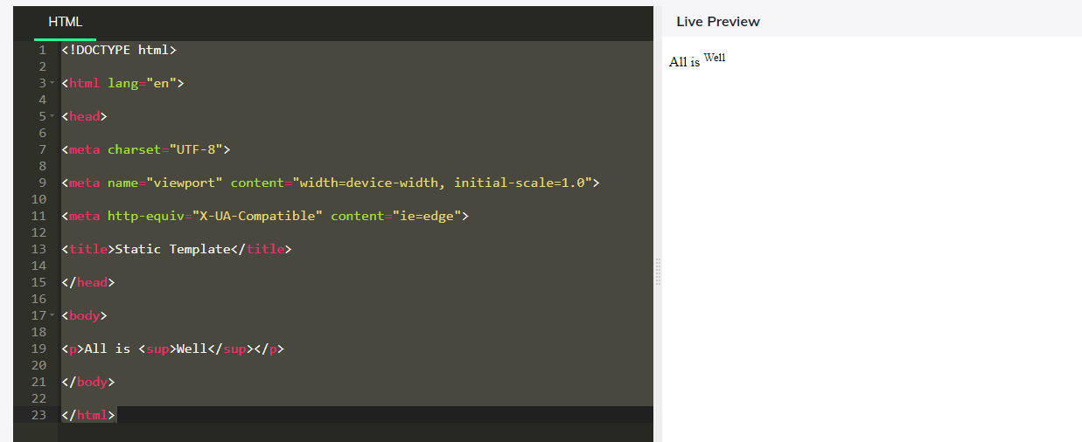

36. Subscript the word 'Hard' in the paragraph 'Work Hard'

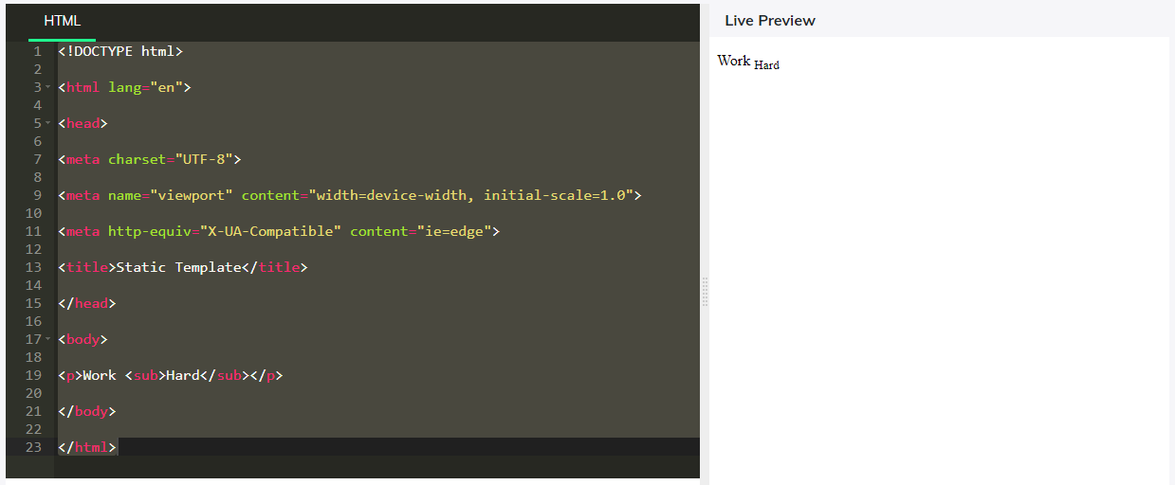

37. Separate the given two paragraphs 'I am first' and 'I am second' with a line between them using a tag in html.

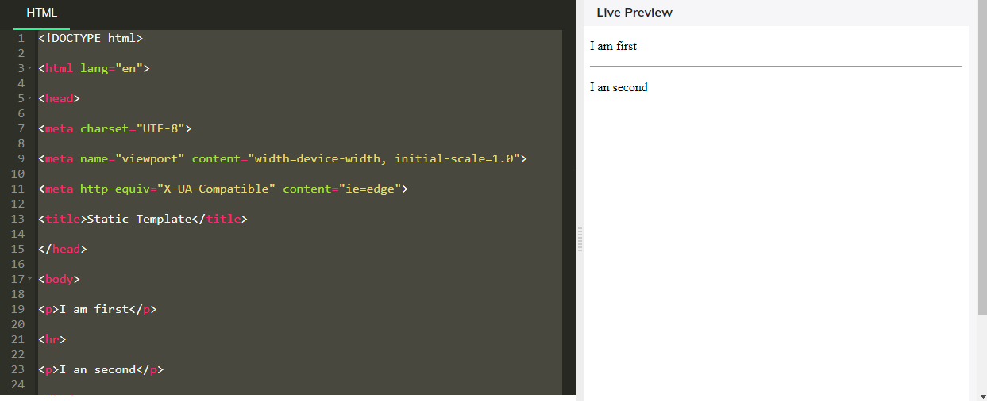

38. Create a table of width 100% and table header's Firstname, Lastname, Age.

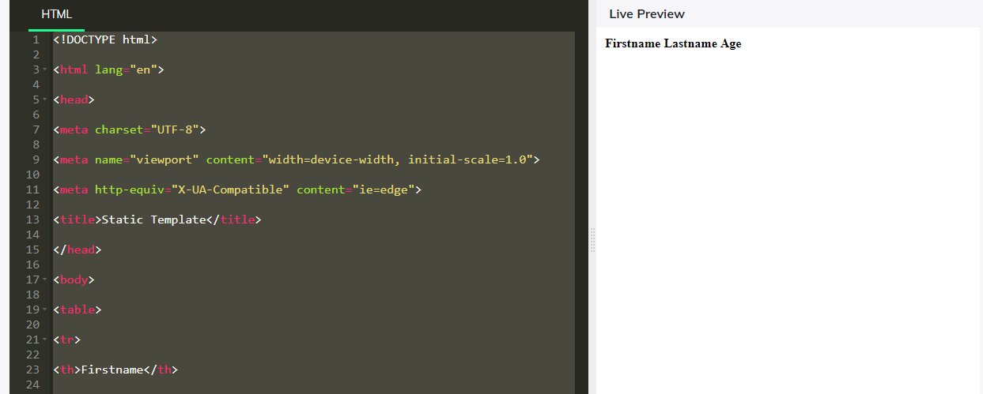

39. Superscript the word 'Honesty' in the paragraph "Honesty is the best Policy".

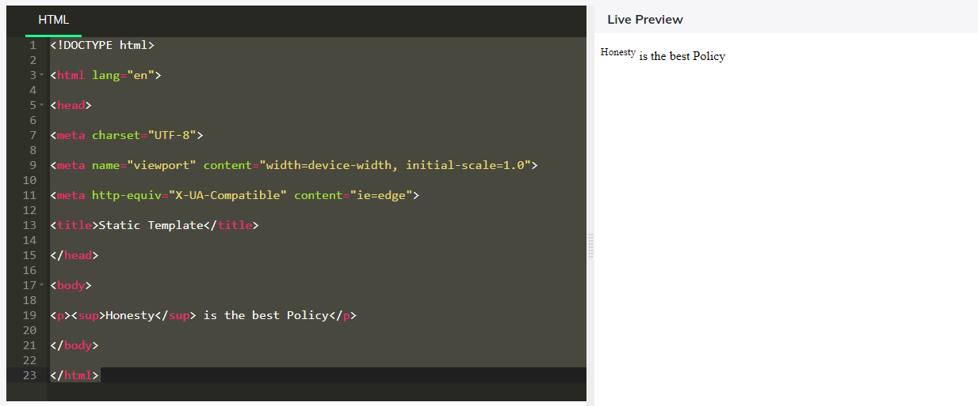

40. Display a border with a border radius of 25px with 2px thick red color around the text "The border-radius property defines the radius of the element's corners".

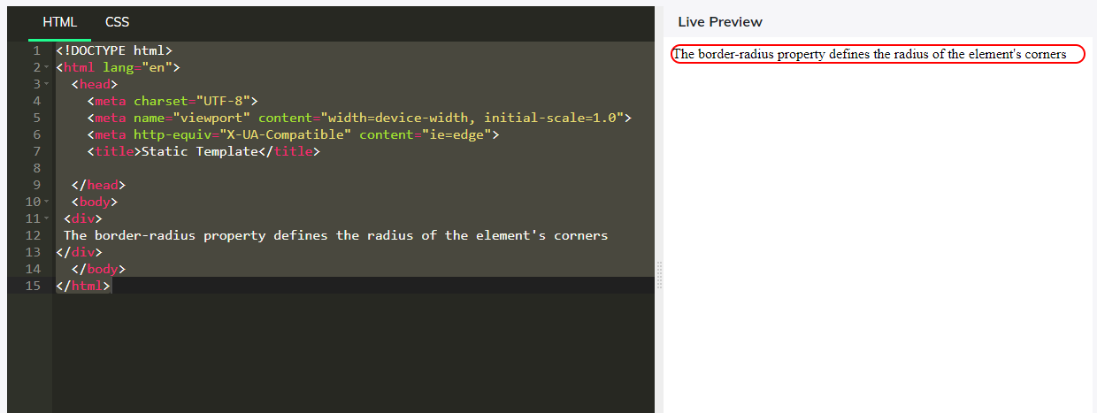

41. Given a paragraph "I am a quick grasper". Mark the above text as the italic

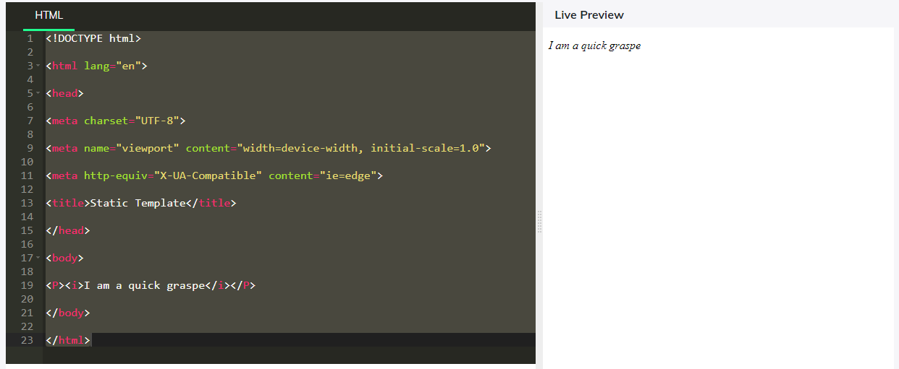

42. Display "This is a paragraph" in a bold tag

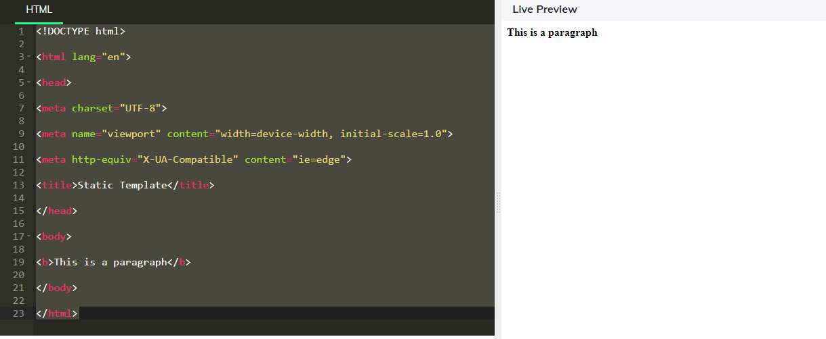

43. Display an ordered list with text ONE, TWO, and THREE as list elements.

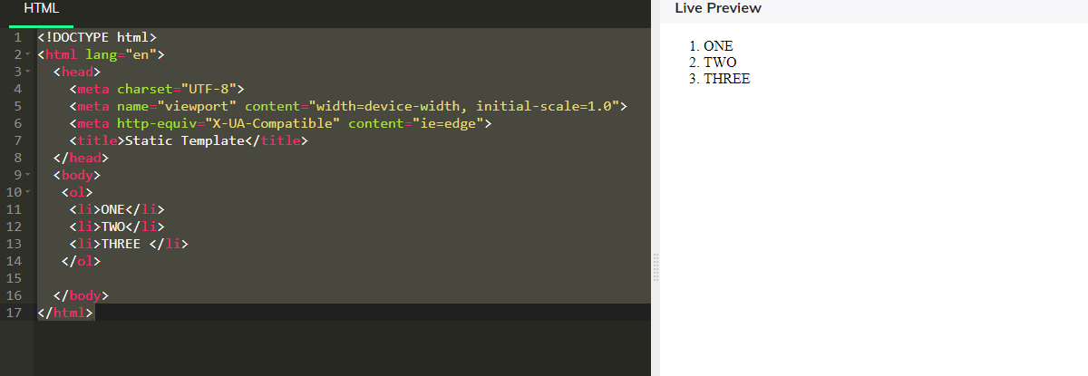

44. Display an ordered list with text ONE, TWO, and THREE as list elements and ordered with alphabet characters like a, b, c....

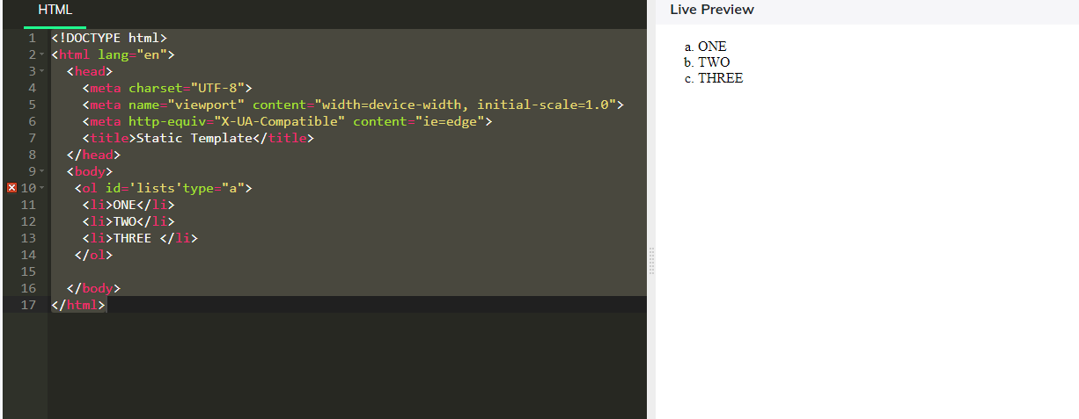

45. Display an ordered list with text ONE, TWO, and THREE as list elements and ordered with roman characters like I, II, III, IV, ....(use id as 'lists')

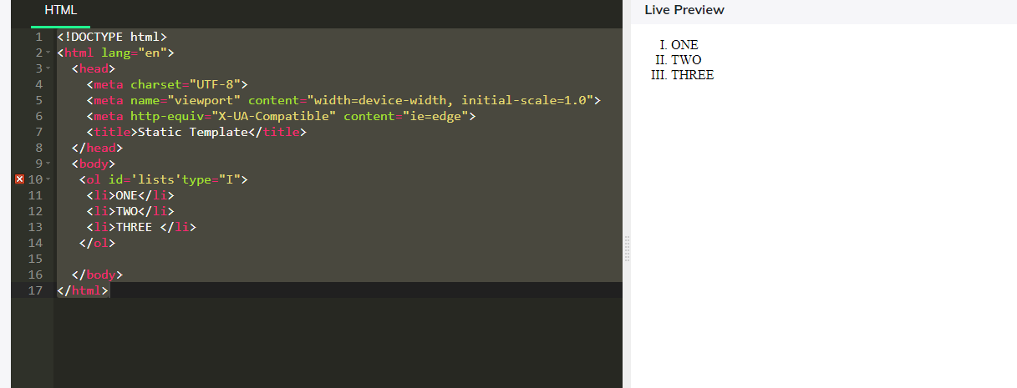

46. Display an ordered list with text ONE, TWO, and THREE as list elements and ordered with roman characters like i, ii, iii, iv, ....

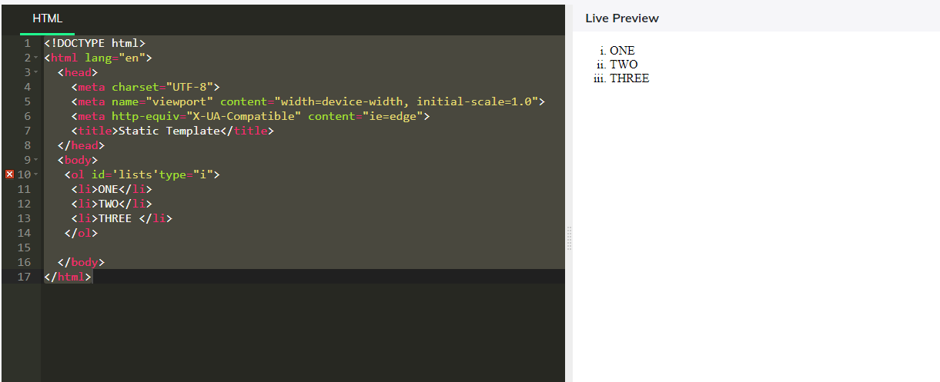

47. Display an unordered list with text ONE, TWO and THREE with list-style-type as "disc" using inline CSS

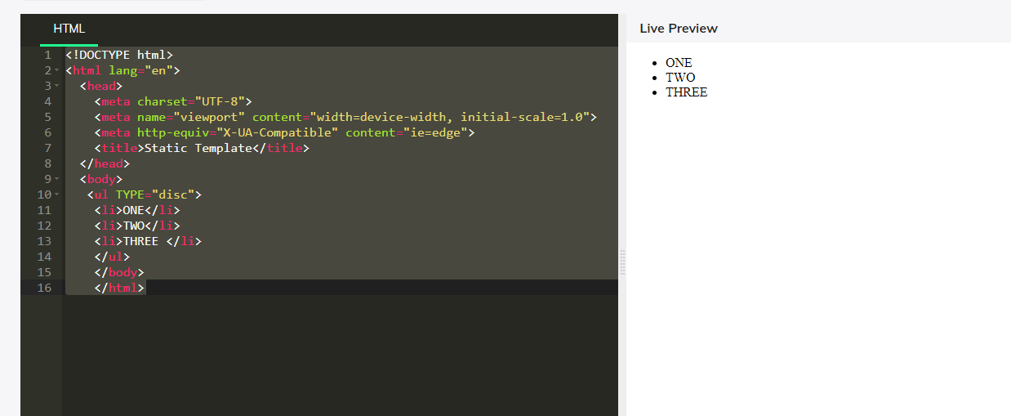

48. Display an unordered list with text ONE, TWO and THREE with list-style-type as "circle" using inline CSS

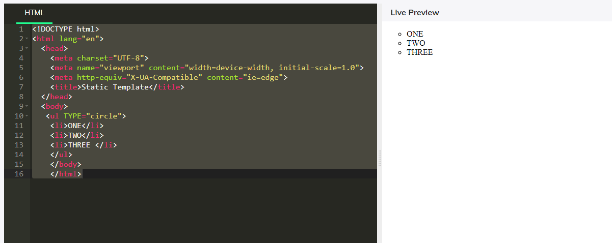

49. Display an unordered list with text ONE, TWO and THREE with list-style-type as "square" using inline CSS

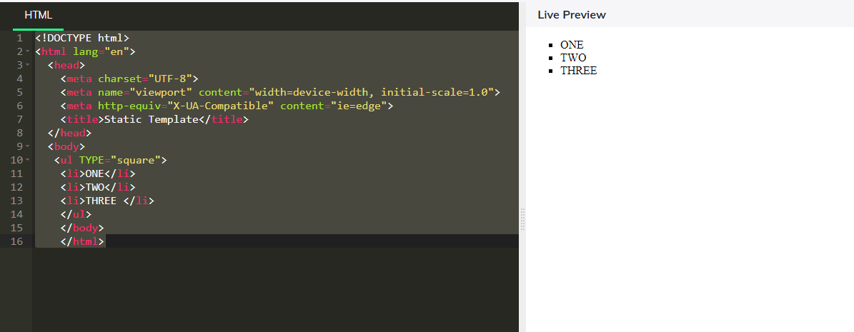

50. Display the given unordered list with text ONE, TWO and THREE without any list style using inline CSS

