**Automated Sleep Stage Classification using Machine Intelligence Techniques: Physiological Signals, Sleep Data Presentation, and Models**

Santosh Kumar Satapathy1,*, Aman Patel1, Om M. Patel1, Visarth Dhorajiya1

1 Department of Information and Communication Technology

1Pandit Deendayal Energy University, Gandhinagar, India  
Santosh.Satapathy@sot.pdpu.ac.in

**Abstract.** Advancements in clinical practice has led to the classification of sleep stages (SSC) establishing an essential step up for physicians when evaluating sleep patterns and diagnosing sleep disorders. Nevertheless, the conventional method of sleep stage classification heavily relies on the manual efforts of sleep experts, presenting a time-consuming and labor-intensive process. To overcome this challenge, computer-aided diagnosis (CAD) emerges as a promising tool to assist sleep experts, facilitating the assessment and decision-making procedures. Particularly, in recent times, CAD integrated with artificial intelligence, notably employing machine learning (ML) and deep learning (DL) techniques, has gained widespread traction in SSC. DL offers enhanced accuracy and cost efficiency, thus making a substantial impact. This study systematically reviews research on SSC employing ML and DL methods (ML-DL-SSC). It examines various critical aspects of ML-SSC and DL-SSC, including signal and data representation, data preprocessing, deep learning models, and performance evaluation. Specifically, the paper aims to address three primary inquiries: (1) What signals can ML-DL-SSC utilize? (2) What are the diverse approaches to representing these signals? (3) What are the efficacious ML and DL models? By elucidating these queries, this paper endeavors to offer a comprehensive overview of ML-DL-SSC. This review explores the latest ML and DL approaches for sleep scoring and the challenges in integrating automated scoring into clinical practice along with the ability to achieve accuracy higher or similar to manual scoring, highlighting the potential of deep learning to improve sleep disorder diagnosis by analyzing a combination of different signals like polysomnography(PSG) and other varieties of data.

**Keywords:** Sleep disorders, Automated sleep-scoring systems, Machine Learning, Deep Learning, Polysomnography (PSG) Signals

1. Introduction

Sleep, which takes up almost one-third of a person's life and is essential to survival, is the most basic biological process [111]. Regretfully, sleep disturbances are common in today's world. According to a 2022 global survey with almost 500,000 participants, the COVID-19 pandemic caused a 40.5% increase in the prevalence of sleeplessness in the general population [112]. Numerous Psychiatric disorders are intimately linked to sleep problems [113]. For example, Zhang et al.'s research revealed a relationship between the degree of dementia and the decreased fraction of deep sleep in Alzheimer's patients [114]. Furthermore, Baglioni et al (2011) reported that insomnia doubled the likelihood of depression in those without depressive symptoms [115]. Sleep disorders are a widespread health concern, and diagnosing them typically involves an overnight test called polysomnography (PSG) that records various body signals. Sleep scoring, the process of analyzing these signals to identify sleep stages and disturbances, has been a challenge due to its time-consuming nature and variations in expert scoring. Recently, deep learning algorithms have been explored as a potential solution to automate scoring. This text discusses the complexities of PSG and the challenges in adopting automated scoring in clinical practice, with a focus on deep learning techniques and their potential to overcome these challenges.

Sleep is vital for our physical and mental well-being. It helps our bodies recover, strengthens our brain connections, and enhances our learning and memory modern lifestyles and traumatic experiences, especially in childhood, can lead to sleep problems. Studies show that a significant percentage of adult experience sleep issues, which can impact their quality of life and productivity. Sleep problems also have economic consequences, costing billions of dollars globally. Mainly, the two main sleep stages are Non-Rapid Eye Moment (NREM) and Rapid Eye Moment (NREM), each with unique characteristics. Sleep experts use a gold standard test called Polysomnography (PSG) to monitor these stages, but it's a complex process with room for interpretation. This is where computational methods come in, assisting experts in analyzing sleep data and potentially improving diagnosis.

* 1. Visual scoring procedure

When experts visually score a person's sleep, they divide the sleep recording into 30-second chunks and assign a sleep stage to each chunk. If more than one stage appears in a chunk, they pick the stage that takes up the most time in that chunk. Originally, there were seven sleep stages, but in 2007, they were reduced to five stages: wakefulness, light sleep (N1), deeper sleep (N2), deep sleep (N3), and REM sleep. They also got rid of a stage for movement. Experts use brainwave patterns (EEG), among other signals, to determine these stages. Sleep stages cycle through the night, and a full cycle takes about 90 to 110 minutes.

Sleep scoring involves dividing sleep into 30-second segments and assigning a sleep stage to each segment based on brainwave patterns and other signals. There are five main stages, and these stages repeat in cycles throughout the night. The process helps experts understand a person's sleep pattern and quality.

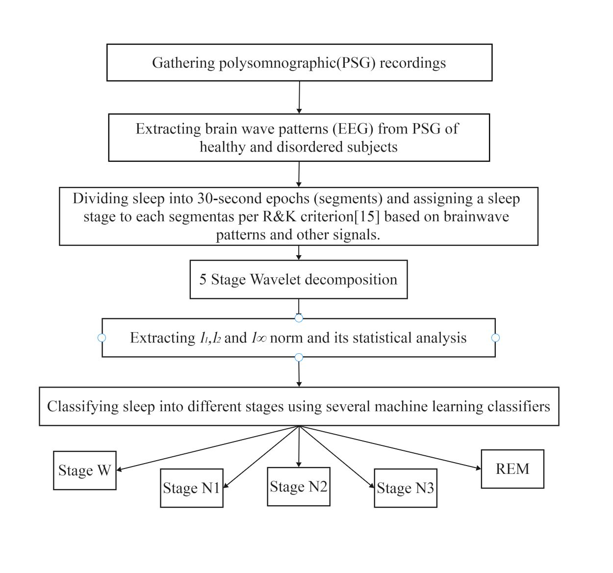

**Fig. 1.** Flowchart of visual scoring procedure

When experts analyze someone's sleep, they break it down into different stages. There are five main stages:

1. Wakefulness (Stage W): This is when you're awake, and it's identified by certain brainwave patterns and eye movements.
2. Light Sleep (Stage N1): It's a light sleep stage, and it's easy to wake up from. Brainwaves are slower, and there might be occasional bursts of activity.
3. Deeper Sleep (Stage N2): This stage is deeper than N1, and it's harder to wake up from. Sleep spindles and K complexes can appear in brainwaves.
4. Deep Restorative Sleep (Stage N3): This is the really deep and restorative sleep stage. Delta waves dominate in brainwaves, and it's tough to wake up from.
5. REM Sleep (Rapid Eye Movement): This is when you dream. Brainwaves are active, but your body is relaxed. You can wake up more easily during REM.

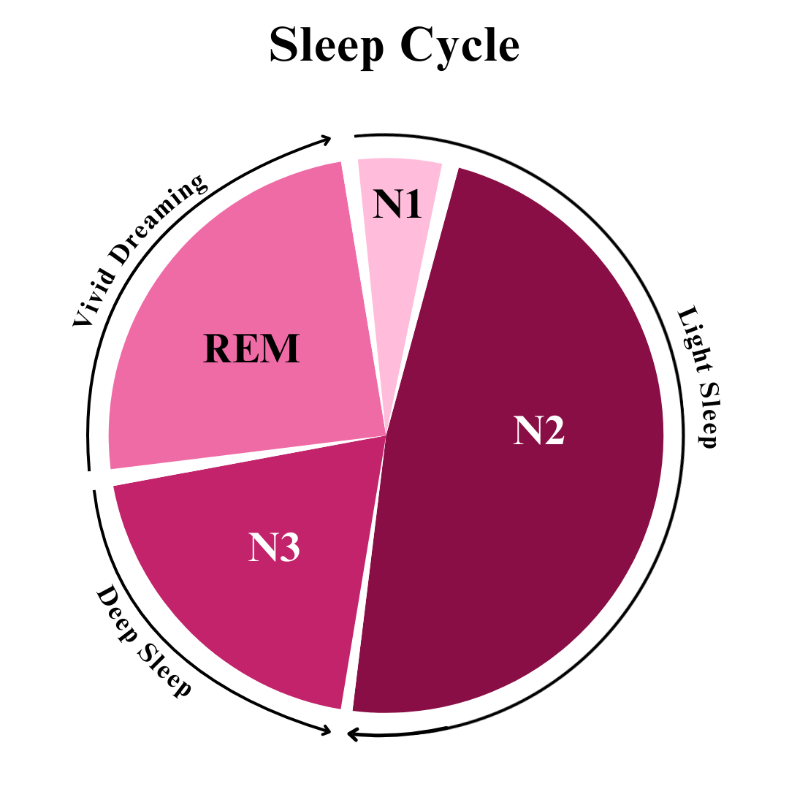

**Fig. 2.** Flowchart of Sleep Cycle

The process of determining these stages can be complex because there are many factors to consider. Different experts might interpret the same sleep recording differently, especially when there are transitions between stages. So, scoring sleep isn't always straightforward, and it can be more challenging for people with sleep disorders. For example, mixing up N2 and N1 or N3 won't have a big impact, but mistaking wakefulness for another stage can affect the overall analysis. Studies have shown that experts sometimes disagree on these stage transitions. This happens because the rules are trying to fit sleep into fixed categories, but sleep is a continuous process with subtle changes.

1. Sleep Stages Classification Using Machine Learning Models
   1. Electrocardiogram (ECG):

Human heart electrical actions are monitored through ECG signals. These signals are used to analyze and diagnose different heart conditions. The signals show the electrical actions of heart rhythms. ECG signals are organized to a great extent and each signal can be spotted visually in the absence of any signs of heart infection. There are two kinds of ECG signals: nonstationary and nonlinear. To get physiology data, the Nonlinear boundaries will be utilized such as guess entropy, fractal aspect, connection component, biggest Lyapunov type, and Hurst. Doctors use ECG signals to monitor the electrical activity of the heart. These signals help them diagnose various heart conditions by showing the rhythm of the heart's electrical actions. [1]. ECG signals were utilized to distinguish the wake (W), non-fast eye development (NREM), and quick eye development (REM) phases of the sleep data. ECG signals were used to tell apart the different stages of sleep: wakefulness (W), non-rapid eye movement (NREM), and rapid eye movement (REM). [2]. Moreover, Yucelbas, et al., Xiao et al., and Kesper et al. stated that though ECG s somewhat complex, it is also equally accurate as compared to PSG signals [2-4]. Redmond et al. have validated ECG-based sleep staging by comparing it with EEG-based sleep staging [5,6].

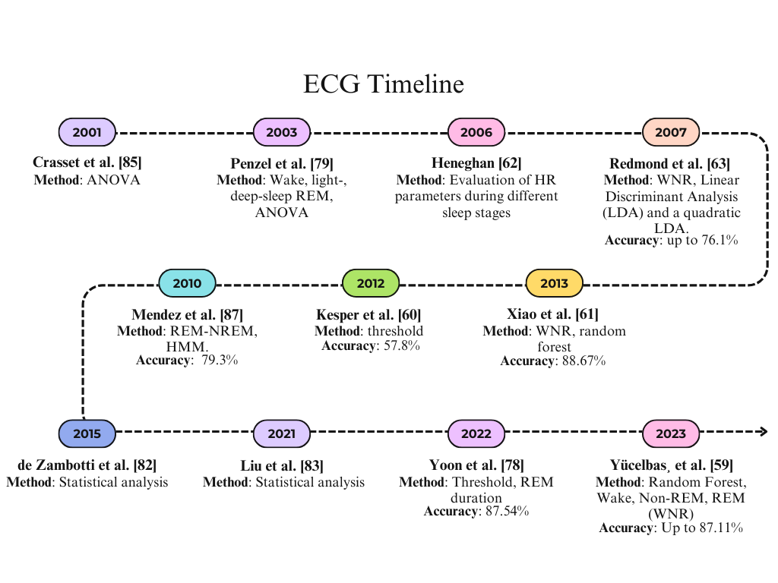

**Fig. 3.** ECG research timeline with classification methods and accuracy

The Autonomic Nervous System is responsible for regulating various involuntary bodily functions including Sleep stages. The Autonomic Nervous System helps control things your body does without you thinking about it, like the different stages of sleep. [7]. During REM (Rapid Eye Movement) sleep, there are specific changes in respiratory patterns compared to those observed during NREM (Non-Rapid Eye Movement) sleep. Due to a decrease in lung tidal volume, a frequent and irregular pattern is exhibited in respiratory rate during the REM phase of sleep During REM sleep, breathing patterns change compared to when you're in deep sleep. Your breaths become shorter and more irregular because your lungs don't fill up as much with air. [8]. Heart Rate Variability (HRV) is a measure of the variation in time between every heartbeat. The regulation of HR signals is estimated using many measures of HRV [9,10]. heart rate (HR) and heart rate variability (HRV) show specific patterns that are very diverse during different stages of sleep. Due to sympathetic and parasympathetic activities, HR and its variability grow during the Rapid Eye Movement stage of sleep [11,12]. It shows drastic differences between NREM and REM stages when HRV parameters are calculated with various factors like time and frequency domains and nonlinear analysis [13,14]. Many such works are also done like Trinder et al. had analyzed autonomic activities on sleep with the help of heart rate variability measurements. Trinder and colleagues analyzed how the body's automatic functions, like heart rate variability, relate to sleep. [15]. Also, de Zambotti et al. analyzed the cardiac autonomic function and stated the effects of alcohol on sleep. De Zambotti and colleagues looked at how alcohol affects the way our heart and nervous system work during sleep. [16]. For the extraction of rest stage data, Penzel and al. have applied detrending change as well as photodynamic analysis. To gather data on rest stages, Penzel and his team used methods like detrending change and photodynamic analysis. Detrending change helps remove any trends or patterns that aren't related to the rest stages, while photodynamic analysis involves studying data related to light exposure during rest. [13]. Moreover, HR was compared with pulse rate variability by Liu et al. [17] Moreover they explored that heart rate variability and pulse rate variability exhibit similar features. It is important to mention that measurement of pulse rate variability is easier than heart rate variability [17]. Analysis of changes in sleep stages in postmenopausal women was carried out by Virtanen et al and their team looked at how the different stages of sleep changed in women after they went through menopause [18]. Also, a real-time Decision support system (DSS) was proposed by Mendez et al. for HR-based sleep stage scoring [19]. Moreover, KNN and different ensemble techniques were applied to get the accuracy of 71.92% and 74.47% respectively by the work done by Alaa Sheta [84].

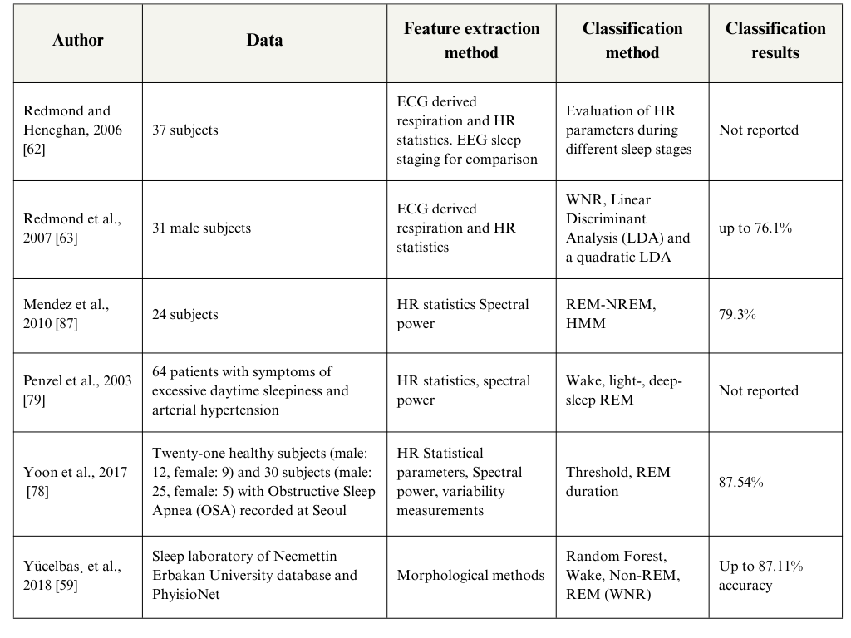**Table 1.** A summary of results of research work in sleep stage scoring using ECG signals.

* 1. Electrooculography (EOG):

EOG stands for "Electrooculogram," which is used to measure and record the electrical activity generated by eye movements. EOG is derived from continuously measuring the standing potential of retina and cornea, and it is a valuable tool for tracking and analyzing eye movements. These signals provide very curtailed information for detecting Rapid Eye Movements. According to the rules and guidance of AASM [20], the EOG electrodes are placed at a position of lateral right from 1 cm and at left outer canthi. This position of EOG electrodes is straightforward and is followed by many patients [21]. Long-term monitoring and assessment of the continuous phase of sleep is a key factor that depends on user-led signal acquisition. In that context, Virkkala et al.'s work is important because it indicates the presence of information on NREM sleep stages in EOG signals [22]. Rahman et al.'s use of the EOG sleep scores may have a significant impact on classification accuracy [23]. Moreover, Liang et al. in 2015 also used SWS classification to give an accuracy of 82.6%. Long et al. use Subject specific quadratic LDA to give a significant amount of 79% accuracy for classifying EOG signals.

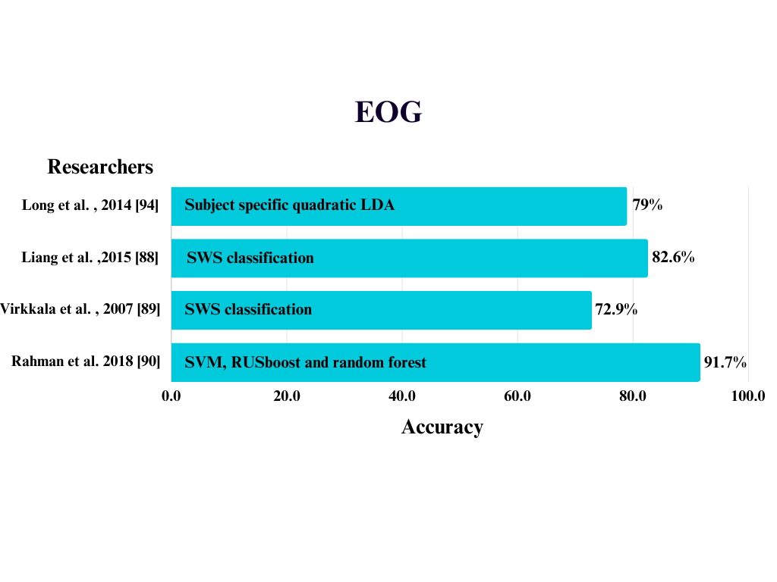

**Fig. 4.** Accuracy of research work that using EOG signals with classification methods

Sleep is very important as it activates and regulates processes with restorative functions for physical and mental conditions [24]. Human nocturnal sleep objectives can also be widely accessed with the help of respiratory information [24-26]. Respiratory efforts are amplitude by Long et al. to establish a classification system on automated sleep stages [27]. They used a subject-specific feature normalization to enhance the classification accuracy. As regards monitoring the long-term health of sleep due to changes in physiological parameters resulting from aging, this type of individualized intervention is a major topic.

* 1. Electroencephalogram (EEG):

### In EEG the electrical activity of the brain is tracked using numerous sleep staging classification systems [29-32]. From EEG signals various signal processing techniques have been in use to gather sleep-related information, which includes: spectral features [37-39], time-frequency features[35,40,41], non-linear features [42,43], and time-domain features [33-36]. Machine Learning Classification methods have been used to help practitioners in decision-making. From reviewing sleep classification studies, some of the widely used classification methods are K-mean classification [33], support vector machine (SVM) [41], Also Ensemble Learning Classification techniques have shown improved results, some of them are Random forest [44], Bootstrap Aggregating [45], Artificial Neural Network (ANN) [46], The below figure shows the amount of work done using EEG signals for given classification methods.

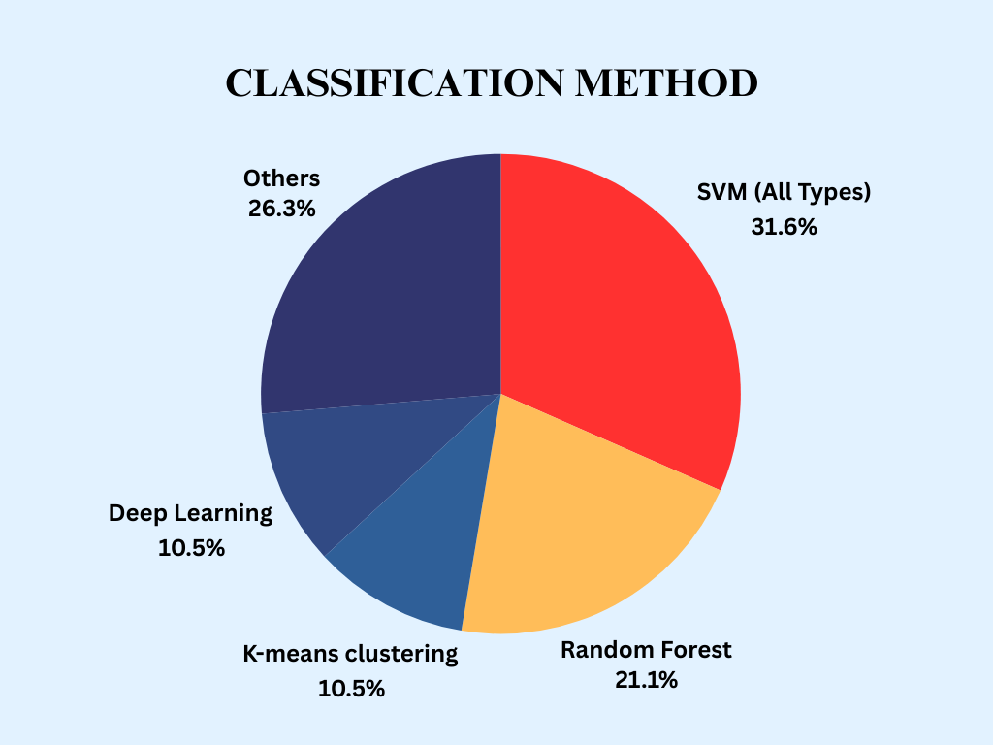

**Fig. 5.** Amount of work done for EEG signals using different classification methods

Hassan and Bhuyian analyzed EEG signals to develop a sleep classification system that used the Ensemble Empirical Mode decomposition technique and the RUS Boost classifier with an average accuracy of 88.1% for the six-class problem [47]. When they used the tunable-Q factor wavelet transform technique with the help of Random Forest Classification [40], the average rises to 90.4%.Li, Wen, and Diykh analyzed EEG signals using time-domain features using a k-mean classification algorithm to identify six sleep stages which give 95.9% accuracy. Bajaj and Prachori [48] analyzed EEG signals using time-frequency features and multiclass least square SVM classifier for the six-class problem, which gave an average accuracy of 88.5%. Hsu et al. analyzed EEG using energy features and recurrent neural classifier, which gave an average accuracy of 87.2% [49]. Seifpour et al. [34] analyzed novel multi-class sleep stage classification using symbolic analysis concepts and developed a new time-domain feature named Statistical SBLE. They achieved an average accuracy of 90.6% for six-stage classification and 97.% average accuracy for two-stage classification.

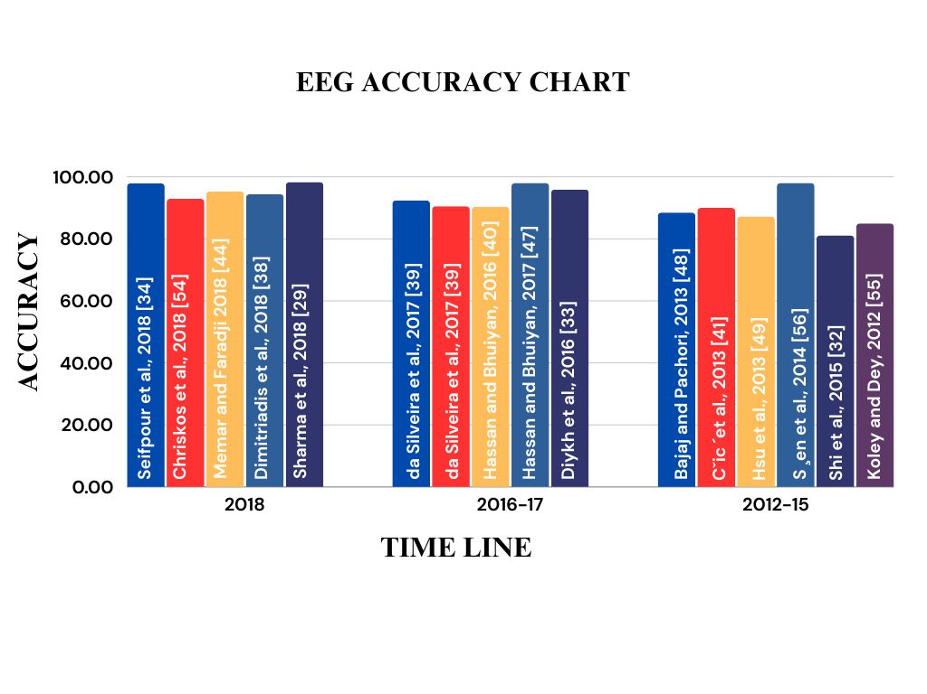

**Fig. 6.** Bar graph showing the accuracy result of different research work that uses EEG signals

* 1. PSG And Combination Of Signals :

Polysomnogram (PSG) is a combination of Physiological signals such as electroencephalogram (EEG), electrocardiogram (ECG), electrooculogram (EOG), and electromyogram (EMG).[95]. PSG recordings are carried out entire night [23,96]. Sleep experts manually score 30 30-second epochs using a Polysomnogram for the entire night [22]. R.S.T Leung analyses autonomic functions with the help of PSG signals [100] to study the effects caused by OSA on sleep stages [101].On analyzing the sleep attack pattern of a patient with Parkinson's, Tracik, and Ebersach found that by refraining from passing through three stages, a rapid transition can be possible directly from stable wakefulness to the S2 stage. Khushida et al. compared the reports with sleep patterns which were extracted from Polysomnogram [102]. Where they couldn’t distinguish between subjective and objective sleep staging. Montgomery-Downs et al. studied the changes in sleep patterns of children. [103] and Long et al. analyzed sleep and wake states [104] using actigraphy and respiratory effects. Furthermore, their studies emphasize on the non-linear concepts of dynamic warping for improving classification results. Kirjavainen et al. analyzed respiratory and body movement signals and its combined study is used for wakefulness and sleep stages in adults and infants. [105]. The body movements can be measured with the help of a novel sensor-enhanced bed.

The above figure summarizes the findings of automated sleep based on a combination of signals and PSG where accuracy has been reported.

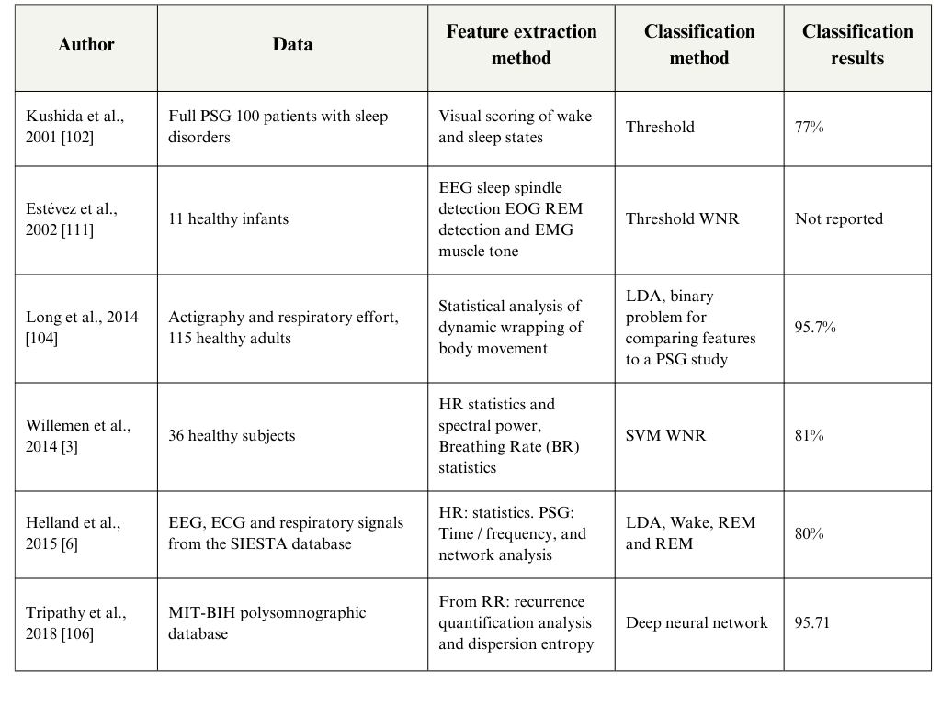**Table 2.** A summary of review results on combination of physiological signals for sleep stage scoring

1. Discussion

The use of machine learning, particularly deep learning, to score and analyze sleep patterns from physiological data (like PSG, which monitors various body signals during sleep). using computer programs, and machine learning algorithms, to help score sleep stages accurately. These algorithms are getting quite good, with an average accuracy of around 85%, which means they agree well with human experts who visually score sleep.

Deep learning, a type of machine learning, is becoming popular because it can learn directly from raw data without needing a lot of prior knowledge or complex mathematical rules. It's like a black box that figures things out on its own. Some deep learning algorithms can even learn how to handle problems like artifacts (unwanted signals) in the sleep data.

It depends on things like the characteristics of the dataset used for training the algorithm. The data must be diverse and representative of different types of sleep patterns and people. If the dataset is too limited or biased, the algorithm may not perform well on new data from different sources.

When evaluating deep learning for sleep scoring, it's not just about getting high accuracy. The dataset used must be diverse and resemble real-world sleep patterns. Very high accuracy can sometimes mean the algorithm is just memorizing the data it was trained on and not understanding sleep. So, researchers need to be careful and use diverse datasets to get reliable results.

It depends on things like the characteristics of the dataset used for training the algorithm. The data must be diverse and representative of different types of sleep patterns and people. If the dataset is too limited or biased, the algorithm may not perform well on new data from different sources.

When evaluating deep learning for sleep scoring, it's not just about getting high accuracy. The dataset used must be diverse and resemble real-world sleep patterns. Very high accuracy can sometimes mean the algorithm is just memorizing the data it was trained on and not understanding sleep.

* 1. Limitations

Calculate a person's heart rate (HR) from ECG signals by identifying the R wave in the ECG, which marks each heartbeat, and then measuring the time between these R waves (called RR intervals). But, it's much easier and more efficient to directly measure HR without using ECG. Direct HR sensors are efficient because they can easily detect the R wave, making it simpler and requiring fewer tools than using ECG.

The process of detecting the heartbeat isn't always well-documented and is often a secret of the companies that make these sensors. So, it's hard to be sure that the HR measurements from these sensors give the same RR intervals as those calculated from ECG, especially for small changes in the signal that show different sleep stages. The difficulties in using direct HR sensors are because the way they detect heartbeats isn't always clear. Researchers usually stick to ECG signals to calculate RR intervals, even though it might not be the most efficient method.

* 1. Future Work

### Future Directions for DSS in Sleep Medicine:

Develop Transparency and Trust: Provide user-friendly decision support system (DSS) methods that can catalyze clinicians towards faster decision-making and assist patients with intuitive visualizations to gain their trust.

Adaption and Learning: Enhance the algorithms for dynamic learning and ad staying updated to evolve with new research techniques, findings, and patient-specific conditions.

Sensor Technology: As the paper mentions patient comfort is essential for long term monitoring, and advancements in sensor design for unobtrusive and comfortable sleep monitoring are required.

Heart Rate (HR): Based Scoring Innovation: Research and Investigate to refine HR-based sleep scoring, assessing its applicability across diverse patient demographics and further enhancing it by seamless integration with Internet of Health Things (IoHT) for comprehensive real-time monitoring.

Real-time Analysis with Feedback: Real-time analysis is crucial for controlling the therapeutic process effectively. Further research can focus on developing real time analysis algorithms that provide immediate feedback to both patients and healthcare providers using various Artificial Intelligence and Deep Learning advancements. This can facilitate timely interventions and adjustments in treatment plans.

Data Rate Considerations: As different physiological signals have varying rates of data, further research should explore their data rates on communication and storage infrastructure to ensure seamless handling of information

1. Conclusion

This work examines and discusses deep learning techniques for classifying sleep stages automatically. Deep learning techniques, in contrast to traditional methods, may automatically extract latent and advanced complex features from sleep data, obviating the need for further feature extraction stages. The signals, datasets, data representation strategies, preprocessing approaches, deep learning models, and performance evaluations in sleep stage classification are all thoroughly examined in this work. This review provides a well-reasoned argument for the importance of physiological signals in sleep monitoring. It effectively highlights the potential of DSS systems to improve the reliability of sleep stage scoring while reducing the need for human interpretation and addressing issues of fatigue-related errors.

References

1. U.R. Acharya, E.C.-P. Chua, O. Faust, T.-C. Lim, L.F.B. Lim, Automated detection of sleep apnea from electrocardiogram signals using nonlinear parameters, Physiol. Measur. 32 (3) (2011) 287.
2. S. Yücelbas, C. Yücelbas, G. Tezel, S. Özs¸ en, S. Yosunkaya, Automatic sleep staging based on svd, vmd, hht and morphological features of single-lead ecg signal, Expert Syst. Appl. 102 (2018) 193–206.
3. K. Kesper, S. Canisius, T. Penzel, T. Ploch, W. Cassel, ecg signal analysis for the assessment of sleep-disordered breathing and sleep pattern, Med. Biol. Eng. Comput. 50 (2) (2012) 135–144.
4. M. Xiao, H. Yan, J. Song, Y. Yang, X. Yang, Sleep stages classification based on heart rate variability and random forest, Biomed. Signal Process. Control 8 (6) (2013) 624–633.
5. S.J. Redmond, C. Heneghan, Cardiorespiratory-based sleep staging in subjects with obstructive sleep apnea, IEEE Trans. Biomed. Eng. 53 (3) (2006) 485–496.
6. S.J. Redmond, P. de Chazal, C. O’Brien, S. Ryan, W.T. McNicholas, C. Heneghan, Sleep staging using cardiorespiratory signals, Somnologie-Schlafforschung und Schlafmedizin 11 (4) (2007) 245–256.
7. R.P. Bartsch, A.Y. Schumann, J.W. Kantelhardt, T. Penzel, P.C. Ivanov, Phase transitions in physiologic coupling, Proc. Natl. Acad. Sci. 109 (26) (2012) 10181–10186.
8. M. Kryger, T. Roth, W. Dement, Principles and Practice of Sleep Medicine, Saunders W.B, Elsevier, 2016
9. U.R. Acharya, O. Faust, S.V. Sree, D.N. Ghista, S. Dua, P. Joseph, V.T. Ahamed, N. Janarthanan, T. Tamura, an integrated diabetic index using heart rate variability signal features for diagnosis of diabetes, Comput. Method. Biomech. Biomed. Eng. 16 (2) (2013) 222–234.
10. T.S. Hock, O. Faust, T.-C. Lim, W. Yu, Automated detection of premature ventricular contraction using recurrence quantification analysis on heart rate signals, J. Med. Imag. Health Inf. 3 (3) (2013) 462–469
11. M. Kryger, T. Roth, W. Dement, Principles and Practice of Sleep Medicine - E-Book: Expert Consult Premium Edition - Enhanced Online Features, Elsevier Health Sciences, Amsterdam, Netherlands, 2010.
12. H. Yoon, S.H. Hwang, J.-W. Choi, Y.J. Lee, D.-U. Jeong, K.S. Park, Rem sleep estimation based on autonomic dynamics using r–r intervals, Physiol. Measur. 38 (4) (2017) 631.
13. T. Penzel, J.W. Kantelhardt, L. Grote, J.-H. Peter, A. Bunde, Comparison of detrended fluctuation analysis and spectral analysis for heart rate variability in sleep and sleep apnea, IEEE Trans. Biomed. Eng. 50 (10) (2003) 1143–1151
14. P.K. Stein, Y. Pu, Heart rate variability, sleep and sleep disorders, Sleep Med. Rev. 16 (1) (2012) 47–66.
15. J. Trinder, J. Kleiman, M. Carrington, S. Smith, S. Breen, N. Tan, Y. Kim, Autonomic activity during human sleep as a function of time and sleep stage, J. Sleep Res. 10 (4) (2001) 253–264.
16. M. de Zambotti, A.R. Willoughby, F.C. Baker, D.S. Sugarbaker, I.M. Colrain, Cardiac autonomic function during sleep: effects of alcohol dependence and evidence of partial recovery with abstinence, Alcohol 49 (4) (2015) 409–415.
17. S. Liu, J. Teng, X. Qi, S. Wei, C. Liu, Comparison between heart rate variability and pulse rate variability during different sleep stages for sleep apnea patients, Technol. Health Care 25 (3) (2017) 435–445.
18. I. Virtanen, E. Ekholm, P. Polo-Kantola, H. Huikuri, Sleep stage dependent patterns of nonlinear heart rate dynamics in postmenopausal women, Autonomic Neurosci. 134 (1–2) (2007) 74–80.
19. M.O. Mendez, M. Matteucci, V. Castronovo, L. Ferini-Strambi, S. Cerutti, A. Bianchi, Sleep staging from heart rate variability: time-varying spectral features and hidden markov models, Int. J. Biomed. Eng. Technol. 3 (3–4) (2010) 246–263.
20. R.B. Berry, R. Brooks, C.E. Gamaldo, S.M. Harding, C. Marcus, B. Vaughn, The AASM manual for the scoring of sleep and associated events, Rules, Terminol. Tech. Specificat. Darien, Illinois, Am. Acad. Sleep Med. (2012).
21. S.-F. Liang, C.-E. Kuo, Y.-C. Lee, W.-C. Lin, Y.-C. Liu, P.-Y. Chen, F.-Y. Cherng, F.-Z. Shaw, Development of an EOG-based automatic sleep-monitoring eye mask, IEEE Trans. Instrument. Measur. 64 (11) (2015) 2977–2985.
22. J. Virkkala, J. Hasan, A. Värri, S.-L. Himanen, K. Müller, Automatic sleep stage classification using two-channel electro-oculography, J. Neurosci. Method. 166 (1) (2007) 109–115.
23. M.M. Rahman, M.I.H. Bhuiyan, A.R. Hassan, Sleep stage classification using single-channel EOG, Comput. Biol. Med. (2018), doi:10.1016 j.compbiomed. 2018.08.022
24. T. Penzel, N. Wessel, M. Riedl, J.W. Kantelhardt, S. Rostig, M. Glos, A. Suhrbier, H. Malberg, I. Fietze, Cardiovascular and respiratory dynamics during normal and pathological sleep, Chaos 17 (1) (2007) 015116.
25. N. Douglas, D. White, C.K. Pickett, J. Weil, C. Zwillich, Respiration during sleep in normal man., Thorax 37 (11) (1982) 840–844.
26. V.K. Somers, M.E. Dyken, A.L. Mark, F.M. Abboud, Sympathetic-nerve activity during sleep in normal subjects, New Engl. J. Med. 328 (5) (1993) 303–307.
27. X. Long, J. Foussier, P. Fonseca, R. Haakma, R.M. Aarts, Analyzing respiratory effort amplitude for automated sleep stage classification, Biomed. Signal Process. Control 14 (2014) 197–205.
28. O. Faust, R.J. Martis, L. Min, G.L.Z. Zhong, W. Yu, Automated detection of pulmonary edema and respiratory failure using physiological signals, J. Med. Imag. Health Inf. 3 (3) (2013) 424–431.
29. M. Sharma, D. Goyal, P. Achuth, U.R. Acharya, An accurate sleep stages classification system using a new class of optimally time-frequency localized three- -band wavelet filter bank, Comput. Biol. Med. 98 (2018) 58–75.
30. L. Doroshenkov, V. Konyshev, S. Selishchev, Classification of human sleep stages based on eeg processing using hidden markov models, Biomed. Eng. 41 (1) (2007) 25–28.
31. A. Flexer, G. Gruber, G. Dorffner, A reliable probabilistic sleep stager based on a single eeg signal, Artif. Intell. Med. 33 (3) (2005) 199–207.
32. J. Shi, X. Liu, Y. Li, Q. Zhang, Y. Li, S. Ying, Multi-channel eeg-based sleep stage classification with joint collaborative representation and multiple kernel learning, J. Neurosci. Method. 254 (2015) 94–101.
33. M. Diykh, Y. Li, P. Wen, Eeg sleep stages classification based on time domain features and structural graph similarity, IEEE Trans. Neural Syst. Rehabilit. Eng. 24 (11) (2016) 1159–1168.
34. S. Seifpour, H. Niknazar, M. Mikaeili, A.M. Nasrabadi, A new automatic sleep staging system based on statistical behavior of local extrema using single channel eeg signal, Expert Syst. Appl. 104 (2018) 277–293.
35. K. Pillay, A. Dereymaeker, K. Jansen, G. Naulaers, S. Van Huffel, M. De Vos, Au- tomated eeg sleep staging in the term-age baby using a generative modelling approach, J. Neural Eng. 15 (3) (2018) 036004.
36. F. Ebrahimi, S.-K. Setarehdan, H. Nazeran, Automatic sleep staging by simul- taneous analysis of ecg and respiratory signals in long epochs, Biomed. Signal Process. Control 18 (2015) 69–79.
37. U.R. Acharya, E.C.-P. Chua, K.C. Chua, L.C. Min, T. Tamura, Analysis and auto- matic identification of sleep stages using higher order spectra, Int. J. Neural Syst. 20 (06) (2010) 509–521.
38. S.I. Dimitriadis, C. Salis, D. Linden, A novel, fast and efficient single-sensor automatic sleep-stage classification based on complementary cross-frequency coupling estimates, Clin. Neurophysiol. 129 (4) (2018) 815–828.
39. T.L. da Silveira, A.J. Kozakevicius, C.R. Rodrigues, Single-channel eeg sleep stage classification based on a streamlined set of statistical features in wavelet domain, Med. Biol. Eng. Comput. 55 (2) (2017) 343–352.
40. A.R. Hassan, M.I.H. Bhuiyan, A decision support system for automatic sleep staging from EEG signals using tunable q-factor wavelet transform and spec- tral features, J. Neurosci. Method. 271 (2016) 107–118.
41. M. Cˇic ́, J. Šoda, M. Bonkovic ́, Automatic classification of infant sleep based on instantaneous frequencies in a single-channel EEG signal, Comput. Biol. Med. 43 (12) (2013) 2110–2117.
42. U.R. Acharya, S. Bhat, O. Faust, H. Adeli, E.C.-P. Chua, W.J.E. Lim, J.E.W. Koh, Nonlinear dynamics measures for automated EEG-based sleep stage detec- tion, Eur. Neurol. 74 (5–6) (2015) 268–287.
43. M. Peker, an efficient sleep scoring system based on EEG signal using complex-valued machine learning algorithms, Neurocomputing 207 (2016) 165–177.
44. P. Memar, F. Faradji, A novel multi-class eeg-based sleep stage classification system, IEEE Trans. Neural Syst. Rehabilit. Eng. 26 (1) (2018) 84–95.
45. A.R. Hassan, A. Subasi, A decision support system for automated identification of sleep stages from single-channel eeg signals, Know-Based Syst. 128 (2017) 115–124.
46. M. Ronzhina, O. Janoušek, J. Kolárˇová, M. Nováková, P. Honzík, I. Provazník, Sleep scoring using artificial neural networks, Sleep Med. Rev. 16 (3) (2012) 251–263.
47. A.R. Hassan, M.I.H. Bhuiyan, Automated identification of sleep states from eeg signals by means of ensemble empirical mode decomposition and ran- dom under sampling boosting, Comput. Method. Progr. Biomed. 140 (2017) 201–210.
48. V. Bajaj, R.B. Pachori, Automatic classification of sleep stages based on the time-frequency image of EEG signals, Comput. Method. Program. Biomed. 112 (3) (2013) 320–328.
49. Y.-L. Hsu, Y.-T. Yang, J.-S. Wang, C.-Y. Hsu, Automatic sleep stage recurrent neural classifier using energy features of EEG signals, Neurocomputing 104 (2013) 105–114.
50. C. Vural, M. Yildiz, Determination of sleep stage separation ability of features extracted from EEG signals using principle component analysis, J. Med. Syst. 34 (1) (2010) 83–89.
51. A. Supratak, H. Dong, C. Wu, Y. Guo, Deepsleepnet: a model for automatic sleep stage scoring based on raw single-channel EEG, IEEE Trans. Neural Syst. Rehabilit. Eng. 25 (11) (2017) 1998–2008.
52. N. Michielli, U.R. Acharya, F. Molinari, Cascaded lstm recurrent neural net- work for automated sleep stage classification using single-channel eeg signals, Comput. Biol. Med. (2019).
53. S. Mousavi, F. Afghah, U.R. Acharya, Sleepeegnet: automated sleep stage scoring with squence to sequence deep learning approach, (2019). arXiv: 1903. 02108.
54. P. Chriskos, C.A. Frantzidis, P.T. Gkivogkli, P.D. Bamidis, C. Kourtidou-Papadeli, Achieving accurate automatic sleep staging on manually pre-processed EEG data through synchronization feature extraction and graph metrics, Front. Hu- man Neurosci. 12 (2018) 110.
55. B. Koley, D. Dey, an ensemble system for automatic sleep stage classification using single channel EEG signal, Comput. Biol. Med. 42 (12) (2012) 1186–1195.
56. B. S ̧ en, M. Peker, A. Çavus ̧ og ̆ lu, F.V. Çelebi, A comparative study on classifica- tion of sleep stage based on EEG signals using feature selection and classification algorithms, J. Med. Syst. 38 (3) (2014) 18.
57. R. Acharya, O. Faust, N. Kannathal, T. Chua, S. Laxminarayan, Non-linear analysis of EEG signals at various sleep stages, Comput. Method. Progr. Biomed. 80 (1) (2005) 37–45.
58. U.R. Acharya, E.C.-P. Chua, O. Faust, T.-C. Lim, L.F.B. Lim, Automated detection of sleep apnea from electrocardiogram signals using nonlinear parameters, Physiol. Measur. 32 (3) (2011) 287.
59. S. Yücelbas ̧, C. Yücelbas, G. Tezel, S. Özs ̧ en, S ̧. Yosunkaya, Automatic sleep staging based on svd, vmd, hht and morphological features of single-lead ecg signal, Expert Syst. Appl. 102 (2018) 193–206.
60. K. Kesper, S. Canisius, T. Penzel, T. Ploch, W. Cassel, Ecg signal analysis for the assessment of sleep-disordered breathing and sleep pattern, Med. Biol. Eng. Comput. 50 (2) (2012) 135–144.
61. M. Xiao, H. Yan, J. Song, Y. Yang, X. Yang, Sleep stages classification based on heart rate variability and random forest, Biomed. Signal Process. Control 8 (6) (2013) 624–633.
62. S.J. Redmond, C. Heneghan, Cardiorespiratory-based sleep staging in subjects with obstructive sleep apnea, IEEE Trans. Biomed. Eng. 53 (3) (2006) 485–496.
63. S.J. Redmond, P. de Chazal, C. O’Brien, S. Ryan, W.T. McNicholas, C. Heneghan, Sleep staging using cardiorespiratory signals, Somnologie-Schlafforschung and Schlafmedizin 11 (4) (2007) 245–256.
64. J. Fell, K. Mann, J. Röschke, M. Gopinathan, Nonlinear Analysis of continuous ECG during sleep i. reconstruction, Biol. Cybernet. 82 (6) (2000) 477–483.
65. J. Fell, K. Mann, J. Röschke, M. Gopinathan, Nonlinear analysis of continu- ous ECG during sleep ii. dynamical measures, Biol. Cybernet. 82 (6) (2000) 485–491.
66. R.P. Bartsch, A.Y. Schumann, J.W. Kantelhardt, T. Penzel, P.C. Ivanov, Phase transitions in physiologic coupling, Proc. Natl. Acad. Sci. 109 (26) (2012) 10181–10186.
67. M. Kryger, T. Roth, W. Dement, Principles and Practice of Sleep Medicine, Saunders W.B, Elsevier, 2016.
68. N. Chattipakorn, T. Incharoen, N. Kanlop, S. Chattipakorn, Heart rate variability in myocardial infarction and heart failure, Int. J. Cardiol. 120 (3) (2007) 289–296.
69. O. Faust, V.R. Prasad, G. Swapna, S. Chattopadhyay, T.-C. Lim, Comprehensive analysis of normal and diabetic heart rate signals: a review, J. Mech. Med. Biol. 12 (05) (2012) 1240033.
70. U.R. Acharya, O. Faust, S.V. Sree, D.N. Ghista, S. Dua, P. Joseph, V.T. Ahamed,
71. N. Janarthanan, T. Tamura, an integrated diabetic index using heart rate variability signal features for diagnosis of diabetes, Comput. Method. Biomech. Biomed. Eng. 16 (2) (2013) 222–234.
72. T.S. Hock, O. Faust, T.-C. Lim, W. Yu, Automated detection of premature ven- tricular contraction using recurrence quantification analysis on heart rate sig- nals, J. Med. Imag. Health Inf. 3 (3) (2013) 462–469.
73. U.R. Acharya, O. Faust, V. Sree, G. Swapna, R.J. Martis, N.A. Kadri, J.S. Suri, Linear and nonlinear analysis of normal and cad-affected heart rate signals, Comput. Method. Progr. Biomed. 113 (1) (2014) 55–68.
74. U.R. Acharya, O. Faust, N.A. Kadri, J.S. Suri, W. Yu, Automated identification of normal and diabetes heart rate signals using nonlinear measures, Comput. Biol. Med. 43 (10) (2013) 1523–1529.
75. M. Malik, J.T. Bigger, A.J. Camm, R.E. Kleiger, A. Malliani, A.J. Moss, P.J. Schwartz, Heart rate variability: standards of measurement, physiological interpretation, and clinical use, Eur. Heart J. 17 (3) (1996) 354–381.
76. A. Camm, M. Malik, J. Bigger, G. Breithardt, S. Cerutti, R. Cohen, P. Coumel, E. Fallen, H. Kennedy, R. Kleiger, Heart rate variability: standards of measurement, physiological interpretation and clinical use. task force of the European society of cardiology and the north american society of pacing and electro- physiology, Circulation 93 (5) (1996) 1043–1065.
77. O. Faust, R. Acharya, S. Krishnan, L.C. Min, Analysis of cardiac signals using spatial filling index and time-frequency domain, BioMed. Eng. Online 3 (1) (2004) 30.
78. M. Kryger, T. Roth, W. Dement, Principles and Practice of Sleep Medicine - E-Book: Expert Consult Premium Edition - Enhanced Online Features, Elsevier Health Sciences, Amsterdam, Netherlands, 2010.
79. H. Yoon, S.H. Hwang, J.-W. Choi, Y.J. Lee, D.-U. Jeong, K.S. Park, Rem sleep estimation based on autonomic dynamics using r–r intervals, Physiol. Measur. 38 (4) (2017) 631.
80. T. Penzel, J.W. Kantelhardt, L. Grote, J.-H. Peter, A. Bunde, Comparison of de- trended fluctuation analysis and spectral analysis for heart rate variability in sleep and sleep apnea, IEEE Trans. Biomed. Eng. 50 (10) (2003) 1143–1151.
81. P.K. Stein, Y. Pu, Heart rate variability, sleep and sleep disorders, Sleep Med. Rev. 16 (1) (2012)47–66.
82. J. Trinder, J. Kleiman, M. Carrington, S. Smith, S. Breen, N. Tan, Y. Kim, Auto- nomic activity during human sleep as a function of time and sleep stage, J. Sleep Res. 10 (4) (2001) 253–264.
83. M. de Zambotti, A.R. Willoughby, F.C. Baker, D.S. Sugarbaker, I.M. Colrain, Cardiac autonomic function during sleep: effects of alcohol dependence and evidence of partial recovery with abstinence, Alcohol 49 (4) (2015) 409–415.
84. S. Liu, J. Teng, X. Qi, S. Wei, C. Liu, Comparison between heart rate variability and pulse rate variability during different sleep stages for sleep apnea patients, Technol. Health Care 25 (3) (2017) 435–445.
85. I. Virtanen, E. Ekholm, P. Polo-Kantola, H. Huikuri, Sleep stage dependent pat- terns of nonlinear heart rate dynamics in postmenopausal women, Autonomic Neurosci. 134 (1–2) (2007) 74–80.
86. V. Crasset, S. Mezzetti, M. Antoine, P. Linkowski, J.P. Degaute, P. Van De Borne, Effects of aging and cardiac denervation on heart rate variability during sleep, Circulation 103 (1) (2001) 84–88.
87. O. Faust, L.M. Yi, L.M. Hua, Heart rate variability analysis for different age and gender, J. Med. Imag. Health Inf. 3 (3) (2013) 395–400.
88. M.O. Mendez, M. Matteucci, V. Castronovo, L. Ferini-Strambi, S. Cerutti, A. Bianchi, Sleep staging from heart rate variability: time-varying spectral features and hidden markov models, Int. J. Biomed. Eng. Technol. 3 (3–4) (2010) 246–263.
89. S.-F. Liang, C.-E. Kuo, Y.-C. Lee, W.-C. Lin, Y.-C. Liu, P.-Y. Chen, F.-Y. Cherng, F.-Z. Shaw, Development of an EOG-based automatic sleep-monitoring eye mask, IEEE Trans. Instrument. Measur. 64 (11) (2015) 2977–2985.
90. J. Virkkala, J. Hasan, A. Värri, S.-L. Himanen, K. Müller, Automatic sleep stage classification using two-channel electro-oculography, J. Neurosci. Method. 166 (1) (2007) 109–115.
91. M.M. Rahman, M.I.H. Bhuiyan, A.R. Hassan, Sleep stage classification using single-channel EOG, Comput. Biol. Med. (2018), doi:10.1016/j.compbiomed. 2018.08.022.
92. T. Penzel, N. Wessel, M. Riedl, J.W. Kantelhardt, S. Rostig, M. Glos, A. Suhrbier, H. Malberg, I. Fietze, Cardiovascular and respiratory dynamics during normal and pathological sleep, Chaos 17 (1) (2007) 015116.
93. N. Douglas, D. White, C.K. Pickett, J. Weil, C. Zwillich, Respiration during sleep in normal man., Thorax 37 (11) (1982) 840–844.
94. V.K. Somers, M.E. Dyken, A.L. Mark, F.M. Abboud, Sympathetic-nerve activity during sleep in normal subjects, New Engl. J. Med. 328 (5) (1993) 303–307.
95. X. Long, J. Foussier, P. Fonseca, R. Haakma, R.M. Aarts, Analyzing respiratory effort amplitude for automated sleep stage classification, Biomed. Signal Process. Control 14 (2014) 197–205.
96. S.H. Sheldon, M.H. Kryger, R. Ferber, D. Gozal, Principles and Practice of Pediatric Sleep Medicine E-Book, Elsevier Health Sciences, 2014.
97. A.A. of Sleep Medicine Task Force, Sleep-related breathing disorders in adults: recommendations for syndrome definition and measurement techniques in clinical research, Sleep 22 (1999) 667–689.
98. S.-F. Liang, C.-E. Kuo, Y.-H. Hu, Y.-S. Cheng, A rule-based automatic sleep staging method, J. Neurosci. Method. 205 (1) (2012) 169–176.
99. M.E. Tagluk, N. Sezgin, M. Akin, Estimation of sleep stages by an artificial neural network employing EEG, EMG and EOG, J. Med. Syst. 34 (4) (2010) 717–725.
100. A. Kishi, H. Yasuda, T. Matsumoto, Y. Inami, J. Horiguchi, M. Tamaki, Z.R. Struzik, Y. Yamamoto, Nrem sleep stage transitions control ultradian REM sleep rhythm, Sleep 34 (10) (2011) 1423–1432.
101. R.S. Leung, Sleep-disordered breathing: autonomic mechanisms and arrhythmias, Progress Cardiovasc. Diseases 51 (4) (2009) 324–338.
102. F. Tracik, G. Ebersbach, Sudden daytime sleep onset in parkinson’s disease: polysomnographic recordings, Movement Disorders 16 (3) (2001) 500–506.
103. C.A. Kushida, A. Chang, C. Gadkary, C. Guilleminault, O. Carrillo, W.C. De- ment, Comparison of actigraphic, polysomnographic, and subjective assess- ment of sleep parameters in sleep-disordered patients, Sleep Med. 2 (5) (2001) 389–396.
104. H.E. Montgomery-Downs, L.M. OBrien, T.E. Gulliver, D. Gozal, Polysomnographic characteristics in normal preschool and early school-aged children, Pediatrics 117 (3) (2006) 741–753.
105. X. Long, P. Fonseca, J. Foussier, R. Haakma, R.M. Aarts, Sleep and wake classification with actigraphy and respiratory effort using dynamic warping, IEEE J. Biomed. Health Inf. 18 (4) (2014) 1272–1284.
106. T. Kirjavainen, D. Cooper, O. Polo, C. SULLIVAN, Respiratory and body movements as indicators of sleep stage and wakefulness in infants and young children, J. Sleep Res. 5 (3) (1996) 186–194.
107. R. Tripathy, U.R. Acharya, Use of features from rr-time series and eeg signals for automated classification of sleep stages in deep neural network frame- work, Biocybernet. Biomed. Eng. 38 (4) (2018) 890–902.
108. O. Yildirim, U.B. Baloglu, U.R. Acharya, A deep learning model for automated sleep stages classification using PSG signals, Int. J. Environ. Res. Public Health 16 (4) (2019) 599.
109. T. Takatani, Y. Takahashi, R. Yoshida, R. Imai, T. Uchiike, M. Yamazaki, M. Shima, T. Nishikubo, Y. Ikada, S. Fujimoto, Relationship between frequency spectrum of heart rate variability and autonomic nervous activities during sleep in newborns, Brain Dev. 40 (3) (2018) 165–171.
110. P. Fonseca, X. Long, M. Radha, R. Haakma, R.M. Aarts, J. Rolink, Sleep stage classification with ECG and respiratory effort, Physiol. Measur. 36 (10) (2015) 2027.

1. Aminoff, Michael & Boller, François & Swaab, Dick. We spend about one-third of our life either sleeping or attempting to do so. Handbook of clinical neurology .(2011)/ edited by P.J. Vinken and G.W. Bruyn. 98. vii. 10.1016/B978-0-444-52006-7.00047-2
2. Jahrami, H.A., Alhaj, O.A., Humood, A.M., Alenezi, A.F., Fekih-Romdhane, F., AlRasheed, M.M., Saif, Z.Q., Bragazzi, N.L., Pandi-Perumal, S.R., BaHammam, A.S., Vitiello, M.V. Sleep disturbances during the COVID-19 pandemic: A systematic review, meta-analysis,and meta-regression.Sleep Medicine Reviews*,* 62, 101591. (2022). <https://doi.org/10.1016/j.smrv.2022.101591>
3. Krystal AD. Psychiatric disorders and sleep. Neurol Clin. 2012 Nov;30(4):1389-413. doi: 10.1016/j.ncl.2012.08.018. PMID: 23099143; PMCID: PMC3493205.
4. Huang, SY., Li, YZ., Zhang, YR. *et al.* Sleep, physical activity, sedentary behavior, and risk of incident dementia: a prospective cohort study of 431,924 UK Biobank participants. Mol Psychiatry **27**, 4343–4354 (2022). https://doi.org/10.1038/s41380-022-01655-y
5. Baglioni, C., Battagliese, G., Feige, B., Spiegelhalder, K., Nissen, C., Voderholzer, U., Lombardo, C., & Riemann, D. Insomnia as a predictor of depression: A meta-analytic evaluation of longitudinal epidemiological studies. *Journal of Affective Disorders*, **135**(1–3), 10–19 . <https://doi.org/10.1016/j.jad.2011.01.011>