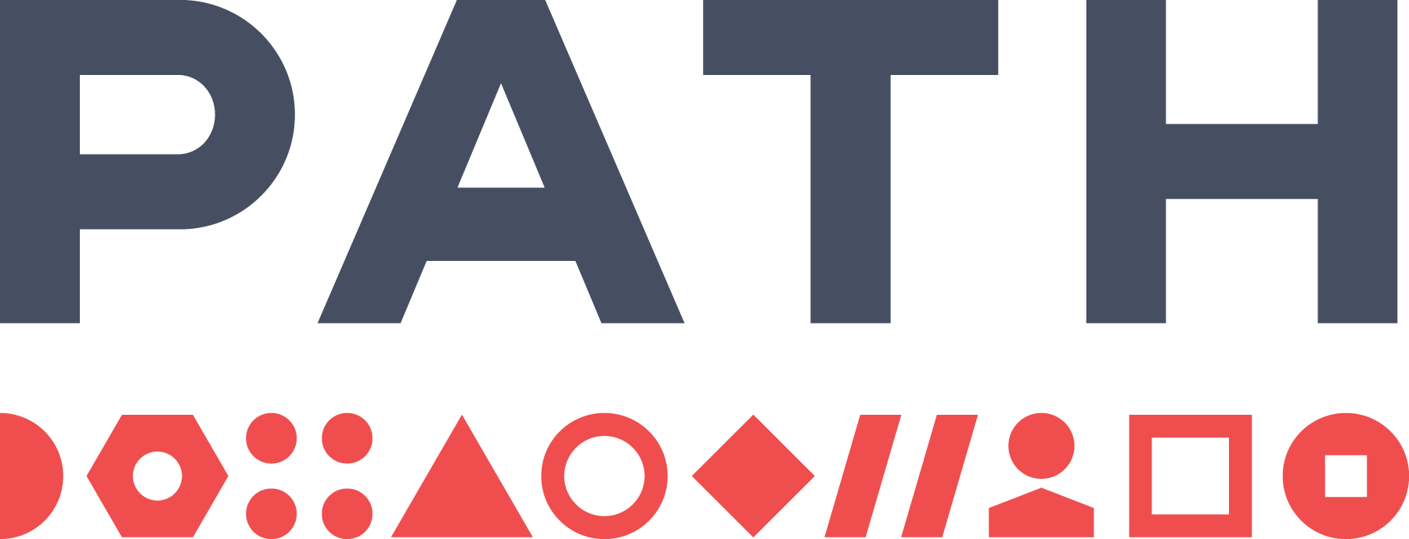
The Gambia Malaria Budgeting Tool
Detailed User Guide
Version 1.0 · Last updated July 2026
Live app: https://path-global-health.github.io/gmb-malaria-budget-app/
For help, contact: Hayley @ hthompson@path.org

Contents
Quick Orientation 1
Your First Budget (Quick Start) 1
Current Scope of the Tool 1
Getting Started and Signing In 1
Shared Saving and Collaboration 1
Overview Page 1
Scenario Specification Walkthrough 1
Step 1: Choose a Scenario 1
Step 2: Review Plan Basics 1
Step 3: Review Stratification Rules 1
Step 4: Review Intervention Mix by Stratum 1
Step 5: Use Manual Targeting Overrides 1
Step 6: Review Intervention Assumptions 1
Step 7: Use Set by Geography 1
Step 8: Save the Scenario 1
Cost Specification Walkthrough 1
Step 1: Choose a Cost Set 1
Step 2: Check Cost Row Fields 1
Step 3: Understand Cost Categories 1
Step 4: Understand Units 1
Step 5: Understand Type Matching 1
Step 6: Edit Data Quality Scores 1
Step 7: Save the Cost Set 1
Budget Generation Walkthrough 1
Step 1: Select Scenario and Cost Set 1
Step 2: Read Pre-generation Warnings 1
Step 3: Generate, Regenerate, or Queue 1
Step 4: Check the Budget Library 1
Budget Visualisation Walkthrough 1
Step 1: Select a Budget 1
Step 2: Read the Headline Figures 1
Step 3: Use Filters 1
Step 4: Set a Budget Envelope 1
Step 5: Review Maps and Charts 1
Step 6: Review Cost Tables 1
Step 7: Review Top Cost Elements 1
Step 8: Export to Excel 1
Budget Comparison Walkthrough 1
Step 1: Select Budgets 1
Step 2: Read the Scoreboard 1
Step 3: Set a Budget Envelope 1
Step 4: Review Cost Change 1
Step 5: Review Commodity Change 1
Step 6: Composition — Where the Money Goes 1
Step 7: Check Stale Budget Warnings 1
Excel Export Guide 1
How to Cross-check a Budget in Excel 1
Practical Interpretation Tips 1
Common Tasks and Recipes 1
Troubleshooting 1
You Cannot Sign In 1
You Do Not See a Budget Someone Else Generated 1
A Budget Is Out of Date 1
You See Pre-generation Warnings 1
Shared Saving Shows an Error 1
You Are Unsure Whether to Click Sync Now 1
A Chart or Table Does Not Look Right 1
A Budget Total Looks Too Low 1
A Budget Total Looks Too High 1
Glossary of Key Terms 1
Appendix: Default Assumptions 1
Population, currency, and buffer 1
Coverage defaults by intervention 1
Demographic proportions (share of total population) 1
Household size for IRS (people per household) 1
Mass-ITN net-cap reduction by region 1
Cost-reduction lever defaults 1
Final Checklist Before Sharing Outputs 1

Quick Orientation
This guide is for programme users who need to use, check, or explain outputs from The Gambia Malaria Budgeting Tool. It is written as a practical walkthrough: what each page is for, what to click, what to check before moving on, and what common warnings mean.
The app turns an SNT-style malaria plan into a costed, multi-year budget. You define which interventions are delivered, where they are delivered, in which years, and at what coverage. The tool then combines that scenario with a unit cost set to generate budget tables, maps, charts, comparisons, and Excel exports.
The workflow is arranged across the top of the app:
- Scenario specification: define the plan and intervention assumptions.
- Cost specification: review or edit unit costs.
- Budget generation: combine a scenario and cost set.
- Budget visualisation: review one generated budget.
- Budget comparison: compare generated budgets.
The Methods tab is a reference section. It explains the formulas, assumptions, type-matching logic, line-item costing, and worked examples.

Your First Budget (Quick Start)
Start here
If you read only one page, read this. It takes you from signing in to a shareable budget in six steps. The detailed walkthroughs later in this guide explain every option in depth.

To create your first budget:
- Sign in and wait until the top-right corner shows “Shared data loaded”.
- Open a scenario. Go to Scenario specification and click a scenario chip (for example, NSP). This is a ready-made plan you can use as-is.
- Check the costs. Go to Cost specification, open the COOP costs set, and confirm the exchange rate looks right. You do not need to change anything to get started.
- Generate. Go to Budget generation, choose that scenario and cost set from the dropdowns, and click Generate now. The budget is calculated and saved automatically.
- Review it. Go to Budget visualisation, choose your budget, and read the headline totals, maps, charts, and tables.
- Share it. Use Export to Excel to download a full budget workbook you can send to colleagues or attach to a funding application.

Tip
Duplicate a scenario or cost set before making major edits — it protects the original and gives you a clean version to compare against.

Current Scope of the Tool
The current Gambia version supports SNT-based budgeting for these six intervention areas:
- Mass ITN campaign
- Routine / continuous ITN
- Indoor residual spraying (IRS)
- Seasonal malaria chemoprevention (SMC)
- IPT for school-age children (IPTsc)
- Malaria vaccine
The current version does not support:
- Case management
- Other malaria interventions
- Programme or activity cost areas that are not represented in the uploaded/default unit cost file
- Real-time expenditure tracking
- Live co-editing like Google Docs
- Automatic production of a full Global Fund detailed budget template
Use this tool for strategic planning, scenario comparison, funding gap discussions, and checking major cost drivers. Do not use it as the only source for activity-level workplanning, procurement orders, or expenditure monitoring.

Getting Started and Signing In
Open the live app in a browser: https://path-global-health.github.io/gmb-malaria-budget-app/
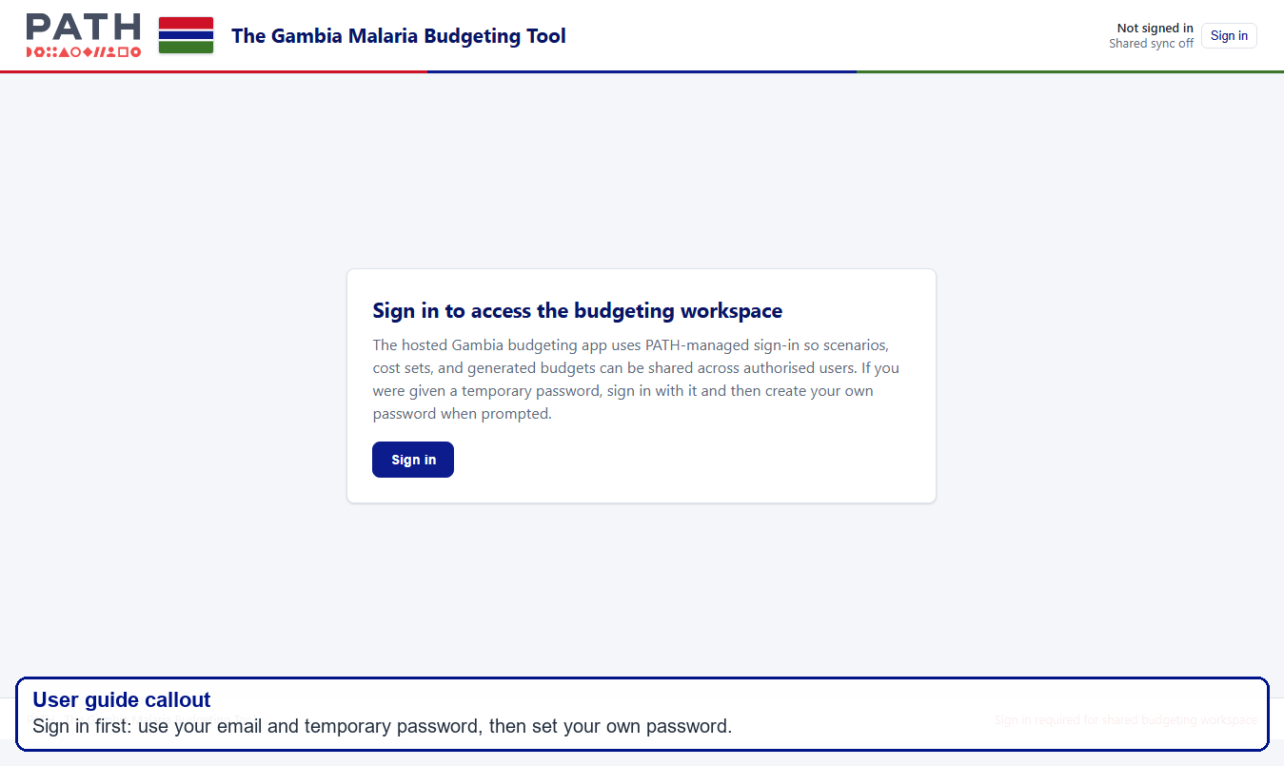
Sign-in screen and shared access status
Use your email address as your username. If you were given a temporary password, enter it at first sign-in and then create your own password when prompted.
After signing in, check the top-right corner of the app:
- Your email address should appear.
- The shared saving status should move through loading and then show “Shared data loaded” or “Shared data saved”.
- The workflow tabs should be visible.

Tip
If the page seems stuck after sign-in, refresh the page once and wait for the shared status to update.

Shared Saving and Collaboration
The hosted app shares saved scenarios, cost sets, and generated budgets across authorised users. This is what lets one person generate a budget and another person open it later.
The top-right corner shows the shared saving status:
- Shared data loaded — the browser loaded the shared workspace.
- Shared data saved — the latest saved work reached shared storage.
- Saving shared data… — the app is still saving.
- Shared save skipped — the app prevented this browser from overwriting shared budgets, usually because this browser has no local budget library to preserve.
- Shared save failed — the app could not save to shared storage. Your browser may still hold local changes, but ask for support before closing if the work is important.

Important habits
- Wait for “Shared data saved” before closing the browser.
- If you open the app in a second browser, hard refresh and wait for “Shared data loaded”.
- Use “Sync now” only from a browser that has the budget library you want to preserve.
- Avoid two people editing the same scenario or cost set at the same time. The app is shared storage, not live co-editing.

Plain-language example: if two people open the same scenario at 10:00am and both edit it, the person who saves last may overwrite the other person’s changes. Agree who is editing before making major changes.

Overview Page
The Overview page is the starting point. It summarises the workflow and shows the current scope of the tool. Use it to orient new users before they move into the scenario and cost pages.
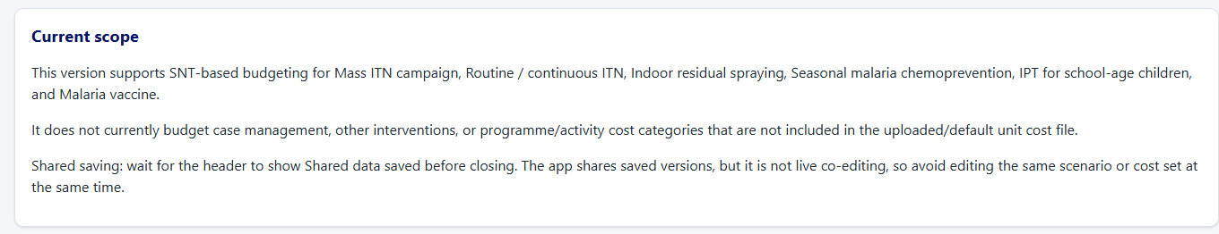
Overview page and current scope note
Check before moving on
- The footer says reference data are loaded.
- The current scope matches the work you are trying to do.
- You understand that unsupported interventions or cost activities cannot be budgeted unless they are added to the scenario logic and cost file which requires discussing with the PATH technical team.

Scenario Specification Walkthrough
Use Scenario specification to define the malaria plan. This page controls what the budget engine will quantify: target districts, plan years, intervention mix, product choices, coverage, cycles, buffers, and special levers such as ITN caps or routine-net pauses.

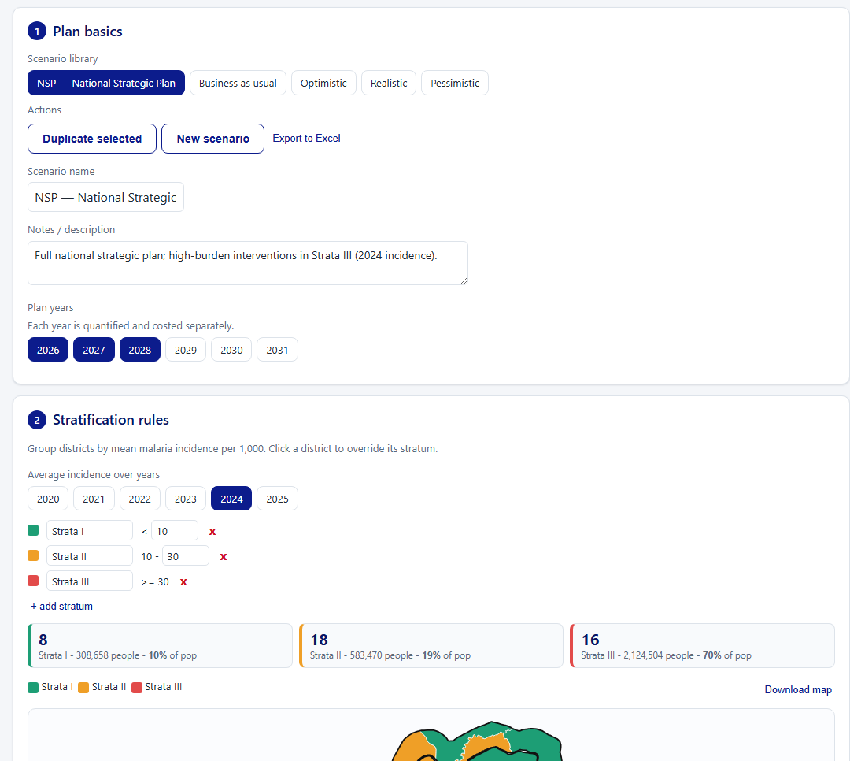
Scenario specification main screen

Step 1: Choose a Scenario
At the top of the page, the Scenario library shows saved scenario names. Click a chip to open that scenario. Scenarios currently loaded are based on the SNT stratification work.
The action buttons are separate from the scenario library:
- Duplicate selected: creates a copy of the currently selected scenario.
- New scenario: starts a blank/new scenario.
- Export to Excel: exports the selected scenario assumptions.

Tip
Duplicate before making major edits. It gives you a clean comparison version and protects the previous scenario.

Check before moving on
- The selected chip is the scenario you intend to edit.
- The scenario name and notes describe the plan clearly.
- If you are editing an existing scenario, confirm with colleagues that nobody else is editing it at the same time.

Step 2: Review Plan Basics
In Plan basics, check:
- Scenario name
- Notes / description
- Plan years
- Population growth rate
Each selected plan year is quantified and costed separately. If a year is switched off, no quantities or costs are generated for that year.
Important
If you change plan years or population growth, existing budgets generated from this scenario should be treated as out of date and regenerated.

Step 3: Review Stratification Rules
The stratification section groups districts by malaria incidence. These strata are then used as base rules for intervention targeting.
Typical checks:
- Incidence years: confirm which incidence year(s) are used for stratification — a single year or an average of multiple years can be used.
- Stratum thresholds: check the cut-off values — add or remove strata as required.
- District counts: review how many districts and people are in each stratum.
- Map: check that the district distribution of strata looks correct.

Important
Changing a threshold can move districts between strata. Because intervention targeting can be based on strata, this may change which districts receive IRS, SMC, IPTsc, vaccine, or other interventions. Regenerate affected budgets after changing thresholds.

Step 4: Review Intervention Mix by Stratum
The intervention mix table is one of the most important setup areas. It controls whether each intervention is on and which districts are targeted before any manual overrides are applied.
For each intervention, review:
- On: whether the intervention is active.
- All: whether all districts are targeted by the base rule.
- S I, S II, S III: whether the base rule targets those strata.
- Base: the base targeting rule.
- Manual: whether manual additions or exclusions have been applied.
- Final: the number of districts targeted after base rules plus manual changes.
The intervention map viewer beside the table shows where interventions are running. Use it to check that the table and map tell the same story.
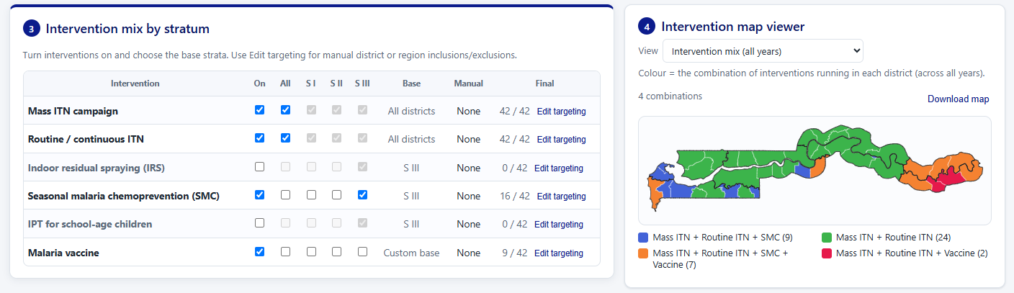
Intervention map viewer
Check before moving on
- Each intervention that should be budgeted is switched on.
- The base strata match the programme strategy.
- Any custom additions/exclusions are intentional.
- The final district count looks right.

Step 5: Use Manual Targeting Overrides
Click Edit targeting for an intervention when the final district list should differ from the base stratum rule.
The targeting override modal lets you:
- keep a base rule, such as all districts or selected strata
- manually include a full region
- manually exclude a full region
- manually include selected districts
- manually exclude selected districts
- clear manual changes
The map uses a specific colour logic:
- Light green: targeted by the base rule
- Blue: manually added
- Dark burgundy: manually excluded
- Grey: not targeted
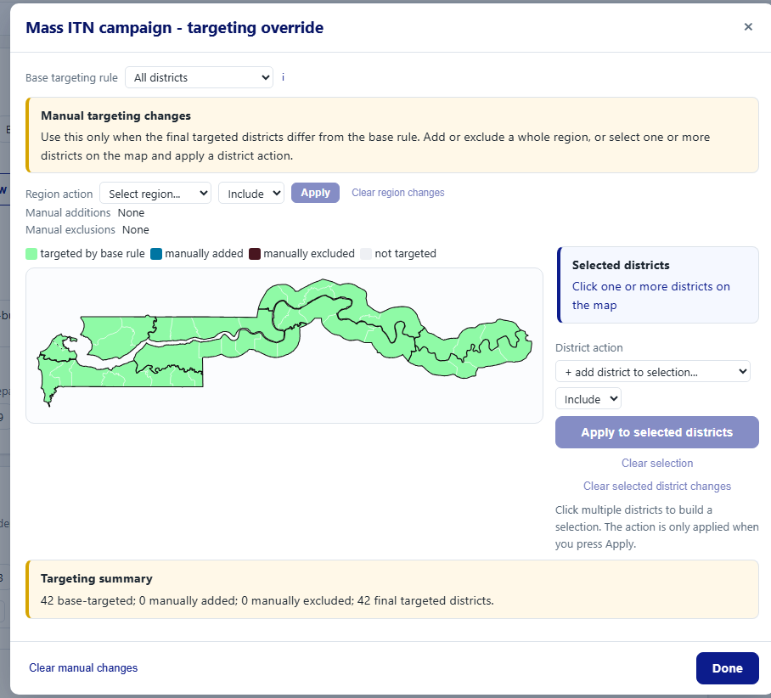
Targeting override modal
District actions are deliberate. Click one or more districts on the map, choose include or exclude, and then apply the action. This reduces accidental changes because clicking the map alone does not immediately change the scenario.
Note
Use manual exclusions when a district should not receive an intervention at all. Excluded districts are removed from targeting, quantification, costing, diagnostics, maps, and exports for that intervention. This is different from partial quantity levers — for example, “deprioritise urban” for ITNs reduces quantities in eligible areas but does not mean the district is fully untargeted.

Step 6: Review Intervention Assumptions
The intervention specification cards set the quantities that feed the budget. Review each intervention that is switched on.
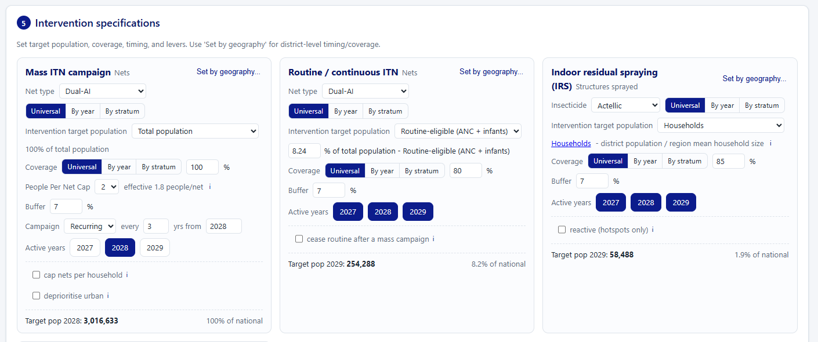
Intervention assumptions and Mass ITN card
For Mass ITN campaign, check:
- Net type
- Target population
- Coverage
- People per net cap
- Buffer
- Campaign timing and active years
- Household cap option
- Urban deprioritisation option
People per net cap is programme-facing language. It maps to an internal effective people-per-net value used for quantification:
- Cap 2 uses effective 1.8 people per net.
- Cap 3 uses effective 2.7 people per net.

Mass ITN formula
Nets = Target population × Coverage ÷ Effective people per net × (1 + Buffer)

If a mass campaign is set as recurring, check the campaign interval and the first campaign year. The target population shown on the Mass ITN card uses the active campaign year, not simply the final scenario year.
For Routine / continuous ITN, check:
- Net type
- Routine-eligible target population
- Coverage
- Buffer
- Active years
- Whether routine nets pause after a mass campaign
If routine nets pause after a mass campaign, users enter pause months. The tool converts this into a percentage reduction using the Mass ITN campaign interval:
Routine-net pause
- Reduction percentage = Pause months ÷ (Campaign interval years × 12)
- Example: if the Mass ITN campaign interval is 3 years and routine nets pause for 6 months, the reduction is 6 ÷ 36 = 16.7%.

For IRS, check:
- Insecticide selected: Actellic, SumiShield, or Fludora Fusion
- Target population, usually households/structures
- Coverage
- Buffer
- Active years
- Any reactive/hotspot option if used
IRS procurement costs are type matched. If Actellic is selected, only Actellic product rows are used, plus shared blank-type add-on rows.
For SMC, check:
- Drug type
- Target age group
- Coverage
- Cycles
- Buffer
- Active years
SMC procurement is split by age/pack: SP+AQ 3–11m and SP+AQ 12–59m. Per-child costs use covered children; per-dose, per-pack, or per-treatment-course costs use cycle-adjusted commodity quantities.
For IPT for school-age children, check:
- Drug type
- Coverage
- Cycles / rounds
- Buffer
- Active years
IPTsc procurement is split by school-age pack where applicable: DHA-PPQ 5–11y and DHA-PPQ 12–15y. If SP-AQ or SP is selected but no matching typed procurement row exists in the cost set, the tool will cost legitimate shared add-ons and warn that procurement is missing.
For Malaria vaccine, check:
- Vaccine product
- Eligible infant cohort
- Dose coverages
- Active years
Vaccine procurement rows remain product-specific. Vaccine delivery, administration, communication, support, and monitoring rows are shared add-ons unless a typed row is provided.

Step 7: Use Set by Geography
Click “Set by geography…” on an intervention card when timing, product, coverage, or target assumptions differ by region or district.
The modal is organised by region and district. Region rows can be used to set assumptions for all districts in that region, while district rows can be used for specific local changes.
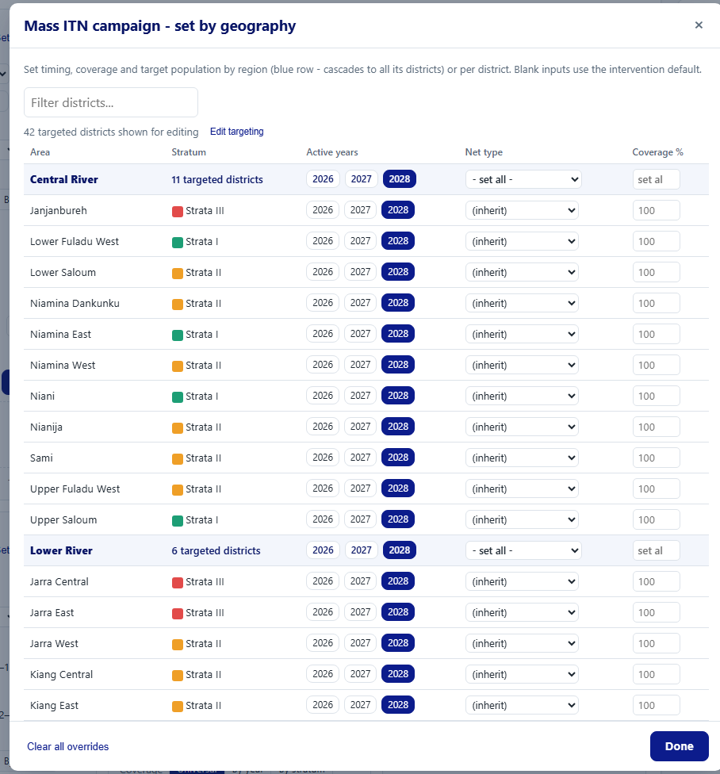
Set-by-geography modal
Excluded districts are respected here. By default, excluded rows are hidden so users do not accidentally configure districts that are not targeted. Use the show-excluded toggle only when you need to audit or troubleshoot exclusions.
Check before moving on
- The number of targeted districts shown in the modal matches your expectation.
- Region-level settings have cascaded as intended.
- District-level overrides are only used where genuinely needed.
- Excluded districts are not being unintentionally configured.

Step 8: Save the Scenario
Use the summary panel on the right to save scenario changes. The save state shows whether there are unsaved changes.
Check before moving on
- Click Save changes if the scenario was edited.
- Wait for the shared status to show “Shared data saved”.
- Remember that budgets generated before the edit will become out of date and should be regenerated.

Cost Specification Walkthrough
Use Cost specification to review or edit the unit cost set. A cost set is a library of line-item costs. The budget engine costs each matched line item, then aggregates those line items into summary tables and charts.
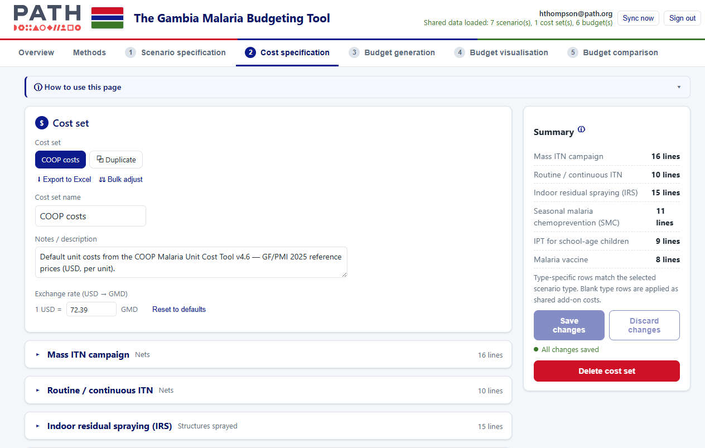
Cost specification main screen

Step 1: Choose a Cost Set
Click a cost set chip to open it. The default/reference cost set is currently labelled COOP costs.
Before major edits
- Duplicate the cost set if you want to preserve the previous version.
- Update the notes/description so colleagues understand what changed.
- Check that the exchange rate is correct.

Step 2: Check Cost Row Fields
Each cost row includes: Intervention, Cost category, Input description, Type, Unit, Unit cost in USD, Local currency equivalent, and a Data quality score. The cost engine uses these rows as line items.
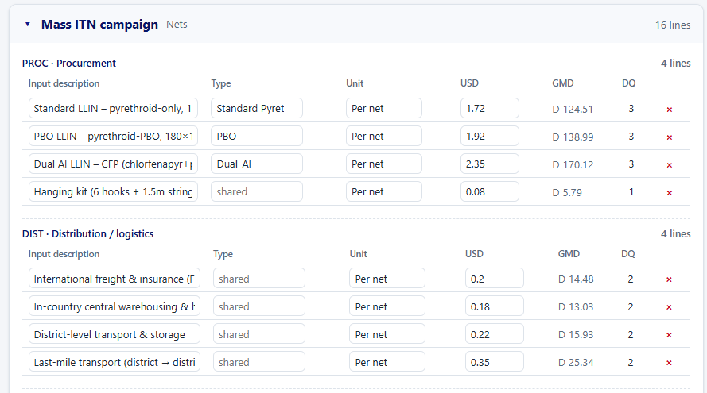
Cost rows grouped by intervention and category

Step 3: Understand Cost Categories
Cost categories are used for summaries and charts. Common categories include Procurement, Distribution / logistics, Operational, Support / capacity, Monitoring & evaluation, Communication / BCC, and Administration.
Important
If a row is assigned to the wrong category, the total budget may still be correct but category charts and tables will be misleading.

Step 4: Understand Units
The unit controls which quantity is multiplied by the unit cost:
- Per net: uses net quantity.
- Per structure: uses structures sprayed.
- Per dose: uses dose quantity.
- Per pack: uses pack quantity.
- Per treatment course: uses treatment-course quantity.
- Per child and Per person: use coverage-adjusted target population.
- Per year: applies once per intervention year.
- One-off: applies once per budget.

Important
If the unit is blank or unsupported, the row may be skipped and a warning appears during budget generation.

Step 5: Understand Type Matching
Typed procurement rows must match the scenario-selected type exactly. Blank-type rows are shared add-on rows and can apply across product types.
Examples:
- IRS selected as Actellic uses Actellic procurement rows plus blank-type IRS add-ons.
- IRS selected as SumiShield uses SumiShield procurement rows plus blank-type IRS add-ons.
- SMC age-pack quantities match SP+AQ 3–11m and SP+AQ 12–59m.
- IPTsc DHA-PPQ quantities match DHA-PPQ 5–11y and DHA-PPQ 12–15y.
- ITN campaign and routine ITN procurement rows should match the selected net type.
- Vaccine procurement rows should match the selected vaccine product.

Note
If a typed commodity is selected but no exact typed procurement row exists, the tool warns you. It may still cost shared add-on rows where those are legitimate.

Step 6: Edit Data Quality Scores
Data quality (DQ) scores appear as coloured pills. Click or tab into the pill and type to adjust:
- 1: model estimate
- 2: programme data
- 3: primary study
- blank: not set
The colour and label help users quickly identify how reliable or evidence-based a cost row is. After editing a DQ score or any other row field, the save state shows unsaved changes.

Step 7: Save the Cost Set
Before leaving Cost specification
- Check the summary panel for unsaved changes.
- Click Save changes.
- Wait for “Shared data saved”.
- Regenerate budgets that use the edited cost set.

Budget Generation Walkthrough
Use Budget generation to combine a scenario and a cost set.
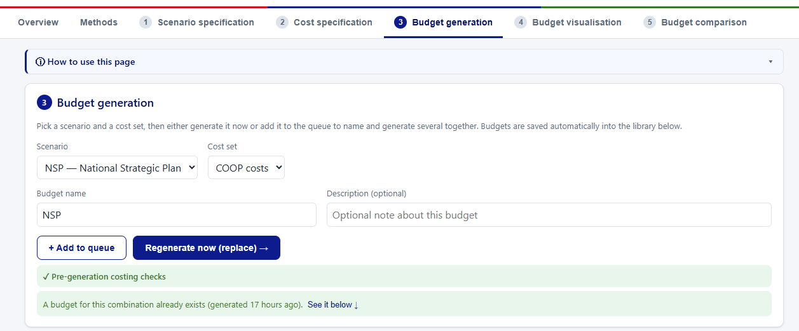
Budget generation and the budget library

Step 1: Select Scenario and Cost Set
Choose the scenario and cost set from the dropdowns. The budget name is suggested automatically but can be edited. For a clean audit trail, keep budget names descriptive.

Step 2: Read Pre-generation Warnings
The warning panel appears before generation when the tool detects possible costing issues. Common warnings include:
- An enabled intervention has no cost rows.
- A selected product/type has no exact typed procurement row.
- A quantity row is only costed by shared blank-type add-ons.
- A cost row has an unsupported unit.
- A quantity is zero because no districts, years, or coverage are active.
Warnings are not automatically blockers. They tell you what to review before relying on the result.
High-priority warning example
“IPT for school-age children type SP: no matching typed procurement row” means the tool can cost shared distribution or operational add-ons if present, but the drug procurement itself is missing from the selected cost set.

Step 3: Generate, Regenerate, or Queue
- Generate now: create a new budget for the selected scenario and cost set.
- Regenerate now (replace): refresh an existing budget for the same scenario and cost set.
- Add to queue: prepare several runs and generate them together.
- Regenerate all: refresh all budgets whose source scenario and cost set still exist.
Regenerate when: a scenario changes; a cost set changes; the budget is marked out of date; or the costing/quantity logic has been updated.

Step 4: Check the Budget Library
The Budget library lists saved budgets. Use it to open, export, edit, delete, compare, or regenerate budgets. Status labels:
- Current: the budget matches the current saved scenario and cost set.
- Out of date: the source scenario or cost set changed after the budget was generated.
- Source deleted: the original scenario or cost set no longer exists.
Out-of-date budgets remain viewable, but regenerate them before using outputs for decisions.
Check before moving on
- Confirm the new budget appears in the library.
- Wait for “Shared data saved”.
- If another user needs the budget, ask them to hard refresh and wait for “Shared data loaded”.

Budget Visualisation Walkthrough
Use Budget visualisation to review one generated budget in depth.

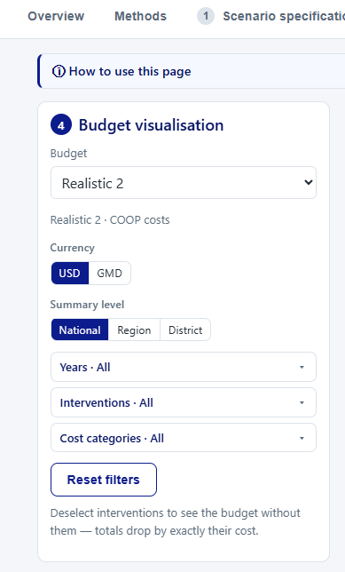
Step 1: Select a Budget
Choose a budget from the dropdown. If the budget is out of date, the page shows a warning — regenerate before relying on the outputs.

Step 2: Read the Headline Figures
The value cards at the top summarise the budget for the current filters:
- Total budget — the total cost in the selected currency. When filters exclude anything, a small subline shows the difference versus the full budget (for example, “−$1.8M vs full budget”).
- Cost per person — total cost divided by the average population across the selected years (the subtitle shows that population).
- Coverage of the plan — the number of years, regions, and districts included.

Step 3: Use Filters
Filters can narrow the output by years, interventions, cost categories, geography, currency, and summary level.
When you filter out an intervention, totals drop by exactly that intervention’s cost — a quick “what if we dropped X?” check.
Important
Filters are useful for analysis, but always reset filters before quoting the full budget total.

Step 4: Set a Budget Envelope
Enter an available budget in the “Budget envelope” card. The card then shows how much of the envelope is used and whether you are under or over it, with a progress bar. It respects the active filters and currency.
Note
The envelope is a planning aid only. It is not saved with the budget and resets when you reload.

Step 5: Review Maps and Charts
The maps show the geographic intervention mix and budget patterns:
- Intervention-mix map — each district coloured by the package of interventions it receives, with a legend listing each package.
- Four cost choropleths — Region and District, each shown as Total cost and Cost per person.
Charts summarise the budget by year, intervention, category, or geography. Use the expand icon in the bottom-right corner of a chart or map to open it larger. PNG downloads are available for sharing visuals in slides or documents.

Step 6: Review Cost Tables
The cost tables have multiple views:
- Intervention costs: grouped summaries, with per-year columns.
- Cost lines: line-item costs.
- Quantities: commodity and population quantities.

Tip
Use Cost lines when you need to understand exactly why a total is high or low. The line-item table is the best audit view because it shows descriptions, units, quantities, unit costs, and line costs.

Step 7: Review Top Cost Elements
The top cost elements chart is a lollipop plot based on specific cost lines, not only broad intervention categories. Use the top-N selector in the chart card to choose how many elements to display. The tooltip shows the cost description, intervention, category, unit cost, and quantity information where available.

Step 8: Export to Excel
Use the Excel export when you need to audit, share, or archive the budget. The export includes line-item detail, quantities, diagnostics, status information, assumptions, and summary sheets. See the Excel Export Guide below.

Budget Comparison Walkthrough
Use Budget comparison to compare generated budgets against a baseline.

Step 1: Select Budgets
Select a baseline budget and one or more comparison budgets. Choose budgets generated from the scenarios you intend to compare.
Before interpreting differences
- Each selected budget is current.
- The scenario and cost set names are clear.
- The same currency and filter settings are being used.

Step 2: Read the Scoreboard
The scoreboard at the top gives one card per budget so you can size up the options at a glance:
- the total cost (in the selected currency),
- its relative size compared with the others,
- its difference from the baseline as both an amount and a percentage,
- and its cost per person.
Charts use short scenario labels (for example, “NSP”); the full name appears when you hover.

Step 3: Set a Budget Envelope
Enter an available budget to test affordability. The totals chart then shows a dashed “available budget” line, and each scoreboard card flags whether that option is under or over the envelope, with the percentage used.
Note
Like the visualisation envelope, this is a planning aid and is not saved with the comparison.

Step 4: Review Cost Change
The comparison page includes a tabbed table card. The cost view shows cost change versus baseline by intervention. For each intervention, review: baseline cost, comparison cost, absolute change, and percentage change. Use the table filters (has increases, has decreases, all) to focus on the direction of change.

Step 5: Review Commodity Change
The commodity view shows change in intervention commodity requirements versus baseline. It mirrors the cost-change table so rows are easy to compare. Use it when a budget change needs to be explained by quantity changes, for example:
- fewer ITNs because of a different people-per-net cap
- fewer districts targeted by IRS or SMC
- fewer vaccine doses because fewer years or districts are active
- lower routine net quantities because routine distribution pauses after a mass campaign

Step 6: Composition — Where the Money Goes
The “Compare by” toggle (Intervention, Cost category, Year, or Region) drives both the delta table and the composition chart. The composition chart has a $ / % toggle: “$” shows absolute stacked totals per budget, while “%” shows each budget as a 100% stack so you can compare the shape of spend regardless of size.

Step 7: Check Stale Budget Warnings
Important
If either the baseline or a comparison budget is out of date, regenerate before relying on the comparison. A stale comparison can be misleading because it may compare old scenario logic to new scenario logic.

Excel Export Guide
The Excel export is the strongest audit output. It is designed so programme staff can trace from high-level totals down to the line-item calculations. Every breakdown sheet carries a column per plan year plus an all-years total.
Key sheets to use:
- Summary / totals: quick review of budget totals.
- By intervention: cost per intervention with its cost categories nested beneath, and per-year columns.
- Cost detail: line-item costs, including intervention, type, description, unit, quantity used for costing, unit cost, source, and match metadata.
- Quantities: target populations, covered populations, commodity quantities, age bands, and quantity basis, by year.
- By district: district costs grouped by region, with a bold regional subtotal row.
- Diagnostics: warnings and notes captured during budget generation.
- Source status: whether the scenario/cost set behind the budget is current or out of date.
- Assumptions snapshot: scenario inputs at the time of generation.
- Cost set audit: cost rows and whether they were used, matched, unused, unsupported, or missing required data.
- Top cost elements: the same line-item aggregation used by the lollipop plot.

How to Cross-check a Budget in Excel
- Open Cost detail.
- Sum the cost (USD) column.
- Compare that sum to the budget total.
- Group Cost detail by intervention and compare to the intervention summary sheet.
- Group Cost detail by cost category and compare to category summaries.
- Open Quantities to check whether quantities look plausible.
- Open Diagnostics to see whether anything was missing, skipped, or only partially costed.

Tip
If totals do not reconcile, use the line-item sheets first. They are the source of truth for the generated budget.

Practical Interpretation Tips
Use budget totals together with quantities. A cost difference can come from:
- different target districts
- different coverage
- different years
- different product types
- different unit costs
- different unit handling, such as per child versus per dose
- routine-net pause assumptions
- ITN cap assumptions
- manual inclusions or exclusions
When explaining differences, try to say both what changed and why it changed. For example:
Worked example
“Realistic 2 is lower than NSP mainly because the Mass ITN campaign applies a household/net cap and uses fewer ITNs, which reduces procurement, distribution, and operational line items linked to net quantities.”

Common Tasks and Recipes
Short recipes for the questions users most often bring to the tool. Each points to the section with the full detail.
Compare NSP with Realistic
- Generate a budget for each scenario (Budget generation → Generate now).
- Go to Budget comparison and pick NSP as the baseline and Realistic as the comparison.
- Read the scoreboard for the totals and the difference, then use “Compare by” to see where the money differs.
Lower procurement costs by 15%
- Go to Cost specification and Duplicate the cost set (so the original is preserved).
- Use Bulk adjust, choose the Procurement category, and apply −15%.
- Save the cost set, then regenerate any budget that uses it.
Add or remove a district for one intervention
- Go to Scenario specification and find the intervention card.
- Click Edit targeting, select the district(s) on the map, and choose Include or Exclude, then Apply.
- Save the scenario and regenerate affected budgets.
Deprioritise urban areas for ITNs
- On the Mass ITN card, enable the urban deprioritisation lever.
- Confirm the urban areas and the percentage reduction.
- Save and regenerate.
Explain why a total changed
- Open the budget in Budget visualisation and look at Cost lines and the commodity view.
- In Budget comparison, use the commodity view to see quantity changes behind the cost change.
- State both what changed (e.g. fewer nets) and why (e.g. a 3-person net cap).
Produce a funding-application Excel pack
- Confirm the budget status is Current.
- Open Budget visualisation (or the budget library) and choose Export to Excel.
- Use the Summary, By intervention, Cost detail, and Quantities sheets in the application.

Troubleshooting

You Cannot Sign In
Check that you are using the correct app link; your username is your email address; you have accepted or reset the temporary password; and the password was typed exactly. If the login page accepts the password but returns you to the app without loading data, refresh once and wait for the shared status.

You Do Not See a Budget Someone Else Generated
- Hard refresh the browser.
- Wait for “Shared data loaded”.
- Open Budget generation and check the Budget library.
- If still missing, ask the person who generated it whether their browser showed “Shared data saved”.

Important
Do not click “Sync now” from a browser with no local budgets unless you are specifically troubleshooting with support.

A Budget Is Out of Date
This means the scenario or cost set changed after the budget was generated. Go to Budget generation and regenerate the budget before using it for decisions.

You See Pre-generation Warnings
Warnings are prompts to check the setup. Read the intervention/type named in the warning. Common responses:
- Missing typed procurement: add or correct the matching cost row, or accept that procurement is not costed.
- Shared add-ons only: check whether this is intentional.
- Zero quantity: check district targeting, active years, coverage, and cycles.
- Unsupported unit: edit the cost row unit to a supported value.

Shared Saving Shows an Error
Do not close the browser immediately if important work was just created. Wait a few moments and try a refresh only if you are confident local changes are visible. If the error remains, ask for support and mention the exact message in the top-right corner.

You Are Unsure Whether to Click Sync Now
Most users should not need Sync now. Use it only when you know this browser has the correct budget library that should be preserved in shared storage.

A Chart or Table Does Not Look Right
- Are filters active?
- Is the selected budget current?
- Is the expected intervention switched on?
- Are the expected districts targeted?
- Are manual exclusions applied?
- Does the cost set contain matching typed procurement rows?

A Budget Total Looks Too Low
- An intervention is switched off.
- Districts or regions are excluded.
- Coverage is low or active years are missing.
- The selected product/type has no matching procurement cost.
- A cost row has an unsupported unit.
- Routine nets are reduced after a mass campaign.
- An ITN cap or deprioritisation lever is reducing net quantities.

A Budget Total Looks Too High
- Too many districts are targeted.
- Coverage is set too high.
- The intervention is active in too many years.
- Per-dose or per-cycle costs are being applied to cycle-adjusted quantities.
- A one-off or per-year row is included unintentionally.
- A cost row is duplicated.

Glossary of Key Terms
Term | Meaning
Stratum | A group of districts with similar malaria incidence. Strata (often I, II, III) are used as base rules for where interventions run.
Coverage | The share of the target population reached by an intervention (e.g. 80%).
Buffer | A small percentage added to quantities to allow for wastage and contingency (default 7%).
People per net cap | Programme-facing setting for mass ITN campaigns. Cap 2 → 1.8 effective people per net; Cap 3 → 2.7.
Cycle | One round of a repeated intervention (e.g. an SMC monthly cycle). More cycles means more commodity.
Type matching | Costing rule where a typed procurement row (e.g. “Actellic”) is only used when the scenario selects that type.
Shared add-on (blank-type row) | A cost row with no specific type that applies across product types (e.g. freight, training, M&E).
Lever | A scenario switch that adjusts quantities, such as an ITN household cap, urban deprioritisation, or a routine-net pause.
Data quality (DQ) score | A 1–3 rating of how evidence-based a cost is (1 model estimate, 2 programme data, 3 primary study).
Out of date | A budget whose source scenario or cost set changed after it was generated. Regenerate before using it.
Envelope | An available-budget figure you enter to check whether a plan is affordable. A planning aid; not saved.
What-if filter | Deselecting an intervention (or year/area) in visualisation to see the total without it.

Appendix: Default Assumptions
These are the current default values. All are editable in the app (per scenario or per cost set); the in-app Methods tab always reflects the current logic. Values are seeded from the SNT scenario scripts.

Population, currency, and buffer
Assumption | Default
Population data | Observed to 2025; later plan years are projected.
Population growth rate | 2.3% per year (editable; can vary by year).
Exchange rate | 72.39 GMD per USD (set on the cost set).
Buffer on quantities | 7%.
People-per-net cap → effective | Cap 2 → 1.8; Cap 3 → 2.7.

Coverage defaults by intervention
Intervention | Default coverage / settings
Mass ITN campaign | 100% coverage
Routine / continuous ITN | 80% coverage
Indoor residual spraying (IRS) | 85% coverage
Seasonal malaria chemoprevention (SMC) | 100% coverage, 4 cycles
IPT for school-age children (IPTsc) | 75% coverage, 3 cycles
Malaria vaccine | Dose coverages 90 / 90 / 90 / 85%

Demographic proportions (share of total population)
Group | Share
Children under 5 | 16%
SMC eligible (3–59 months) | 14.5%
School-age children (5–14) | 25%
Pregnant women | 4.2%
Infant vaccine cohort | 3.5%

Household size for IRS (people per household)
Region | Household size
National fallback | 8.2
Central River | 10.3
Lower River | 8.3
North Bank East | 9.5
North Bank West | 9.5
Upper River | 12.6
Western 1 | 5.3
Western 2 | 7.7

Mass-ITN net-cap reduction by region
Region | Max nets / household | Reduction in nets
Central River | 7 | 6.5%
Lower River | 5 | 11.5%
North Bank East | 6 | 9.1%
North Bank West | 6 | 9.1%
Upper River | 7 | 12.7%
Western 1 | 4 | 6.8%
Western 2 | 5 | 9.2%

Cost-reduction lever defaults
Lever | Default
Urban deprioritisation areas | Kanifing, Banjul, Kombo North
Urban deprioritisation reduction | 30% of population
Cease routine after campaign | 6 months → 17% reduction that year
Reactive IRS | 20% partial coverage in hotspots

Final Checklist Before Sharing Outputs
Before sending charts, tables, or Excel files to colleagues:
Final checks
- Confirm the budget status is Current.
- Reset filters unless you are intentionally sharing a filtered view.
- Check pre-generation diagnostics.
- Open Cost detail if a major total looks surprising.
- Confirm scenario assumptions, especially targeting, active years, coverage, ITN cap, and routine pause.
- Confirm cost set assumptions, especially product/type matching, unit costs, units, and DQ scores.
- Export Excel for any budget that will be reviewed outside the app.

