Embedded Data Logger Using SD Card
Author: Pathan Sahil
Department of Electronics and Communication Engineering
KLH University, Bachupally, India

Abstract
An embedded data logger is used to record sensor data over time. This project uses an Arduino microcontroller to read sensor data and store it on an SD card using the SPI communication protocol. The system provides a low‑cost and efficient method for long‑term monitoring and data storage.

Keywords
Embedded System, Arduino, Data Logger, SD Card, SPI Protocol, Sensor Monitoring

1. Introduction
Data logging systems are widely used in environmental monitoring, industrial automation, and IoT applications. Embedded microcontrollers allow sensors to collect data continuously and store it for later analysis.

2. System Architecture
The system consists of a sensor, Arduino microcontroller, SD card module, and power supply. The sensor collects data, the Arduino processes it, and the SD card stores it.

3. Circuit Diagram
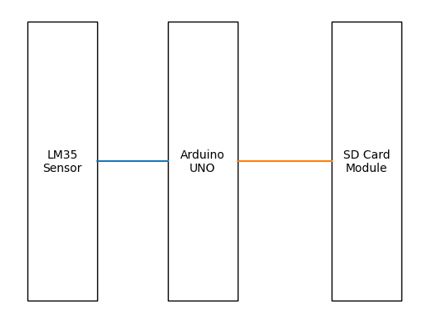

4. Block Diagram
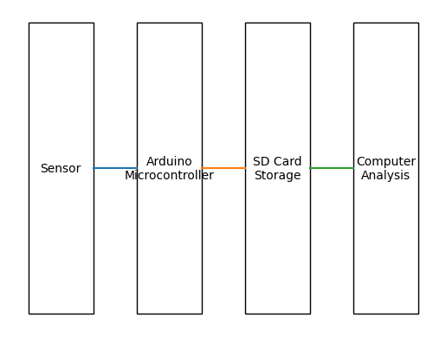

5. Flowchart
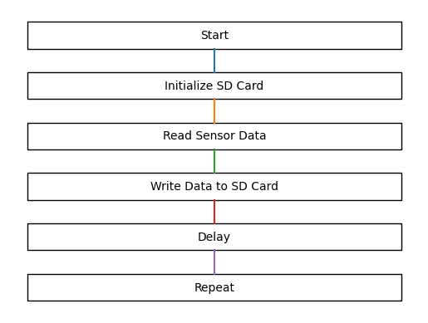

6. Working Principle
The sensor measures environmental data and sends it to the Arduino. The Arduino converts the signal using ADC and stores the readings on the SD card through SPI communication.

7. Applications
Weather monitoring, industrial data logging, environmental monitoring, and IoT systems.

8. Conclusion
The embedded data logger using an SD card provides a reliable and low‑cost method for recording sensor data for long‑term monitoring applications.

References
1. Arduino Official Documentation
2. Raj Kamal, Embedded Systems Architecture

