- WHO WE ARE
Lafarge Africa PIc is a Member of Huaxin Cement Co. Ltd - founded in 1907 and incorporated in China. Huaxin is listed on the Shanghai and on the Hong Kong stock exchanges, and is among the 10 largest cement groups in the world. In addition to cement, Huaxin operates aggregates and ready-mixed concrete as well as waste management businesses, and has its own cement and waste pre-/co-processing equipment manufacturing with proprietary technology. Huaxin is recognised among the world's top manufacturing enterprises and most valuable brands..

With plants in Ewekoro and Sagamu in the South-West, Mfamosing in the South-South and Ashaka in the North-East of Nigeria, Lafarge Africa Plc currently has an installed cement production capacity of 10.5MTPA and has plans to grow in the near term.

Lafarge Africa’s Readymix business in Nigeria produces quality and innovative concrete and aggregates solutions from various locations with plants currently located in Lagos, Abuja, Port-Harcourt and Ewekoro.

- LAFARGE AFRICA FOOTPRINT
Lafarge Africa operates across multiple regions in Nigeria through a network of cement plants, ready-mix sites, and depots.

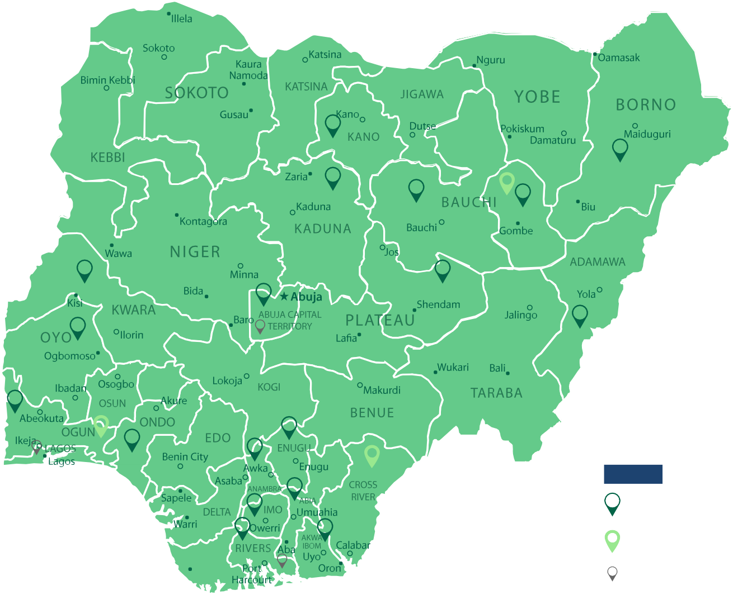
CEMENT PLANTS
READYMIX SITES
DEPOTS

Cement Plants
- Ewekoro (EWE) – Ogun State
- Sagamu (SGU) – Ogun State
- Mfamosing (MFA) – Cross River State
- Ashaka (ASH) – Gombe State

ReadyMix Locations
- Oregun Office & NKB Plant
- Lekki Plant
- Ewekoro Plant
- Mfamosing Plant
- Freedom Plant
- BCL Plant
- Trans-Amadi Plant
- Abuja Plant (Idu)

Depots
Lafarge maintains depots across Nigeria — in the North (Gombe, Kaduna, Jos, Abuja, Kano, Bauchi, Yola, Mubi, Maiduguri), the West (Abeokuta, Ajah, Oregun, Eleyele, Akure, Ilorin, Ijebu Ode), and the East (Enugu, Aba, Onne, Uyo, Owerri, Port Harcourt, Onitsha).

- LAFARGE AFRICA CULTURE

Our vision is to be a building solutions company renowned for creating a greener planet through innovation and operational excellence. This vision is —anchored by a culture built to deliver it. Lafarge Africa’s culture is built on innovation, operational excellence, and strong behavioral pillars that define how we work together and lead change.

Culture
Lafarge Africa’s culture is built on innovation, operational excellence, and strong behavioral pillars that define how we work together and lead change.

Behavioural Pillars – Building a Culture of Excellence
- Prepare: Align Vision with Values
- Trek In: Trust One another and our teams
- Base Camp: Deliver on our Commitments
- Acclimatize: Feedback, Celebrate & Reassess
- Summit: Speed & Innovation – Be Best in Class

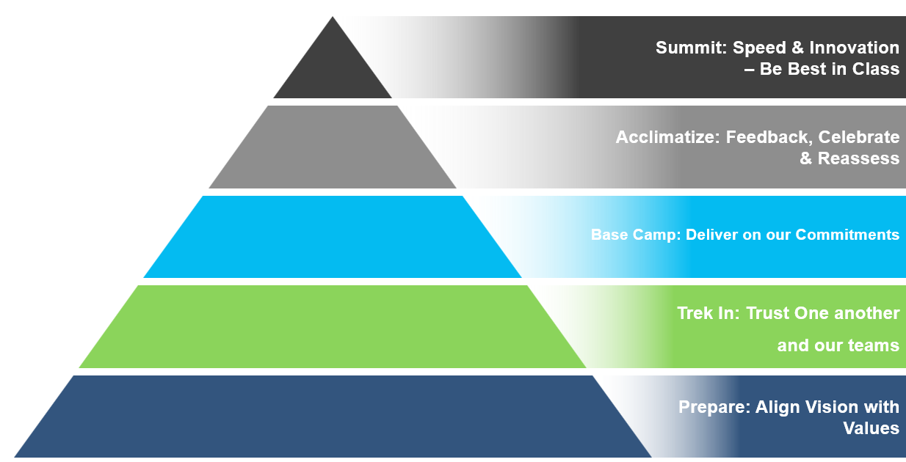

Huaxin Spirit:
- Integrity: Telling the truth, seeking truth from facts, respecting laws and regulations, acting in line with company’s values.
- Dedication: Engaging mind and heart in implementing the company’s strategy, having a bias for action, seeking to make better the lives of our employees and our communities through our actions.
- Pragmatism: Addressing problems in practical ways, implementing practical solutions, taking a fact-based approach.
- Innovation: Challenging the status quo, empowering employees to experiment, practical implementation of ideas that result in the introduction of new products or services or improvement in our offering of products and services

Respectful Workplaces
Lafarge Africa is committed to a culture of dignity and inclusion. Our Respectful Workplaces Framework ensures that all employees are treated fairly, communication remains civil, and differences are valued.

- Bullying & Harassment: Our Bullying & Harassment Policy is robust, addressing various forms of misconduct—including online harassment—to promote a safe and respectful workplace. It emphasizes confidentiality and encourages employees to speak up without fear of retaliation.
- Speak up Line: To further support this, we have established a third-party helpline that allows employees to anonymously report any bullying or discriminatory behavior, ensuring that all concerns are addressed discreetly and effectively.
- Sexual Harassment: Our Bullying & Harassment Policy defines sexual harassment as any unwanted sexual conduct—verbal, physical, or digital—that violates a person’s dignity. The recipient decides what’s unwanted. Lafarge Africa has zero tolerance for such behavior.
- Resolution: Employees may file a formal complaint of harassment or bullying if informal efforts to resolve the issue have been exhausted, or if the nature of the behavior makes an informal approach inappropriate.

