Milestone1
Receipt & Invoice Digitizer

1.Introduction:

In today’s digital era, businesses and individuals handle a large volume of paper-based receipts and invoices. Manual handling of these documents often leads to challenges such as data loss, incorrect entries, lack of traceability, and increased operational costs. Automating the digitization of invoices is therefore a critical requirement for efficient financial management.
The Receipt & Invoice Digitizer project focuses on building an automated system that converts scanned receipts and invoices into structured digital data using Optical Character Recognition (OCR). This milestone lays the foundation by enabling file upload, image preprocessing, and raw text extraction.

2.Problem Statement:

Businesses and individuals handle numerous paper receipts and invoices, which are prone to loss, errors, and manual entry delays. This project builds a system that automatically scans, extracts, and digitizes information from receipts and invoices using OCR (Optical Character Recognition) and NLP-based field extraction. The digitized data is stored in a structured format, making it easy to search, analyze, and integrate with accounting or ERP systems.

Key points:
- Manual data entry is time-consuming and error-prone
- OCR enables automatic extraction of text from receipts/invoices
- Persistent storage allows long-term data tracking and analytics

Objectives of the Milestone
• Implement file upload.
• Preprocess images for OCR.
• Extract raw text from sample receipts.
System Architecture
The high-level architecture of the system is as follows:
User Upload → Image Preprocessing → OCR Engine → Raw Text Output → UI Display
Each module is loosely coupled, allowing easy extension in future milestones.
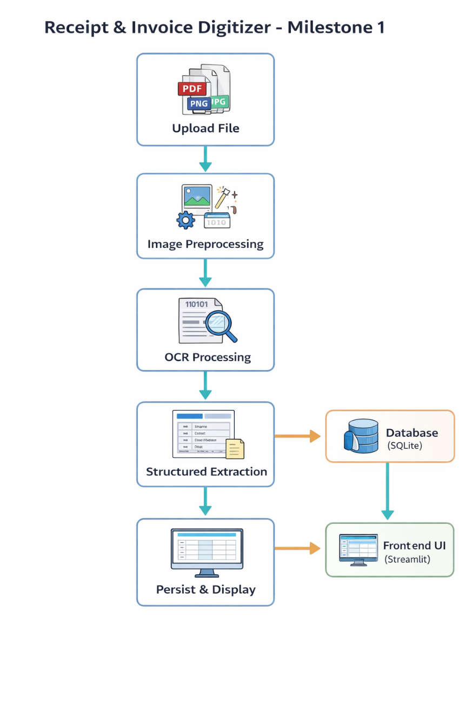

Functional Modules Description
5.1 File Upload Module
Purpose:
Allows users to upload invoice or receipt files through the web interface.
Features:
- Built using Streamlit’s file_uploader
- Supports JPG, JPEG, PNG, and PDF formats
- Uploaded files are saved locally using unique UUID-based filenames
Benefits:
- Prevents file name collisions
- Ensures traceability of uploaded documents

5.2 Image Preprocessing Module
Purpose:
Enhances image quality to improve OCR accuracy.
Techniques Used:
- Conversion to grayscale
- Image resizing for better character recognition
- Noise reduction using bilateral filtering
- Adaptive thresholding for clearer text regions
Outcome:
Preprocessed images provide significantly improved OCR results compared to raw images.

5.3 OCR Module
Purpose: Extracts machine-readable text from preprocessed images.
Tool Used:
- Tesseract OCR (Open Source)
Configuration:
- OCR Engine Mode: --oem 3
- Page Segmentation Mode: --psm 4
Output:
- Raw unstructured text extracted from the invoice or receipt

5.4 PDF Handling Module
Purpose:
Enables OCR on multi-page PDF invoices.
Approach:
- PDFs are converted to images using Poppler
- Each page is processed individually
- OCR results are concatenated
Advantages:
- Supports scanned invoices
- Works for invoices spanning multiple pages

5.5 Text Structuring
Although full structuring is implemented in later milestones, this stage includes:
- Initial regex-based exploration
- Identification of potential invoice fields such as:
  - Store name
  - Invoice number
  - Date
  - Total amount
This helps validate OCR quality early in development.

5.6 Persistent Storage Module
- SQLite used for lightweight persistent storage
- Table schema:
  - store_name
  - invoice_no
  - date
  - total
  - category
  - created_at
Advantages:
- No external DB dependency
- Easy integration with Streamlit
6. User Interface Design
The Streamlit-based UI includes:
- File upload section
- Side-by-side display of original and preprocessed images
- Structured and raw OCR output sections
Benefits:
- Improves transparency of OCR processing
- Helps users visually verify extraction quality

7. Tools & Technologies Used
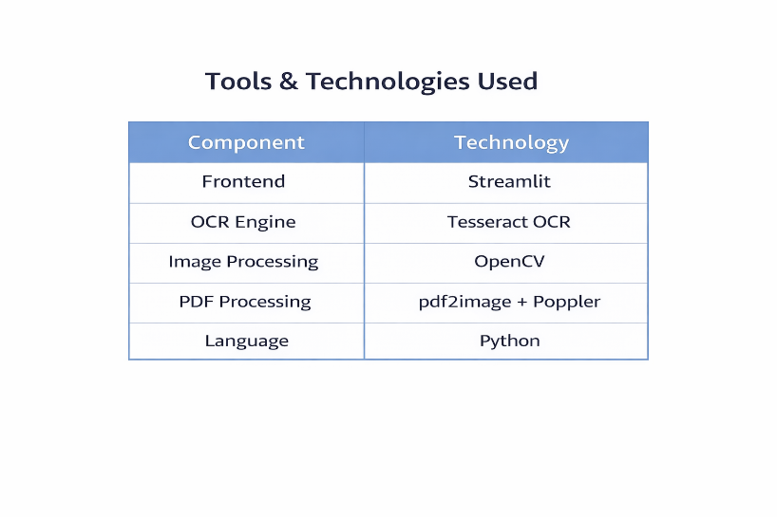
8.Output
- OCR successfully extracts text from clear invoice images
- Preprocessing significantly improves recognition accuracy
- Complex layouts may require fine-tuning of OCR parameters
Screenshots of extracted output validate the working of the pipeline.

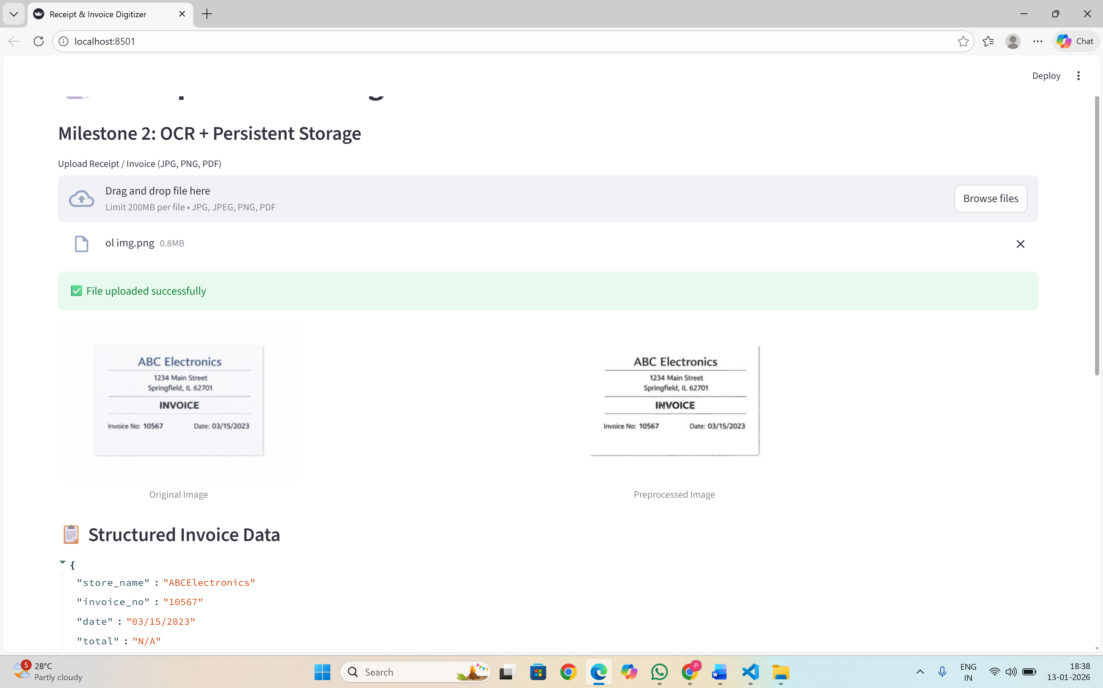

9. Conclusion
Milestone 1 successfully establishes the OCR foundation for the Receipt & Invoice Digitizer project. The system can upload files, preprocess images, extract text, and display results effectively. This milestone serves as a strong base for implementing structured extraction, duplicate detection, and persistent storage in future phases.

10. Future Enhancements
- Advanced preprocessing techniques
- Intelligent field extraction using NLP
- Database persistence and analytics
- Invoice classification and categorization

