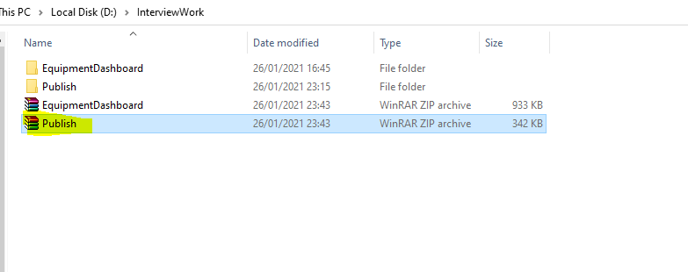

Download publish zip folder which attached in email and Unzip it.

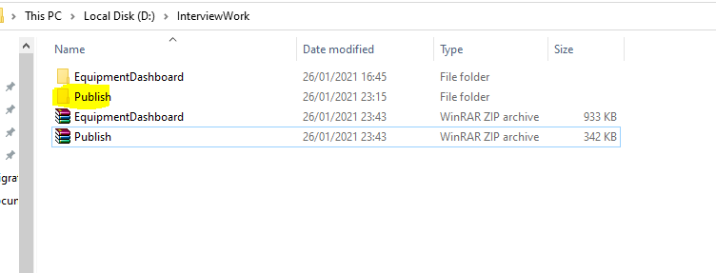

Copy unzipped publish folder path

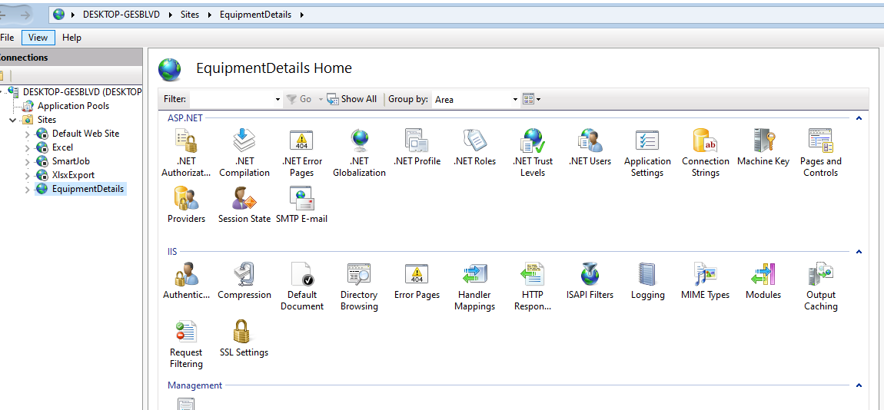

Open IIS manager

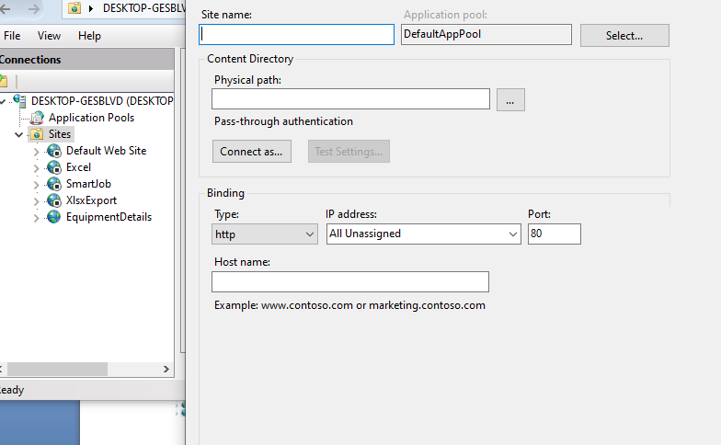

Right click on IIS sites side menu and click create site.

Type any meaningful site name in opened popup window

Paste copied publish folder path in physical path text box

Change the port number to 8080 or any port which is unused by system.

Click ok button.

Open browser and type localhost:{Entered Port Number} and click enter

Your localhost direct to graph view

