Developing an Organized Internship Administration System for
Pan-Atlantic University

PROJECT PLAN

Introduction

Most universities in Nigeria run their student internship program processes manually through spreadsheets, email communications, and documentation on paper. This centralized process lacks collaborative efforts from all stakeholders and is therefore inefficient and error-prone.

This project intends to use Structured Systems Analysis and Design (SSAD) methodology to develop a systematic design that will support technology-based tracking, communication, and other processes surrounding student internship management.

Problem Definition

Various problems were identified with the existing internship management system.

- Assigning students to appropriate internship positions can be challenging.
- Absence of a centralized method to monitor students' activities
- Not enough communication between students, industry supervisors, and school supervisors
- Ineffective daily record keeping for internship defense and grading
- Unpredictable tracking of daily logs and evaluation
Objectives

The main objectives of the project are;

- To create a centralized internship management system
- To improve communication between the stakeholders
- To enable effective and efficient tracking of student activities and progress
- To ensure proper documentation and record keeping
- To apply SSAD tools in system analysis and design

Scope

This project will cover the following phases of system development which are;

- Planning phase
- Requirements analysis
- System design
It has limitations though as it will not cover the;
- Software development
- System deployment and maintenance
- Joining with external systems

Methodology

The project will use SSAD(Structured Systems Analysis and Design) which includes;

Planning phase
- Problem identification
- Stakeholder analysis
- Feasibility study

Analysis Phase

- Requirements gathering
- Functional and Non functional requirements
- Use case identification

Design Phase

- Process modeling(DFDs)
- Data modeling(ERD)
- System structure and design

Deliverables

The project has some of the following deliverables;

- Project plan
- Stakeholder map
- Feasibility analysis
- Requirements Specification
- Use case list
- Context diagram
- Data Flow Diagrams(DFDs)
- Process descriptions / Data dictionaryEntity Relationship Diagram(ERD)
- Structure Charts
- Interface design
- Final reports(20-30 pages)
Timeline

As with every project this one has a timeline. The timeline for this is;
Timeline
Week 1 | Project briefing and team formation
Week 2 | Planning phase
Week 3 | Requirements Analysis
Week 4 | Process Modeling(DFDs)
Week 5 | Data and system design
Week 6 | Final report and presentation

Team Structure and Roles

The project team is organized to ensure efficiency and specialization;

- Team Lead: Oversees coordination and progress
- Business Analyst: Gathers and documents requirements
- System Analyst: Develops process models
- Data Analyst: Designs data structures
- Designer: Handles system and interface design
- QA Reviewer: Ensures quality and consistency
- Documentation Lead: Prepares the final report
- Presenter: Delivers the final presentation

This structure supports modular and collaborative system development.

STAKEHOLDER ANALYSIS

Introduction

The stakeholder map is a technique of identifying people who might have a ‘stake’ in the proposed internship management system. That is, those for whom the system must be functionally correct, that is, it meets all functional requirements, and/or those for whom it must be easy to coordinate the university and industry partners.

Stakeholder Identification

Primary Stakeholders
Students: These are the main and important users of the system, using it for placement and activity logging purposes.

School Supervisors: School supervisors or faculty members are responsible for monitoring student progress and grading.

Industry Supervisors: are professionals outside of the university who supervise students at their place of employment/internship

Secondary Stakeholders: include the university administration (Uni Admin), the office in charge of recording and monitoring academic standards.

IT Department: They are responsible for the technical hosting, upkeep, and continuation of the platform.

Stakeholder Analysis Table

Stakeholder Name | Role in the System | Interest Level | Influence Level | Needs/Expectations
Students | Primary User | High | Low | Easy log submission and placement tracking
School Supervisors | Academic Monitor | High | High | Efficient grading and centralized monitoring tools
Industry Supervisors | External Evaluator | High | Low | Simple interface for student evaluations
University Admin | Record Keeper | High | High | System control,summaries, and poor record-keeping resolution.
IT Department | Tech Support | Low | Low | System stability and maintenance protocols

Stakeholder Categorization (Power vs. Interest)

High Power – High Interest (They Manage Closely): They are the School Supervisors and University Administration and they have the authority to define system requirements and must be satisfied for project success.

High Power – Low Interest (Keep Satisfied): Internal auditing or regulatory bodies.

Low Power – High Interest (Must be Informed): They are the Students and Industry Supervisors. While they use the system daily, they have less influence over its structural design and build.

Low Power – Low Interest (Monitor Closely): They ae the IT Department and they require periodic updates on technical requirements and maintenance needs.

Stakeholder Map Diagram

 | Low Interest | High Interest
High Power | Keep Satisfied | Manage Closely (School Supervisors, Admin)
Low Power | Monitor (IT Department) | Keep Informed (Students, Industry Supervisors)

Stakeholder Map using Lucidchart
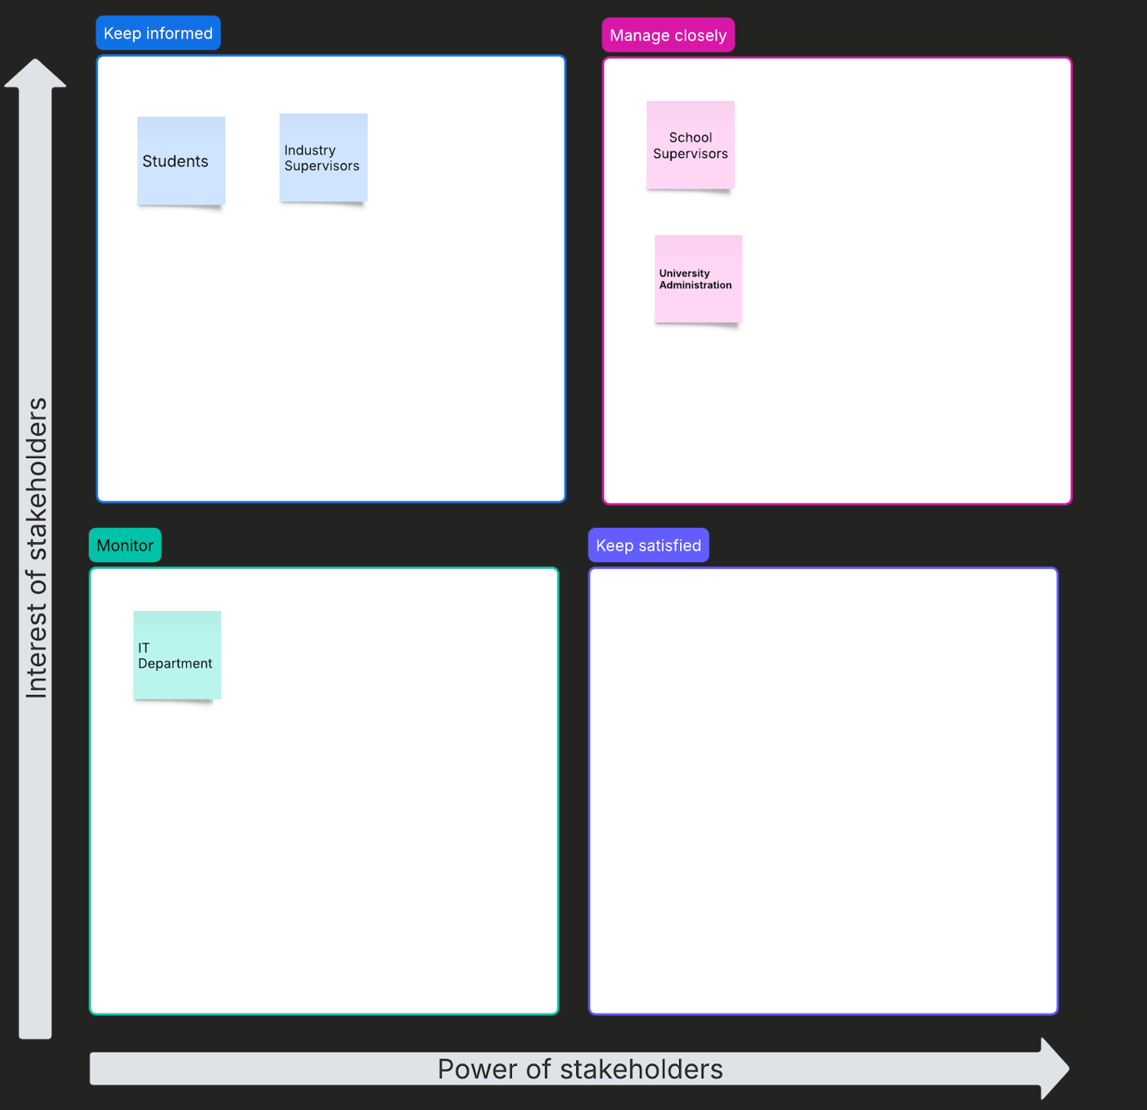

Stakeholder Engagement Strategy

Students: Engage through regular updates and patches and ensure the UI provides "easy access and use" to logging features.

Supervisors: They Provide specialized evaluation tools and automated reporting features to reduce manual workload and tasks.

University Administration: They provide high-level system control and coordination and dashboard summaries for grading defense.

IT Department: Maintaining a documentation trail for technical upkeep and continuation and system integration is done by the IT department.

How each stakeholder will be managed:
Students → Regular updates, easy access
Supervisors → Reports and evaluation tools
Admin → System control and summaries
IT → Technical maintenance

Conclusion

By performing this stakeholder analysis, we can ensure that our Internship Management System actually meets the needs stated, resolving poor communication and lack of recordkeeping in the current manual system. Furthermore, we can ensure that both the needs of high-power admins and those who will actually use the system every day, students and supervisors, are met, creating better coordination.

FEASIBILITY ANALYSIS
Introduction
A feasibility study is an essential part of the software development lifecycle that determines whether a software system is worth developing. The study helps developers to understand the challenges that they might encounter while also giving an indication of the benefits that will come from implementing the system.
The purpose of this feasibility study will be to determine whether it is worthwhile to develop an internship management system that can automatically handle the current semi-manual processes that are followed by the universities today.
Feasibility Types Selected
The feasibility of the internship management system will be analyzed from three different perspectives:
- Technical Feasibility—will determine whether the system can be built with the available technology.
- Economic Feasibility—will determine whether the system is financially worth it.
- Operational Feasibility—will determine whether the users can accept and effectively use the system.

Technical Feasibility
Technical feasibility determines whether the system can be built with the available technology. To build the internship management system, the following technology will be required:
System Requirements
A web-based application will be built that will include the following:
- Database for storing student, supervisor, and internship records.
- Internet connectivity: User interfaces for students, school supervisors, and industry supervisors.
Available Technology
- To develop the internship management system, the following technology is available:
- Programming languages (e.g., Java, Python, PHP)
- Database systems (e.g., My SQL, PostgreSQL)
- Cloud or local Servers for hosting
- Available IT infrastructure in the schools and industries
Technical Challenges
The following challenges will have to be overcome during the development of this project:
- Ensuring Data security
- Integration with existing school management systems
- Simultaneous access by multiple users
- Providing Reliable Internet access for all users

Conclusion
It is definitely possible to create the internship management system from a technical standpoint. All of the necessary tools and technology are available for its creation. Although there are some technical challenges that will have to be overcome, these challenges can be managed prior to system implementation.
Economic Feasibility
Economic feasibility determines whether the benefits of the system outweigh the cost of creating it. To determine this, the costs of creating the internship management system will be calculated:
Costs
- Cost of software development
- Hardware specifications and requirements
- Hosting requirements
- System maintenance requirements
- Training costs

Benefits
- Paperwork reduction and less administrative work
- More timely and efficient student placements
- Communication improvement between all stakeholders
- Student performance tracking improves
- Record-keeping improves for grading/evaluation
Long-Term Costs vs. Long-Term Benefits
There are likely to be some high upfront development costs but they will ultimately be offset by the long-term advantages (time, cost & error reduction) of the IMS.
Conclusion
IMS is operationally viable because it produces a large long-term net gain while reducing operational inefficiencies.
Operational Feasibility
How well will the internship management system perform in an organizational setting, and how well will it be received by its users?
User Acceptance
- Students will benefit from easy log submission and updates
- The supervisor’s ability to track and monitor students’s progress
- Easier management of records by administrators

Ease of Use
- A user-friendly interface
- Simple to navigate
- Can access via multiple devices
- Need for training and on-boarding
- Dependence on internet access

Organizational Support
- Universities are currently implementing various forms of digital systems.
- IT departments can provide assistance in the rollout and upkeep of these systems.
Challenges
- Resistance to change in users’ existing systems
Conclusion
The system has operational feasibility because users will most likely find it convenient and efficient, providing they receive the appropriate training.
Overall Feasibility Conclusion
It is technically possible to build the system using the current tools and infrastructure.
In terms of economics, the long-term advantages far outweigh the initial costs.
Operational acceptance and a streamlined process for workflow, will occur with this system.

Final Statement
The proposed internship management system is both feasible and viable. The system should be developed, as it will greatly enhance the university's ability to coordinate, monitor, and manage internships.

Team 1 Group Members
Onyinyechukwu Anakua - 24120112010
Kenechukwu Emenike - 24120112019
Oghenerukevwe Agolo - 24120112006
Tamilore Femi-Sipe - 24120112022
Nnaemeka Ngige - 24120112036
Emmanuel Yakubu - 24120112059
Kelvin Adongo - 24120112005
Tochukwu Nwaohiri - 24120112041
Chibuifem Okonkwo - 24120112043

