Final Project Report
Pavlos Papachrysanthou s-pp276330
ITC4214 Internet Programming
Summer Term 2026
Professor Leonardos Mageiros

Website Link 3
Dummy Users Credentials 3
Demonstration Video Link 3
GitHub Link 3
General 4
requirements.txt 4
.gitignore 4
External Components 4
Bcrypt 4
Django 5
Templates 5
Static Files (CSS, JavaScript, Images) 5
Authentication 5
Email case sensitivity 5
Name validator 6
Phone Validator 6
Shopping cart after logging out 6
Recommender 6
Building the product grid 7
Admin page 7
Image upload 8
Product likes 8
JavaScript 8
CSS 9
Database 10
Sitemap 11
References 11
Images Used 11

Website Link
https://pavlospapachrys.pythonanywhere.com/

Dummy Users Credentials
Customer: Bobert BARathean
bobert@wavebar.com
bobert123
Customer: Anakin Johnwalker
anakin@wavebar.com
anakin123
Employee: Mace Mojito
mace@wavebar.com
mace1234
Employee: QuiGon Gin
quigon@wavebar.com
quigon123
Admin : Darth Drinker
darth@wavebar.com
darth1234

Demonstration Video Link
https://youtu.be/uvcr3a1yesE

GitHub Link
https://github.com/PAULPAPACHRYS/ITC4214-Final

General

requirements.txt
This text file lists all the packages installed to run the project.

.gitignore
This file is a plain text that tells git which files or folders to ignore when tracking version control. I did this because certain files are generated automatically, and there is no need to back them up. Git ignores these files and won’t add them to commits or list them as untracked.

External Components
Bcrypt
Bcrypt is a one way password hashing algorithm which I used to conceal the passwords of users, so instead of plain text the password is saved as an irreversible string of characters. This string is a one way hash, since the original password cannot be recovered from the hash, login works by hashing the entered password the same way and comparing the two. AbstractBaseUser already provides set_password and check_password which are the functions to hash the password and to check if the passwords match when logging in, but they do not call bcrypt directly, instead they use any configured hasher from the PASSWORD_HASHERS in settings.py. By adding this line at the top of the PASSWORD_HASHERS array I ensure that passwords are hashed before being stored: 'django.contrib.auth.hashers.BCryptSHA256PasswordHasher',
I wrote it first to override Django’s default so that new passwords use bcrypt instead.

Django

Templates
The templates directory contains all shared templates, in settings.py under TEMPLATES added BASE_DIR / ‘templates’ to DIRS so that the template engine knows where the shared templates are.
The base.html serves as the standard page layout that contains the header and footer that all pages use. Every page extends this shared layout with {% extends ‘base.html’ %} and populates a {% block content %}.

Static Files (CSS, JavaScript, Images)
In settings.py added the static file directory with STATICFILES_DIRS = [BASE_DIR / ‘static’].

Authentication
Rather than keeping Django’s default user table and a separate customer table, I made one table to do both jobs. Users subclasses AbstractBaseUser (which has the hashed password and last_login fields) and PermissionMixin (which has is_superuser and the groups and permissions). UsersManager implements the create_user and create_superuser methods Django requires.
USERNAME_FIELD = ‘email’ makes users log in with their email instead of their username and REQUIRED_FIELDS lists what createsuperuser must also ask for.
This allows Django’s built in UserCreationForm and AuthenticationForm to work directly against a custom and specific user record (with fields like bar_name, bar_location, role, etc). In settings.py I made AUTH_USER_MODEL = 'accounts.Users' to redirect to the custom Users model.

Email case sensitivity
Email addresses are not case sensitive, but a database’s UNIQUE constraint and the login lookup are. To prevent any issues I made clearn_email(...) in accounts/validators.py to lowercase the whole address (Django’s normalize_email only lowercases the domain), before running the uniqueness check.

Name validator
In accounts/validators.py the line name_validator = RegexValidator( regex=r"^[^\W\d_]+(?:[ '\-.][^\W\d_]+)*$" allows word characters but not digits or underscores, so any letter in any alphabet. Otherwise, names like Ελένη, Müller, Jean-Luc, O’Brien, J. Smith would not be acceptable. This way digits and symbols are blocked while also allowing names with extra characters besides just letters.

Phone Validator
The PHONE_PATTERN = r'\+?(?=(?:\D*\d){8,})[\d \(\)\-]{8,20}' requires at least 8 digits somewhere in the value and allows for characters like + and () so phone numbers like +3069... and (210) ... would be acceptable while also rejecting characters that do not belong in phone numbers.

Shopping cart after logging out
There is no separate “cart’ table because the cart is saved as an unfinished order temporarily with the attribute is_cart = True. If the user logs out before checkout any items he added to the cart, are stored on that “order” and remain there when he logs back in. After checkout this becomes False. The _get_cart() uses get_or_create(user=user, is_cart=True) so each user has exactly one live cart and Order.total / line.total are computed on the spot rather than being stored.

Recommender
The recommender works by suggesting similar items to the ones the user has in the cart by calculating a similarity score based on stored product attributes.
_similarity( target, candidate ) scores a pair of products by adding weighted signals:
-> same sub-category +5
-> same category +2
-> same brand +2
-> same tag +1.5 (per tag)
->similar price +1 within 2$ or +0.5 within 5$
Tags and categories are compared by id.
_rank( cart_products, candidate ) scores each candidate as the sum of its similarity to every product in the cart, so items that resemble the cart as a whole rise to the top. Only positive scores are kept and ties are broken by id sort( key= lambda row: (-row[0], row[1])).
The for_cart() excludes products already in the cart, ranks the rest then reuses the catalogue’s _product_as_dicts function to build the response cards and stores the ranked order because that function returns rows sorted by id.

Building the product grid
To avoid generating hundreds of queries per product for its brand, category, to count likes, etc, i did the following: The select_related( ‘subcategory__category’, ‘brand’) pulls the related rows in the same query via SQL joins, prefetch_related(‘tags’) fetches all tags in one additional query. To compute each product’s like count I use annotate (like_count = Count (‘likes’ , distinct=True)) that does so as part of the same query. The set of products the current user has liked is fetched once with a single values_list (‘product_id’, flat=True) and kept in a set.
This way, all the related pieces of data are gathered in a constant number of queries no matter how many products there are.

Admin page
The Database page is only available to users with the role of Employee or Admin. They can browse, add, edit and delete rows of each table of the database with the only exception being the users table that is only available to Admin users. The staff_required decorator is used to redirect not logged in users and Customer role users to the home page. The _get_config enforces the admin_only rule (ex: only admins can see the user table) and returns None for unknown or forbidden keys, which the views turn into a 404.
Because several foreign keys use on_delete = PROTECT trying to delete a referenced row raises ProtectedError, so the view catches it and displays a message saying “other records depend on it” message instead of a server error.

Image upload
When an Employee or Admin uploads an image first, os.path.basename( upload.name) removes any folder part and the file name stem is passed through re.sub(r'[^A-Za-z0-9._-]', '_', stem) to avoid malicious names. If a file with the same name already exists, then a counter is appended, so existing images are not replaced by mistake. The file is written with upload.chunk(), which handles large files without loading them entirely into memory. The use of FileField instead of ImageField is deliberate to avoid depending on the Pillow image library, validity is checked by clean_upload.

Product likes
A like is a row linking a user and a product with UniqueConstraint( fields=['product’, ‘user’]), the like count is the total number of rows pointing to a product ( product.likes.count() ), so there is no separate counter to keep in sync. The toggle endpoint uses get_or_create so if the row was newly created then the user just liked it, if it already existed then the row is deleted (user removes the like).

JavaScript
Browse.js
Function apply_url_params()
The purpose of this function is to let other pages preselect a filter when they send the user to the browse page. For example, the home page has 3 buttons with the categories of beverages (Non-Alcoholic, Fermented and Distilled) if the user presses one of these buttons instead of the browse page button, then he will be redirected to the browse page with the category of the associated button already selected.
Each of those buttons adds at the end of the url ?cat=... and the name of the category.
The line URLSearchParams(window.location.search) uses window.location.search to return the url part after the ‘?’ character. Then URLSearchParams() creates an object that can read query parameters. Then, depending on the category, loads the browse page with that category preselected.

CSS
General_styles.css
*, *::before, *::after { box-sizing: border-box; margin: 0; padding: 0; }
* is a universal selector, that selects every element of the page
*::before and *::after are elements that display certain content before or after an html element
box-sizing: border-box; The declared width includes the padding and border, this makes an element stay the specified width.

Database
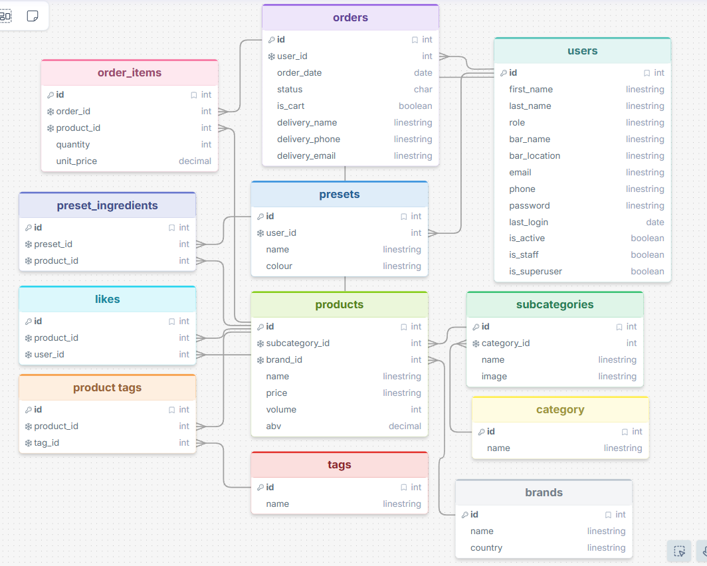

Sitemap
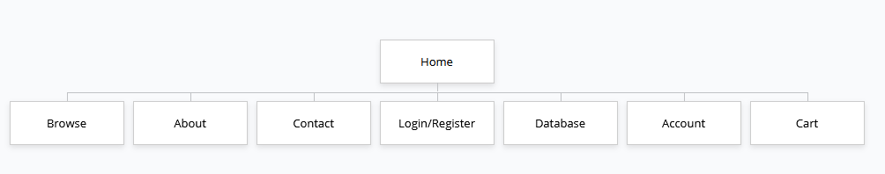

References

Images Used
https://unsplash.com/
https://pixabay.com/

