Midterm Report
ITC4214 Internet Programming
Dr Leonardos Magiros
Summer Term, 2026
Pavlos Papachrysanthou s-pp276330

Table of Contents
Introduction 3
Task Allocation 3
Documentation 4
Tasks Page (workouts) 5
workout_table.js 5
exercise_gif.js 6
analytics_graphs.js 7
latest_activity.js 8
GitHub link 9
Chrome Lighthouse Results 9
Home Page 9
Tasks Page (workouts) 15
Analytics Page (personal page) 19
About Page 23
Contact Page 28
Images Used 32
Reflection 32

Introduction
The website I chose to create for my midterm project is for a cross-training gym in my neighborhood that I use called the Basement. Although they do not have an official website, they only use a simple form for members to book sessions. I decided to expand on that concept and create a website where coaches can create workouts programs and members can view them and all the relative details and track their progress through graphs. The website consists of five pages: Home which contains some general information and a welcome message, Workouts (the tasks page) which includes a table of all available workouts and their info and tools to create/edit/delete them, Analytics page (custom page) that contains the graphs and offer a more detailed progress tracking, About where I include all info for the Basement, the staff and pictures of the interior and finally Contact which contains a fillable form, contact information and a map location.

Task Allocation
As a first step, I created the html files and the code for recurring elements like the header, the navigation bar and the footer which would be present in all pages. In the beginning since I was still uncertain how I would present the overall theme of the page, I started working first on the About and Contact page which I already had a layout in mind and because these two pages would not have any dependences on the tasks page unlike the latest activity and the analytics. Afterwards, I prioritized creating the html layouts and then the JavaScript scripts, leaving any CSS for last when working on each page. Lastly, I wrapped up with adjusting the colors for the dark and light mode.

Documentation
To make the tasks page, latest activity section and analytics page function properly, I made use of local storage to save the data so each page can access it and make use of it since changes to workouts affect all these pages. Local storage is a browser feature that allows you to store data in the user’s browser and preserve it even after refreshing the page, closing the browser or switching to another page. Local storage has the limitation that only stores strings, for this reason, I used commands to turn anything I want to store into a string and to reverse that when I wanted to load something from local storage. For example:
localStorage.setItem('gym_workouts', JSON.stringify(workouts));
This command uses JSON.stringify() to turn the entire workouts list into a single large string then saves that string to localStorage using setItem() under the name gym_workouts. So, we store a key named “gym_workouts” with value the stringified JSON.
const saved = localStorage.getItem('gym_workouts');
if (saved) workouts = JSON.parse(saved);
Here I do the opposite, which is to load from the local storage using getItem(). Since we already saved the gym_workouts as a string, it will return a large string with all the details of the list. The if statement is there to check if the data was retrieved successfully otherwise saved would be null, after that I use JSON.parse() to turn the string back to JavaScript code and save the list as workouts.
JSON acts as a converter for both processes to turn code into string and back.

Tasks Page (workouts)
At the start I check if the workouts list has been saved previously, otherwise initialize it. I use stored to load the data from localStorage as I explained previously and if it returns null then I create default_workouts as the list of workouts with all their attributes and the save it to localStorage.

workout_table.js
This script renders the workout table in the Tasks page.
Lines 253 - 262
In this section, I process a workout description, detecting which lines are the exercise instructions and turning them into clickable elements that display a gif with the exercise when clicked.
if (trimmed.includes('—') && /×|\d+\s*(sets|reps|sec|min)/i.test(trimmed))
The format I use for the default workouts is "Push-ups — 3 sets × 10 reps" so this condition checks if the line contains a “—” and a regex that checks if it contains any symbols or keywords related to workouts. The purpose of it is to identify a line that contains exercise instructions.
const exercise_name = trimmed.split(/\s*[—–-]\s*/)[0].trim();
Following that, I split the line using any dash type and take the first element which is [0] which is the exercise name, at the end trim() helps to remove any extra spaces.
`<span class="exercise_link" data-action="gif" data-exercise="${convert_html_entity(exercise_name)}">${convert_html_entity(trimmed)}</span>`;
Finally, I build the html element and use data-action and data-exercise so I can use them later on an event listener to trigger the gif display overlay and the buttons for mark complete/edit/delete workout and to expand the description. The convert_html_entity function returns a string with proper character replacement to avoid breaking HTML attributes (example: ‘>’ turns into ‘&gt’). In line 491 there is an event listener that calls the function that each button represents depending on the data-action attribute.

exercise_gif.js
This script loads the exercise gifs using an API in the workout table in the Tasks page.
async function open_gif_overlay
I made the function async on purpose to use await when waiting for a response from the API.
Lines 25-28
encodeURIComponent(cleaned_name);
Converts string into URL safe format (ex: push up -> push%20up) before sending it to the API website.
await fetch(`${WORKOUTX_BASE}/exercises/name/${encoded}`
Send the exercise name and wait for the response.
Lines 34-35
if (!response.ok) throw new Error('API error ' + response.status);
The response.ok returns true if status is something like 200-299 or false if 400, 404, 500, etc. which means something went wrong. In this case, this line throws an error which is caught by the try catch block.
Lines 43-52
const gif_response = await fetch(ex.gifUrl, { headers: { 'X-WorkoutX-Key': WORKOUTX_API_KEY } });
After the exercise has been identified by the API, I ask for the URL of the specific gif.
const gif_blob = await gif_response.blob();
Because the response is not yet usable as an image, blob() converts it into a Blob object. This is a Binary Large Object, raw binary data not directly displayable but represents the GIF file that is downloaded in memory.
const gif_object_url = URL.createObjectURL(gif_blob);
This line afterwards converts the Blob into a temporary local URL (ex: blob:http://localhost:3000/...). I did this because browsers can not directly assign a Blob to an html <img> tag.

analytics_graphs.js
This is the script that runs with the Analytics page to update the charts according to the changes made to the workout table. It uses an Immediately Invoked Function Expression (function () {... to create a private scope so that variables inside do not leak into global scope. This page creates two graphs one for the overall progress of workouts (completed vs pending), and the other counts specifically how many workouts of each intensity level have been completed out of the total of each intensity level.
Lines 81-88
The function patch_after is used to intercept an existing function and add extra behavior after it runs. It takes the name of a function on window, replaces it with a new version and ensures that render_analytics() runs after every call to the original function.
window[fn_name] = function ()
Overwrites the original function with a new one.
original.apply(this, arguments);
This line manually calls the original function inside the new one. The keyword this preserves the original context and ensures the function behaves correctly if it relies on this. All the passed arguments are contained in the arguments keyword. So, apply() calls this function with a specific this and a list of arguments. Then render_analytics() runs after every call to the newly patched function.
The functions I want to target with this be found in line 93 inside an eventListener with the ‘load’ attribute. In short, every time there is a change in the workout table (ex deleting a workout, marking a workout as completed, etc) then the render_analytics() is also called and updates the charts according to the changes.
Lines 101-106
In this section I have an event listener with the ‘storage’ attribute, which listens for changes in locatStorate from other pages only for the key gym_workouts. The updated value is e.newValue and this Analytics page’s data is synced with the data from the other tab.

latest_activity.js
This script updates the home page’s latest activity section with information regarding recent workout additions or changes. Just like before, I use an Immediately Invoked Function Expression to run the script. Additionally, I also use the function patch_after and the EventListener('storage',..) just like before for the same reason, with the addition that here besides render_activity I also call update_stats to update the values of the stat cards at the top.
Line 26
I use [...workouts] to create a copy of the list so that .sort() will not affect the original. Then sort descending by id, meaning that newer workouts appear first since they will have ids with higher numbers.

GitHub link
PAULPAPACHRYS/ITC4214-Midterm
https://github.com/PAULPAPACHRYS/ITC4214-Midterm

Chrome Lighthouse Results

Home Page
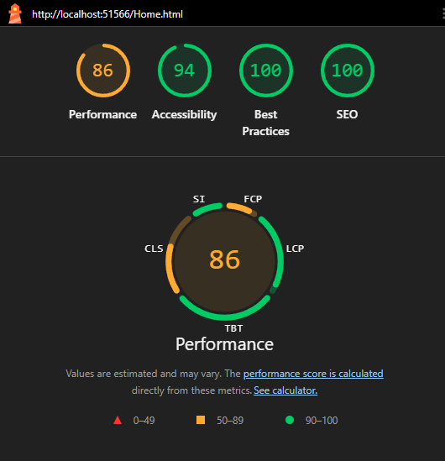
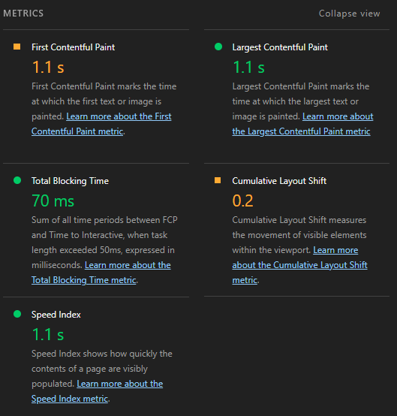
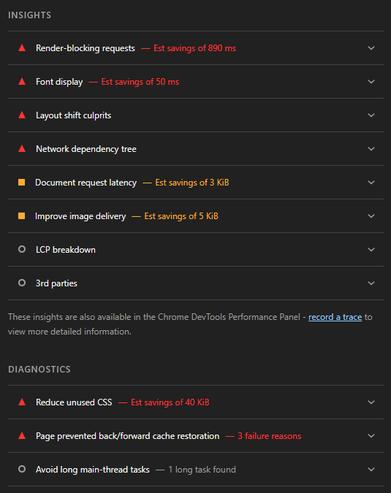
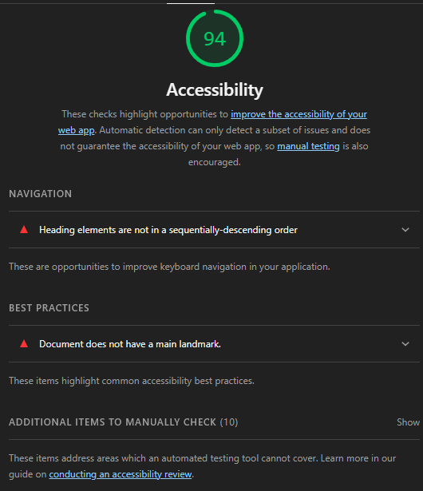
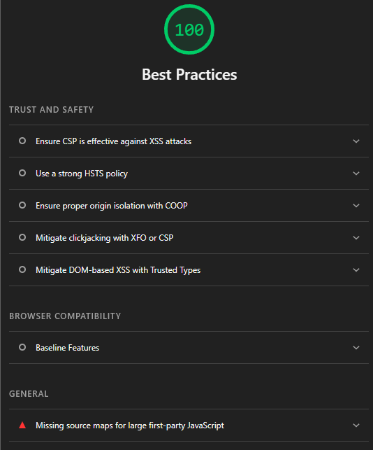
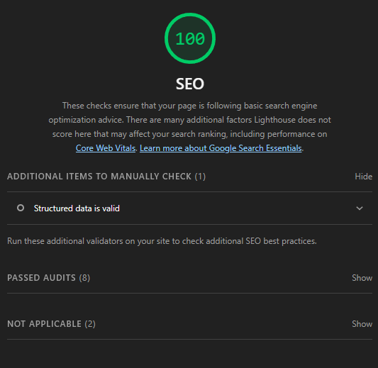

Tasks Page (workouts)
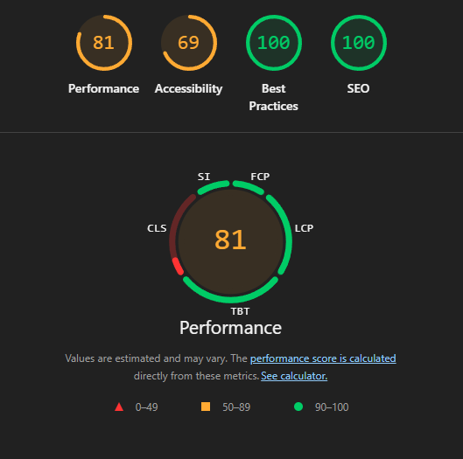
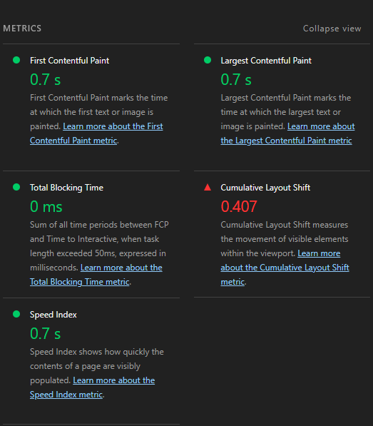
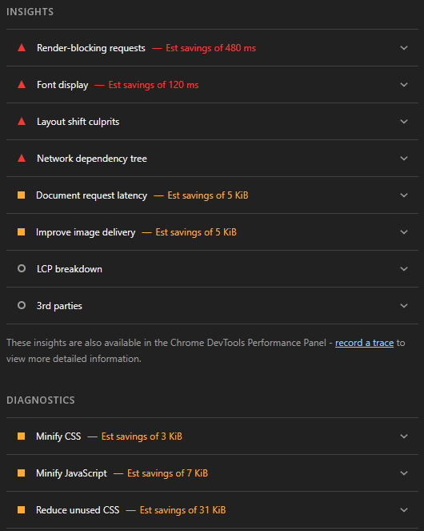
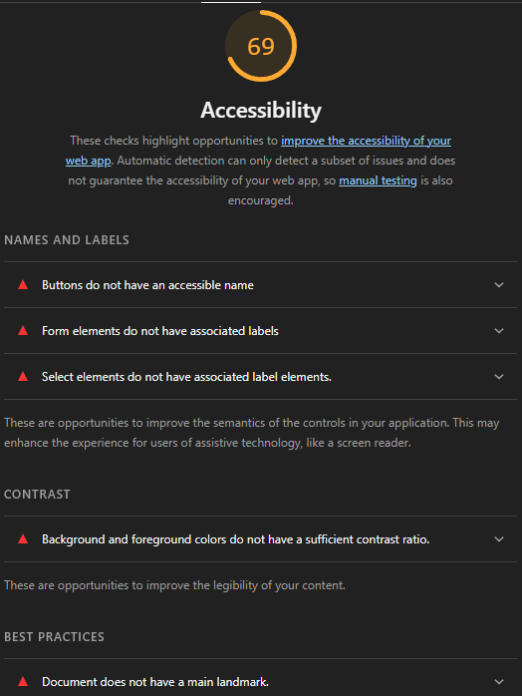

Analytics Page (personal page)
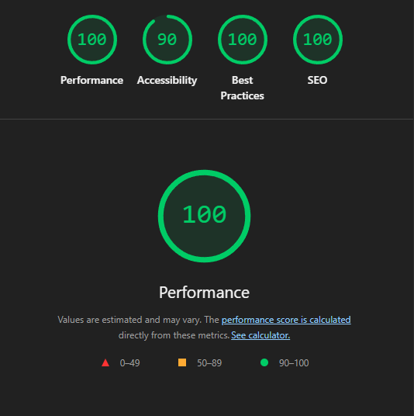
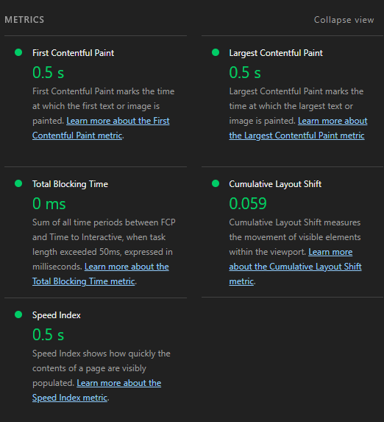
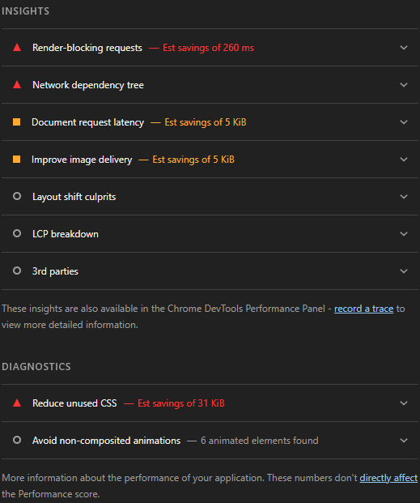


About Page
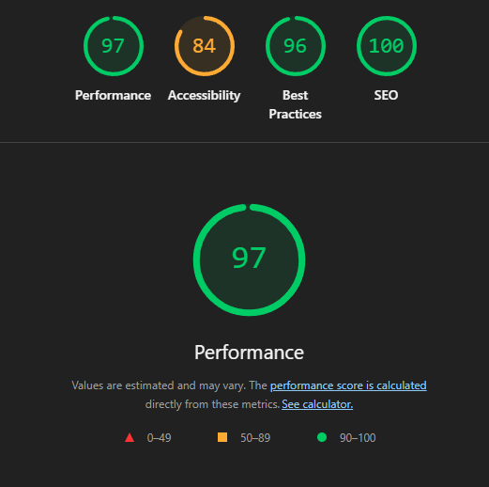
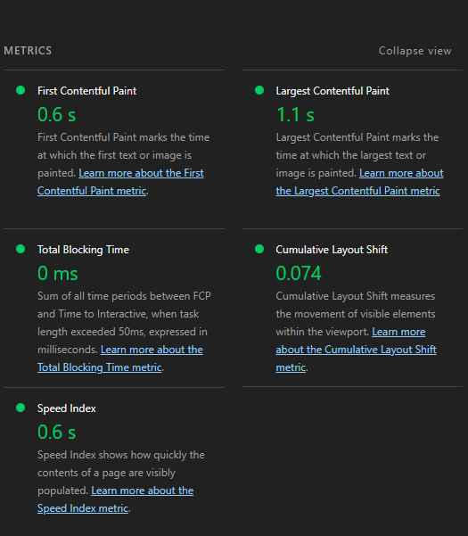
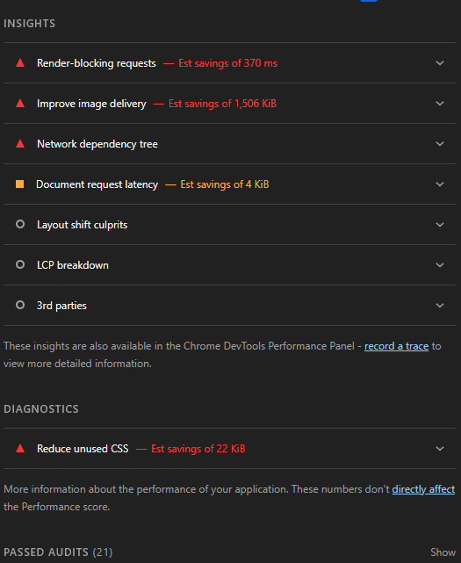
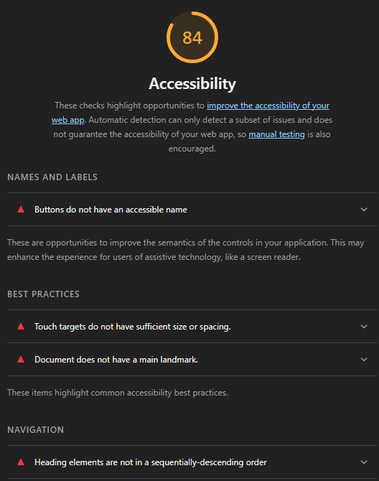
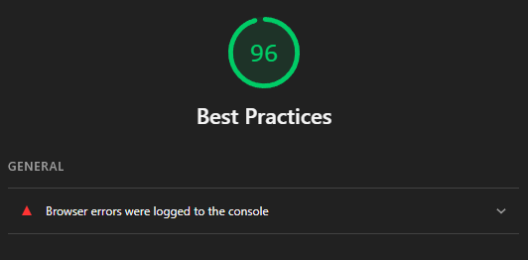

Contact Page
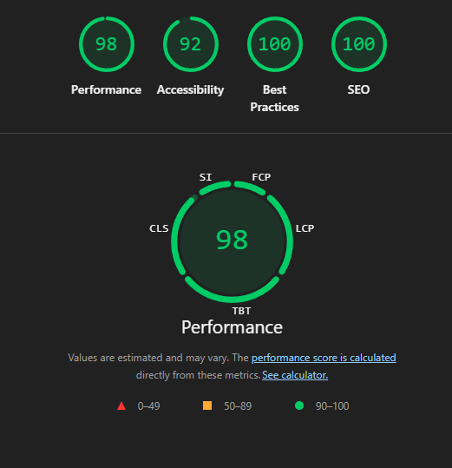
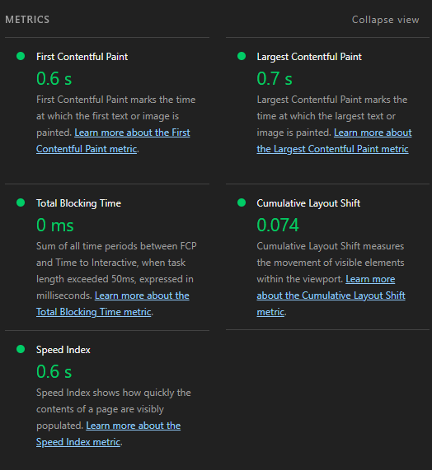
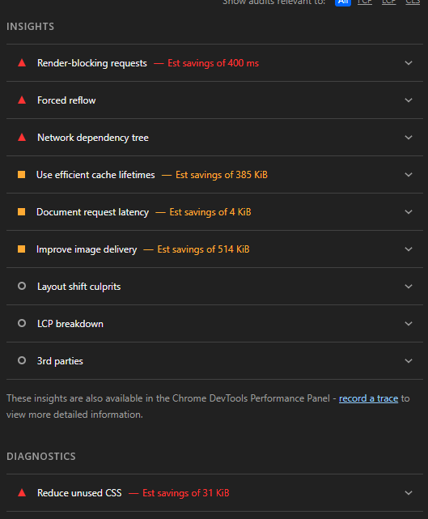
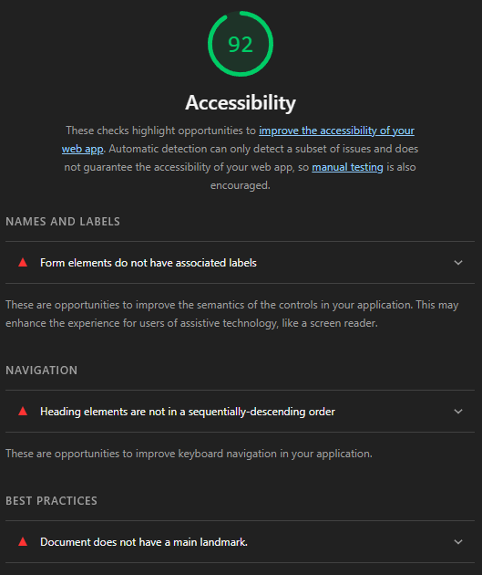

Images Used
-All images in the folder named coaches were generated by AI.
-All images in the folder named Basement_Images were taken from uploaded images in the Basement’s official Instagram account or google maps images.
-All other images were taken from Flaticon https://www.flaticon.com/

Reflection
As someone with little front end development experience, this project was a great opportunity to improve my skills with html, CSS, and most importantly JavaScript. One of the most interesting challenges was figuring out how to keep data consistent across different pages without a backend, which led me to explore localStorage as a practical solution. Integrating a third party API for the exercise GIFs was also a highlight and although the integration was challenging, when it finally worked properly, it was one of the most rewarding aspects of the project. Overall, I enjoyed the process of creating this project as it taught me how to connect concepts I had learned separately into one that actually functions as a whole.

