# Find Help NYC

Richard Paul Silvius (LEC VC1B) [paulsilvius0@gmail.com](mailto:paulsilvius0@gmail.com)

**CISC 4900**

## Technical Supervisor

Jillian Kaufman, LCSW

Social Work Supervisor

@ Bellevue H+H

jillian.b.kaufman@gmail.com

## Table of contents

(optional)

Generate the table of contents by going to the menu > **Insert > Table of Contents**

## Abstract

(optional, but highly recommended!)

Provide the purpose of this project, what is the objective.

Provide a brief summary of your project. A few sentences should suff ce since you will provide details below.

This is like an elevator pitch that you might give to someone who is unfamiliar with the project.

Abstract goes here.

## Changelog

## Project Details

This is an example of a description page. Your version does not have to follow the structure presented here exactly, you may have more or less depending on your project. The section presented is a suggested guideline for general organization of a project proposal.

This section is where you can provide the details of your project. In particular, make sure to include:

* Why? – Motivation – Why should it be used? Having a good story as to why you are creating the application is always a seller. It also gives you a start to the prof le building of your users.

? – A description – In more detail than your abstract, explain what your project will do. What is the solution/features? Does the solution to your problem already exist? If so, how is your solution better? Are you re inventing the wheel? Think of an Infomercial, present your problem, present known solutions and flaws, and convince us why yours is better. What is the real world impact of your solution? What will prevent them from going back to the old solution or still have the same problems?

* Who? – A target audience – Describe the intended audience, customer, user of the project. Yes, there is a difference between the customer, who pays for it, and the user, who uses it. What is your primary audience? Who is going to use your solution/program? Are there other markets you could advertise? Will your solution only be in a certain geographic area? community? age range? Etc.

1. My primary audience are people seeking therapy
2. My secondary audience is the therapist seeking new patients
3. The solution to the problem will be used by our primary audience
4. Somewhat for our secondary but they will befit indirectly with from our product
5. The community would be the same as our audience/people who care about mental health around them. advocates, participants, clients, and therapist
6. Age range might skew towards younger because of it being based on the web and not having someone necessarily walk them through over the phone, but it will be the design will be inclusive as possible.

* Where? – Platform – Where are you going to develop your solution? Where is it going to be used?

1. Our community range is New York City for now because the data is more readily available to us.
2. I intend to develop the solution both at home and at school but will be using GitHub to host my repository and assure

* How? – Workflow – How will your solution be used? How will it work?

1. I will be using a waterfall workflow to keep it simple as me and my supervisor are the only people working on the project.
2. I will modify and expand on that model as necessary because there is always more to add, and modify a project, especially when the project goals to be presentable in such a small window of time.

* When? – A target audience – When do you know the project is done? When is good enough, or I have a valid product that I can demo. When do I know I am done with one stage of the project and should move on to the next.

1. This project would be completely done if I figure an ethical way to update data from the mental health professionals themselves, and/or have legal access to the data that would be needed to truly have a functional product.
2. With or without, the obstacle being holding back (the data itself). I intend to have a relational database that gets as close to mimicking the data that would be stored if the website was going to be used in the real world.

### Executive Summary

In a world where there a numerous apps to find nearly anything, whether its products, locations, or people. There always seems to be a void when it comes to find a therapist that meets even a couple of your categorical expectations. Even with other apps and listings, the results of the searches are rarely sufficient when it comes to finding the right therapist. This problem is only exacerbated when you are trying to find an affordable therapist.

The end-user in this project are people searching for therapist, and our intention is to alleviate some of the stress, and time spent trying meet the right therapist. For the therapists that are affordable, they will use what is called a sliding scale setting their prices. A sliding scale entails that the therapist is willing to negotiate pricing, based off a patient’s potential needs and income. In order to find therapist that are specifically open to sliding scale clients, you sometimes have to make a multitude of searches before someone can find someone can meet the needs the client, other websites that offer services that are loosely similar to ours. The amount of time it takes to find a hopeful match, coupled with the wait times for the few time slots available, entirely too long for many people seeking therapy, let alone when someone is going through or recovering from a crisis.

Our user experience aims to be straightforward. We aim at helping users that might not be as technically proficient, answer questions and sort through to find therapist that would more likely, fit their wants and needs. In order to have a less technical approach for our end-users the questions to sort the database will aim to be more conversational in nature. There will be clickable buttons for answers to questions making the users input as easy as possible to enter. Also, we want to make the accessibility to the app as easy as possible by adding different languages as well as, making sure to incorporate options for those who are visually impaired to use Find Help NYC.

### Technical overview of the project

A brief technical description of the solution that addressed the problems stated.

How you would describe the project to someone who is in the f eld, especially of the various tools and materials used to construct the application as well as projected techniques and principles that may be used.

1. The app that we are creating is a Crud (Create, Read, Update and Delete app) that allows users to interact with the database on non-technical terms.

### Background

What do you already know about the topic, technology, or subject you will be working in? Do you consider yourself Novice.

Provide information essential to understanding your project. This describes any previous work that has been completed, if this project is a continuation.

If applicable, this can include:

* Prior work by others - Are you recreating something that has been done before? Are you building on top of others' work?
* Prior work by you - Have you already done things in this area, and you are adding to it?

It can further describe the problem to be addressed, as well as literature review. If work is cited, do not forget to include the bibliography.

You might describe any existing workflows and processes that you have to adhere to while completing your project.

Optional: Provide information on what foundational course background got you interested in this subject and how you are going to use that information in your project.

#### Literature Review

A literature review stitches together different subtopics to present a greater understanding on a larger issue. The individual pieces (arguments) must be put together in order to reveal the whole (state of knowledge). Write about the process you employed to research materials (i.e. BC Library, Internet, Textbooks, etc) along with the f nal description that cites the relevant materials.

The literature you review could be research papers, conference proceedings, documentation, user manuals, etc.

**Mind Map:** present a mind map of your idea and a description of it to help the reader understand how you organize your ideas.

### Project Objectives and Expected Outcomes

#### Objectives

Describe the objective(s) you’ve set out to achieve with this project.

An activity is not an objective. For example, if you’re building a basic calculator as your project, one objective is “to allow the user to input an arithmetic expression composed of operands and operators”. The objective is something that often has a measurable outcome. An activity is a more general and vague description, such as “writing source code”.

#### Expected Outcomes

Describe what your expected outcomes were from the objectives.

You may describe this from the end users’ perspective. For example, with the basic calculator your outcome may be to enable the end user to compute simple arithmetic expressions. Perhaps a specif c scenario for the calculator is to enable a student to use the calculator to calculate the total number of coursework credits accumulated to date.

You may also describe this from the developer perspective. For example, with the basic calculator your outcome may be to compare the implementations of two different algorithms. Perhaps the developer wants to compare the effectiveness when the user inputs inf x notation compared to when the user inputs postf x notations into the calculator.

### Actual Outcomes

Describe what outcomes you have reached with your project. Were these outcomes the same as the expected outcomes? If not, why not?

### Obstacles & Risks

My project in practice would need to have to access the real data stored on the websites that I am scrapping for data. For a closed project I am okay with storing data that is publicly available online

## Software and Hardware Technology Requirements

This is an example of describing the technical requirements page. Your version does not have to follow the structure presented here exactly.

List resources used to complete your project. This may include hardware, software licenses, reference material, etc. Specify the estimated cost for each resource, if relevant.

Be sure to explain any changes if they have occurred since the project initiated. For example, if you started out with Python and ended with Java, please elaborate on reasons for change.

### Hardware Requirements

Describe any hardware that was required to complete your project objective(s).

This is an optional section for most software only projects.

### Software Requirements

Describe any software (tooling) dependency that is required to complete your project objective(s). Operating systems and programming languages are included in this section.

If you are creating an application, or working with computers, it would be unusual for this section to be left blank.

### Architecture

Briefly describe how the data might flow through the system you are building.

Be as detailed as you can, given what you know about the system at this moment.

One way to make your description clearer is by including a diagram showing the parts of the system. This is to describe the layers and components. This is what the architectural diagrams and descriptions typically convey. Another way is to show the data flow from input to output.

Figure 1. Example diagrams

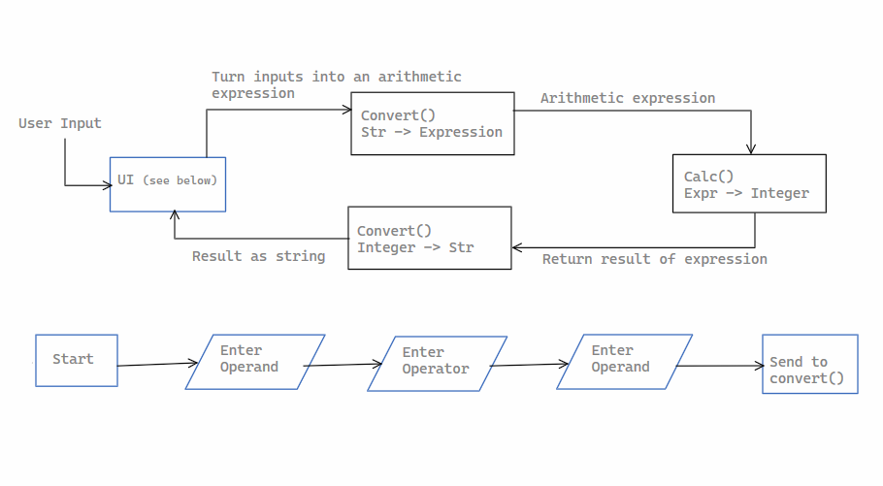

Finally, another way is to show the user flow diagram of how the end user would navigate the system. You may make a brief description here but please also consider having a separate section with end user documentation as well.

## Software Construction

Explain how you organized your coding process and your source code.

For example, how did you manage any source code dependencies? Did you follow any design patterns or frameworks? How did you go about tracking revisions? Did your team use code style guidelines? How often did source code go through review to ensure quality?

The book [Code Complete](https://www.dropbox.com/s/e1r1x34iz4cjpbb/Code%20Complete%202nd%20Edition.pdf?dl=0) may be a good resource to consult for better understanding of dialogue surrounding software craftsmanship.

## Milestones and reporting

Give a brief introduction here describing the aims of this section of the document.

### Project Management

Describe how the project was managed and how often you check in with your supervisor. If it’s a group project, how will you be able to know each other has completed portions of the work and report status to each other? Was there a team lead?

### Tasks

A detailed list of technical tasks that have to be undertaken. Sample tasks may include: education/research, design, implementation, deployment, hardware setup, etc.

Note down changes to the tasks since the project initiated and reasons for the changes.

### Estimated Timeline

Describe when you focused on each task

If you’re on a team, describe who was responsible for each task.

### Actual Timeline

Describe when you f nished each task

If you’re on a team, describe who was responsible for the task

## Project Logs

This is an example of a project log. Each member of a group project should provide their own log. Logs can be submitted in a standalone document with an appropriate title or combined into the f nal report.

**Name:** Jane Doe

**Areas of responsibilities:** In my group I was the team lead and I also was a full stack developer. This means I took on the creation and maintenance of the database along with creating an API and also starting the UI.

Below is an example. Please ensure that your log shows chronological ordering to make it easy to read through the sequence of tasks performed. Descriptions should indicate what was completed, along with the purpose or motivation for the task, and can refer to evidence of work shown (i.e. commit hashes in your commit log).

|  |  |  |  |
| --- | --- | --- | --- |
| **Date** | **Duration** | **Description of completed work** | **Challenges or Next steps** |
| 2/1/21 | 1 hour | Reviewed the syllabus and added due dates listed to my calendar app |  |
| 2/2/21 | 1 hour | Attended the orientation session | Look for project and technical supervisor |
| 2/3/21 | 2 hours | Reviewed the lists of people to contact and drafted up emails and sent it out. Sent out 20 emails. Heard back from 2 and scheduled appointments with 2 |  |
| 2/5/21 | 4 hours | Took a look at all of the templates and submission criteria |  |
| 2/6/21 | 2 hours | Professor X suggested I read a couple of papers, so I did that | Look up definitions of new words |
| 2/10/21 | 1 hour | Created the source code repository for the project and made the first few commits. The repository is at: <url>. Commit hashes (#xxxx, #xxxx) |  |

## Delivery

### Deployment

(optional)

Briefly describe the processes and setup for your deployment pipeline.

This section is great to have if you are deploying your project into production. Consider what you would want to showcase in your portfolio as a way of deciding whether to include this.

### Testing

Briefly describe 3-5 test cases that you tested against to ensure the completion of your project to the requirements set out from the project proposal.

### Documentation & Source Code

Briefly describe any documentation and source code you prepared explaining your f nal outcome.

## Additional Project Documents

You may have source code, html f les, screen captures, documentation, etc that you wish to submit as further evidence of your work.

Feel free to include these items. Please follow a good sense of organization and naming conventions.

Please try to submit as much of this as you can — if your internship precludes you from supplying such information because of their proprietary nature or other conf dentiality consideration, please send an email to your instructor explaining the situation. it's not necessarily a problem, but we would like to know that there is an issue.

## Bio Sketch

This is a section to describe the role of each member on the team (with descriptions of their responsibilities) and also their background and/or interests relating to the project.