EE5351_DIGITAL VIDEO CODING

ASSIGNMENT_CALIC

NAME:PAVAI ARCHIMEDES

ST ID: 1001233996

PROGRAM:

clc;

close all;

clear all;

fid1 = fopen('sena.img');

fid2=fopen('sensin.img');

fid3=fopen('Omaha.img');

fid4=fopen('earth.img');

image_sena = fread(fid1,[256 256]);

image_sensin = fread(fid2,[256 256]);

image_Omaha = fread(fid3,[256 256]);

image_earth = fread(fid4,[256 256]);

image_sena=uint8(image_sena');

image_sensin=uint8(image_sensin');

image_Omaha=uint8(image_Omaha');

image_earth=uint8(image_earth');

imwrite(image_sena,'C:\Users\PAVAI ARCHIMEDES\Desktop\sena.bmp');

imwrite(image_sensin,'C:\Users\PAVAI ARCHIMEDES\Desktop\sensin.bmp');

imwrite(image_Omaha,'c:\Users\PAVAI ARCHIMEDES\Desktop\omaha.bmp');

imwrite(image_earth,'c:\Users\PAVAI ARCHIMEDES\Desktop\earth.bmp');

subplot(2,2,1);

imshow('C:\Users\PAVAI ARCHIMEDES\Desktop\sena.bmp');

title('FORMAT CONVERTED IMAGE OF SENA');

subplot(2,2,2);

imshow('C:\Users\PAVAI ARCHIMEDES\Desktop\sensin.bmp');

title('FORMAT CONVERTED IMAGE OF SENSIN');

subplot(2,2,3);

imshow('c:\Users\PAVAI ARCHIMEDES\Desktop\earth.bmp');

title('FORMAT CONVERTED IMAGE OF EARTH');

subplot(2,2,4);

imshow('C:\Users\PAVAI ARCHIMEDES\Desktop\omaha.bmp');

title('FORMAT CONVERTED IMAGE OF OMAHA');

OUTPUT:



OMEGA OUTPUT:

ENCODED:

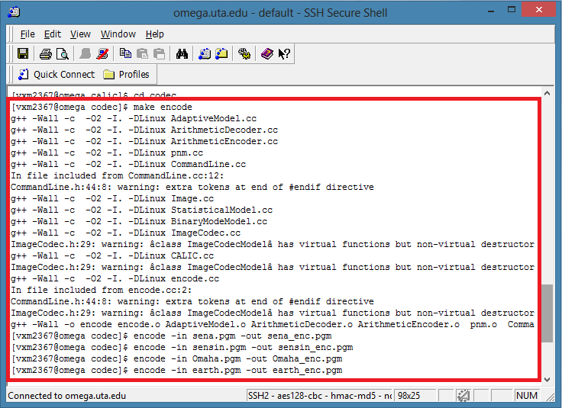

DECODED:

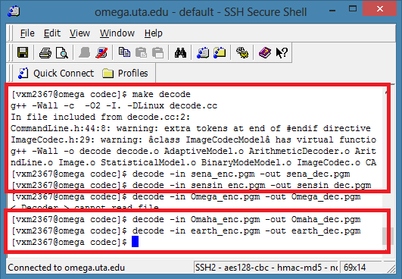

RECONSTRUCTED IMAGE PROGRAM:

clc;

close all;

clear all;

subplot(2,2,1);

imshow(imread('C:\Users\PAVAI ARCHIMEDES\Desktop\sena_dec.pgm'));

title('RECONSTRUCTED IMAGE OF SENA');

subplot(2,2,2);

imshow(imread('C:\Users\PAVAI ARCHIMEDES\Desktop\sensin_dec.pgm'));

title('RECONSTRUCTED IMAGE OF SENSIN');

subplot(2,2,3);

imshow(imread('C:\Users\PAVAI ARCHIMEDES\Desktop\earth_dec.pgm'));

title('RECONSTRUCTED IMAGE OF EARTH');

subplot(2,2,4);

imshow(imread('C:\Users\PAVAI ARCHIMEDES\Desktop\Omaha_dec.pgm'));

title('RECONSTRUCTED IMAGE OF OMAHA');

OUTPUT:

