EE5351_DIGITAL VIDEO CODING

ASSIGNMENT_HINT

NAME: PAVAI ARCHIMEDES

ST ID: 1001233996

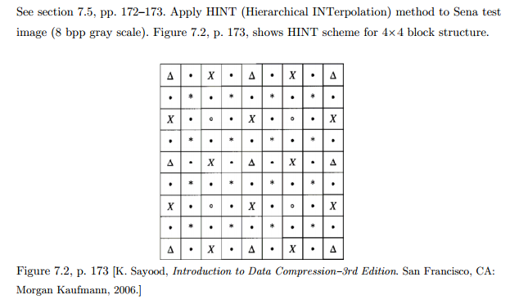

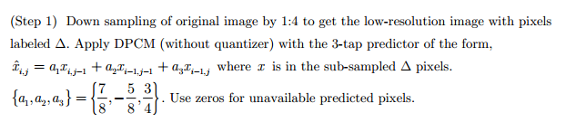

PROGRAM:

img = fopen('sena.img', 'r');

O_Img = fread(img,[256,256]);

O_Img=O_Img';

E=entropy(uint8(O_Img));

[c,x]=imhist(uint8(O_Img));

figure(1);

subplot(3,3,1);

stem(x,c);

title('Histogram- Sena image');

O_Img1=O_Img;

delta_pix(64,64)=0;

for i_delta=1:64

for j_delta=1:64

delta_pix(i_delta, j_delta)= O_Img(1+4*(i_delta-1), 1+4*(j_delta-1));

end

end

delta_pix1(64,64)=delta_pix(64,64);

for i_delta=2:64

for j_delta=2:64

delta_pix1(i_delta, j_delta)= (7/8)*delta_pix(i_delta, j_delta-1)- (5/8)*delta_pix(i_delta-1, j_delta-1)+ (3/4)*delta_pix(i_delta-1, j_delta) ;

end

end

err=abs(delta_pix-delta_pix1);

E1=entropy(uint8(err));

[c1,x1]=imhist(uint8(err));

figure(1);

subplot(3,3,2);

stem(x1,c1);

title('Histogram- Delta pixel errors');

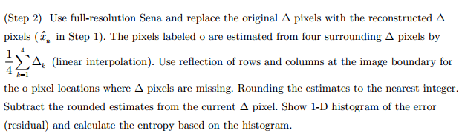

for i_delta=1:64

for j_delta=1:64

O_Img1(1+4*(i_delta-1), 1+4*(j_delta-1))= delta_pix1(i_delta, j_delta);

end

end

O_Img1(257,1:256)=O_Img1(256,1:256);

O_Img1(1:256,257)=O_Img1(1:256,256);

O_Img1(257,257)=O_Img1(256,256);

O_Img1(258,1:257)=O_Img1(257,1:257);

O_Img1(1:257,258)=O_Img1(1:257,257);

O_Img1(258,258)=O_Img1(257,257);

O_Img1(259,1:258)=O_Img1(258,1:258);

O_Img1(1:258,259)=O_Img1(1:258,258);

O_Img1(259,259)=O_Img1(258,258);

O_Img_org=O_Img1;

for i_o=1:64

for j_o=1:64

O_Img1(3+4*(i_o-1), 3+4*(j_o-1)) = round((O_Img1(1+4*(i_o-1), 1+4*(j_o-1))+ O_Img1(1+4*(i_o-1), 1+4*(j_o))+O_Img1(1+4*(i_o), 1+4*(j_o-1))+ O_Img1(1+4*(i_o), 1+4*(j_o)))/4);

end

end

for i_o=1:64

for j_o=1:64

o_64(i_o,j_o)= O_Img1(3+4*(i_o-1), 3+4*(j_o-1));

end

end

err2=abs(delta_pix1-o_64);

E2=entropy(uint8(err2));

[c2,x2]=imhist(uint8(err2));

figure(1);

subplot(3,3,3);

stem(x2,c2);

title('Histogram- O pixel errors');

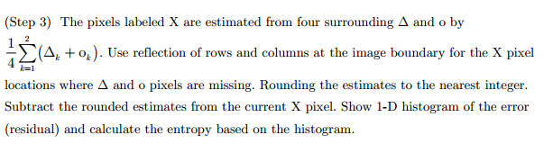

OImg_x(3:261,3:261)= O_Img1(1:259, 1:259);

OImg_x(1:2,1:2)=O_Img1(1:2,1:2);

OImg_x(262:267,262:267) = OImg_x(256:261,256:261);

f=1;

for i_x=3:66

for j_x=3:66

if(f~=0)

OImg_x(3+4*(i_x-1),5+4*(j_x-1))= round((OImg_x(3+4*(i_x-1),3+4*(j_x-1))+ OImg_x(3+4*(i_x-1),7+4*(j_x-1))+OImg_x(1+4*(i_x-1),3+4*(j_x-1))+ OImg_x(5+4*(i_x-1),7+4*(j_x-1)))/4);

else

OImg_x(5+4*(i_x-1),3+4*(j_x-1))= round((OImg_x(5+4*(i_x-1),1+4*(j_x-1))+OImg_x(5+4*(i_x-1),5+4*(j_x-1))+OImg_x(3+4*(i_x-1),3+4*(j_x-1))+ OImg_x(5+4*(i_x-1),3+4*(j_x-1)))/4);

end

end

f = ~f;

end

f=1;

for i_x=1:64

for j_x=1:64

if(f~=0)

OImg_x64(i_x,j_x)= OImg_x(1+4*(i_x-1), 3+4*(j_x-1));

else

OImg_x64(i_x,j_x)= OImg_x(3+4*(i_x-2), 1+4*(j_x-1));

end

end

f = ~f;

end

f=1;

for i_x=1:64

for j_x=1:64

if(f~=0)

OImg_64(i_x,j_x)= O_Img1(1+4*(i_x-1), 3+4*(j_x-1));

else

OImg_64(i_x,j_x)= O_Img1(3+4*(i_x-2), 1+4*(j_x-1));

end

end

f = ~f;

end

err3=abs(OImg_x64-OImg_64);

E3=entropy(uint8(err3));

[c3,x3]=imhist(uint8(err3));

figure(1);

subplot(3,3,4);

stem(x3,c3);

title('Histogram- X pixel errors');

f=1;

for i_x=1:64

for j_x=1:64

if(f~=0)

O_Img1(1+4*(i_x-1), 3+4*(j_x-1))= OImg_x64(i_x, j_x);

else

O_Img1(3+4*(i_x-2), 1+4*(j_x-1))= OImg_x64(i_x, j_x);

end

end

f = ~f;

end

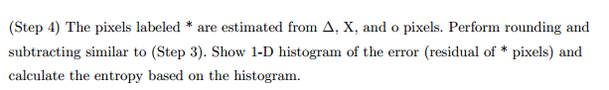

OImg_s(1:257,1:257)=O_Img1(1:257,1:257);

for i_ast=1:128

for j_ast=1:128

OImg_s(2*i_ast,2*j_ast)= round((OImg_s(2*i_ast-1,2*j_ast-1)+OImg_s(2*i_ast-1,2*j_ast+1)+OImg_s(2*i_ast+1,2*j_ast-1)+OImg_s(2*i_ast+1,2*j_ast+1))/4);

end

end

for i_ast=1:128

for j_ast=1:128

P_s(i_ast,j_ast)=OImg_s(2*i_ast,2*j_ast);

OImg_sf(i_ast,j_ast)=O_Img1(2*i_ast,2*j_ast);

end

end

err4=abs(OImg_sf-P_s);

E4=entropy(uint8(err4));

[c4,x4]=imhist(uint8(err4));

figure(1);

subplot(3,3,5);

stem(x4,c4);

title('Histogram- * pixel errors');

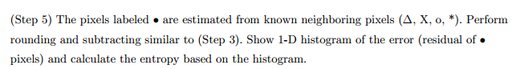

OImg_d(2:257,2:257)=O_Img1(1:256, 1:256);

OImg_d(1:256,1)=OImg_d(2:257,1);

OImg_d(1,1:256)=OImg_d(1,1:256);

OImg_d(257,1)=OImg_d(256,1);

OImg_d(1,257)=OImg_d(1,256);

OImg_d(258,1:257)=OImg_d(257,1:257);

OImg_d(1:257,258)=OImg_d(1:257,257);

OImg_d(258,258)=OImg_d(257,257);

OImg_d(259,1:258)=OImg_d(258,1:258);

OImg_d(1:258,259)=OImg_d(1:258,258);

OImg_d(259,259)=OImg_d(258,258);

f=1;

for i_d=1:256

for j_d=1:128

if(f~=0)

OImg_d(2+(i_d-1),3+2*(j_d-1))= round((OImg_d(1+(i_d-1),2+2*(j_d-1))+OImg_d(1+(i_d-1),3+2*(j_d-1))+OImg_d(3+(i_d-1),2+2*(j_d-1))+OImg_d(3+(i_d-1),4+2*(j_d-1)))/4);

else

OImg_d(3+(i_d-1),2+2*(j_d-1))= round((OImg_d(2+(i_d-1),1+2*(j_d-1))+OImg_d(2+(i_d-1),3+2*(j_d-1))+OImg_d(4+(i_d-1),1+2*(j_d-1))+OImg_d(4+(i_d-1),3+2*(j_d-1)))/4);

end

end

f = ~f;

end

f=1;

for i_d=1:256

for j_d=1:128

if(f~=0)

OImg_df(i_d,j_d)=OImg_d(2+(i_d-1),3+2*(j_d-1));

else

OImg_df(i_d,j_d)=OImg_d(3+(i_d-1),2+2*(j_d-1));

end

end

f = ~f;

end

f=1;

for i_d=1:256

for j_d=1:128

if(f~=0)

OImg_v(i_d,j_d)=O_Img1(2+(i_d-1),3+2*(j_d-1));

else

OImg_v(i_d,j_d)=O_Img1(3+(i_d-1),2+2*(j_d-1));

end

end

f = ~f;

end

err5=abs(OImg_df-OImg_v);

E5=entropy(uint8(err5));

[c5,x5]=imhist(uint8(err5));

figure(1);

subplot(3,3,6);

stem(x5,c5);

title('Histogram- Dot pixel errors');

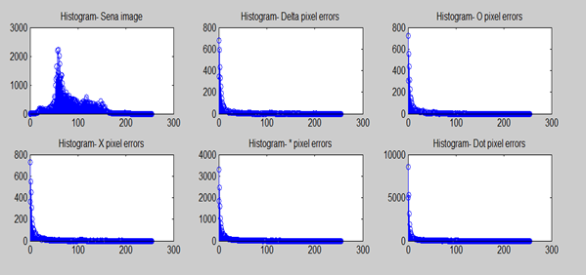

Conclusion:

This results gives pyramid like representation of image with each layer of pyramid serving as prediction model for the layer below it and technique such is HINT-Hierarchical Interpolation.