**EE5356 -DIGITAL IMAGE PROCESSING**

**Project 1**

**NAME: PAVAI ARCHIMEDES**

**ST ID:1001233996**

**Zooming with interpolation:**

**Apply the following 3 interpolators to a test image (8bpp 256 level gray scale)**

**to zoom it by 2.**

1. **Replication (See Figure 7.28 in the textbook pp.254)**
2. **Linear interpolator (See Figure 7.29 in the textbook pp.255)**
3. **Cubic spline interpolator (See Figure 7.30 in the textbook pp.255)**

PROGRAM:

FUNCTION USED:

function B = zero_interlace(ori)

a=0;

b=0;

[m,n]=size(ori);

k=2*m;

l=2*n;

B=zeros(k,l);

for i = 0: k-1

for j = 0:l-1

if rem(i,2) == 0

if rem(i+j,2) == 0

B(i+1,j+1) = ori(a+1,b+1);

if b+1 == n

a = a+1;

b = 0;

else

b = b+1;

end

end

end

end

end

MAIN PROGRAM:

clc;

clear all;

close all;

ori=imread('C:\Users\PAVAI ARCHIMEDES\Desktop\cameraman.bmp');

figure(1);

imshow(ori);

title('Original Image');

dow = zero_interlace(ori);

H_repl = [1 1;1 1];

zoom_repl = conv2(dow,H_repl);

figure(2);

imshow(uint8(zoom_repl));

title(' Image by using replication');

H_linear_interpolation = [1/4 1/2 1/4;1/2 1 1/2;1/4 1/2 1/4];

zoom_linear_interpolation = conv2(dow,H_linear_interpolation);

figure(3);

imshow(uint8(zoom_linear_interpolation));

title(' Image by linear interpolation');

Bar = double(dow);

h = [1 1;1 1];

H = conv2(h,h);

H_cubic = conv2(H,H);

d_fac = max(max(H_cubic));

H_cubic = H_cubic./d_fac;

zoom_cubic_spline_interpolation = conv2(H_cubic,Bar);

figure(4);

imshow(uint8(zoom_cubic_spline_interpolation));

title('Image by cubic spline interpolation');

RESULTS:

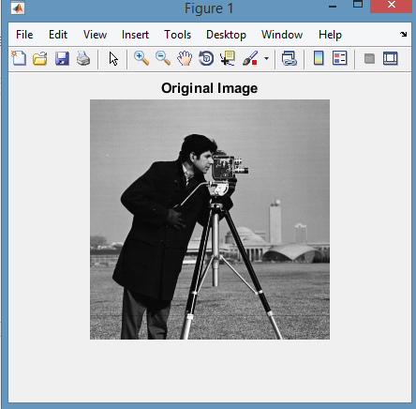

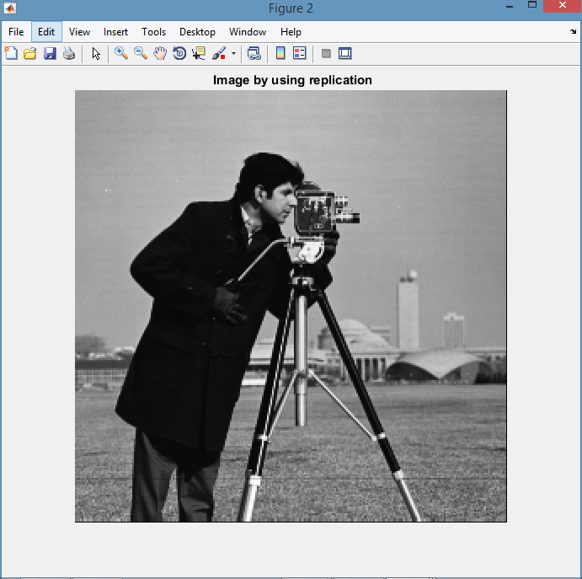

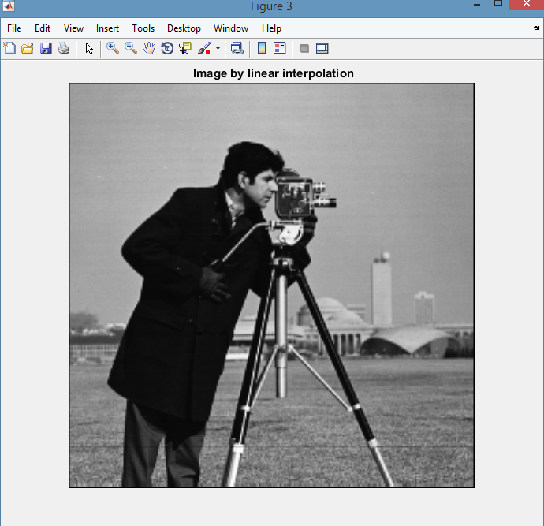

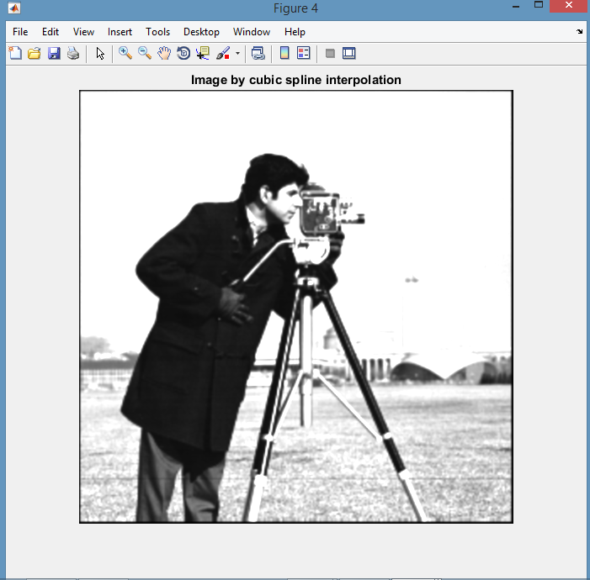

CONCLUSION:

Hence all the zooming interpolation techniques has been applied to cameraman image.