EE5351_DIGITAL VIDEO CODING

ASSIGNMENT SPHIT

NAME: PAVAI ARCHIMEDES

ST ID: 1001233996

**Image compression by SPHIT algorithm**

Part A. Encode the Sinan image by SPHIT algorithm in 0.5 bits per pixel. Find the compression ratio, and mean square error.

Part B. Decode the encoded image

BY USING MATLAB CODE GV:

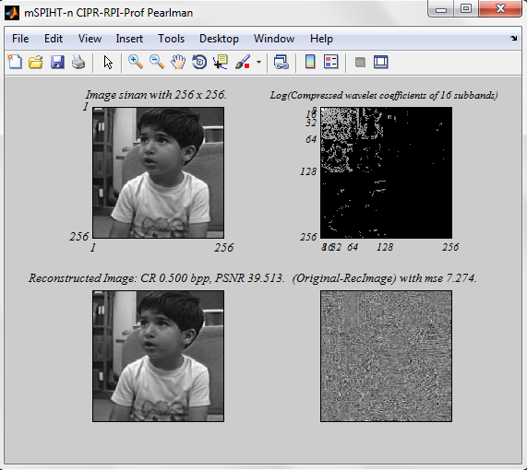

🡪Alternate method using code tree and decode tree

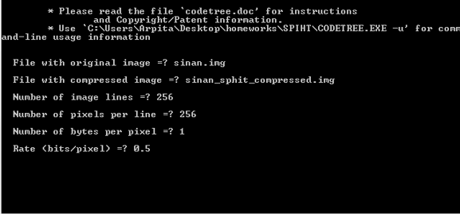

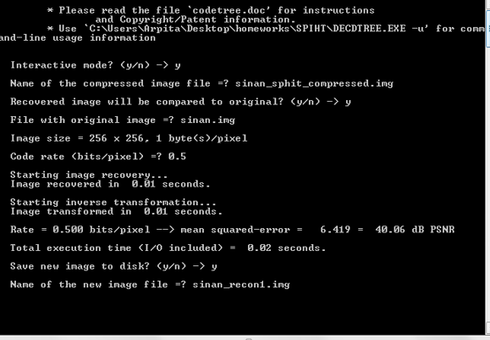

Compression ratio=65536/4097 bytes=15.99

CONCLUSION:

The original image size is 64KB and the reconstructed image size is 64KB.Hence proved that the original and the reconstructed image size remains same after compression and de-compression using SPHIT algorithm.