**Multiplexer 4:1 using dataflow Model**

1. **Code**

----------------------------------------------------------------------------------

library IEEE;

use IEEE.STD_LOGIC_1164.ALL;

use IEEE.STD_LOGIC_ARITH.ALL;

use IEEE.STD_LOGIC_UNSIGNED.ALL;

entity mux_data is

Port ( a,b,c,d : in STD_LOGIC;

s : In STD_LOGIC_VECTOR(1 Downto 0);

y : out STD_LOGIC);

end mux_data;

architecture Dataflow of mux_data is

begin

Y<= a WHEN S(1)='0' AND S(0)='0' ELSE

b WHEN S(1)='0' AND S(0)='1' ELSE

c WHEN S(1)='1' AND S(0)='0' ELSE

d WHEN S(1)='1' AND S(0)='1' ;

end dataflow;

1. **RTL Schematic**

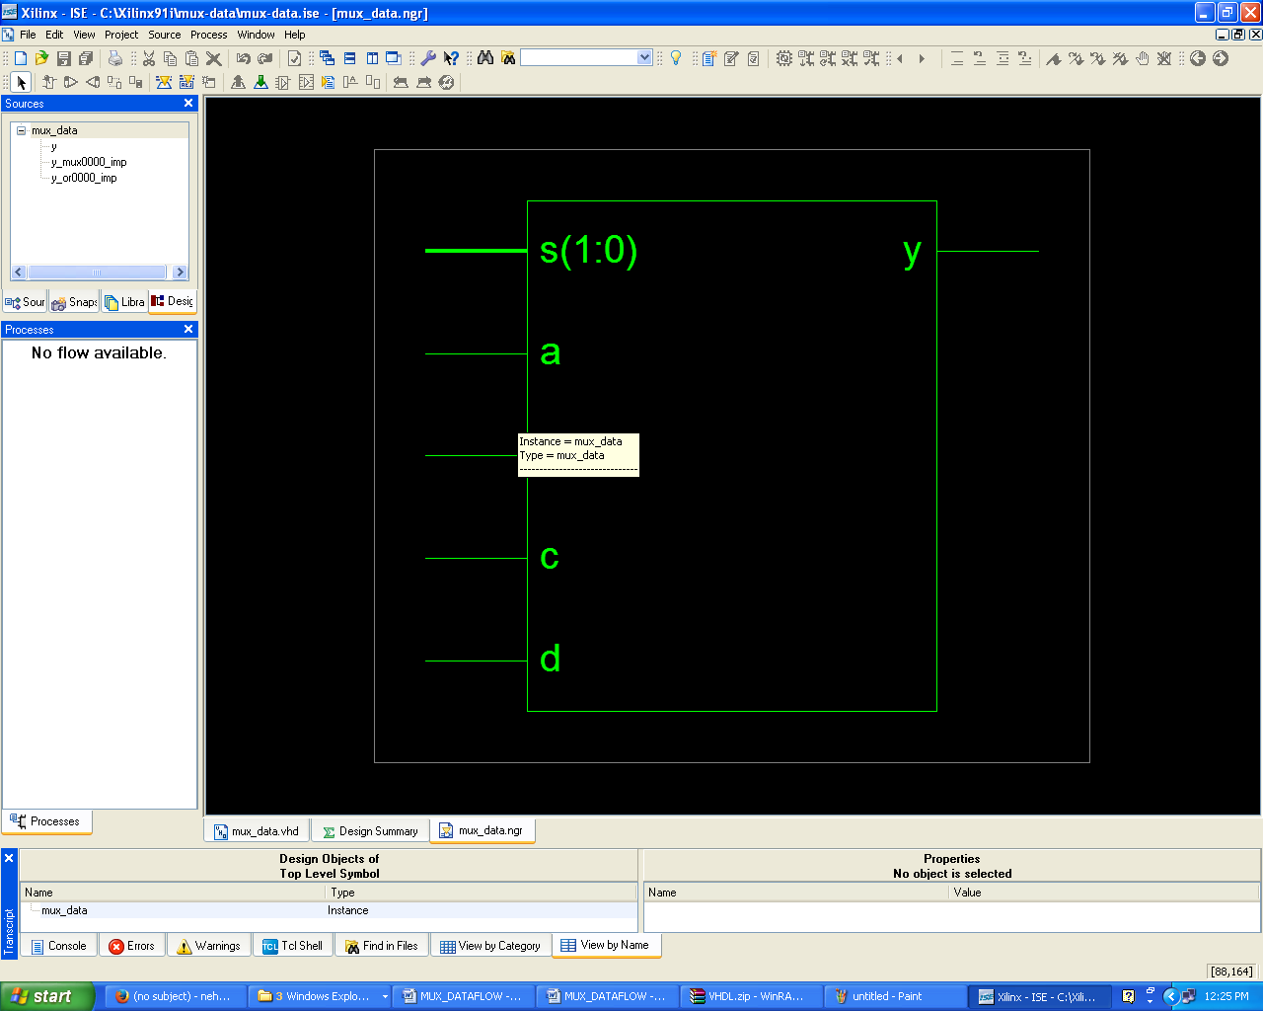

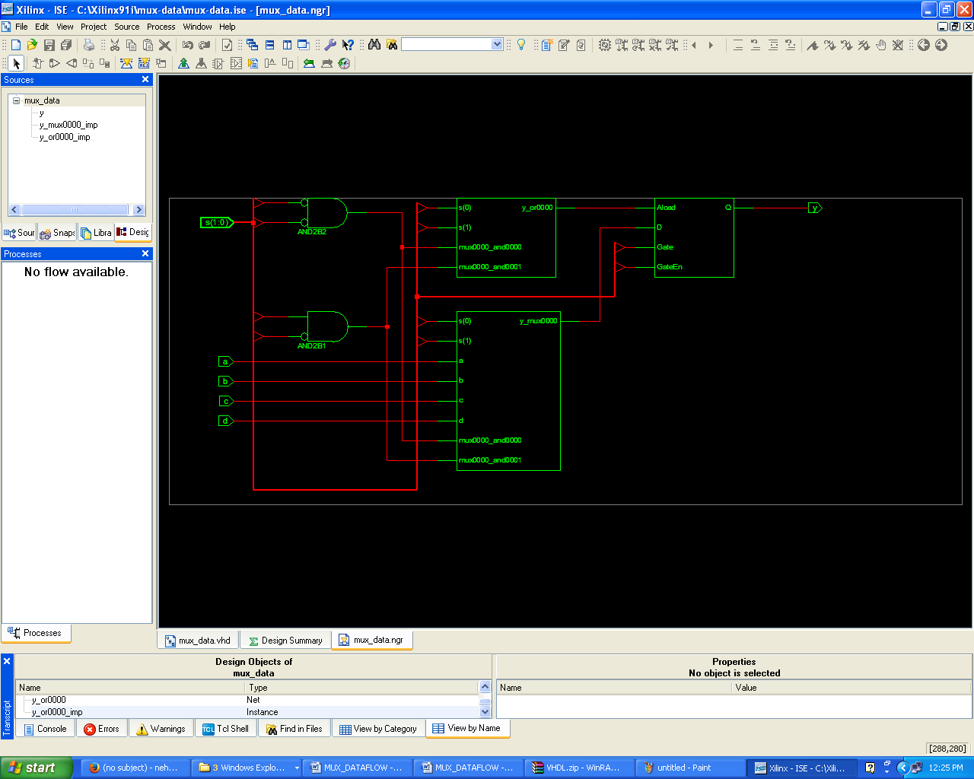

1. **Simulation Output**

