If I place an image in one(source) folder.

1. It will copy to other(destination) folder  
2. It will read image name and size (azure function).  
3. Name and Size information display in service bus  
  
All above process integration in data factory.

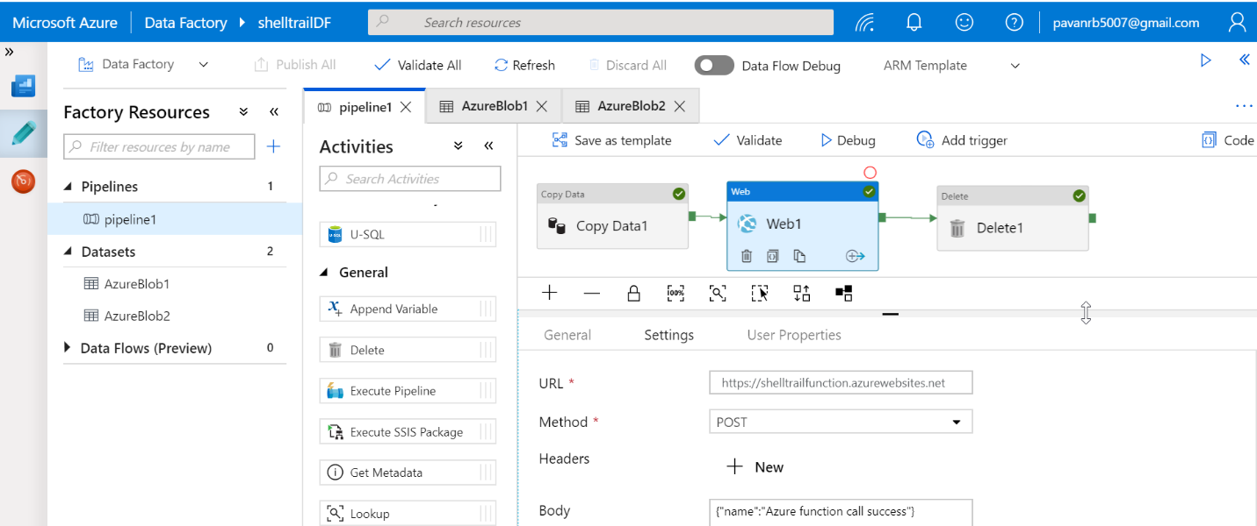

{

"name": "pipeline1",

"properties": {

"activities": [

{

"name": "Web1",

"type": "WebActivity",

"dependsOn": [

{

"activity": "Copy Data1",

"dependencyConditions": [

"Succeeded"

]

}

],

"policy": {

"timeout": "7.00:00:00",

"retry": 0,

"retryIntervalInSeconds": 30,

"secureOutput": false,

"secureInput": false

},

"userProperties": [],

"typeProperties": {

"url": "https://shelltrailfunction.azurewebsites.net",

"method": "POST",

"body": {

"name": "Azure function call success"

}

}

},

{

"name": "Copy Data1",

"type": "Copy",

"dependsOn": [],

"policy": {

"timeout": "7.00:00:00",

"retry": 0,

"retryIntervalInSeconds": 30,

"secureOutput": false,

"secureInput": false

},

"userProperties": [],

"typeProperties": {

"source": {

"type": "BlobSource",

"recursive": true

},

"sink": {

"type": "BlobSink"

},

"enableStaging": false

},

"inputs": [

{

"referenceName": "AzureBlob1",

"type": "DatasetReference"

}

],

"outputs": [

{

"referenceName": "AzureBlob2",

"type": "DatasetReference"

}

]

},

{

"name": "Delete1",

"type": "Delete",

"dependsOn": [

{

"activity": "Web1",

"dependencyConditions": [

"Succeeded"

]

}

],

"policy": {

"timeout": "7.00:00:00",

"retry": 0,

"retryIntervalInSeconds": 30,

"secureOutput": false,

"secureInput": false

},

"userProperties": [],

"typeProperties": {

"dataset": {

"referenceName": "AzureBlob1",

"type": "DatasetReference"

},

"enableLogging": false

}

}

],

"annotations": []

}

}