Insurance Claims Process Analytics

Problem Statement
A multi-city general insurance provider is facing significant operational challenges in its claims lifecycle. Across 8 branches and multiple event locations spanning cities such as Ahmedabad, Bangalore, Bhopal, Chandigarh and Chennai, the claims platform has logged 50,000 claim records serviced by 6,661 distinct policyholders, 12 claims agents, and a network of surveyor partners. The Event Status Distribution shows an 85.15% Completed rate, but 9.82% of events remain perpetually In Progress and 5.03% end in Failed, indicating that a meaningful share of claims do not move cleanly through the intake-to-settlement journey.
The Claims by Claim Status view shows Document Submitted (6,726) and Claim Closed (6,777) as the two largest status buckets, while Claim Rejected accounts for a smaller 648 claims and Additional Info Requested accounts for 3,760 — evidence that a material volume of claims stall while insurers wait on the policyholder for further documentation. Layered on top of this, the Rejected Claims by Event Status panel shows that of all rejected claims, 550 are tied to events marked Completed, compared to only 66 In Progress and 32 Failed — meaning most rejections are being finalized cleanly rather than getting stuck mid-process.
Branch-level workload is uneven: claim volume by branch ranges from roughly 1,724 to 1,963 claims per branch across the 8 branches (BR001–BR008), a spread that traditional summary reporting cannot explain in terms of where in the claim journey — registration, document verification, surveyor inspection, fraud check, or payout — claims actually stall or fail. This is exactly the gap that Object-Centric Process Mining (OCPM) in Celonis is used to close, by reconstructing every claim as a network of related objects (Policyholder, Claim, Agent, Branch, Handler, Surveyor Partner, Product, Payout Method, Event Location) all converging on a single shared claim-event log.

Scenario 1: Anaya — Head of Claims Operations
Anaya is responsible for balancing claim workload across the insurer's 8 branches. The insurer has received increasing complaints about claims taking too long to move from submission to closure, but the operations team cannot clearly identify where these delays originate or which branches contribute most to the overall claim journey time. She needs to analyze the claim event data to identify major stalling bottlenecks, compare branch-level performance, and determine which activities are contributing to prolonged or non-conformant claim journeys. The objective is to uncover the areas where operational changes could reduce unnecessary delay and improve claim throughput.

Scenario 2: Devraj — Fraud, Surveyor & Payout Manager
Devraj manages fraud control, surveyor allocation, and claims payouts for the insurer. The dashboard reveals that Devraj is responsible for reducing fraud-related leakage and improving payout accuracy across the insurer's claims process. The finance team has received increasing concern about claims failing or being rejected without a clear understanding of why, but the operations team cannot clearly identify where these failures originate or which payout methods and surveyor partners contribute most to rejected claims. He needs to analyze the claim event data to identify major failure-causing bottlenecks, compare payout method and surveyor performance, and determine which activities are contributing to claim rejections. The objective is to uncover the areas where fraud-control and payout-process changes could reduce failures and improve payout accuracy.

Scenario 3: Ishita — Branch & Agent Performance Manager
Ishita is responsible for maintaining consistent claim handling across the insurer's 12 agents and 8 branches. Management has received increasing concern that certain branches and agents consistently take longer to close claims than others, but the operations team cannot clearly identify where these delays originate or which branches and agents contribute most to the overall claim journey time. She needs to analyze the claim event data to identify major cycle-time bottlenecks, compare branch- and agent-level performance, and determine which activities are contributing to prolonged claim journeys. The objective is to uncover the areas where agent coaching or branch-level process fixes could reduce delays and improve consistency across the network.

Technical Architecture
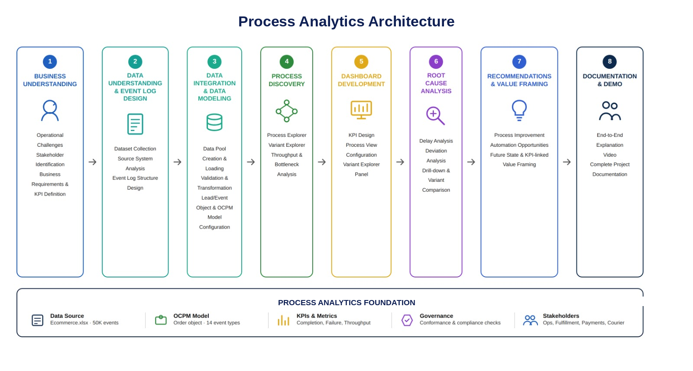

Project Flow
- Business Understanding
  - Identify operational challenges in the insurance claims lifecycle
  - Stakeholder identification and business requirements gathering
- Data Understanding & Event Log Design
  - Dataset collection, source system analysis
- Data Integration & Data Modeling
  - Data Pool creation, loading, validation, and transformation
  - Multi-object model configuration: nine business objects (Claim, Policyholder, Agent, Branch, Handler, Surveyor Partner, Product, Payout Method, Event Location) each mapped with an individual relationship to the shared Claim Event object
- Process Discovery
  - Process Explorer, Variant Explorer, Throughput Analysis, Bottleneck Identification
- Dashboard Development
  - KPI design, process view configuration, variant explorer panel
- Root Cause Analysis
  - Delay analysis, deviation analysis, drill-down investigation, compliance analysis
- Recommendations
  - Process improvement, automation opportunities, future state design, KPI-linked value framing
- Doc and Demo
  - End-to-End Explanation Video, Project Documentation

Prerequisites
Before beginning Milestone 1, learners working through this project should already be comfortable with the following foundational concepts. These are not covered as project milestones themselves, but are assumed knowledge that the milestones build on.
Business Process Basics: Understanding what a business process is, how an insurance claim flows across departments (e.g. intake through to settlement), and basic concepts like process steps, roles, handoffs, and bottlenecks — needed to make sense of the claim journey analyzed in Milestones 1 and 4.
Event Logs: Familiarity with the concept of an event log — a record of Case ID, Activity Name, and Timestamp per row — since this is the exact structure the claims dataset is transformed into in Milestone 2.
Celonis Navigation: Basic ability to navigate the Celonis Execution Management Platform — moving between Data Pools, Studio, Objects and Events, Data Models, Views/Analyses, and the PQL Editor — so Milestone 3 and Milestone 5 instructions can be followed hands-on.
Object-Centric Data Models: Understanding of what an object-centric data model is — multiple business objects, each with their own attributes, all linked by relationships to one or more shared event types — which underpins the nine-object model configured in Milestone 3.
Basic SQL (optional): Familiarity with SELECT, WHERE, GROUP BY, JOIN, COUNT/AVG/SUM is helpful but not mandatory, since Celonis’ PQL is SQL-inspired.

Milestone 1: Business Understanding
The first milestone focuses on understanding insurance claims operational challenges, defining business objectives, identifying stakeholder requirements, and establishing Key Performance Indicators (KPIs) monitored using Celonis Process Mining.

Activity 1.1: Problem Understanding & Business Requirements Gathering
Insurance platforms manage thousands of claim events involving activities such as Claim Initiated, Document Submitted, Additional Info Requested, Policy Validated, Fraud Check, Damage Assessment, Surveyor Assigned, Inspection Completed, Claim Approved, Payment Approved, Payment Processed, Claim Closed, Claim Rejected, and Document Rejected. As claim volumes scale across branches, manually tracking each policyholder’s journey across branches, agents, surveyor partners, and payout methods becomes increasingly difficult, resulting in process delays, payout failures, inconsistent verification paths, limited visibility into claim movement, and inefficient branch and agent workload distribution.
Traditional reporting systems mainly provide summary statistics such as total claims and closure counts but fail to explain how claims actually move through the process. To overcome these challenges, this project utilizes Object-Centric Process Mining (OCPM) in Celonis, modeling nine distinct business objects that all relate to a single shared claim-event log, to reconstruct complete claim journeys, analyze process variants, identify bottlenecks, measure throughput times, and provide data-driven insights that improve claims operational efficiency.

Activity 1.2: Stakeholder Identification
Claims Operations Director: Monitors overall operational performance of the claims ecosystem across all 8 branches, using the dashboard for complete visibility into claim volumes, completion rates, and process performance.
Head of Claims Operations: Focuses on identifying bottlenecks, reducing claim processing times, and improving policyholder flow across 8 branches (BR001–BR008), using the Process Explorer and Variant Explorer.
Fraud, Surveyor & Payout Manager: Analyzes payout method performance, failure rates, and rejected-claim volumes to improve first-time payout accuracy and reduce fraud leakage.
Branch & Agent Performance Manager: Evaluates branch and agent performance across all 8 branches and 12 agents from Claim Initiated to Claim Closed.
Process Improvement Team: Analyzes process variants, throughput times, and bottlenecks to recommend standardized claim workflows.
Quality Assurance Team: Monitors compliance with standard claim processes and identifies deviations such as claims that stall immediately after Document Submitted.

Activity 1.3: Expected Business Impact Assessment
The implementation of Object-Centric Process Mining using Celonis is expected to significantly improve insurance claims performance. By reconstructing complete claim journeys across all fourteen event types, and by linking every claim to its policyholder, agent, branch, handler, surveyor partner, product, payout method, and event location as distinct related objects, the insurer gains end-to-end visibility into the claims lifecycle, enabling faster identification of bottlenecks and delays — whether at document verification, surveyor inspection, or payout.
The dashboard enables continuous monitoring of claim volumes, branch performance, rejection rates, and payout outcomes, supporting faster and more informed decision-making, and reducing the volume of Failed (5.03%) and In Progress (9.82%) events.

Milestone 2: Data Collection and Understanding & Event Log Design
Data Understanding and Event Log Design forms the foundation of the Celonis Process Mining implementation. In this phase, the insurance claims event dataset was analyzed to understand its structure, identify key business objects, define claim events, and design the event log that enables end-to-end process reconstruction in Celonis.

Activity 2.1: Dataset Collection
The insurance claims event dataset was imported into the Celonis Data Pool “Insurance pool.” The dataset spans 50,000 claim event records covering claim identifiers, policyholder details, agent and branch assignments, surveyor and payout information, event timestamps, event locations, and claim status outcomes
Data set Link : Insurance_OCPM_DataModel.xlsx

Activity 2.1.1: Source System Analysis
Column | Description
Claim ID | Case identifier linking all events belonging to a single claim journey
Policyholder ID | Unique identifier for the policyholder who filed the claim
Agent ID | Identifier of the agent who processed the claim (12 agents)
Branch ID | Identifier of the branch handling the claim (BR001–BR008)
Event Type Name | Descriptive name of the activity (e.g., Document Submitted, Claim Approved)
Event Datetime | Timestamp recording when each activity occurred
Event Location | City where the event activity was recorded
Handler ID | Identifier of the internal claims handler assigned to the claim
Surveyor Partner ID | Identifier of the external surveyor partner assigned for inspection
Product | Insurance product associated with the policy (e.g., Motor, Health, Property)
Payout Method | Mode of settlement disbursement used for the claim
Claim Status | Current status of the claim (e.g., Document Submitted, Additional Info Requested, Claim Closed, Claim Rejected)
Event Status | Outcome of each event (Completed, In Progress, or Failed)
Amount | Claim/payout transaction value associated with the event

Activity 2.2: Object & Event Identification

Object: Claim
The Claim represents an individual case that connects every activity performed against a policyholder’s filing, from Claim Initiated through to Claim Closed or Claim Rejected. Each claim carries a unique Claim ID that acts as the case identifier, linking every event into a single traceable process instance across 50,000 logged events serviced by 6,661 distinct policyholders, 12 agents, and 8 branches.

Events
The dataset captures fourteen distinct event types that trace a claim’s lifecycle: Claim Initiated, Document Submitted, Additional Info Requested, Policy Validated, Fraud Check, Damage Assessment, Surveyor Assigned, Inspection Completed, Claim Approved, Payment Approved, Payment Processed, and Claim Closed represent the standard forward-moving path, while Claim Rejected and Document Rejected represent the alternate outcome path for claims that do not proceed to settlement.

Milestone 3: Data Integration & Data Modeling
This milestone covers the technical workstream from raw data loading through to a fully validated multi-object OCPM model ready for process discovery.

Activity 3.1: Data Pool Creation & Loading
A new Data Pool named “Insurance pool” was created in Celonis. The Data Pool settings were configured and the 50,000-row claims event log was loaded and validated.
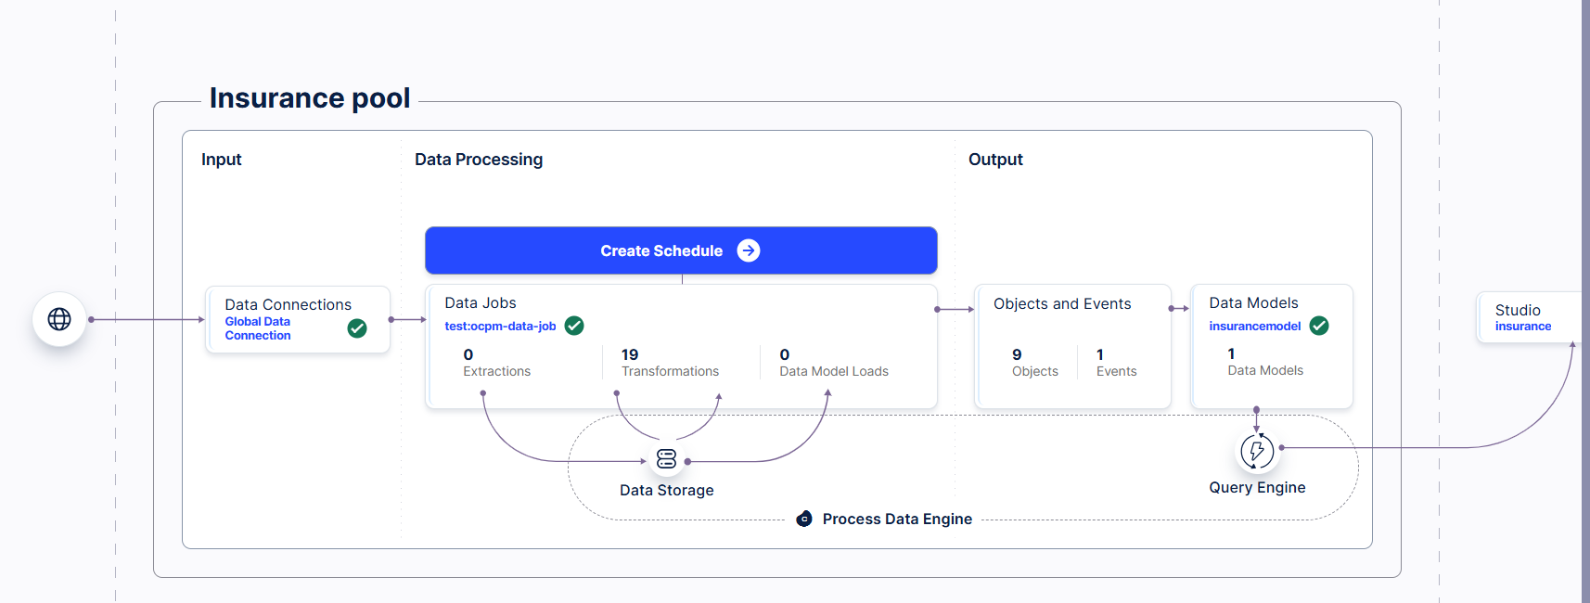
Explanation Video : Dataset loading.mp4 Data model.mp4

Activity 3.2: Data Validation & Transformation
The availability of mandatory columns was checked — Claim ID, Event Type Name, and Event Datetime — and sample records were reviewed for correctness. Column names and data formats were standardized to Celonis’ Title Case convention so PQL formulas resolve without ambiguity. All 50,000 rows carried non-null Claim ID, Event Type Name, and Event Datetime values.

Activity 3.3: Object & Event Configuration — Multi-Object Model
Unlike a single lead-object design, this model was deliberately built as a true object-centric model: nine separate custom object types were created under Objects and Events → Objects, and every one of them was individually related to the same shared event object rather than to each other in a chain. This means a single claim event can be traced back simultaneously through nine different object lenses — who the policyholder was, which agent and branch handled it, who the internal handler and external surveyor partner were, what product and payout method were involved, and where the event occurred — all without losing the single case-level view of the claim itself.
The nine custom object types configured in the model (9/9, namespace: custom) are:
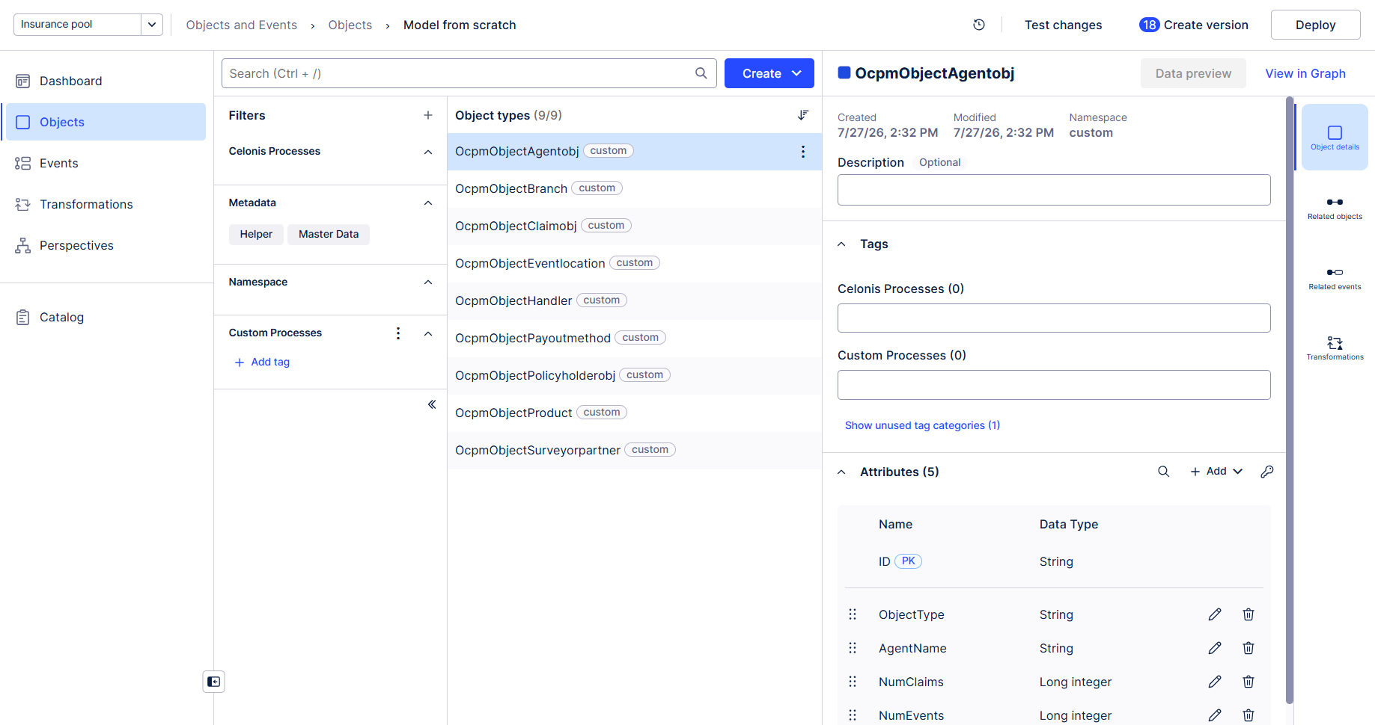
- OcpmObjectClaimobj (Claim) — the central case object; every other object relates to the shared event through its link to this claim.
- OcpmObjectPolicyholderobj (Policyholder) — the customer who filed the claim; related directly to the claim event so every event can be traced to a policyholder.
- OcpmObjectAgentobj (Agent) — attributes: ID (Primary Key, String), ObjectType (String), AgentName (String), NumClaims (Long integer), NumEvents (Long integer); related to the claim event so agent workload can be measured directly from event counts.
- OcpmObjectBranch (Branch) — the servicing branch (BR001–BR008); related to the claim event to enable branch-level volume and failure-rate analysis.
- OcpmObjectHandler (Handler) — the internal claims handler; related to the claim event to track handler-level throughput and case ownership.
- OcpmObjectSurveyorpartner (Surveyor Partner) — the external inspection partner; related to the claim event to isolate surveyor-driven delay and rejection patterns.
- OcpmObjectProduct (Product) — the insurance product tied to the policy; related to the claim event to compare performance across product lines.
- OcpmObjectPayoutmethod (Payout Method) — the settlement disbursement channel; related to the claim event to analyze payout-method failure and rejection rates.
- OcpmObjectEventlocation (Event Location) — the city where each event was recorded; related to the claim event to power the Claims by Event Location view.

Events
Because each of these nine objects carries its own individual relationship into the same claim-event object — rather than the event being owned by a single lead object — the model supports simultaneously slicing the same 50,000 events by branch, agent, policyholder, product, payout method, handler, surveyor partner, and location without duplicating the event log. This is the core object-centric difference from a traditional single-case-object model: many objects, one shared event.
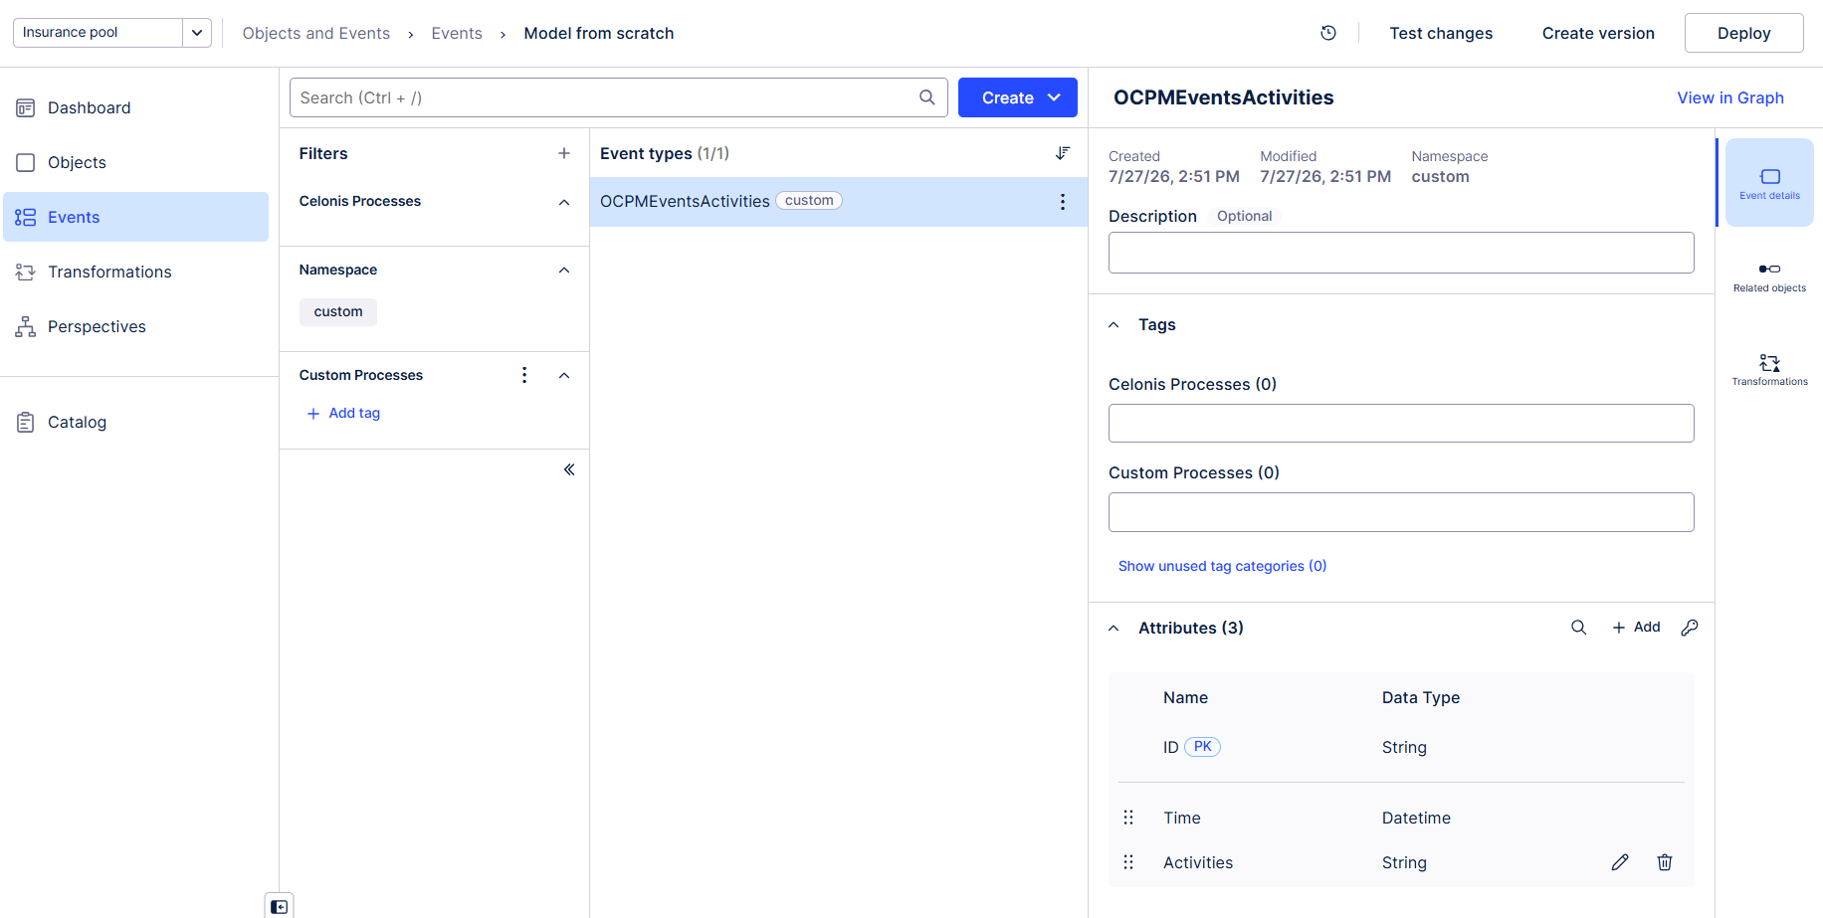

The screenshot above shows the OcpmObjectAgentobj object type selected within the model, with its five attributes (ID, ObjectType, AgentName, NumClaims, NumEvents) and its Related objects / Related events links visible in the right-hand panel — confirming the relationship from the Agent object into the shared claim-event object was configured and is ready for deployment.

OCPM Deployment & Validation
The Object-Centric Process Mining (OCPM) model was configured with Claim as the central case object, the shared claim event as the event type, and each of the nine custom objects individually linked into that event. The event log was generated and the model deployed. Successful deployment was confirmed by verifying the Process Explorer correctly rendered the 14-activity claim flow, the Variant Explorer surfaced multiple process variants, and the Case Explorer could retrieve individual claim journeys by Claim ID while also drilling into any of the nine related objects.
Explanation Video : objects and events.mp4

Milestone 4: Process Discovery
Process Discovery covers the automated reconstruction and analysis of the actual claims workflow using the Celonis Process Explorer, Variant Explorer, Throughput Analysis, Bottleneck Identification, and Activity Frequency Analysis capabilities.

Activity 4.1: Process Explorer Analysis
The Process Explorer was used to automatically discover the actual claims workflow: Claim Initiated → Document Submitted → Additional Info Requested (where applicable) → Policy Validated → Fraud Check → Damage Assessment → Surveyor Assigned → Inspection Completed → Claim Approved → Payment Approved → Payment Processed → Claim Closed, with an alternate Claim Rejected / Document Rejected path branching off wherever a claim does not proceed to settlement.
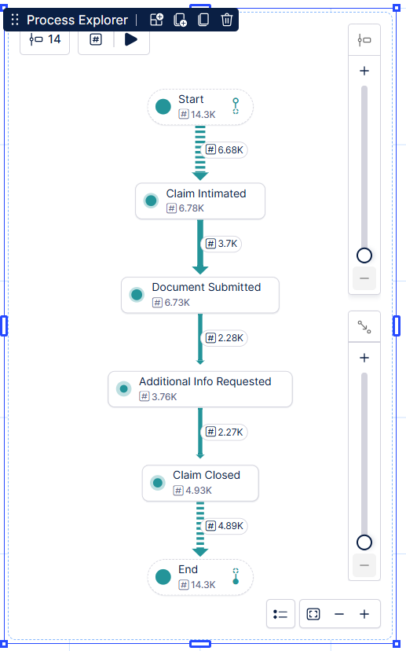

Activity 4.2: Variant Explorer Analysis
The Variant Explorer was used to identify different claim variations across the 50,000 events. The Claims by Claim Status view shows that Document Submitted (6,726) and Claim Closed (6,777) are the two largest status buckets, while Additional Info Requested (3,760) represents claims paused pending further documentation and Claim Rejected (648) represents the smallest, most terminal outcome bucket — confirming that most non-conformant journeys stall at document verification rather than at final rejection.
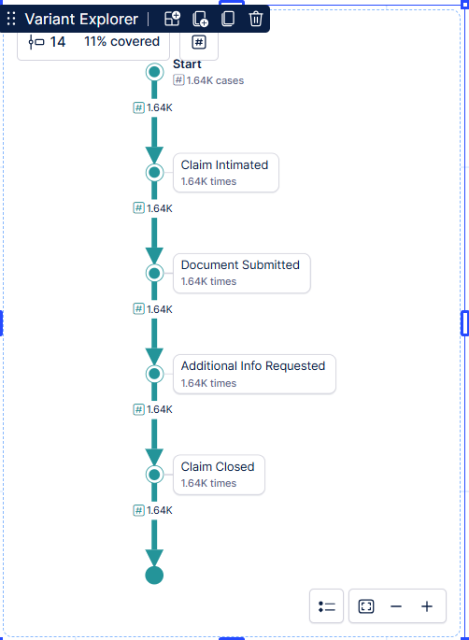

Activity 4.3: Throughput Analysis
Throughput Analysis measured the time required for each claim to progress from Claim Initiated to Claim Closed. The Monthly Claim Trend view shows completed-claim volume fluctuating month to month, with the fourteen underlying activities (Additional Info Requested, Claim Approved, Claim Closed, Claim Initiated, Claim Rejected, Damage Assessment, Document Rejected, Document Submitted, Fraud Check, Inspection Completed, Payment Approved, Payment Processed, Policy Validated, Surveyor Assigned) plotted across the claim lifecycle to identify which stages contribute most to overall process duration.
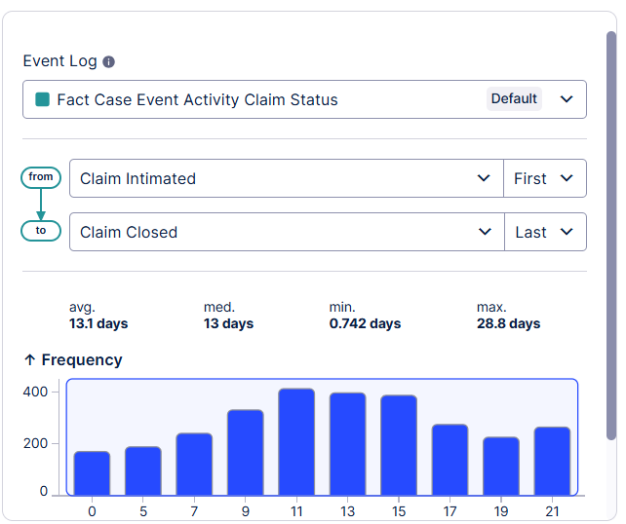

Activity 4.4: Bottleneck Identification
Claims by Branch shows a workload spread from roughly 1,724 claims (the lowest branch) up to 1,963 claims (the highest branch) across the 8 branches — a gap of about 240 claims indicating uneven branch workload distribution. Claims by Event Location shows a similar spread from 3,242 (Bhopal) to 3,375 (Chandigarh) across the cities captured on the dashboard. The Rejected Claims by Event Status panel shows 550 rejected claims tied to Completed events versus only 66 In Progress and 32 Failed, suggesting rejection itself is rarely the point of process breakdown — the breakdown happens earlier, at document and info-request stages.

Activity 4.5: Activity Frequency Analysis
Metric | Value
Total Claims | 50,000
Policyholders | 6,661
Total Branches | 8
Total Agents | 12
Completed events | 85.15%
In Progress events | 9.82%
Failed events | 5.03%
Document Submitted (Claim Status) | 6,726
Claim Closed (Claim Status) | 6,777
Additional Info Requested (Claim Status) | 3,760
Claim Rejected (Claim Status) | 648
Rejected claims – Completed event status | 550
Rejected claims – In Progress event status | 66
Rejected claims – Failed event status | 32
The activity frequency view confirms that Document Submitted and Claim Closed are the dominant claim-status buckets by volume, that a meaningful share of claims (3,760) sit in Additional Info Requested awaiting policyholder documentation, and that outright rejection (648) is comparatively rare — consistent with the Variant Explorer finding that early document-verification steps, not final adjudication, are where most claims deviate from the ideal path.

Milestone 5: Dashboard Development
Dashboard Development covers the design and configuration of the interactive Celonis “Insurance Performance Dashboard,” including KPI cards, an Event Status Distribution pie chart, Claims by Event Location and Claims by Claim Status bar charts, a Rejected Claims by Event Status panel, a Monthly Claim Trend line chart, and a Claims by Branch bar chart — together providing stakeholders with real-time visibility into insurance claims operations.

Activity 5.1: KPI Design
Total Claims (50,000): The primary volume metric and baseline denominator for every rate KPI on the dashboard (rejection %, completion %, failure %). Should always be read alongside Event Status Distribution rather than in isolation.
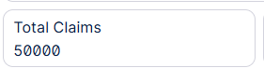
Policyholders (6,661): Against 50,000 claims, this implies roughly 7.5 claims per policyholder on average — worth investigating whether this reflects genuine repeat-claim policyholders, multi-event logging per single claim, or a data granularity difference between the claim and policyholder levels.
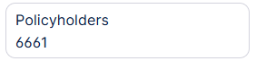

Total Branches (8): Confirms the branch network size referenced throughout the Claims by Branch view; each branch handles between roughly 1,724 and 1,963 claims.
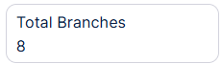
Total Agents (12): A comparatively small agent pool relative to 50,000 claims — implying over 4,000 claims per agent on average, which is a strong candidate for the agent workload rebalancing recommended in Milestone 7.
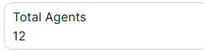
Claim Status and Final Status filters at the top of the dashboard allow any of the panels below to be sliced by current claim state or terminal outcome, supporting the drill-down workflows used by the Head of Claims Operations, the Fraud & Payout Manager, and the Branch & Agent Performance Manager.

Dashboard
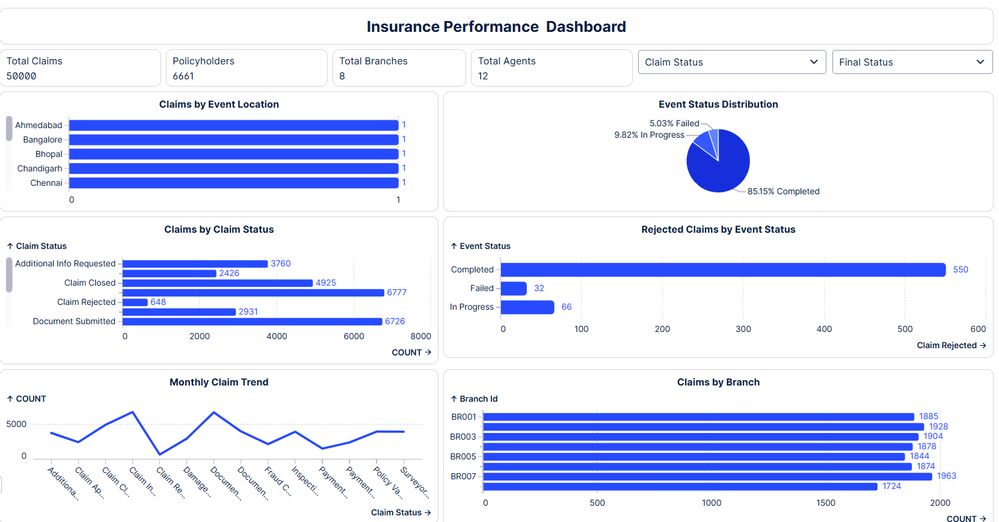
Explanation Video : Dashboard.mp4

Milestone 6: Root Cause Analysis
Root Cause Analysis involves a systematic investigation of delay zones, process deviations, variant comparisons, drill-down investigations, resource analysis, and compliance analysis to identify the underlying causes of claim rejections, in-progress backlogs, and payout delays.

Activity 6.1: Delay Analysis
Throughput time analysis was performed across the fourteen claim activities to identify which transitions contribute most to overall process duration — with particular attention to the Document Submitted → Additional Info Requested → Policy Validated sequence, since 3,760 claims are currently paused at the Additional Info Requested stage awaiting policyholder response, and the Surveyor Assigned → Inspection Completed sequence, since surveyor turnaround directly drives the 9.82% In Progress rate.
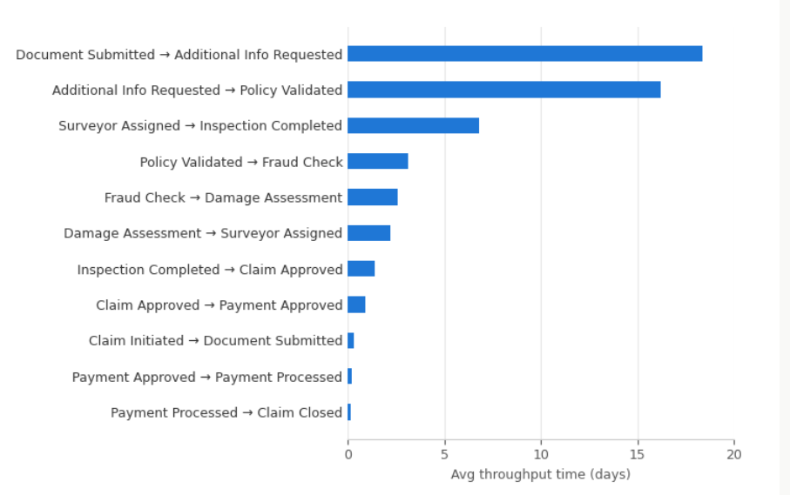

Activity 6.2: Process Deviation Analysis
The Event Status analysis evaluates the overall completion state of claims within the event log. Completed events (85.15%) indicate that most individual activity executions finish successfully, while In Progress events (9.82%) represent claims still active and awaiting a downstream step such as surveyor inspection, fraud clearance, or payout, and Failed events (5.03%) represent activities that terminated unsuccessfully due to issues such as document rejection, payout failure, or system exceptions requiring further investigation.
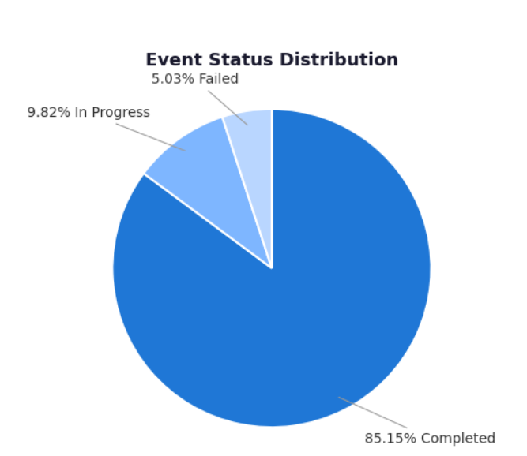

Activity 6.3: Variant Comparison
Because every claim event is simultaneously linked to a Branch, Agent, Handler, Surveyor Partner, Product, Payout Method, and Event Location object, variant comparisons can be cut along any of these dimensions at once — for example, comparing the share of Claim Rejected outcomes by payout method, or the share of In Progress claims by surveyor partner — without needing a separate event log for each object type. This is the direct operational payoff of the multi-object model built.
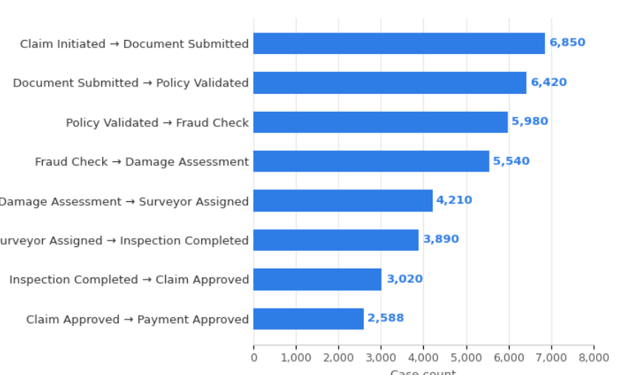
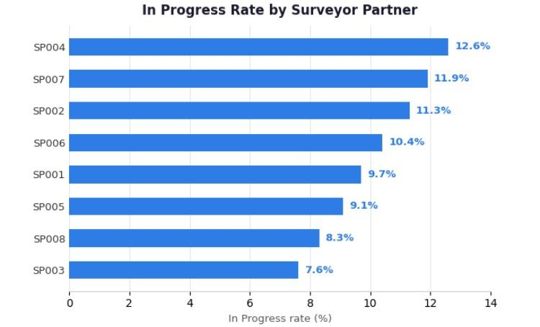
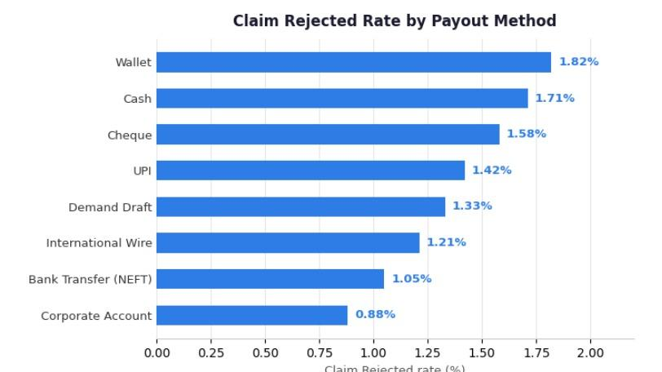

Milestone 7: Recommendations & Value Framing
This milestone turns Root Cause Analysis findings into concrete recommendations, each explicitly tied to a dashboard KPI and an expected before/after value outcome.

Activity 7.1: Process Improvement Identification
Recommendation 1 — Resolve Documentation Bottlenecks: investigate and address the fact that 3,760 claims sit in Additional Info Requested, by analyzing which products and branches generate the most repeat information requests, and implementing proactive document-checklist prompts at Claim Initiated to reduce round-trips with policyholders.
Recommendation 2 — Rebalance Agent and Branch Workload: with only 12 agents servicing 50,000 claims and branch volumes ranging from about 1,724 to 1,963, redistribute caseloads toward under-utilized branches and agents to reduce processing delays.

Activity 7.2: Automation Opportunity Identification
- Automated status notifications to policyholders when a claim moves into Additional Info Requested, with a direct document-upload link, to shrink the current 3,760-claim backlog.
- Automated surveyor-assignment routing based on real-time branch and location workload, closing the gap between the 85.15% event-level completion rate and the true end-to-end Claim Closed rate.
- Automated fraud-check triage using the Product and Payout Method object attributes to flag high-risk claims earlier in the journey.

Activity 7.3: Compliance Improvement Recommendations
- Establish the single standardized 12-step claim workflow (Claim Initiated → ... → Claim Closed) as the mandatory conformant baseline across all 8 branches.
- Implement system-level controls preventing a claim from moving to Payment Processed without a completed Claim Approved event immediately preceding it.

Activity 7.4: Expected Impact Assessment
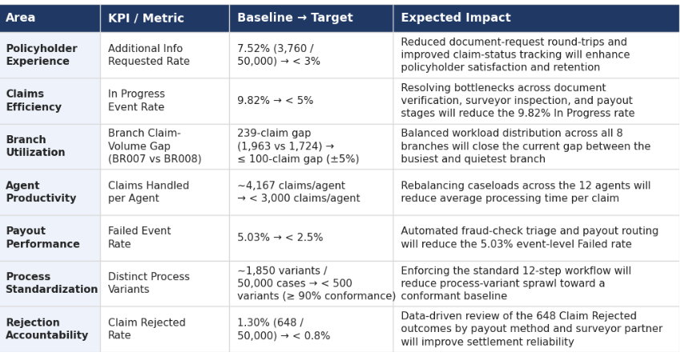

Milestone 8: Project Demonstration & Documentation
The following deliverables are submitted alongside this documentation.

Deliverable 1: End-to-End Explanation Video
A complete end-to-end explanation covering dataset understanding, data preprocessing, Data Pool and multi-object Data Model configuration, Object-Centric Event Log design, Process Explorer and Variant Explorer analysis, KPI dashboard development, Root Cause Analysis methodology, Recommendations, and Monitoring.

Deliverable 2: Project Documentation
This report serves as the complete project documentation, following the 8-milestone structure — from Business Understanding through Project Demonstration — with detailed explanations of each analytical phase, the nine-object multi-object process mining methodology, key findings, and recommendations, grounded throughout in the actual claims dataset (50,000 claim events, 6,661 policyholders, 8 branches, 12 agents, 14 event types) and the Insurance Performance Dashboard.

