Inventory & Warehouse Management
Process Intelligence & Operational Excellence

A regional third-party logistics operator runs a multi-site warehouse network handling inbound receiving, storage, and outbound order fulfillment for B2B, e-commerce, retail transfer, and returns customers. Although warehouse operations follow a defined sequence of activities — from goods receipt and put-away through pick request, picking, packing, and dispatch — the operations team lacks a clear, data-driven view of where delays, rework, and process deviations are occurring.
The company needs to identify where orders spend excessive time between steps, which activities contribute most to delay, and which departments or warehouses create operational bottlenecks. It is also important to understand whether these issues vary across order types, product categories, suppliers, carriers, and individual warehouse agents.
Traditional reporting approaches provide overall averages and summary counts but make it difficult to investigate the relationships between orders, warehouses, products, suppliers, carriers, and departments. As a result, operations teams may struggle to determine the root causes of stockouts, quality rejections, and dispatch delays, and to distinguish isolated incidents from recurring process inefficiencies.
The company therefore requires a process intelligence and Object-Centric Process Mining approach that can analyze the complete event history while preserving relationships between multiple business objects. The objective is to uncover bottlenecks, identify sources of delay and process deviation, compare performance across warehouses and order types, and provide actionable insights for improving fulfillment speed, inventory accuracy, and overall warehouse service delivery.

Scenario 1: Meera — Warehouse Operations Manager
Meera is responsible for improving order flow across the company's warehouse network. Site leads have raised concerns about orders taking too long to move from receipt to dispatch, but the operations team cannot clearly identify where these delays originate or which warehouses contribute most to overall order duration. She needs to analyze the order event data to identify major bottlenecks, compare warehouse performance, and determine which activities are contributing to prolonged fulfillment times. The objective is to uncover the areas where operational changes could reduce unnecessary delay and improve throughput.

Scenario 2: Arjun — Inventory Control Lead
Arjun is responsible for ensuring stock is accurately picked and dispatched without avoidable rework. He has observed that some orders involve considerably more events than others — putaway delays, short-picks, packing exceptions — creating additional workload for picking and packing teams. However, the inventory team does not know what factors are driving this process complexity or whether certain product categories, order types, or warehouses are associated with longer and more complicated fulfillment paths. Arjun needs to analyze the relationships between orders, products, warehouses, and departments to identify recurring patterns and determine where the fulfillment process can be simplified without affecting order accuracy.

Scenario 3: Sana — Supply & Vendor Performance Manager
Sana manages supplier and carrier performance for the warehouse network. Delays and quality failures during goods receipt, along with carrier unavailability at dispatch, are affecting how quickly inbound stock becomes available and how reliably outbound orders leave the warehouse. The existing reports show overall order counts but do not provide enough detail to determine whether disruptions are associated with specific suppliers, carriers, warehouses, or individual process activities. Sana needs to analyze the interconnected order, supplier, carrier, and activity data to identify recurring sources of disruption and understand how these relationships affect overall fulfillment reliability.

Technical Architecture

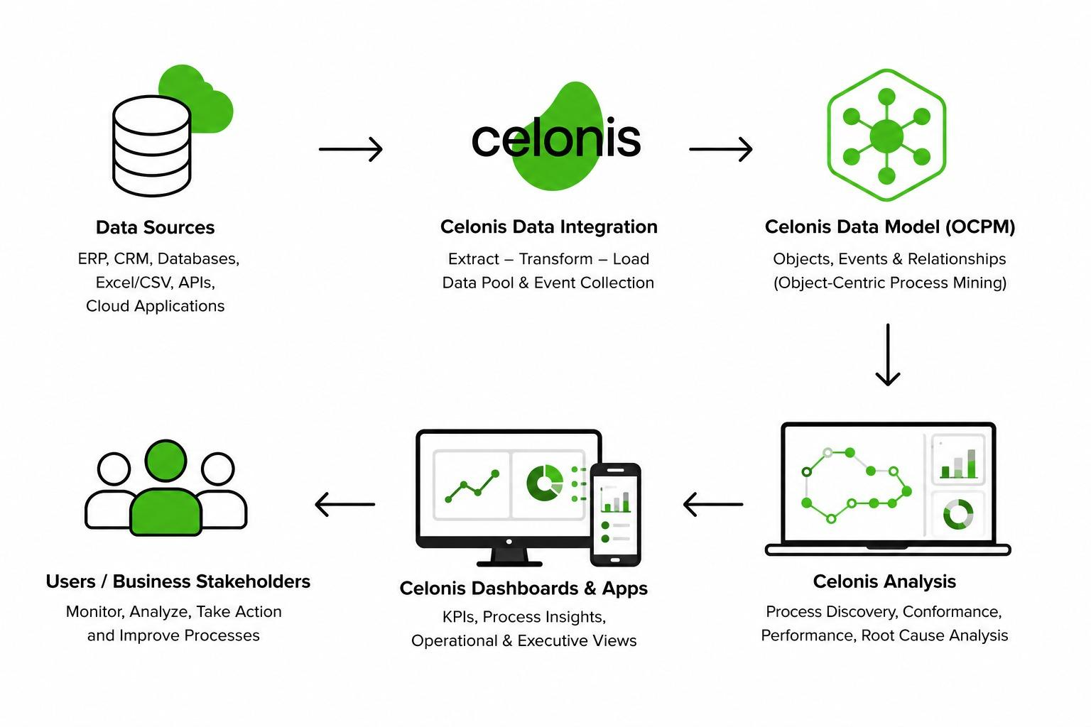

Project Flow
- Business Understanding
  - Problem Understanding & Business Requirements Gathering
  - Stakeholder identification
- Data Collection and Understanding — Event Log Design
  - Dataset collection
  - Object and Event Identification
- Data Integration & Data Modeling
  - Data Pool creation and loading
  - Data Validation and Transformation
  - Object & Event Configuration
- Process Discovery
  - Process Explorer Analysis
  - Variant Explorer Analysis
  - Throughput Analysis
  - Bottleneck Identification
- Dashboard Development
  - Designing Dashboard
- Root Cause Analysis
  - Delay analysis
  - Process Deviation Analysis
  - Variant Comparison
- Recommendations
  - Process Improvement Identification
  - Automation Opportunities Identification
  - Compliance Improvement Recommendations
  - Expected Impact Assessment
- Doc and Demo
  - End-to-End Explanation Video
  - Project Documentation

Prerequisites
Before beginning the project, learners should already be comfortable with the following foundational concepts. These concepts are assumed knowledge and provide the foundation for working effectively with process mining, data analysis, and Celonis.
Business Process Basics: Understanding what a business process is, how processes flow across different steps, departments, and roles, and basic concepts such as process activities, handoffs, delays, bottlenecks, and process variations.
Event Logs: Familiarity with the concept and structure of an event log, including Case ID, Activity, and Timestamp, and an understanding of how event data can be used to reconstruct and analyze process journeys.
Celonis Navigation: Basic ability to navigate the Celonis Execution Management Platform, including Data Pools, Studio, Objects and Events, Data Models, Views/Analyses, and the PQL Editor.
Object-Centric Data Models: Understanding the fundamentals of object-centric process mining, including business objects, object attributes, relationships between objects, and events that can be associated with multiple objects.
Basic Data Analysis: Familiarity with basic analytical concepts such as filtering, grouping, aggregation, averages, counts, and identifying patterns or anomalies in data.
Basic SQL (Optional): Familiarity with SELECT, WHERE, GROUP BY, JOIN, COUNT, AVG, and SUM is helpful but not mandatory, as Celonis PQL is SQL-inspired.
Technologies:
Celonis, OCPM (Object-Centric Process Mining), Celonis Data Pool, Celonis Objects & Events, Celonis Studio, PQL (Process Query Language), Microsoft Excel.

Milestone 1: Business Understanding
Business Understanding is the first step in a process mining project, where learners develop a clear understanding of the business process, its objectives, and the problems that need to be investigated. It involves identifying key stakeholders, understanding the current process flow, defining business goals, and translating business challenges into measurable analytical questions.
Learners should focus on what the business wants to improve, why the problem matters, where inefficiencies may exist, and which metrics can be used to evaluate process performance. This foundation helps ensure that subsequent data analysis and process mining activities are aligned with meaningful business objectives.

Activity 1.1: Problem Understanding & Business Requirements Gathering
The warehouse operator needs better visibility into how orders move across activities, departments, warehouses, suppliers, and carriers. Existing reports provide high-level order counts but do not clearly reveal where delays occur, how fulfillment paths vary, or which factors contribute to inefficiencies.
To address this, the project requires a clear understanding of the business problems, stakeholder needs, process objectives, and key performance measures. Learners will translate these requirements into analytical questions that can be investigated using Celonis and Object-Centric Process Mining (OCPM).
The key requirements include:
- Understand the end-to-end order fulfillment journey and its major activities.
- Identify delays, bottlenecks, and process deviations.
- Analyze process variations and fulfillment complexity.
- Examine relationships between orders, warehouses, products, suppliers, carriers, and departments.
- Measure relevant KPIs such as order duration, dispatch rate, cancellation rate, and process complexity.
- Identify areas where process performance can be improved or optimized.

Activity 1.2: Stakeholder Identification
Warehouse Operations Director: Monitors overall order volume, fulfillment duration, and network-wide process complexity.
Head of Warehouse Operations: Identifies warehouses with high cancellation rates, bottlenecks, and process delays.
Supply & Vendor Performance Manager: Monitors supplier quality and carrier dispatch reliability, and compares performance across vendors.
Product & Order Type Performance Manager: Compares fulfillment duration and process performance across product categories and order types.
Process Improvement Team: Analyzes process patterns, variations, bottlenecks, and opportunities to improve fulfillment flow.
Quality Assurance Team: Identifies deviations from expected fulfillment journeys, unusual process paths, and stalled activities.

Milestone 2: Data Collection and Understanding & Event Log Design
In this milestone, learners work with the warehouse process data and understand how it is structured for process mining. They identify the key business objects, activities, timestamps, attributes, and relationships required to represent order fulfillment journeys in Celonis.
Learners also examine the event data for data quality, completeness, duplicates, missing values, and consistency before using it for analysis. The milestone establishes the foundation for building an Object-Centric Process Mining model and ensures that the data can accurately represent the warehouse process and its interconnected entities.

Activity 2.1: Dataset Collection
The Warehouse OCPM dataset provides the event and business-object data required to analyze order fulfillment using Celonis. Learners will use the dataset to understand the available process information, identify relevant data fields, and prepare the data for process mining analysis.
The dataset contains order fulfillment events along with information about activities, timestamps, orders, warehouses, products, suppliers, carriers, order types, departments, and warehouse agents. This data will serve as the foundation for understanding the warehouse process and creating the required Object-Centric Process Mining model in later activities.
Dataset Link : Inventory_Warehouse_Management

Activity 2.1.1: Source System Analysis
Metric | Value
Order Cases | 1,200 unique warehouse orders
Process Events | 11,260 recorded events
Process Activities | 17 distinct warehouse activities
Process Variants | 7 distinct order fulfillment variants
Warehouses | 12 distribution and fulfillment sites
Warehouse Agents | 70 warehouse resources
Product Categories | 11 categories — Packaged Foods, Beverages, Dairy, Frozen, Personal Care, Cleaning Supplies, Electronics Accessories, Apparel, Stationery, Pharmaceuticals, Industrial Hardware
Order Types | 4 types — B2B Replenishment, E-commerce Fulfillment, Retail Store Transfer, Returns Processing
Suppliers | 6 inbound suppliers
Carriers | 6 outbound carriers
Departments | 7 warehouse departments
Event Status | Completed, Flagged, and Cancelled
Average Case Duration | Approximately 17.3 hours (1,038 minutes)
Data Completeness | No missing values across any table
Case-Centric Model | Includes Fact_WarehouseOrder and Fact_WarehouseOrder_Event_Activity tables
OCPM Event Model | Includes OCPM_Events table
OCPM Objects | 8 objects — Customer, Warehouse, Product, Supplier, Carrier, Order Type, Department, Warehouse Agent
Object Relationships | 85,280 event–object relationships
Analysis Period | January 1, 2024 – November 30, 2025

Activity 2.2: Object & Event Identification

Object: Warehouse Order (Case)
The Warehouse Order represents an individual case that connects every activity performed during a single order's journey, from Goods Receipt through to Dispatch, Return to Supplier, or Cancellation. Each order carries a unique Order_ID that acts as the case identifier, linking every event into one traceable process instance across 11,260 logged events serviced across 1,200 distinct orders, 70 warehouse agents, and 12 warehouses.

Events
The dataset captures 17 distinct event types that trace an order's journey: Goods Receipt, Quality Inspection, Put-away, Pick Request Created, Picking Started, Picking Completed, Packing Started, Packing Completed, Dispatch Scheduled, and Dispatched represent the standard forward-moving path, while Goods Rejected, Return to Supplier, Putaway Delayed, Pick Request Cancelled, Short Picked, Packing Exception, and Dispatch Delayed represent exception or delay states that branch off the ideal flow.

Milestone 3: Data Integration & Data Modeling
In this milestone, learners prepare the collected warehouse data for analysis in Celonis. They will load the required data, understand the relationships between tables, and build a data model that connects events with relevant business objects.
The milestone focuses on transforming the source data into a structured Object-Centric Process Mining (OCPM) model, ensuring that events, objects, and relationships are correctly connected and ready for process analysis.

Activity 3.1: Data Pool Creation & Loading
A dedicated Data Pool is created in Celonis to organize and manage the warehouse process data. The required tables are then uploaded to the Data Pool and checked to ensure that the data has been loaded correctly and is ready for data modeling.
- Create a new Data Pool named Inventorypool.
- Upload the OCPM_Events event table.
- Upload the eight supporting OCPM object tables.
- Verify that the tables and records are loaded successfully.
- Check the data structure before proceeding to the data model creation.
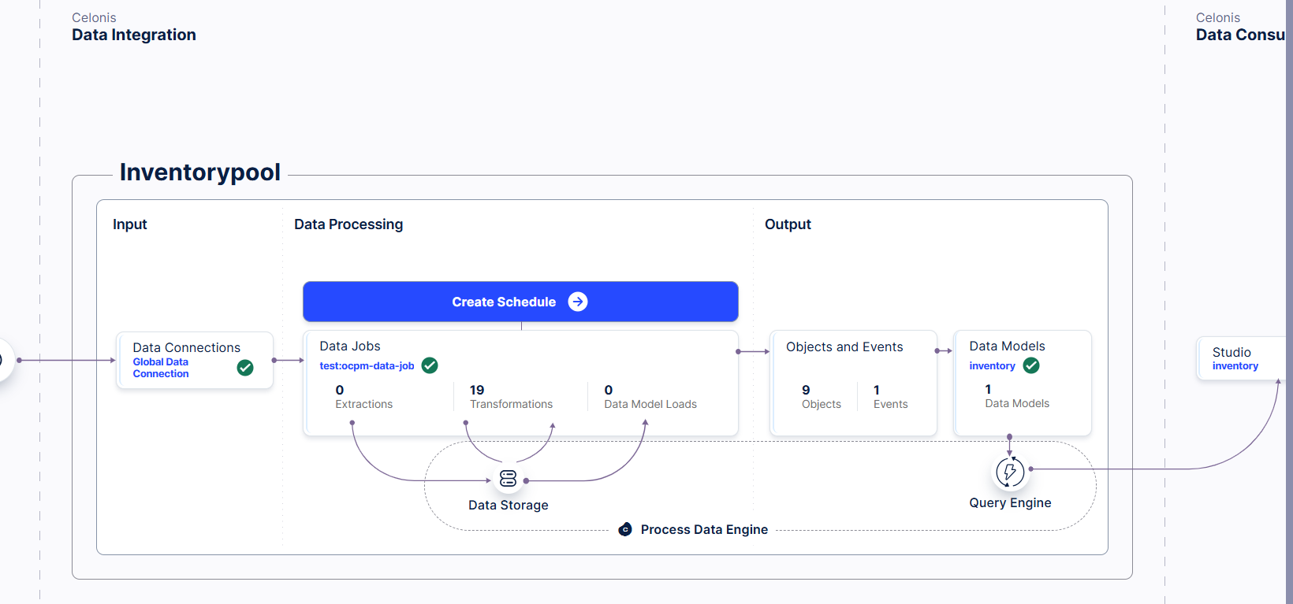

Explanation video: Datamodel.mp4

Activity 3.2: Data Validation & Transformation
The warehouse data is validated and prepared to ensure it is accurate, consistent, and suitable for analysis in Celonis.
- Verify that essential fields such as Event ID, Order ID, Activity, and Timestamp are available.
- Check sample records to confirm that the data values and formats are correct.
- Standardize column names and data types for consistent use in Celonis and PQL.
- Check for missing or null values in important event fields.
- Verify that each Order ID represents a single warehouse order and that events follow the correct sequence.
- Check for duplicate or inconsistent event records.
- Treat orders with no recorded exception as Not Applicable instead of removing them from the analysis.
- Confirm that the validated data is ready for data modeling and process analysis.

Activity 3.3: Object & Event Configuration — Multi-Object Model
In this activity, eight custom objects are created under Objects & Events → Objects: Customer, Warehouse, Product, Supplier, Carrier, Order Type, Department, and Warehouse Agent. Each object represents a different part of the warehouse process. For example, Warehouse represents the fulfillment site, Product represents the item category, Supplier represents the inbound vendor, Carrier represents the outbound freight partner, and Department represents the functional team performing the work.
Next, an EventsActivities event object is created with the attributes Event ID, Time, and Activities. This is the shared event log that stores every activity performed during an order's fulfillment.
Each of the eight objects is then connected to the shared event object using the OCPM_Event_Object_Relations table. Instead of connecting the objects to one another, they all connect directly to the same event log. This allows a single event to be viewed from different perspectives, such as the warehouse where it occurred, the agent who performed it, the department responsible, the supplier or carrier involved, and the product category being handled.
After configuring the relationships, the model is deployed and the Process Explorer is verified to display the order fulfillment workflow, the Variant Explorer to show different process variants, and the Case Explorer to allow analysis of individual orders using any of the configured objects.
Explanation Video:objects and events.mp4
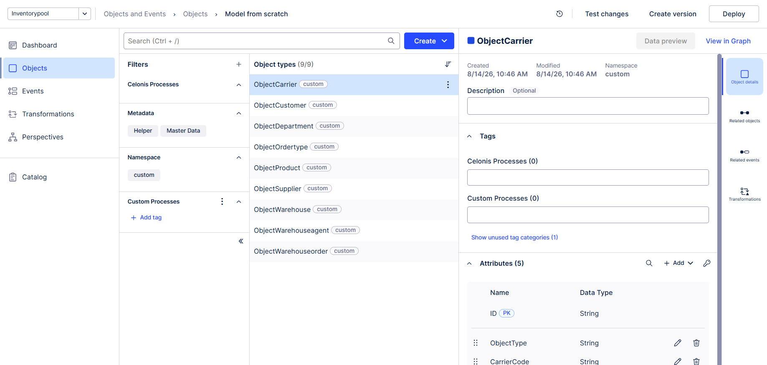

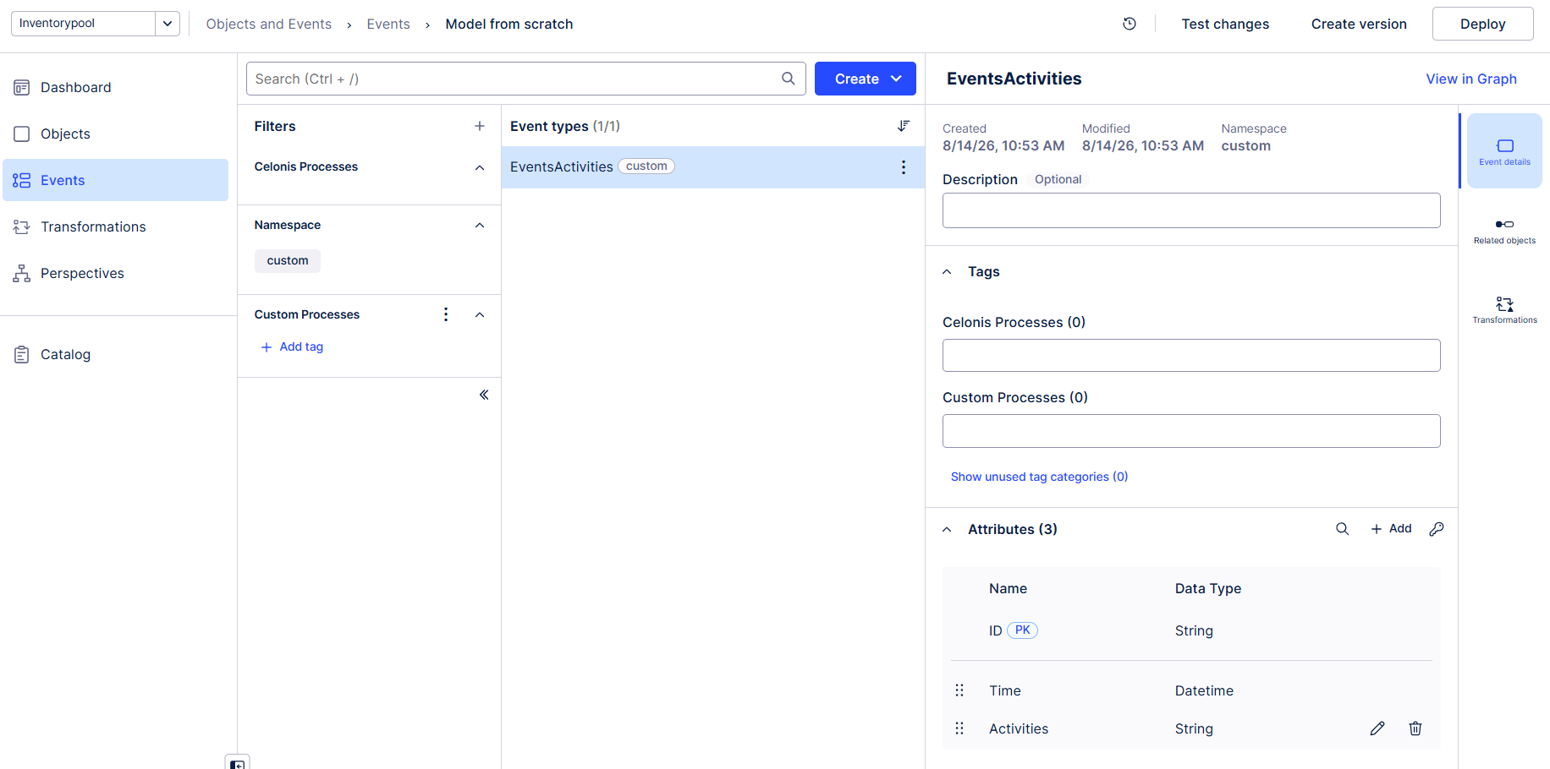

OCPM Deployment & Validation
The Object-Centric Process Mining (OCPM) model was configured with the Event object (EventsActivities) as the shared event type, Warehouse Order as the central case object, and each of the remaining seven custom objects (Warehouse, Product, Supplier, Carrier, Order Type, Department, Warehouse Agent) individually linked into that same event through the relationship table. The event log was generated and the model deployed. Successful deployment was confirmed by verifying the Process Explorer correctly rendered the 17-activity order flow, the Variant Explorer surfaced multiple process variants, and the Case Explorer could retrieve individual orders by Order_ID while also drilling into any of the eight related objects.

Milestone 4: Process Discovery
After completing this milestone, you will be able to reconstruct and analyze the actual order fulfillment workflow using Celonis Process Mining. You will learn how to discover the end-to-end process flow with Process Explorer, analyze different process variants using Variant Explorer, measure process performance through Throughput Analysis, identify bottlenecks and delays across activities and departments, and evaluate activity frequency to understand process complexity. By the end of this milestone, you will be able to interpret process mining insights and identify opportunities for improving operational efficiency and process performance.

Activity 4.1: Process Explorer Analysis
The Process Explorer is used to visualize the actual order journey from the recorded event data and understand how orders move through the warehouse process.
- Identify the main process flow from Goods Receipt to Dispatch.
- Examine how orders move between different activities and departments.
- Identify alternative paths involving Putaway Delayed, Short Picked, and Packing Exception.
- Detect exception paths such as Goods Rejected, Return to Supplier, Pick Request Cancelled, and Dispatch Delayed.
- Compare different order journeys to identify process variations and deviations.
- Use the discovered process flow as a foundation for further bottleneck and performance analysis.
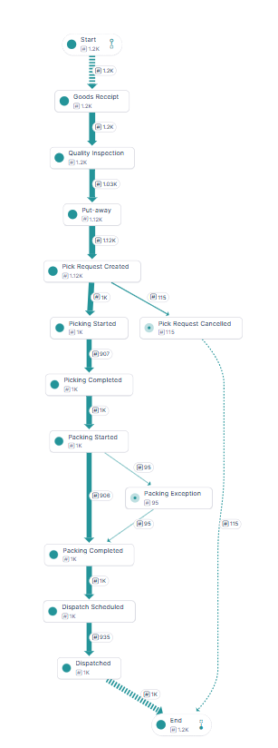

Activity 4.2: Variant Explorer Analysis
The Variant Explorer was used to analyze different order-journey paths across the 1,200 cases. The analysis identifies 7 process variants, with the top variant (the 10-step happy path from Goods Receipt to Dispatched) accounting for 55% of the total case volume. Learners examine how these variants differ in terms of case volume, case percentage, activity count, and process duration, and investigate variants involving Putaway Delayed, Short Picked, Packing Exception, Dispatch Delayed, Pick Request Cancelled, and Goods Rejected. The analysis also highlights that roughly 45% of cases carry at least one deviation event, helping identify process paths that require further investigation.

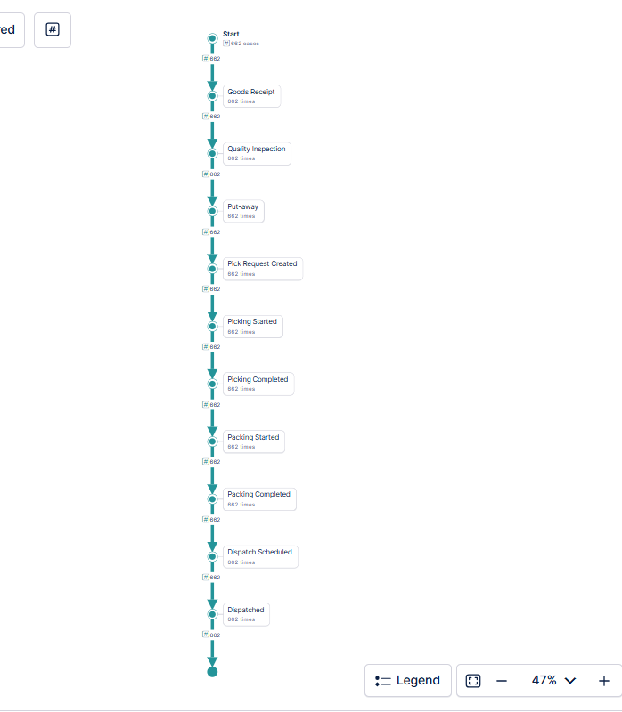

Activity 4.3: Throughput Analysis
Throughput Analysis evaluates the time taken by orders to move through the warehouse process, from Goods Receipt to Dispatch, Cancellation, or Return to Supplier. The 17 activities are grouped into functional stages and compared using average duration by final status. The analysis records approximately 1,260 minutes for Partially Dispatched orders, 1,145 minutes for Dispatched orders, 502 minutes for Cancelled orders, and 361 minutes for orders Returned to Supplier. These metrics help learners compare process performance and identify which outcomes have the greatest impact on overall order duration.
Explanation Video: Explorer.mp4
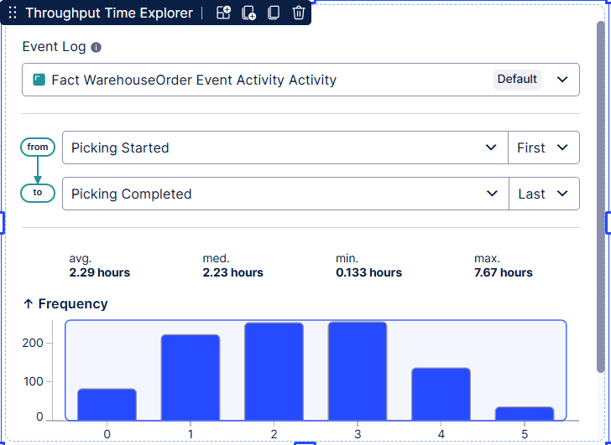

Activity 4.4: Bottleneck Identification
Bottleneck Analysis is used to identify departments and activities where orders experience the most flagged or cancelled events. Across the 7 departments, event volume ranges from 1,200 events at Put-away to 2,097 events at Packing, with Picking and Packing carrying the heaviest load since each generates a Started and a Completed event per order.
At the transition level, the average time between consecutive activities on the happy path ranges narrowly from approximately 122 to 138 minutes, with Quality Inspection to Put-away representing the longest average gap. These metrics help learners identify and prioritize the major process bottlenecks and delay areas.
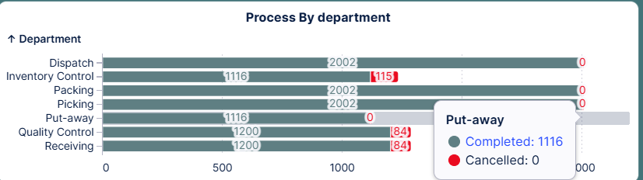

Activity 4.5: Activity Frequency Analysis
Activity Frequency Analysis is used to understand how frequently different activities occur across the 1,200 orders and 11,260 events. Learners compare activity frequency with department event load to identify activities that are both frequently performed and associated with significant deviation.
The analysis focuses on the 17 process activities, including Short Picked, Packing Exception, Putaway Delayed, Dispatch Delayed, Pick Request Cancelled, and Goods Rejected, helping identify activities that have a significant impact on order flow and overall process performance.
Metric | Value
Total Orders | 1,200
Total Events | 11,260
Distinct Activities | 17
Process Variants | 7
Warehouses | 12
Warehouse Agents | 70
Product Categories | 11
Order Types | 4
AVG Order Duration | 1,037.6 min (~17.3 Hrs)
Average Process Complexity | 9.38 events/order
Dispatch Rate | 83.4%
Cancellation Rate | 9.6%
Return-to-Supplier Rate | 7.0%
Slowest Department (by event load) | Packing — 2,097 events
Longest Average Transition | Quality Inspection → Put-away — 138 min

Milestone 5: Dashboard Development
In this milestone, you will build an interactive Celonis dashboard by combining KPI cards, charts, tables, filters, and process visualizations. The dashboard will present key insights such as process flow, order duration, dispatch rate, bottlenecks, variants, warehouse performance, and disruption metrics. By the end of this milestone, you will have a comprehensive dashboard that enables stakeholders to monitor warehouse process performance and identify opportunities for continuous process improvement.

Activity 5.1: Designing Dashboard
The dashboard provides an interactive view of the warehouse process, helping users understand order duration, process complexity, dispatch performance, exceptions, bottlenecks, and process variants. It highlights key KPIs such as Total Orders (1,200), Exception Orders (45), Average Damage Amount (2,690), Total Handling Charges (534K), and Active Warehouses (12), supported by KPI cards, bar charts, a monthly trend line, a pie chart, and department breakdowns.
Users can apply filters based on category name and department to explore specific areas of the process. The dashboard dynamically updates the relevant metrics and visualizations, making it easier to compare segments, identify process variations, and investigate potential bottlenecks.

Best Practices
- Keep it focused: Include only visuals relevant to the defined business questions.
- Use clear titles: Make every KPI and visualization easy to understand.
- Prioritize information: Highlight important KPIs and bottlenecks prominently.
- Maintain consistency: Use consistent metric definitions and calculations.
- Enable exploration: Provide meaningful filters for stakeholder analysis.
- Avoid clutter: Keep the dashboard clean and easy to navigate.
- Validate results: Ensure all metrics and interactions produce accurate results.

Dashboard
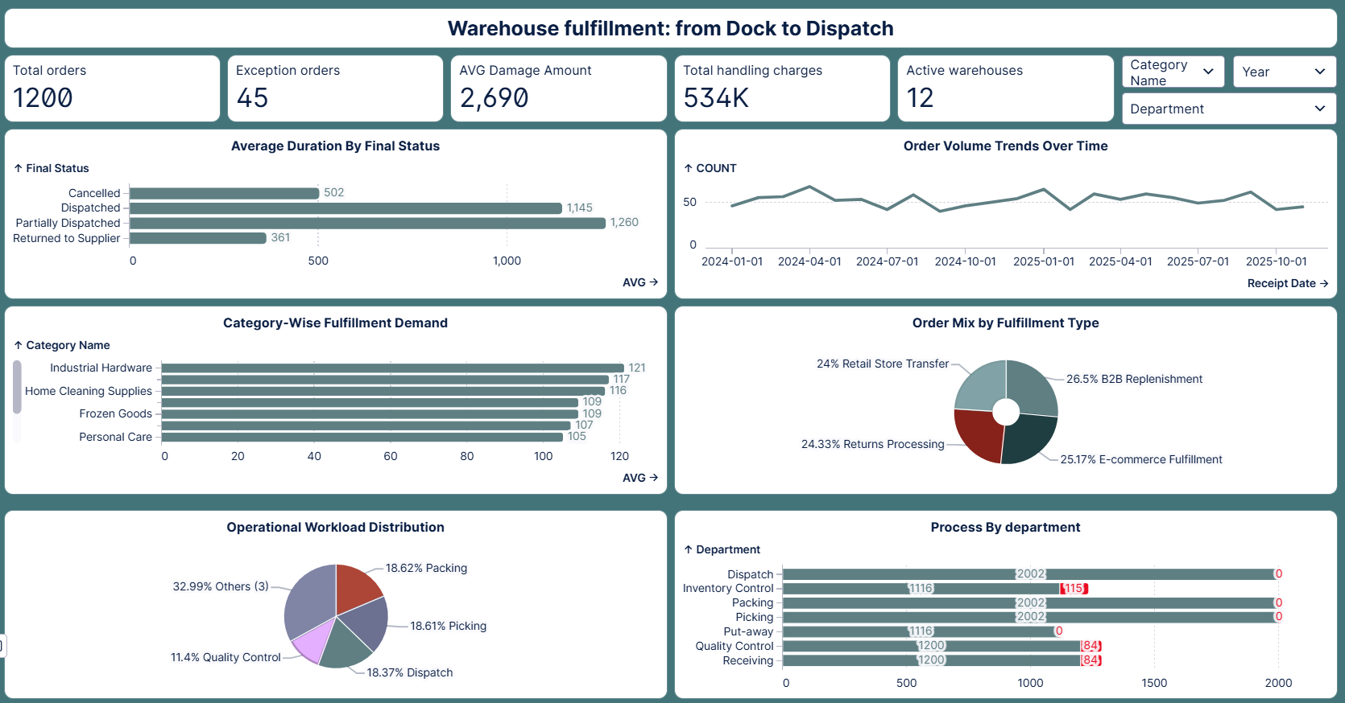

Explanation Video: Dashboard.mp4

Milestone 6: Root Cause Analysis
In this milestone, learners move beyond identifying where bottlenecks and delays occur to investigate why they occur. Using Celonis analysis capabilities, learners examine process activities, departments, warehouses, suppliers, carriers, and other business objects to identify factors associated with poor process performance. The focus is on connecting process problems with their underlying causes, comparing different segments and process paths, and using data-driven evidence to determine which factors contribute most to delays, high complexity, and longer order journeys.

Activity 6.1: Delay Analysis
Delay Analysis is used to identify activities that contribute significantly to overall order duration. The analysis examines transition time and department event load across the 17 process activities to determine where delay accumulates.
Key metrics include Partially Dispatched orders averaging 1,260 minutes and Dispatched orders averaging 1,145 minutes, both well above Cancelled (502 min) and Returned to Supplier (361 min) orders. These metrics help identify significant delay areas and provide a basis for investigating the underlying causes of prolonged order journeys.
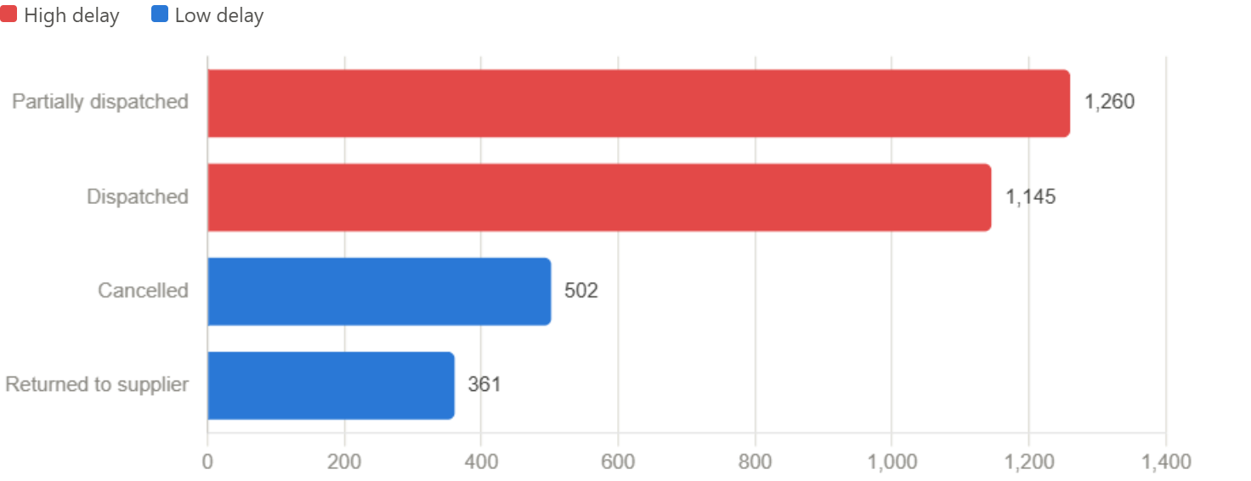

Activity 6.2: Process Deviation Analysis
Process Deviation Analysis is used to identify functional areas where order journeys differ from expected process performance and where additional time may accumulate. The analysis compares event status across departments: Receiving and Quality Control each show 84 Cancelled events (goods rejected at inspection), Inventory Control shows 115 Cancelled events (pick requests cancelled for stockout), and Put-away, Picking, Packing, and Dispatch show 84, 94, 95, and 66 Flagged events respectively. These metrics help learners identify areas with higher process deviation and investigate the factors contributing to delays and inefficiencies.
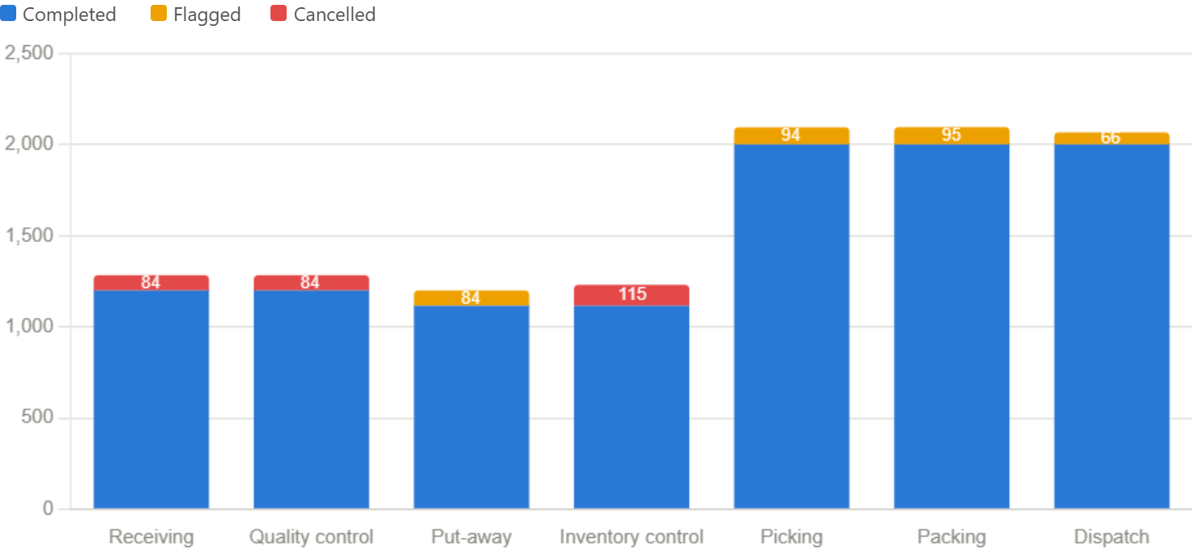

Activity 6.3: Variant Comparison
Variant Comparison helps identify how order fulfillment performance differs across different groups. Learners compare key metrics such as order duration, exception rate, and process complexity across dimensions such as Warehouse, Order Type, Product Category, Supplier, and Carrier.
For example, cancellation rate can be compared across warehouses. Harbor View Warehouse records a 16.5% cancellation rate and Highland Bulk Store records 13.1%, while Eastpoint Logistics Park records only 3.9% — a more than four-fold difference between the highest and lowest performing sites. These comparisons help identify performance differences between groups and areas that need further investigation.
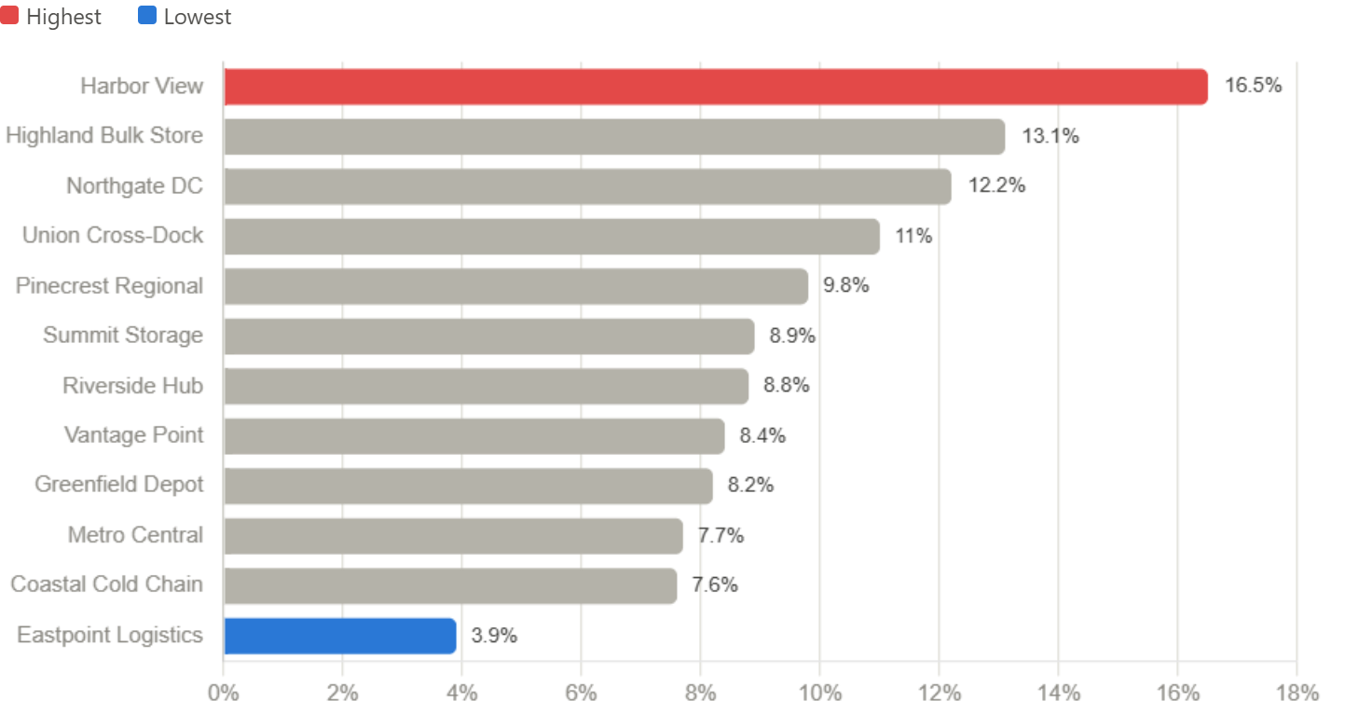

Milestone 7: Process Improvement Recommendations
In this milestone, learners use the findings from the root cause and process analysis to develop practical recommendations for improving the warehouse process. The focus is on translating identified bottlenecks, delays, process variations, and performance gaps into specific improvement actions.
Learners prioritize improvement areas, suggest practical process changes, and define measurable outcomes such as reduced cancellation rate, shorter order duration, lower process complexity, and improved dispatch reliability.

Activity 7.1: Process Improvement Identification
Recommendation 1 — Reduce Pick Request Cancellations: Investigate inventory accuracy and safety-stock policy at Inventory Control, which accounts for 115 cancelled events driven primarily by stockouts at the pick stage.
Recommendation 2 — Improve Supplier Quality Screening: Review supplier-specific quality performance, since Goods Rejected and Return to Supplier events together account for 84 orders (7.0% of total volume) lost at inbound inspection.
Recommendation 3 — Address Warehouse-Level Cancellation Variance: Investigate Harbor View Warehouse (16.5% cancellation rate) and Highland Bulk Store (13.1%) against the network's better-performing sites such as Eastpoint Logistics Park (3.9%) to identify site-specific process or staffing gaps.
Recommendation 4 — Reduce Packing and Picking Rework: Analyze the 95 Packing Exception and 94 Short Picked events to identify whether damage-in-transit and stockout-at-pick issues share a common root cause, such as inbound handling or cycle-count frequency.

Activity 7.2: Automation Opportunity Identification
Process analysis can be used to identify repetitive activities where automation may reduce manual effort and delay. Learners evaluate activities such as Goods Receipt, Quality Inspection, Pick Request Created, and Dispatch Scheduled to identify suitable automation opportunities. Potential improvements may include automated putaway slotting, barcode-driven pick confirmation, exception alerting, and carrier-booking notifications. The goal is to identify activities where automation can improve processing speed, coordination, and overall process efficiency.

Activity 7.3: Compliance Improvement Recommendations
The analysis can be used to identify areas where order journeys deviate from the expected process. Learners review process variations and deviations across activities such as Goods Receipt, Quality Inspection, Picking, Packing, and Dispatch to identify opportunities for better process compliance.
Recommendations may include establishing standard operating procedures (SOPs), defining activity-specific time thresholds, monitoring process deviations, and regularly reviewing process performance through Celonis dashboards. These measures can help improve process consistency, reduce unnecessary variations, and ensure activities are completed within defined operational standards.

Activity 7.4: Expected Impact Assessment
The proposed improvements are expected to improve overall order flow, process efficiency, and compliance. The target is to reduce the network cancellation rate from 9.6% to below 6%, reduce the warehouse-level cancellation-rate spread from a 12.6-point gap to 6 points or less, and bring Average Order Duration below 1,000 minutes.
The improvements should also reduce the share of orders carrying at least one deviation event from 45% to below 30%, improve adherence to the expected fulfillment journey, and increase on-time dispatch compliance. Automation of activities such as Goods Receipt, Pick Request Creation, and Dispatch Scheduling is expected to further reduce manual effort and administrative processing time.

Milestone 8: Project Demonstration & Documentation
The following deliverables are submitted alongside this documentation.
Below mentioned deliverables to be submitted along with other deliverables
Project Demonstration & Documentation involves presenting the project’s functionality, features, and outcomes while providing clear written records, diagrams, and explanations to ensure understanding, usability, and reproducibility for stakeholders and future reference

Activity 1: End-to-End Explanation Video
Record a 5–7 minute screen-share video explaining the project end-to-end. Introduce your/team name, state the problem statement, highlight preprocessing steps, demonstrate dashboards, present findings, and showcase key insights clearly.

Activity 2: Project Documentation
Students have to write the project work step by step — starting from the problem, collecting data, cleaning it, making visuals/dashboards, finding results, and writing everything clearly in the document. Create the document as per the template provided.

Conclusion
In this project, learners use Celonis to understand and improve a warehouse fulfillment process. They learn how to work with warehouse data, build an OCPM model, analyze process flows, identify bottlenecks and delays, and create a dashboard.
Finally, learners use their findings to identify root causes and suggest process improvements. This project helps learners understand how Celonis can turn process data into useful business insights and improvement opportunities.

