1) Create user with name Techie and provide sudo access to user.

2) Navigate to the home directory.

3) Create a new directory.

4) List the contents of a directory.

5) Change the current directory.

6) Create a new empty file.

7) View the contents of a file.

8) Copy a file to another location.

9) Move a file to another location.

10) Rename a file.

11) Delete a file.

12) Grant or revoke permissions on a file or directory.

13) View the current date and time.

14) Check the system uptime.

15) View the running processes.

16) Kill a running process.

17) Install a package using the package manager (e.g., apt or yum).

18) Update the system packages.

19) Create a symbolic link.

20) Search for files using the find command.

21) Compress and decompress files using tar.

22) Monitor system resources with top or htop.

23) Create and manage user groups.

24) Set up SSH password less authentication.

25) Monitor log files using tail or grep.

26) Set up a web server (e.g., Apache or Nginx).

27) Configure and secure a MySQL Database.

28) Set up a Application Server (e.g.,Apache Tomcat)

29) create a service file for Apache Tomcat.(Should execute by using systemtctl command)

30) Print specific columns from a delimited file.

31) Filter and print lines based on a specific pattern or condition.

32) Calculate and print the average, sum, or other statistics of a column.

33) Perform string manipulation, such as extracting substrings or changing case.

34) Count the occurrences of a specific pattern in a file.

35) Sort lines based on a specific field or column.

36) Merge multiple files based on a common field or column.

37) Substitute text in a file using search and replace.

38) Delete specific lines based on a pattern or line number.

39) Append or insert text before or after a specific pattern or line.

40) Print only specific lines from a file.

41) Delete leading or trailing whitespace from lines.

42) Edit files in-place, making changes directly to the file.

43) Join multiple lines into a single line or split a line into multiple lines.

44) Copy file from linux to windows machine

45) 5 use cases for AWK and 5 use cases for sed

1. Create user with name Techie and provide sudo access to user.

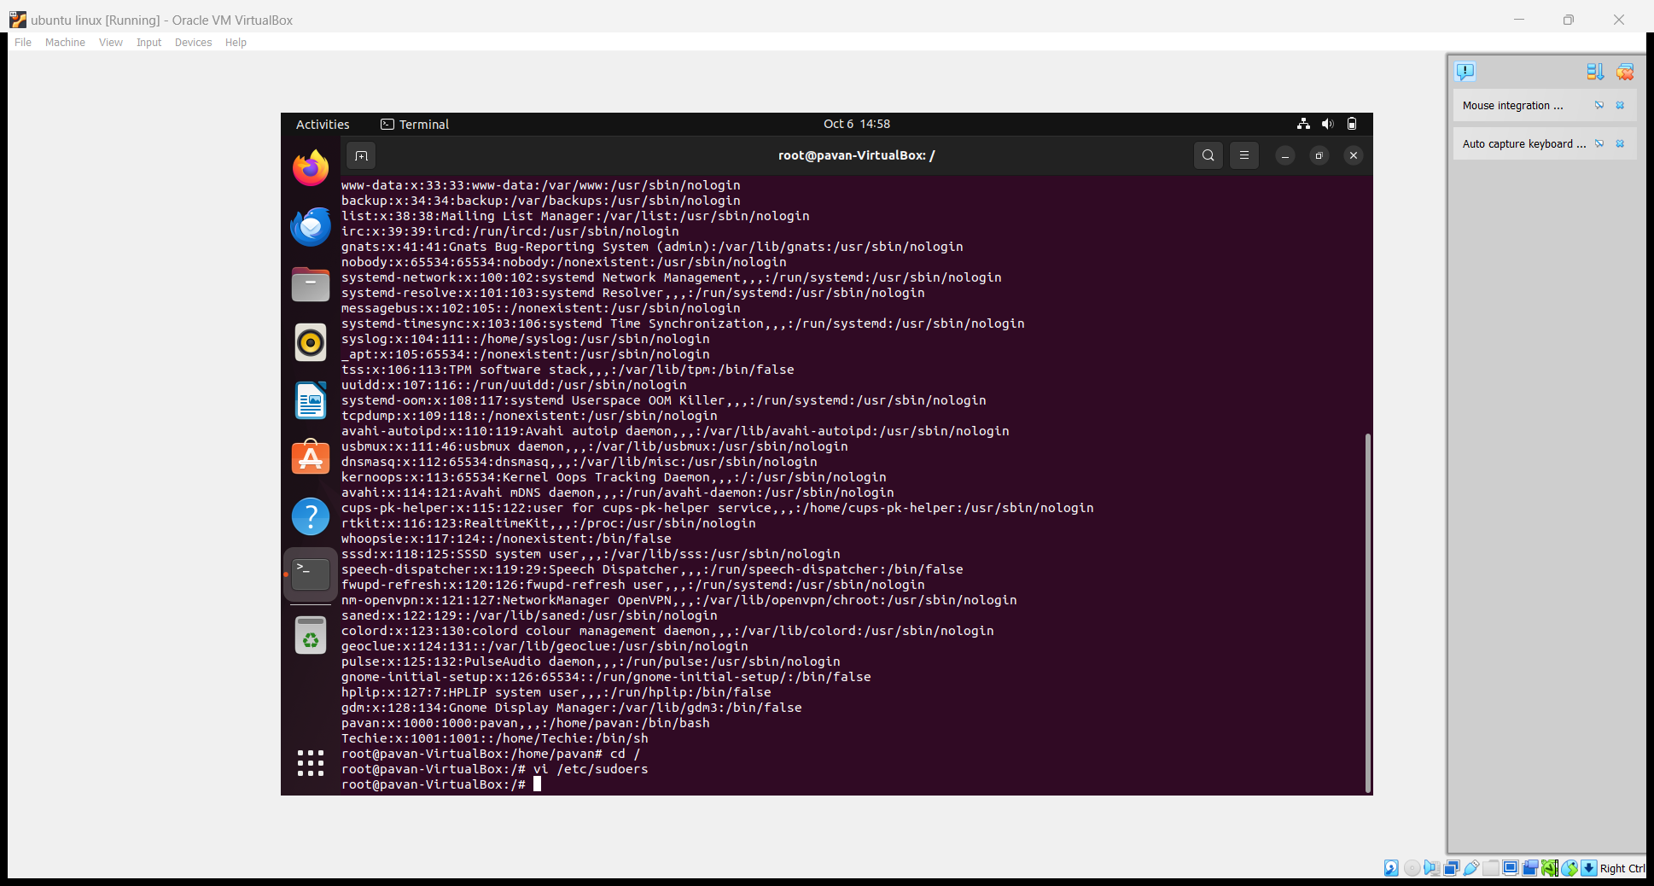

1. Navigate to the home directory



1. Create a new directory.

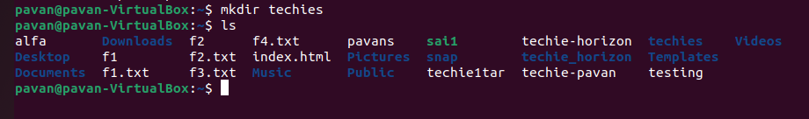

1. List the contents of a directory

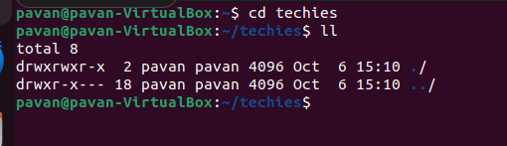

1. Change the current directory

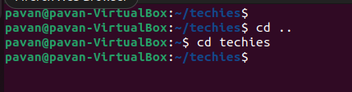

1. Create a new empty file

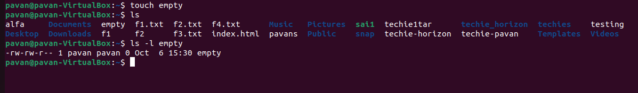

1. View the contents of a file

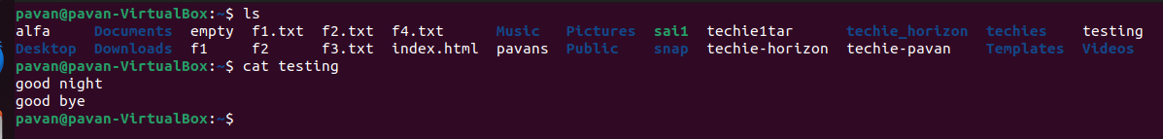

1. Copy a file to another location

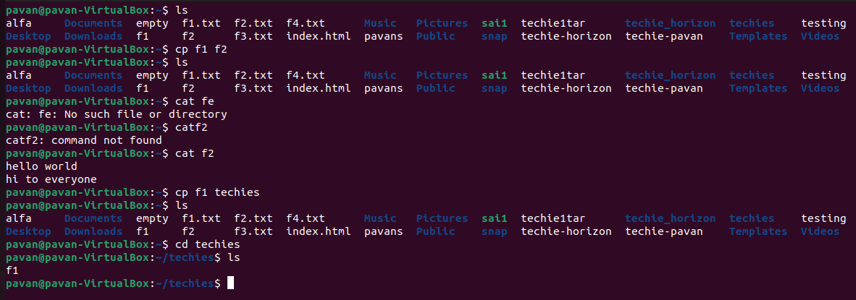

1. Move a file to another location

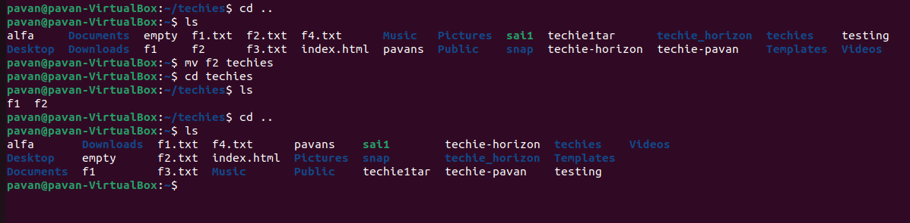

1. Rename a file

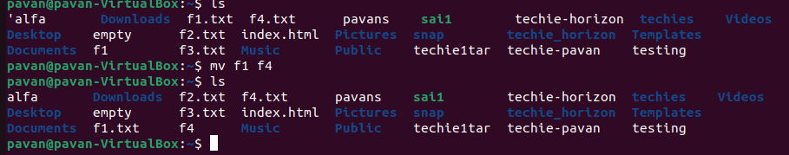

1. Delete a file

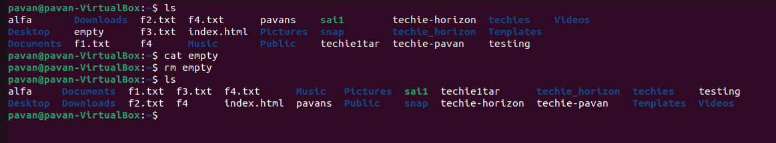

1. Grant or revoke permissions on a file or directory.

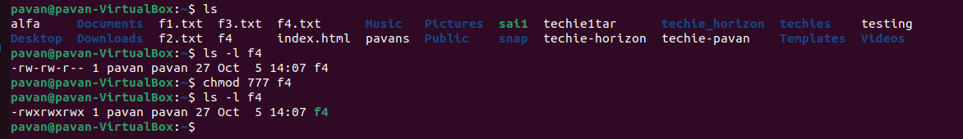

1. View the current date and time

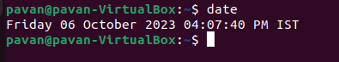

1. View the running process

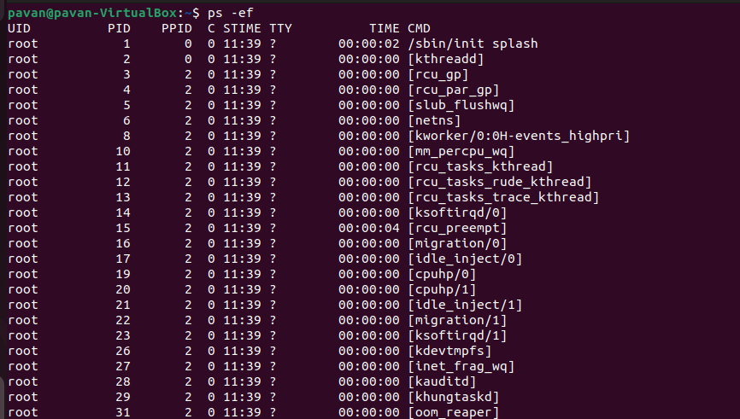

1. Check the system uptime

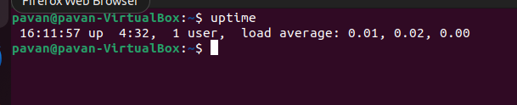

1. Install a package using the package manager (e.g., apt or yum).

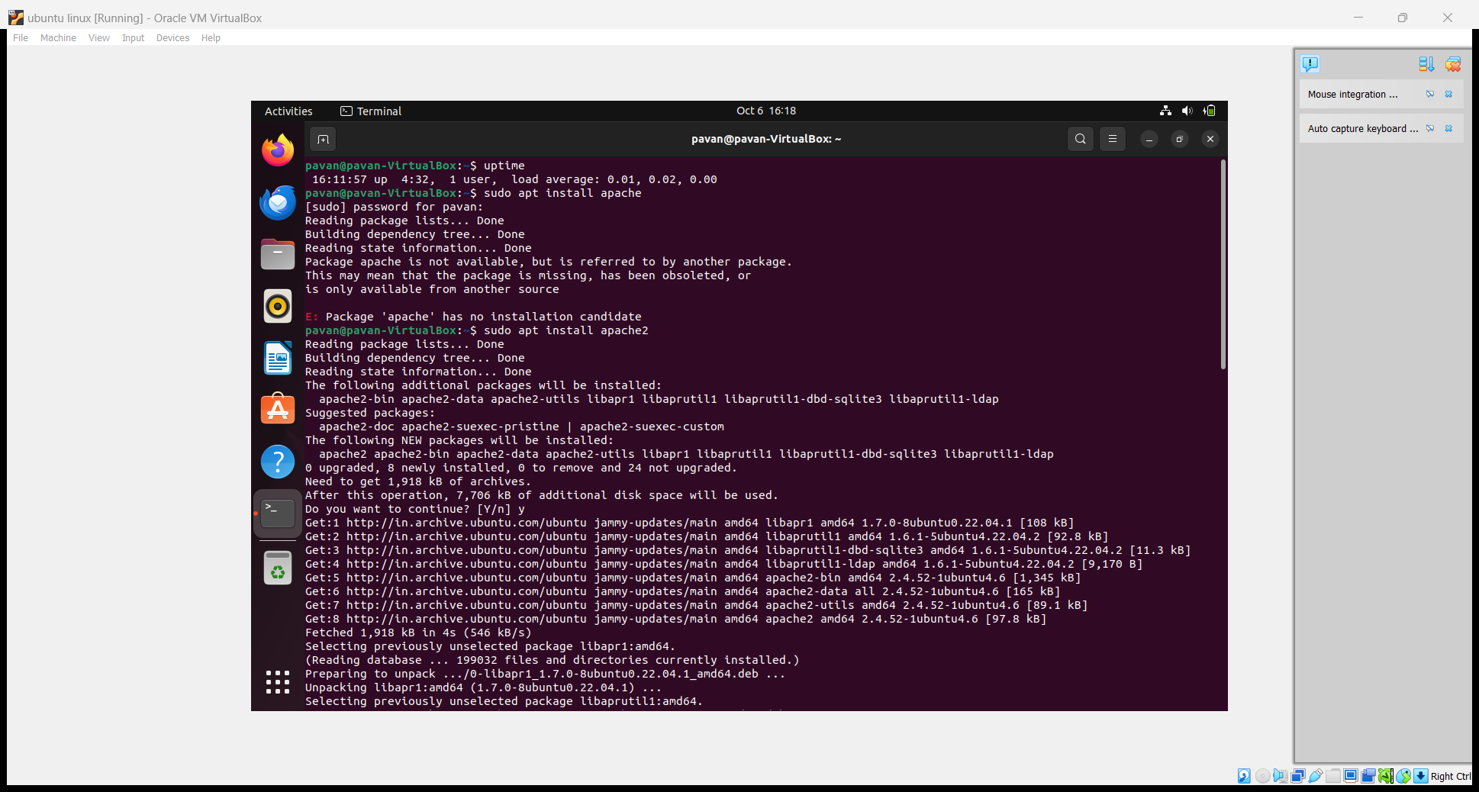

1. Kill a running process

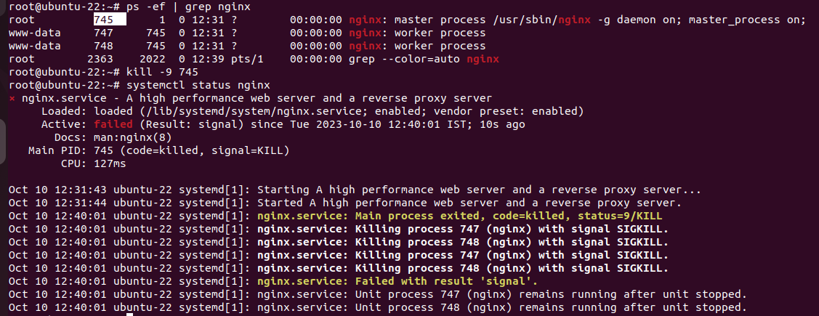

1. Update the system packages

We have to use the command sudo apt update

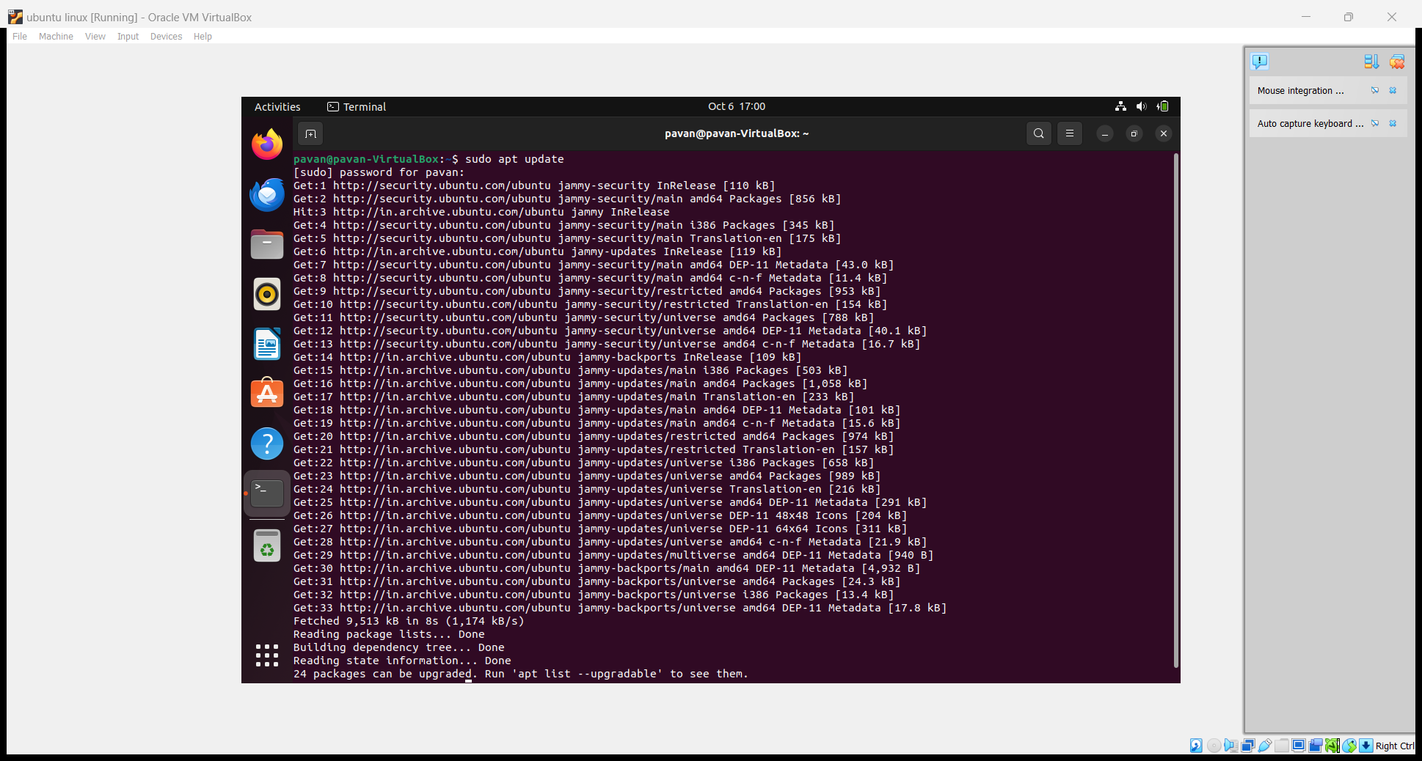

1. Create a symbolic link

**Links Types**

There are two types of links in Linux/UNIX systems:

* **Hard links**. You can think a hard link as an additional name for an existing file. Hard links are associating two or more file names with the same [inode](https://en.wikipedia.org/wiki/Inode) . You can create one or more hard links for a single file. Hard links cannot be created for directories and files on a different filesystem or partition.
* **Soft links**. A soft link is something like a shortcut in Windows. It is an indirect pointer to a file or directory. Unlike a hard link, a symbolic link can point to a file or a directory on a different filesystem or partition**. ln -s source_file symbolic_link**

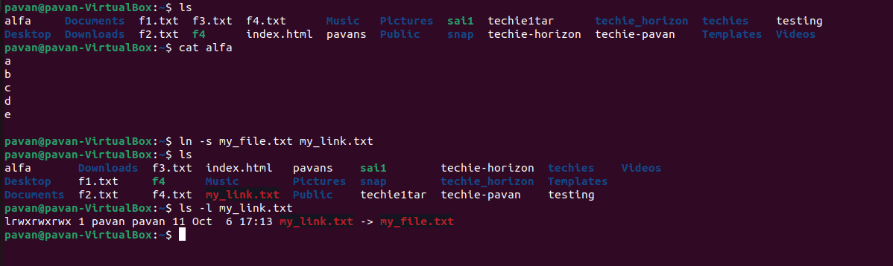

1. Search for files using the find command

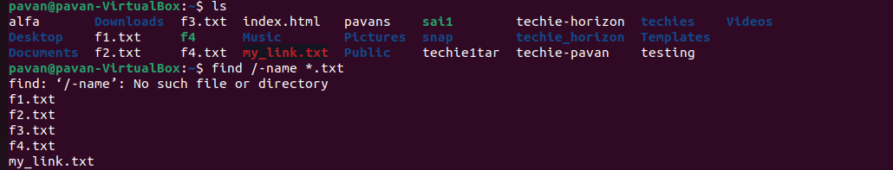

21)compress and decompress files using tar

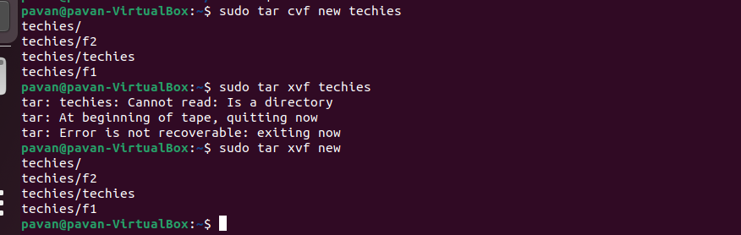

* 1. ) Monitor system resources with top or htop.

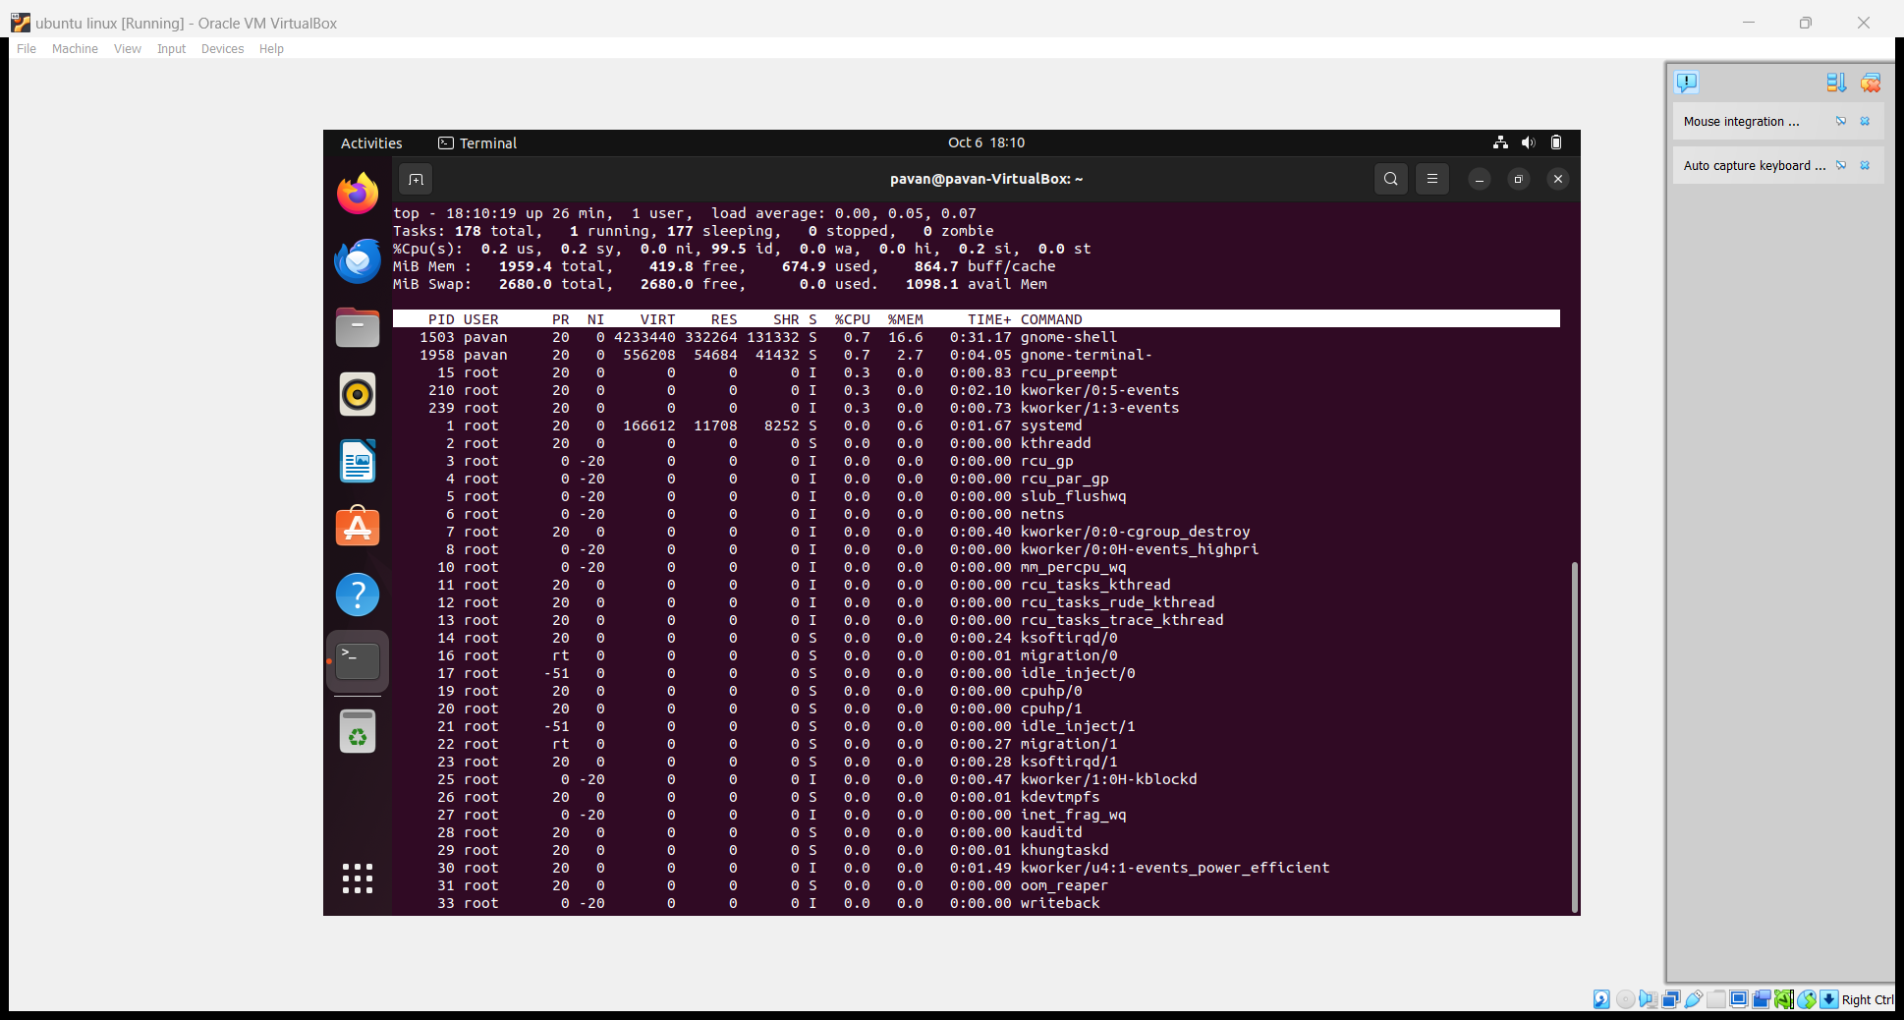

23) Create and manage user groups

To create a group command : **groupadd group_name**



Set password to the group command : **gpasswd group_name**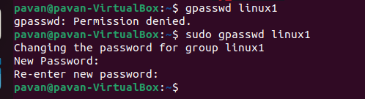

To show password of that group use command : **cat /etc/gshadow**

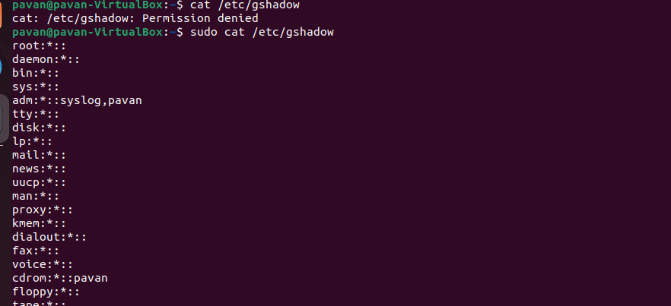

Adding a user to that group command : **sudo usermod -G group_name user_name**



To see that user is added to that group or not command

**Sudo getent group group_name**



To delete the group use command : **groupdel group_name**



24) Set up SSH password less authentication

25) Monitor log files using tail or grep

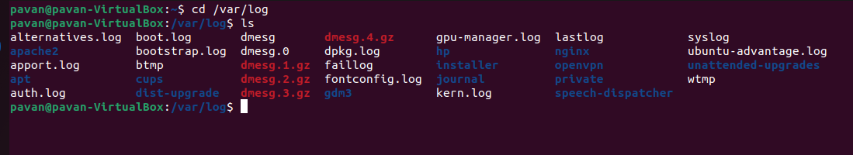

26) Set up a web server (e.g., Apache or Nginx).

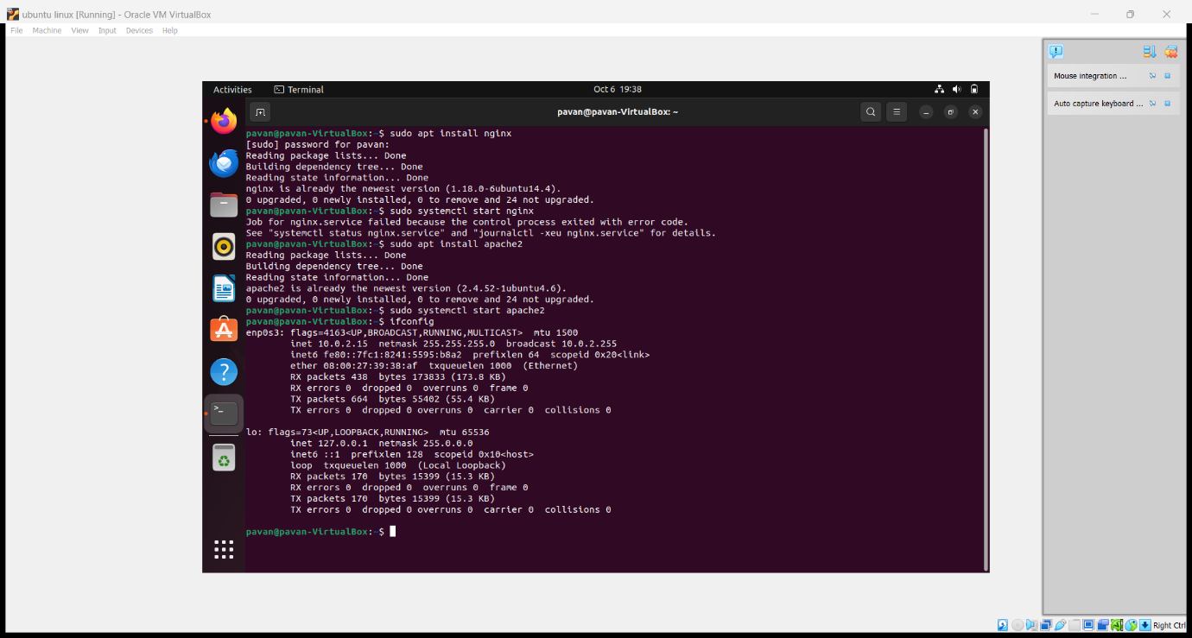

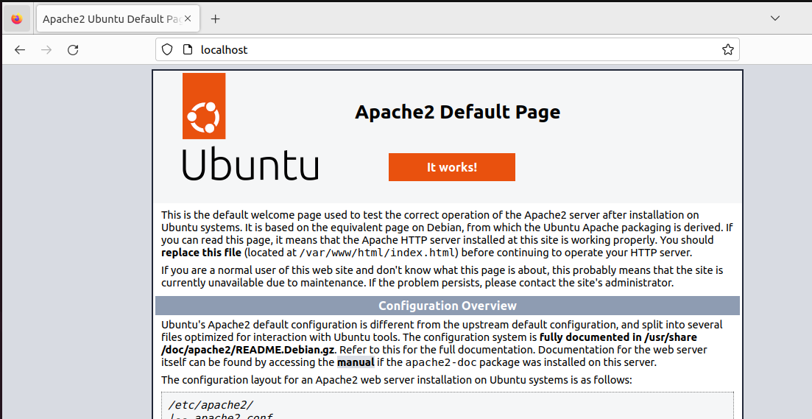

27) Configure and secure a MySQL Database

Install MySQL command **sudo apt-get install mysql-server**

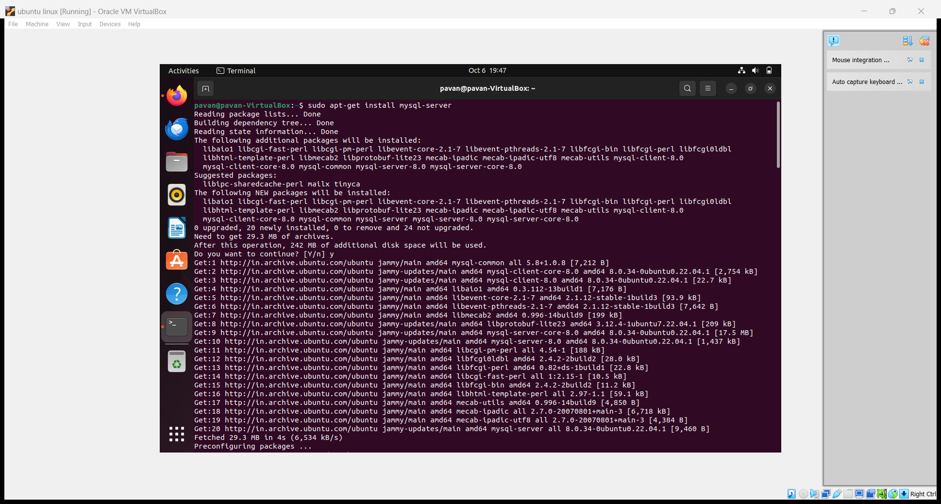

To secure this MySQL **sudo mysql_secure_installation**

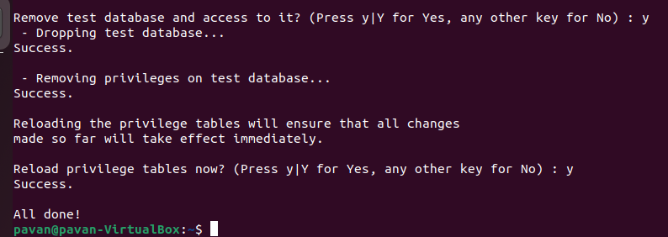

Create user accounts and databases **mysql -u root -p**

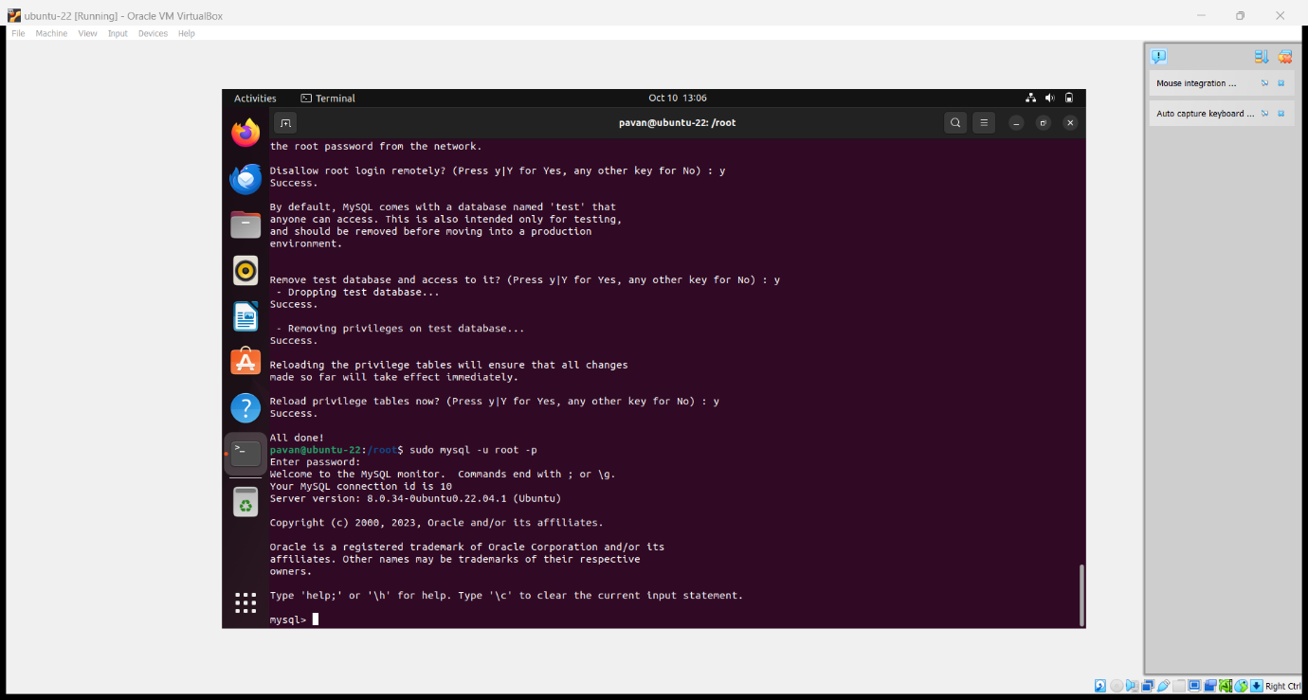

28) Set up a Application Server (e.g.,Apache Tomcat)

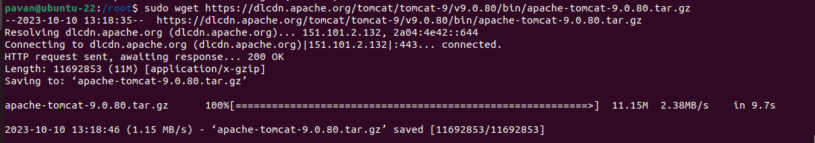

29) create a service file for Apache Tomcat.(Should execute by using systemtctl command)

30) Print specific columns from a delimited file.

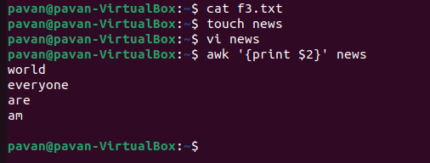

31) Filter and print lines based on a specific pattern or condition.

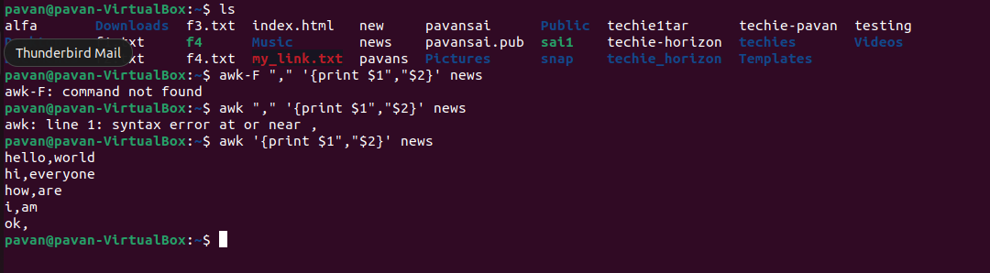

32) Calculate and print the average, sum, or other statistics of a column.

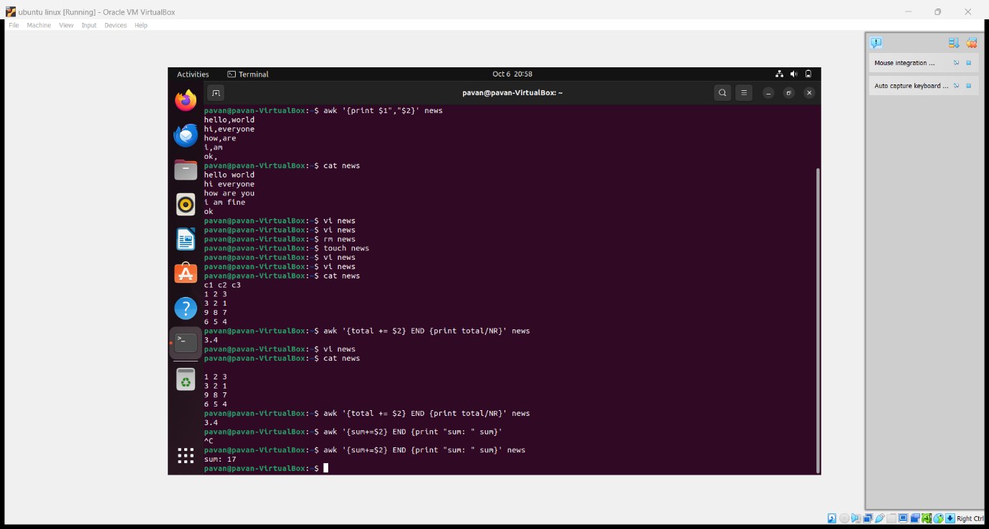

33) Perform string manipulation, such as extracting substrings or changing case

34) Count the occurrences of a specific pattern in a file.

35) Sort lines based on a specific field or column.

36) Merge multiple files based on a common field or column.

37) Substitute text in a file using search and replace.

38) Delete specific lines based on a pattern or line number.

39) Append or insert text before or after a specific pattern or line.

40) Print only specific lines from a file.

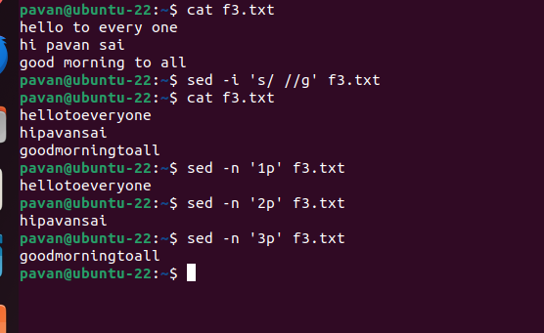

41) Delete leading or trailing whitespace from lines.

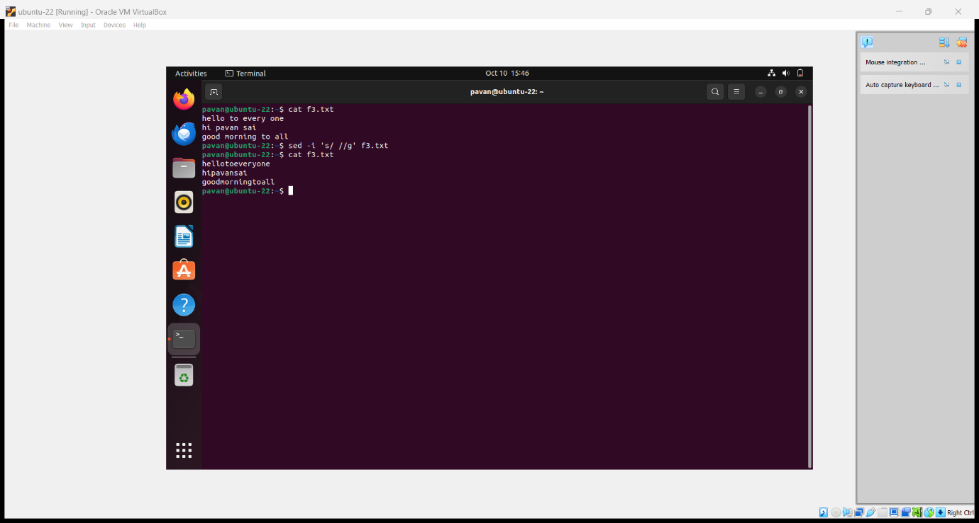

42) Edit files in-place, making changes directly to the file.

43) Join multiple lines into a single line or split a line into multiple lines.

44) Copy file from linux to windows machine

45) 5 use cases for AWK and 5 use cases for sed