**TRACING THE GROWTH OF THE GLOBAL COMMUNITY:**

**A POPULATION FORECASTING ANALYSIS**

**Submitted by**

**P.PAVITHRA**

**(Reg.No.12020U25018)**

**N.NANDHINI**

**(Reg.No.12020U25017)**

**R.KEERTHANA**

**(Reg.No.12020U25014)**

**P.KOKILAMBAL**

**(Reg.No.12020U25015)**

**DEPARTMENT OF BACHELOR OF SCIENCE IN MATHEMATICS**



**KRISHNASAMY COLLEGE OF SCIENCE,ARTS & MANAGEMENT FOR WOMEN- CUDDALORE**

**PROJECT CONTENT**

1. **INTRODUCTION**
   1. **Overview**
   2. **Purpose**
2. **PROBLEM DEFINITION & DESIGN THINKING**
   1. **Empathy Map**
   2. **Ideation & Brainstorming Map**
3. **RESULT**
4. **ADVANTAGES & DISADVANTAGES**
5. **APPLICATIONS**
6. **CONCLUSION**
7. **FUTURE SCOPE**
8. **APPENDIX**
9. **SQL Source code**
10. **HTML Source code**
11. INTRODUCTION
    1. Overview

The world’s population is more than three times larger than it was in the mid-twentieth century. The global human population reached 8.0 billion in mid-November 2022 from an estimated 2.5 billion people in 1950, adding 1 billion people since 2010 and 2 billion since 1998. The world’s population is expected to increase by nearly 2 billion persons in the next 30 years, from the current 8 billion to 9.7 billion in 2050 and could peak at nearly 10.4 billion in the mid-2080s.

This dramatic growth has been driven largely by increasing numbers of people surviving to reproductive age, the gradual increase in human lifespan, increasing urbanization, and accelerating migration. Major changes in fertility rate have accompanied this growth. These trends will have far-reaching implications for generations to come.

* 1. Purpose

The business requirements for ‘Tracing the growth of

global community’ includes  
 1) Accurate data on population growth and demographics for multiple

countries and regions.  
 2) The ability to analyze and forecast population growth trends over a

specific time period.  
 3) The ability to identify key factors influencing population growth and demographic changes.  
 4) The ability to present the data and analysis in a clear and visually appealing format, such as charts and graphs.  
 5) The ability to integrate the data and analysis with other relevant business information.  
 6) The ability to use the data and analysis to inform strategic decision-making for the company or organization

LITERATURE SURVEY:

A literature survey is a method of researching

existing literature and studies related to a specific topic. In the context of ‘Tracing the growth of a global community’ a literature survey would involve reviewing studies and articles that have been published on the topic of population and  demographics, as well as studies specific population increase in cities,The literature survey would include sources such as academic journals, industry reports, and online articles. It would aim to identify key performance indicators (KPIs)

Social Impact:

Improve the infrastructure and strategies through which

the cities could manage the population

Business Model/Impact:

Improved strategic planning: By understanding population growth trends and demographics, a business can make more informed decisions about where to invest resources and expand operations.

1. PROBLEM DEFINITION & DESIGN THINKING
   1. Empathy Map

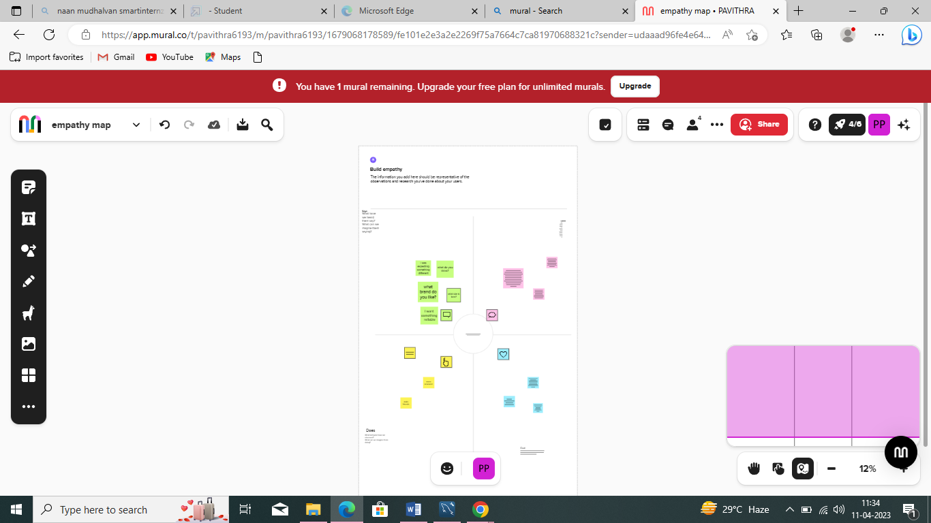

* 1. Ideation & Brainstorming Map

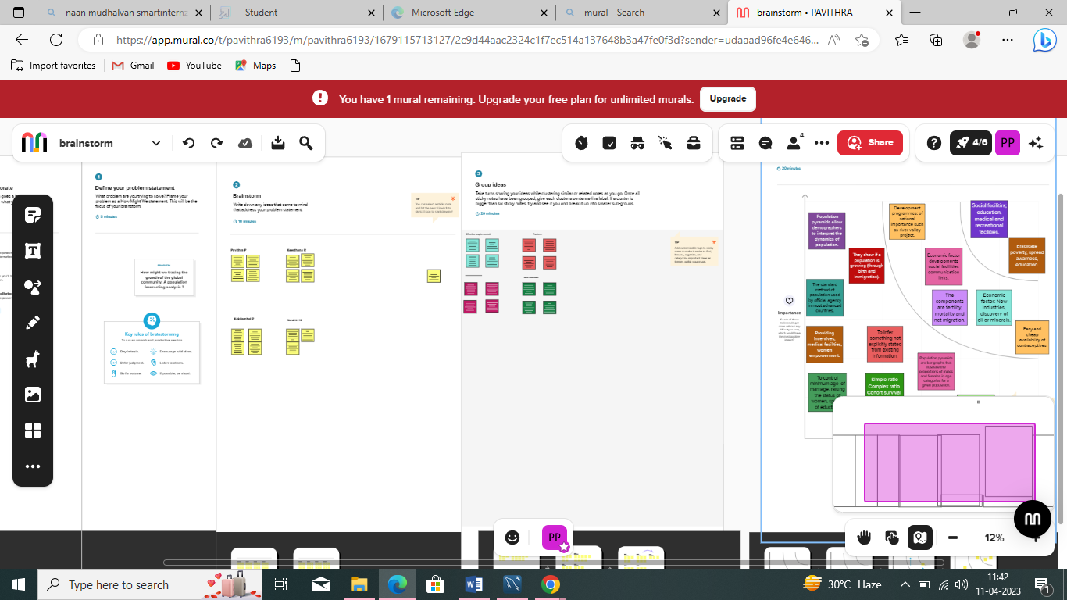

3.RESULT

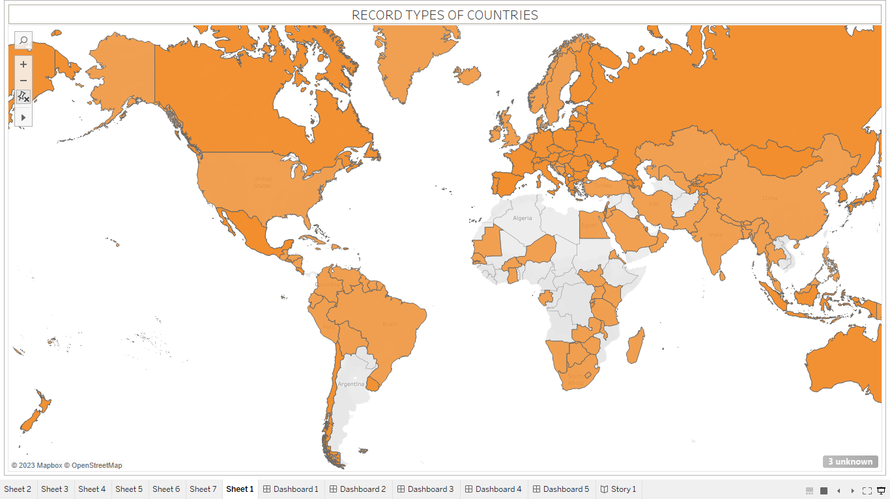

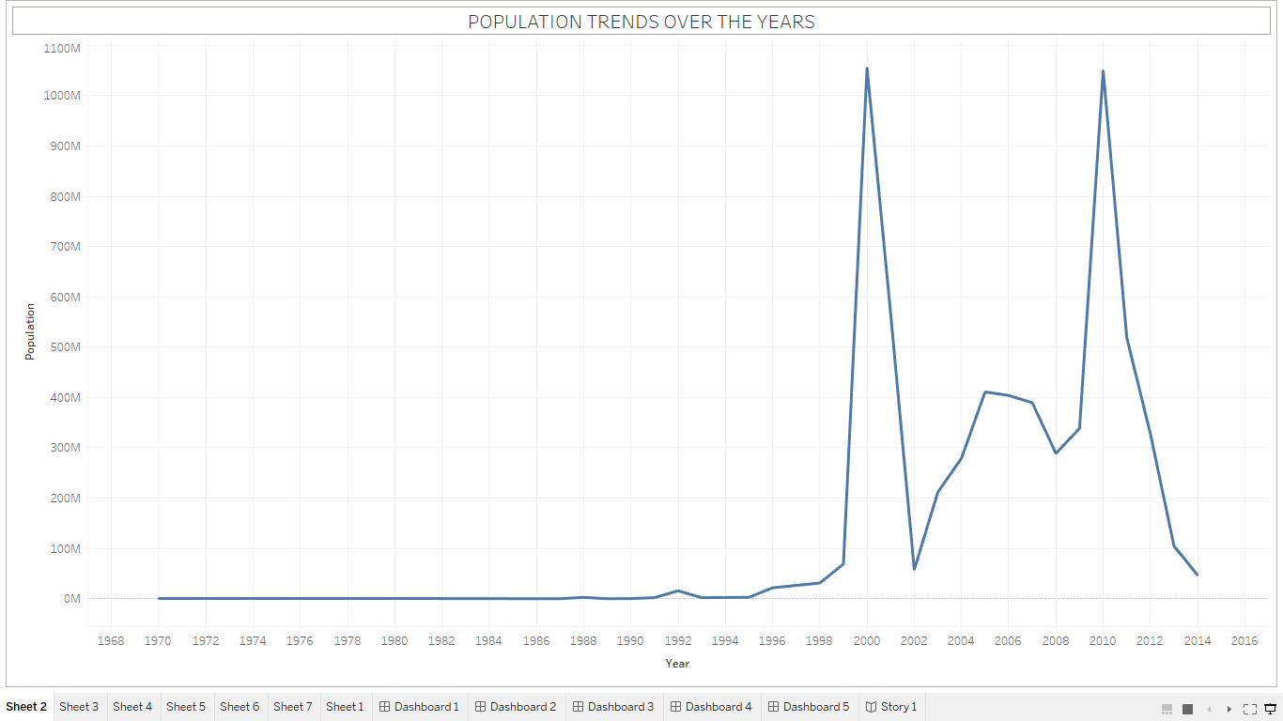

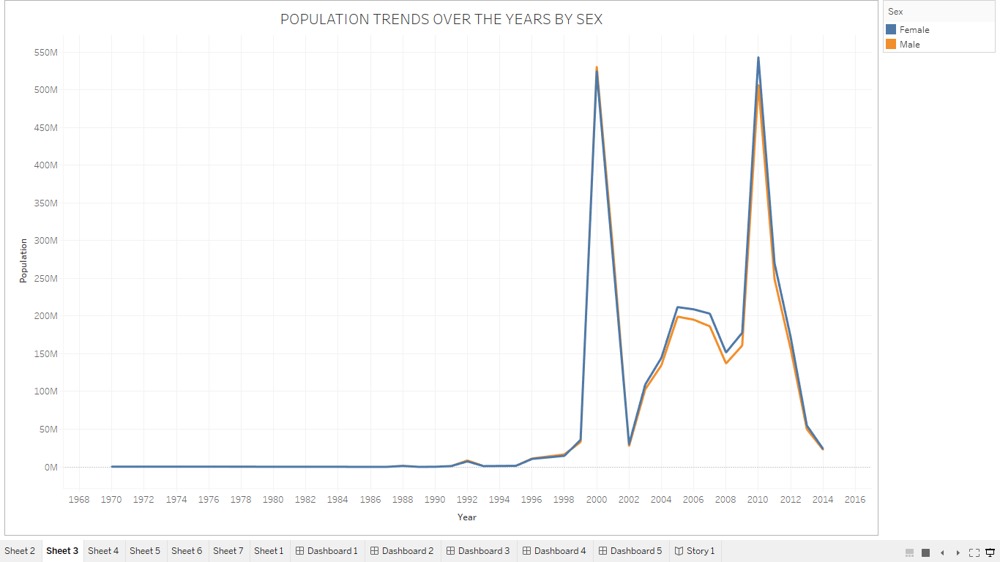

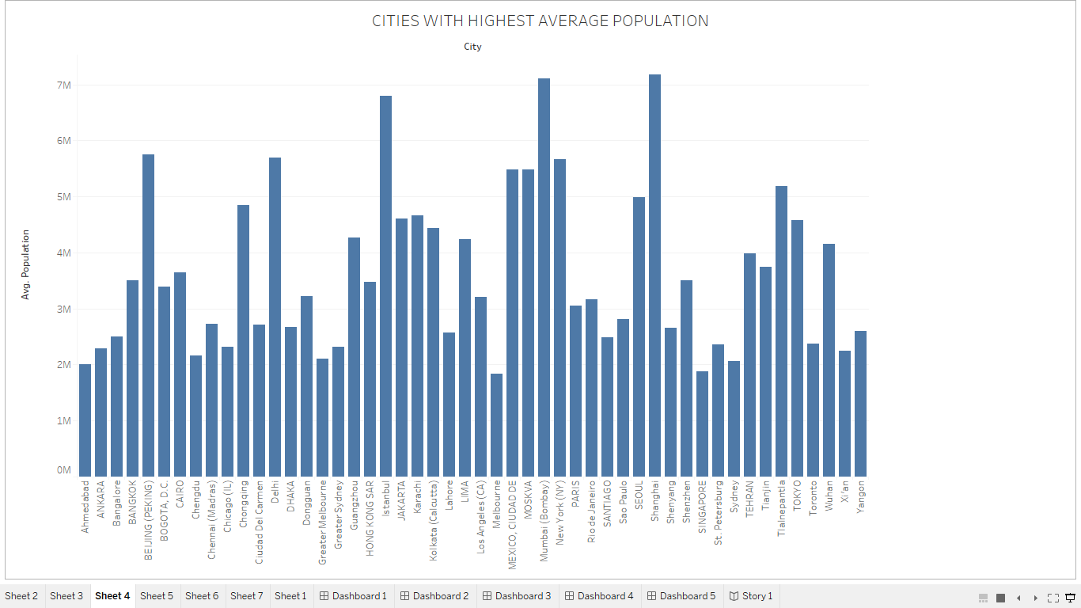

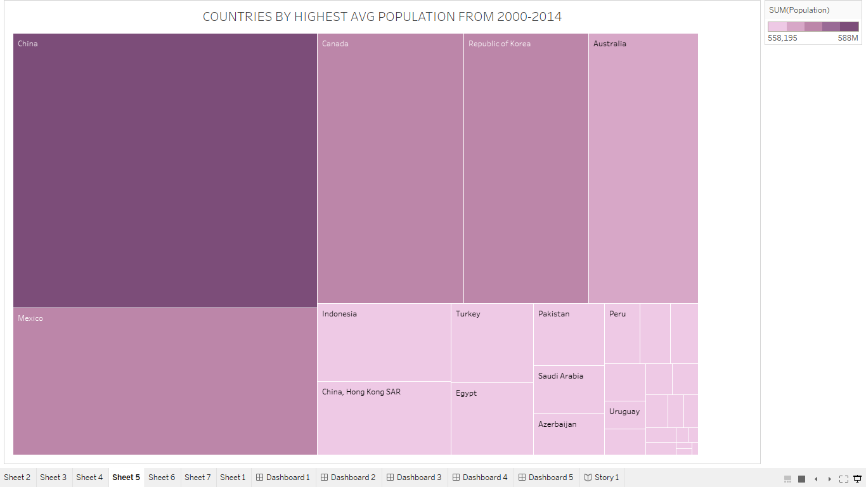

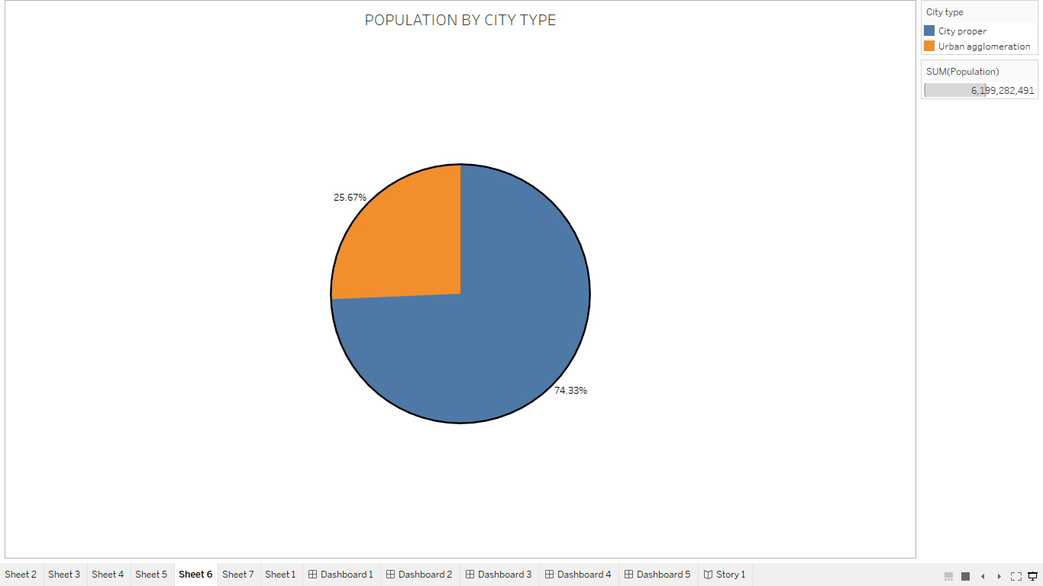

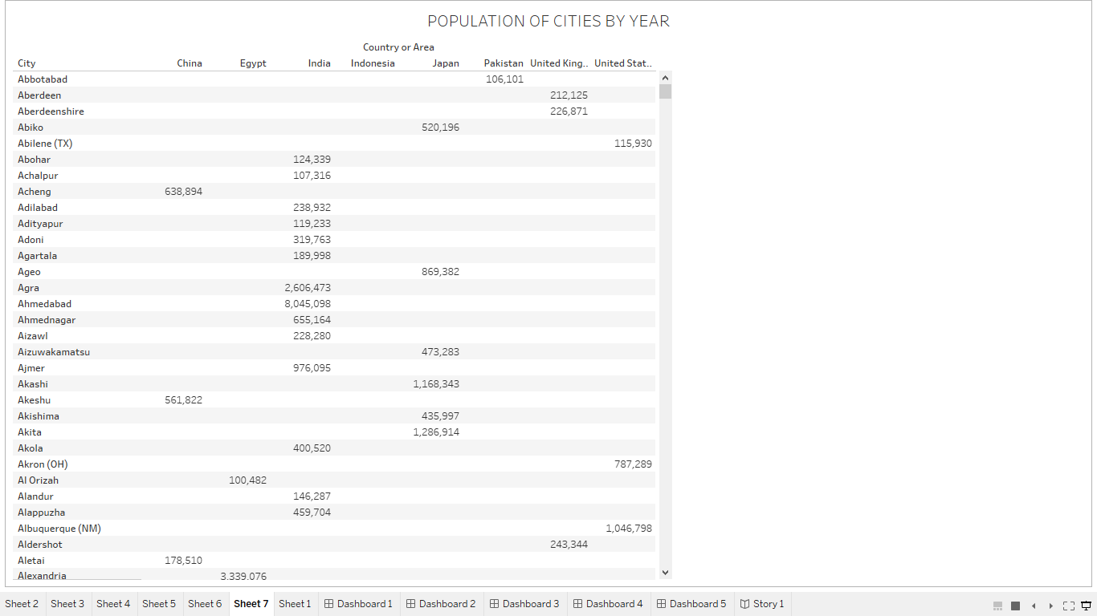

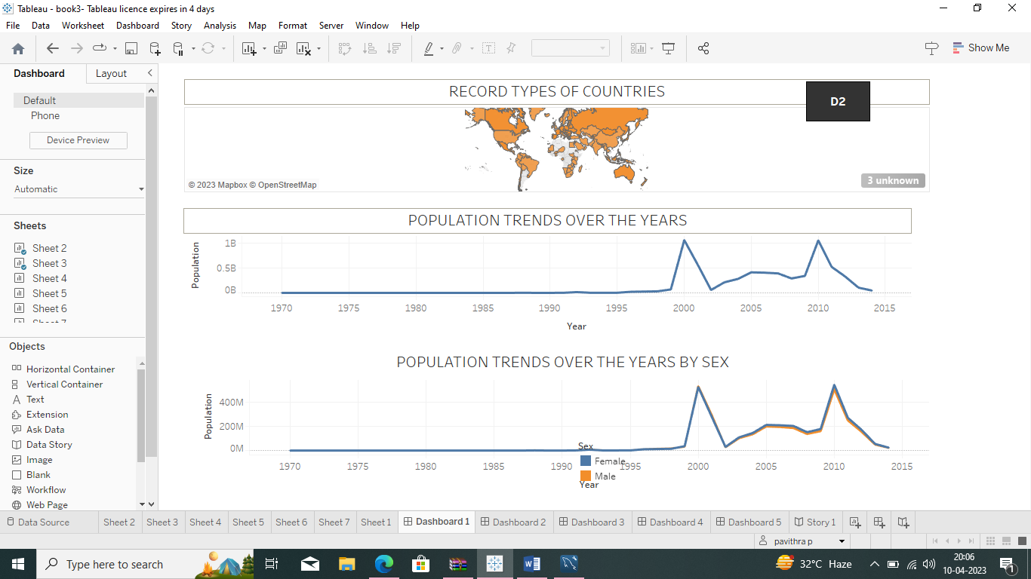

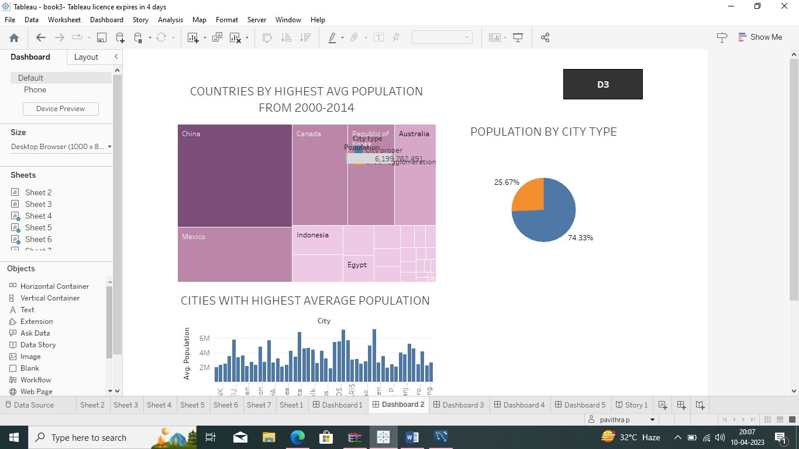

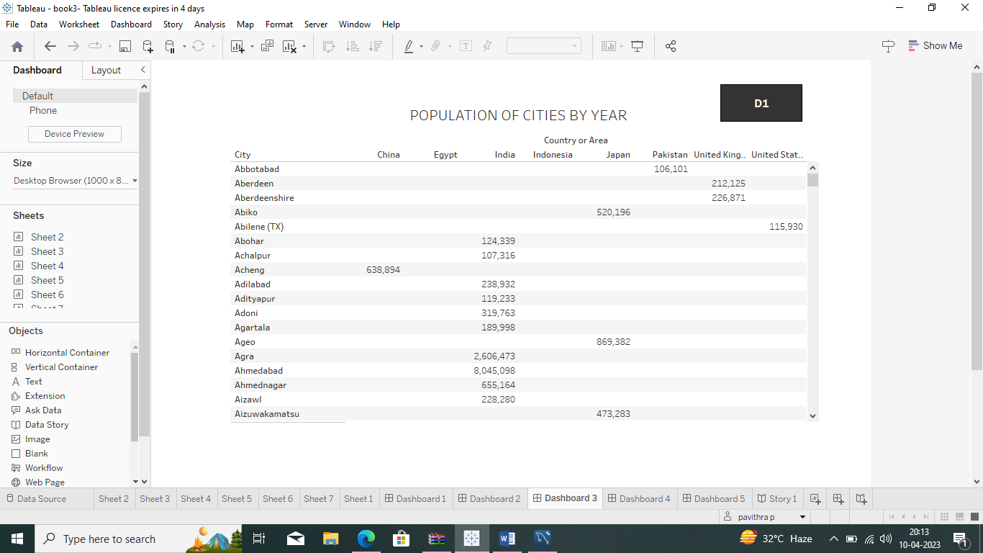

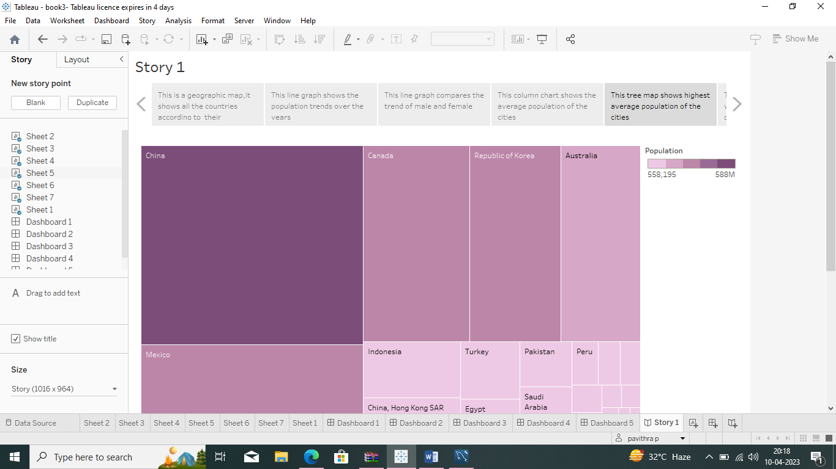

### 4.ADVANTAGES AND DISADVANTAGES:

### Advantages

1. **More people leads to greater human capital**.

If there are more people, the probability of finding a

genius like Einsterin, Marie Curie, Beethoven increase. These exceptional people can lead to technological and cultural masterpieces which enrich our lives. The past 200 years have shown exponential growth in technical development and innovation. There are many factors behind this, but the world’s growing population means we have a bigger pool of human capital and the possibility of these cutting edge discoveries increase.

**2. Higher economic growth**.

Population growth will lead to economic growth with more people able to produce more goods. It will lead to higher tax revenues which can be spent on public goods, such as health care and environmental projects.

* The obvious evaluation is to say, the crucial thing is not GDP, but [GDP per capita](https://www.economicshelp.org/blog/glossary/real-gdp-capita/). If economic growth is at the same rate as population growth, average living standards will not increase. However, it is possible population growth can also improve per capita incomes. As the population increases, the economy can benefit from a bigger talent pool, economies of scale and greater specialisation. All this can enable higher per capita income, which we have seen in major developed economies.

1. **Economies of scale**.

Farming and industry have been able to benefit from economies

of scale, which means as the population grows, food output and manufacturing output have been able to grow even faster than population growth. For example, at the turn of the nineteenth century, Thomas Malthus predicted population growth would lead to famine as we would be unable to feed the growing population. However, his dire predictions failed to materialise because he failed to understand, that the productivity of land, labour and capital could all increase more than proportionately. 300 years ago, most of the population worked on the land. Technological innovation and [economies of scale](https://www.economicshelp.org/microessays/costs/economies-scale/), mean productivity of land has vastly increased as farmers make use of mechanisation and economies of scale for increased food production.

**4. The efficiency of higher population density**.

In terms of per capita carbon footprint, areas with a high population density are significantly more efficient than rural areas and places with a low population. When people live in densely populated areas, they are more likely to use public transport, live in apartment buildings which are easier to heat. In big cities, transport and the delivery of goods is much more efficient, whereas for low population densities, the average cost and environmental footprint are much higher.  Therefore, population growth which leads to growth in city connurbations (which is a feature of global growth in past) is not as environmentally damaging as we may think. In [Green Metropolis](https://books.google.co.uk/books?id=Wkeu5PHQ_ygC&printsec=frontcover&dq=Green+Metropolis&hl=en&ei=lfjETqiuFuLq0gHbuMCeDw&sa=X&oi=book_result&ct=result&redir_esc=y#v=onepage&q&f=fals), by David Owen he argues living in closer proximity in cities is a key aspect of sustainability

* Urban areas account for only 3% of the world’s land surface. But, more than 50% of the population. By 2050, the [United Nations](https://web.archive.org/web/20220217170314/https:/www.un.org/development/desa/en/news/population/2018-revision-of-world-urbanization-prospects.html) predict this will rise to 70%. Therefore, population growth doesn’t have to lead to an equivalent fall in natural habitats.

**5.The improved demographic structure of society.**

Many western economies are now experiencing a falling

population, with the result that their population demographic is being skewed to old, retired people. This is imposing costs on society as we struggle to pay for health care and pensions. Moderate population growth helps to rebalance the population with a higher share of young, working people.

**6. Critical mass**

Higher populations can enable a critical mass of people to enable a sider, more vibrant society. With low populations, there is less scope for diversity. But, when the population grows, it can enable the support of a broader cultural range of activities.

### Disadvantages

* 1. **Cost to the environment.**

 Population growth exacerbates many of the existing environmental

Problems

* Trying to reduce carbon and methane emissions to reduce global warming is relatively more difficult as the population.
* There will be greater threat on natural habitats as a greater population has greater demand for housing and farmland. This will increase pressure to cut down forests to make way for farming and housing.
* Higher population will lead to a greater consumption of non-renewable resources, leading to a faster depletion of natural resources.
* Higher population will lead to greater pollution levels in air, water and land. Higher pollution is associated with a range of health issues, such as cancer and asthma. The pollution also harms animals and plants.
* Soil degradation. To feed a growing planet, we have seen serious degrading of farmland (according to UN estimates) about 12 million hectares of farmland every year. This is due to factors, such as overgrazing, use of chemicals, climate change and use of chemicals.
  1. **Congestion**.

Too many people in a small space will lead to various

types of congestion. Road congestion is a major problem across the world. One study suggested [congestion](https://igees.gov.ie/wp-content/uploads/2018/07/Cost-of-Congestion-Appendix-A-International-Evidence.pdf) cost the EU €111bn (1% of GDP) in 2012. WIth population growth, the costs of congestion will only increase leading to time lost, more pollution and lost output.

* 1. **Water shortages**.

Already up to 40% of the world’s population face

water scarcity and the risk of drought. According to  the [UN](https://www.unccd.int/actions/drought-initiative) water shortages could lead to 700 million people at the risk of displacement. A growing population will put pressure on scarce water supplies and this is a factor behind many minor and major conflicts with countries having to find ways around the shortage of water.

* 1. **Generating unsustainable waste**.

We are currently generating non-biodegradable rubbish

that we are struggling to process. It tends to end in landfill, causing methane emissions and other toxic problems.

### 5.APPLICATIONS:

Selecting a population projection should represent a data-driven decision that is the cornerstone of long-range planning efforts. One of the major pitfalls to avoid is adopting a population projection based on a desired outcome, rather than a projection grounded in reliable data and historical trends.

Planners should recognize that projecting growth is a technical exercise and that policy decisions should be made separately, after finalizing a countywide forecast. Cities and counties should work together to develop the regional projection based on the most likely growth scenario.  Policy discussions should focus on issues local governments can influence directly, such as development patterns and their impact on rural character, trade-offs between increasing density and UGA expansions, and economic development strategies to support and facilitate future growth.

Overly optimistic forecasts can result in long-term infrastructure commitments that run the risk of undermining other local priorities. More conservative forecasts arguably pose less risk. Many decision-makers fear they are locked into a forecast for twenty years, but jurisdictions can (and should) monitor growth as it occurs, and make necessary adjustments during the next periodic review.

6.CONCLUSION

The Earth's current population is almost 7.6 billion people, and it is expanding. It is expected to surpass 8 billion people by 2025, 9 billion by 2040, and 11 billion by 2100. The population is quickly increasing, far surpassing our planet's ability to maintain it, given existing habits.

7.FUTURE SCOPE

Population health forecasting requires rich data, an understanding of the determinants of health and their interactions, and technically innovative modeling. The evidence base for such modeling is supported by systematic reviews of the environmental and policy determinants of health and meta-analyses of specific health risk factors and related interventions. Both give a sense of the extent of missed opportunities for health improvement and the high cost of not undertaking policies and programs of proven effectiveness. However, there continues to be a translation gap between research and practice. Policy researchers have identified many reasons for this gap, including a lack of understanding or awareness, uncertainty about the relevance of research for particular situations, and the lack of confidence in information sources.

Most models that evaluate multiple health determinants and related outcomes are based on a microsimulation framework that allows modeling of individual units, usually individuals. Compared with approaches based on aggregate trends, microsimulation models are particularly suitable to evaluating different interventions and policy scenarios, by allowing the incorporation of data from disparate sources and inclusion of distributional information on variables of interest. Two major types are widely used. Static models use cross-sectional databases that provide a snapshot of the population at a point in time. In contrast, dynamic models build longitudinal databases of individual histories and allow behaviors and exposures to change over the time modeled.

8.APPENDIX

A.SQL Source code

1. create schema population_analysis

2. use population_analysis;

3. select * from un_pop;

B.HTML Source Code

<!doctype html>

<html lang="en">

  <head>

    <meta charset="utf-8">

    <meta name="viewport" content="width=device-width, initial-scale=1">

    <title>Bootstrap demo</title>

    <link href="https://cdn.jsdelivr.net/npm/bootstrap@5.3.0-alpha3/dist/css/bootstrap.min.css" rel="stylesheet" integrity="sha384-KK94CHFLLe+nY2dmCWGMq91rCGa5gtU4mk92HdvYe+M/SXH301p5ILy+dN9+nJOZ" crossorigin="anonymous">

  </head>

  <body>

    <nav class="navbar navbar-expand-lg navbar-dark bg-dark">

        <div class="container-fluid">

          <a class="navbar-brand" href="#">Population Analysis</a>

          <button class="navbar-toggler" type="button" data-bs-toggle="collapse" data-bs-target="#navbarColor02" aria-controls="navbarColor02" aria-expanded="false" aria-label="Toggle navigation">

            <span class="navbar-toggler-icon"></span>

          </button>

          <div class="collapse navbar-collapse" id="navbarColor02">

            <ul class="navbar-nav me-auto">

              <li class="nav-item">

                <a class="nav-link active" href="#">Home

                  <span class="visually-hidden">(current)</span>

                </a>

              </li>

              <li class="nav-item">

                <a class="nav-link" href="#">Features</a>

              </li>

              <li class="nav-item">

                <a class="nav-link" href="#">Pricing</a>

              </li>

              <li class="nav-item">

                <a class="nav-link" href="#">About</a>

              </li>

              <li class="nav-item dropdown">

                <a class="nav-link dropdown-toggle" data-bs-toggle="dropdown" href="#" role="button" aria-haspopup="true" aria-expanded="false">Dropdown</a>

                <div class="dropdown-menu">

                  <a class="dropdown-item" href="#">Action</a>

                  <a class="dropdown-item" href="#">Another action</a>

                  <a class="dropdown-item" href="#">Something else here</a>

                  <div class="dropdown-divider"></div>

                  <a class="dropdown-item" href="#">Separated link</a>

                </div>

              </li>

            </ul>

            <form class="d-flex">

              <input class="form-control me-sm-2" type="search" placeholder="Search">

              <button class="btn btn-secondary my-2 my-sm-0" type="submit">Search</button>

            </form>

          </div>

        </div>

      </nav>

<h1><p class="text-center" style="color:brown;"><b>Dashboard</b></p></h1>

<div class='tableauPlaceholder' id='viz1681108104136' style='position: relative'><noscript><a href='#'><img alt='Dashboard 1 ' src='https:&#47;&#47;public.tableau.com&#47;static&#47;images&#47;bo&#47;book3_16804234731870&#47;Dashboard1&#47;1_rss.png' style='border: none' /></a></noscript><object class='tableauViz'  style='display:none;'><param name='host_url' value='https%3A%2F%2Fpublic.tableau.com%2F' /> <param name='embed_code_version' value='3' /> <param name='site_root' value='' /><param name='name' value='book3_16804234731870&#47;Dashboard1' /><param name='tabs' value='no' /><param name='toolbar' value='yes' /><param name='static_image' value='https:&#47;&#47;public.tableau.com&#47;static&#47;images&#47;bo&#47;book3_16804234731870&#47;Dashboard1&#47;1.png' /> <param name='animate_transition' value='yes' /><param name='display_static_image' value='yes' /><param name='display_spinner' value='yes' /><param name='display_overlay' value='yes' /><param name='display_count' value='yes' /><param name='language' value='en-US' /><param name='filter' value='publish=yes' /></object></div>                <script type='text/javascript'>                    var divElement = document.getElementById('viz1681108104136');                    var vizElement = divElement.getElementsByTagName('object')[0];                    if ( divElement.offsetWidth > 800 ) { vizElement.style.width='100%';vizElement.style.height=(divElement.offsetWidth*0.75)+'px';} else if ( divElement.offsetWidth > 500 ) { vizElement.style.width='100%';vizElement.style.height=(divElement.offsetWidth*0.75)+'px';} else { vizElement.style.width='100%';vizElement.style.height='927px';}                     var scriptElement = document.createElement('script');                    scriptElement.src = 'https://public.tableau.com/javascripts/api/viz_v1.js';                    vizElement.parentNode.insertBefore(scriptElement, vizElement);                </script>

<h1><p class="text-center" style="color:brown;"><b>Story</b></p></h1>

<div class='tableauPlaceholder' id='viz1681108729426' style='position: relative'><noscript><a href='#'><img alt='Story 1 ' src='https:&#47;&#47;public.tableau.com&#47;static&#47;images&#47;bo&#47;book3_16804234731870&#47;Story1&#47;1_rss.png' style='border: none' /></a></noscript><object class='tableauViz'  style='display:none;'><param name='host_url' value='https%3A%2F%2Fpublic.tableau.com%2F' /> <param name='embed_code_version' value='3' /> <param name='site_root' value='' /><param name='name' value='book3_16804234731870&#47;Story1' /><param name='tabs' value='no' /><param name='toolbar' value='yes' /><param name='static_image' value='https:&#47;&#47;public.tableau.com&#47;static&#47;images&#47;bo&#47;book3_16804234731870&#47;Story1&#47;1.png' /> <param name='animate_transition' value='yes' /><param name='display_static_image' value='yes' /><param name='display_spinner' value='yes' /><param name='display_overlay' value='yes' /><param name='display_count' value='yes' /><param name='language' value='en-US' /><param name='filter' value='publish=yes' /></object></div>                <script type='text/javascript'>                    var divElement = document.getElementById('viz1681108729426');                    var vizElement = divElement.getElementsByTagName('object')[0];                    vizElement.style.width='1016px';vizElement.style.height='991px';                    var scriptElement = document.createElement('script');                    scriptElement.src = 'https://public.tableau.com/javascripts/api/viz_v1.js';                    vizElement.parentNode.insertBefore(scriptElement, vizElement);                </script>

<script src="https://cdn.jsdelivr.net/npm/bootstrap@5.3.0-alpha3/dist/js/bootstrap.bundle.min.js" integrity="sha384-ENjdO4Dr2bkBIFxQpeoTz1HIcje39Wm4jDKdf19U8gI4ddQ3GYNS7NTKfAdVQSZe" crossorigin="anonymous"></script>

  </body>

</html>