Nonlinear Unmixing of Hyperspectral Images

Generalized bilinear model (GBM) for nonlinear unmixing of hyperspectral images due to multipath effects. This model is a generalization not only of the usual LMM but also of a bilinear model that has been recently introduced by Fan *et al.* in [9]. Spectral unmixing includes two main steps.

1. The first step (referred to as *endmember extraction*) consists of extracting endmembers from the hyperspectral image. This extraction can be achieved in a supervised manner when prior information about the image is available. For instance, one might recognize classes of pure materials in the image and select the associated endmembers to create a learning set containing samples belonging to the different classes. When this information is not available, an automatic endmember extraction algorithm (EEA) has to be considered. Automatic EEA include the *pixel purity index* [14], the N-FINDR [15], and the *vertex component analysis* (VCA) [16]. They assume that the data set contains at least one pure pixel for each endmember (which is not always a realistic assumption) and extract the purest pixels from the image.
2. The second step, called *inversion*, consists of estimating the corresponding abundances under positivity and sum-to-one constraints. Many different algorithms have been proposed in the literature to estimate the abundances for the LMM. These algorithms are based on the least square principle [3], maximum likelihood estimation [17], or Bayesian algorithms [18], [19]. Estimating the abundances for nonlinear models is a more challenging problem. Almost all algorithms for the unmixing of nonlinear models are based on the least square estimators as in [8], [9], and [13]. Some other methods based on support vector machines (SVMs) [20] and neural networks [21] have also been recently investigated.

Bilinear Interaction:

Bilinear interaction is secondary illumination, indicating that an object is not illuminated by the light source, but by light reflected by another object.



**Multi member Bilinear Mixing Model:**

Nonlinear mixture models account for the presence of multiple photon interactions by introducing additional “interaction” terms in the LMM [10]. The bilinear model considers second order interactions between endmembers #i and #j (for i, j = 1, . . ., R and i _= j) such that the observed mixed pixel y can be written as

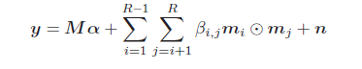

Where

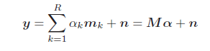

1. L-spectrum y = [y1, . . . , yL]T of a mixed pixel
2. endmember spectra mk = [m1,k, . . . , mL,k]T, k = 1, . . . , R,
3. α = [α1, . . . , αR]T is the R × 1 fractional abundance vector,
4. n = [n1, . . . , nL]T is an additive white noise sequence. n ∼ N(0L, σ2IL)

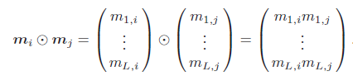

bilinear models differ by the additivity constraints imposed on the abundances.

abundance sum-to-one constraint (ASC)

abundance non-negativity constraint (ANC)

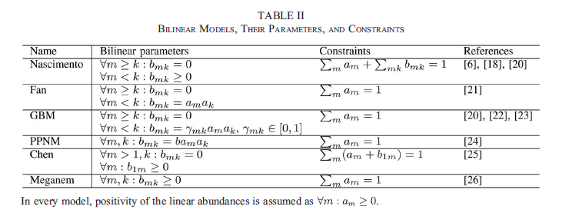

A more advanced two-endmember bilinear model for modelling vegetation and soil interactions was proposed in [17]. The observed spectrum was considered to contain three components: two linear components and one bilinear component, composed of four terms. These terms are as follows:

1) light reflected of a leaf onto the soil or another leaf;

2) light transmitted through a leaf onto the soil or another leaf.

With and the soil es and leaf el endmembers, respectively, and τ the transmittance of the leafs, the mixing equation becomes



Parametric NMM:

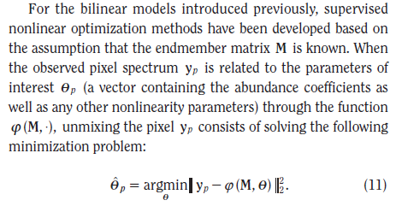

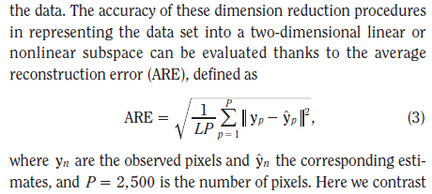

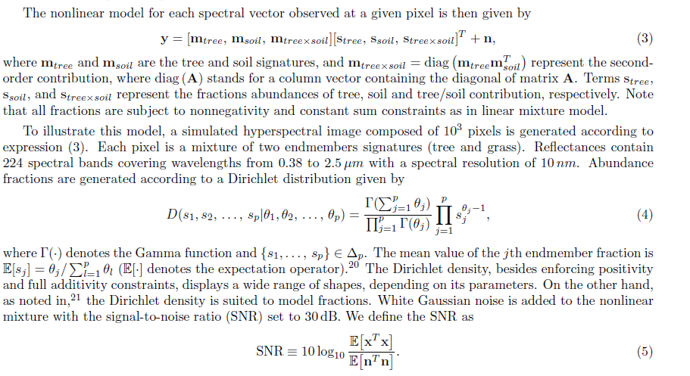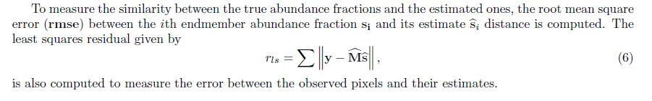

Performance Measures of Model:

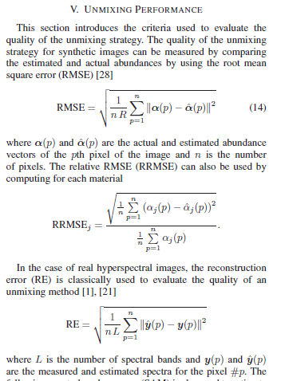

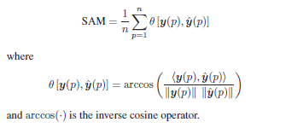

(II) Shortcomings of Bilinear model

1. While several bilinear models have a clear physical interpretation, they may suffer from several drawbacks. Since a bilinear term involves the multiplication of two endmember spectra which are smaller than one, it will have a smaller magnitude than the actual endmembers. This is further exacerbated in several models where these bilinear interaction terms are multiplied with other parameters that are smaller than one, such as the abundance fractions, or free parameters such as the parameters in the GBM. This can cause confusion between bilinear interaction terms and spectral contributions caused by shadows, which should involve a zero endmember.
2. The exclusion of self-interactions encountered in many bilinear models.
3. Introduction of a large number of extra free parameters, often of the order M2, with the number of endmembers makes these models prone to overfitting.

HIERARCHICAL BAYESIAN MODEL:

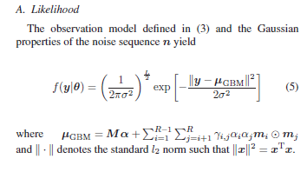

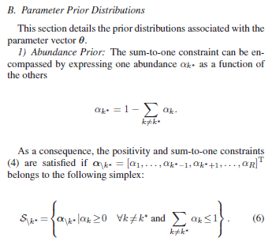

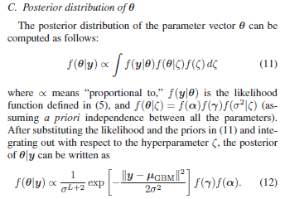

**ANN:**

One of the first unmixing approaches using the standard MLP

was proposed in [100]. In this work, one investigates the

performance of an MLP trained with backpropagation, where

the input consists of three reflectance values, and the outputs are

Fig. 10. MLP with an input layer with four neurons, a single hidden layer with

three neurons, and an output layer of four neurons.

the abundances with respect to three classes. The network is

trained using pure pixels as input, and expected to generate

partial class memberships, or abundances, for mixed pixels. It is

shown that this technique can be successfully used for unmixing

hyperspectral data, and that the unmixing procedure is intrinsically

nonlinear due to the neural network structure.

SVM:

A number of pure pixels are selected from each class, and an SVM is constructed for each class to

separate it from all other classes. The support vectors are then considered to be the endmembers, and mixed pixels will lie in the margin separating the classes. Since the intersection of these

margins will form a simplex with the support vectors as vertices, the classical LMM is recovered. It is shown that under certain conditions, the LMM and the proposed SVM technique are

equivalent.

: